Title - Farmers Train for Success in Agriculture
Video ID: -VsvDZOKPM8
URL: https://www.youtube.com/watch?v=-VsvDZOKPM8
Task | Subtask | Timestamp | Images
Explain the goals of the five-week training programme. | Detail the range of topics covered, including good agricultural practices, cultivation management, and business planning. | 0.0 - 23.8 | 
Discuss the importance of knowledge sharing and networking among farmers. | Note Secretary Barry Morphillisier's encouragement for farmers to share knowledge. | 23.8 - 40.92 | 
Highlight the role of education and attitude in achieving success. | Observe that education and attitude are critical for getting to good agricultural practices. | 40.92 - 59.16 | 
Explain the significance of a training programme in a successful project. | Note Ambassador Peter Cheyenne Chen's congratulations and his encouragement for farmers to take advantage of opportunities. | 84.64 - 126.68 | 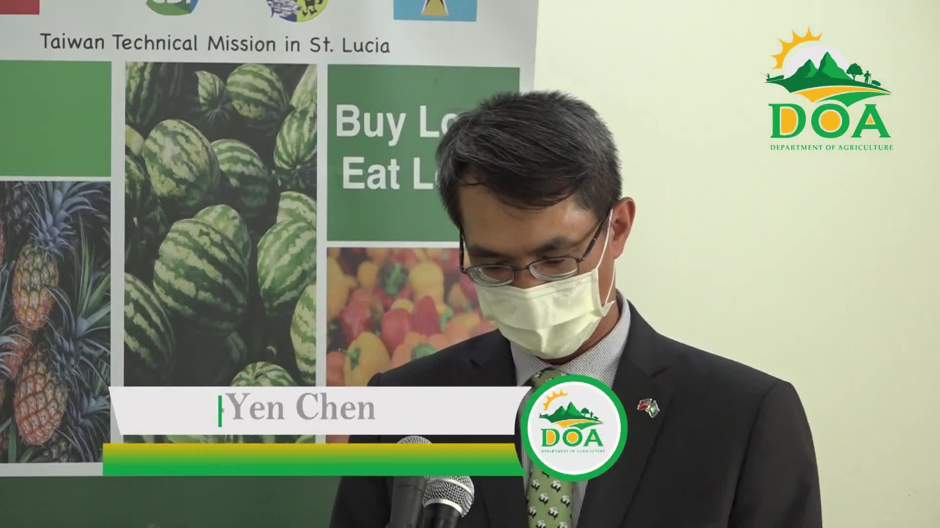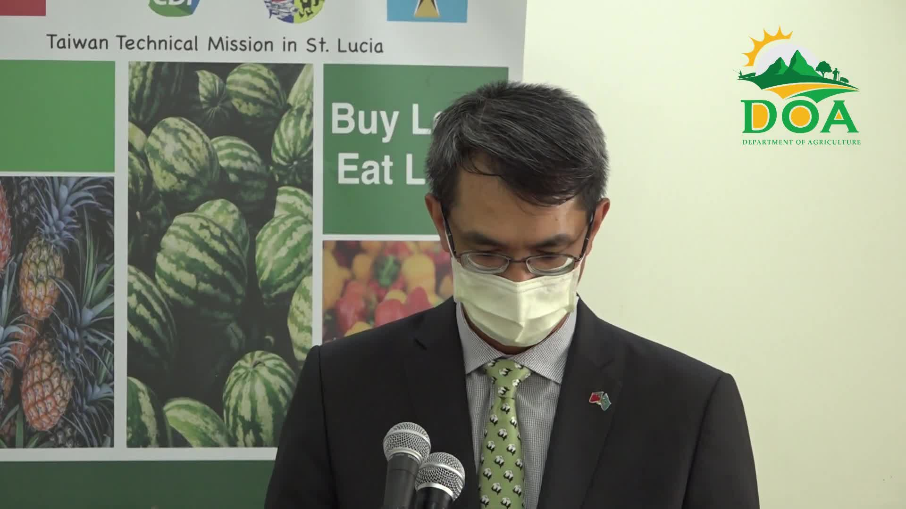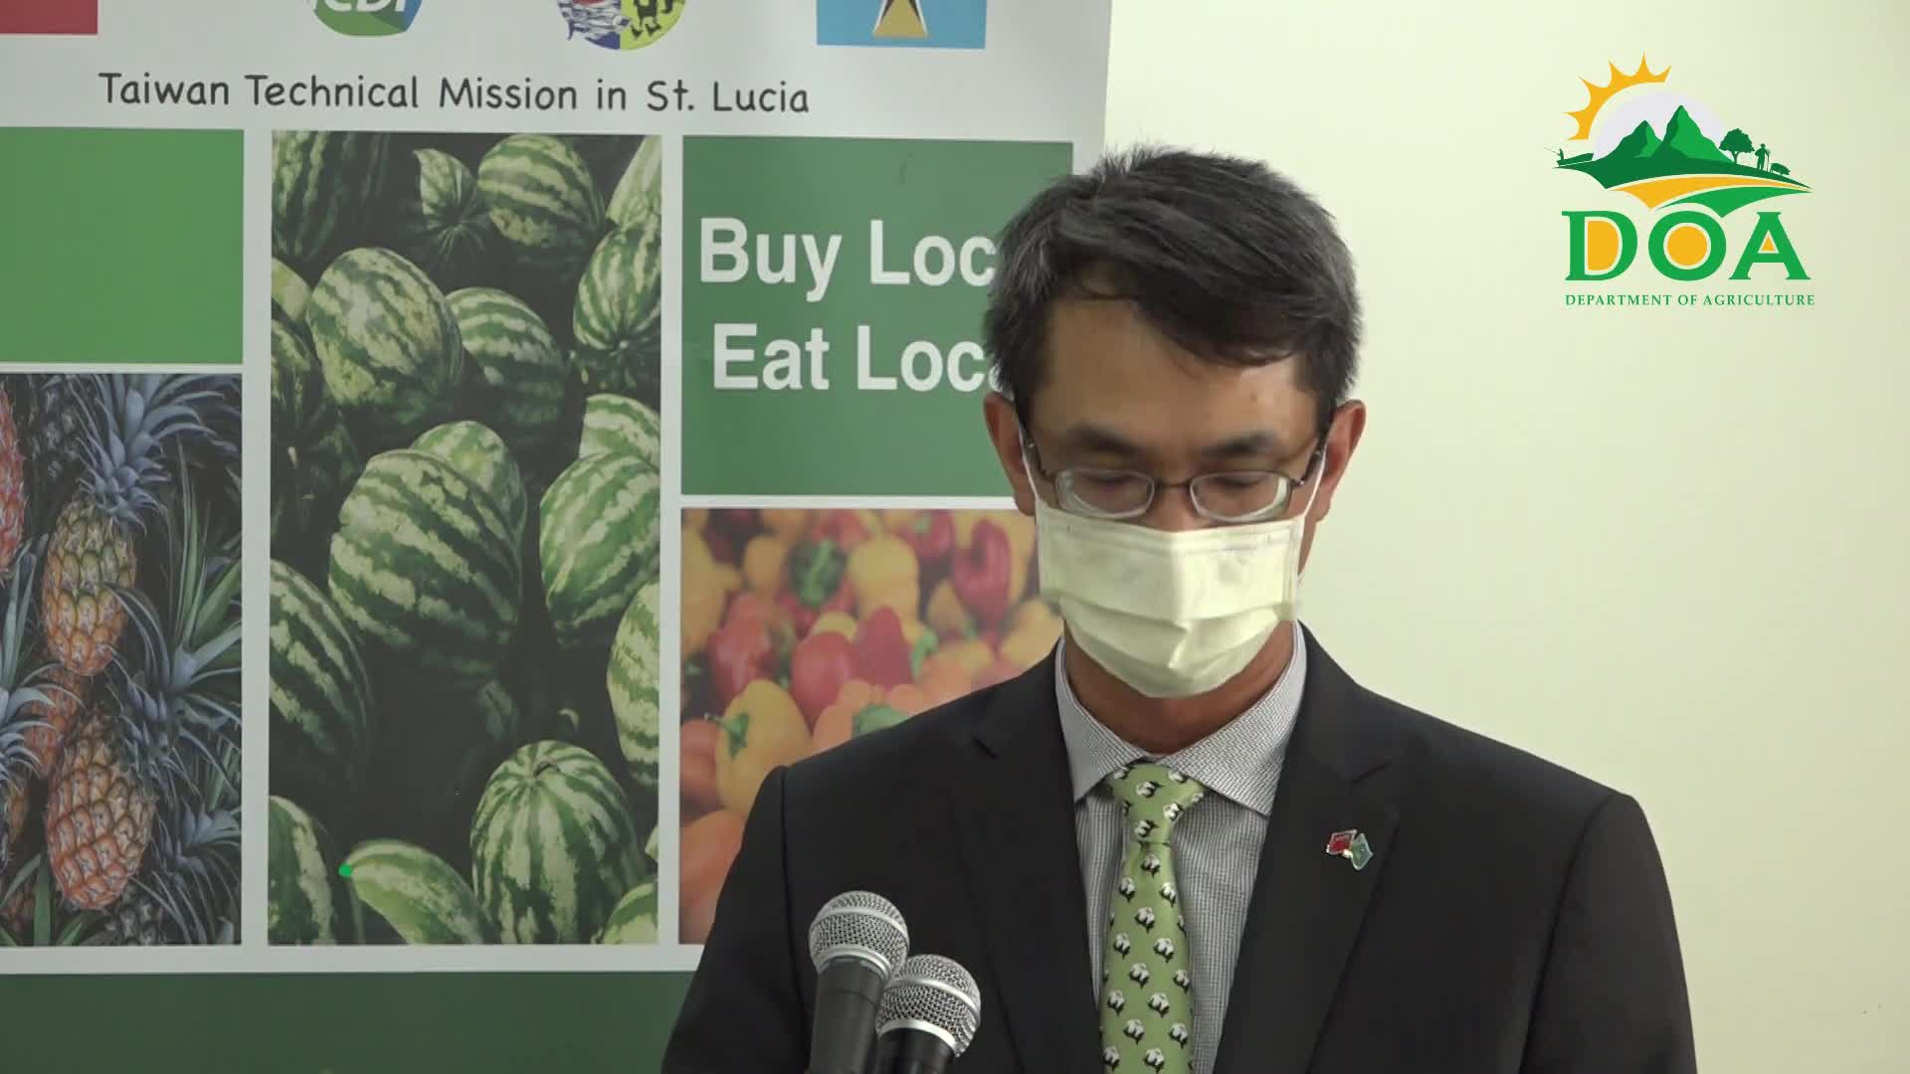
Detail the outcomes of the training programme. | Mention that over 250 farmers have been certified through the programme. | 126.88 - 138.16 | 

