Title - Last Day in Emily Tent Visit Conclusion
Video ID: -m1yW5F41Rs
URL: https://www.youtube.com/watch?v=-m1yW5F41Rs
Task | Subtask | Timestamp | Images
Explore the natural environment and local animals in Emily. | Observe elephants and snakes in the forest. | 44.9 - 47.6 | 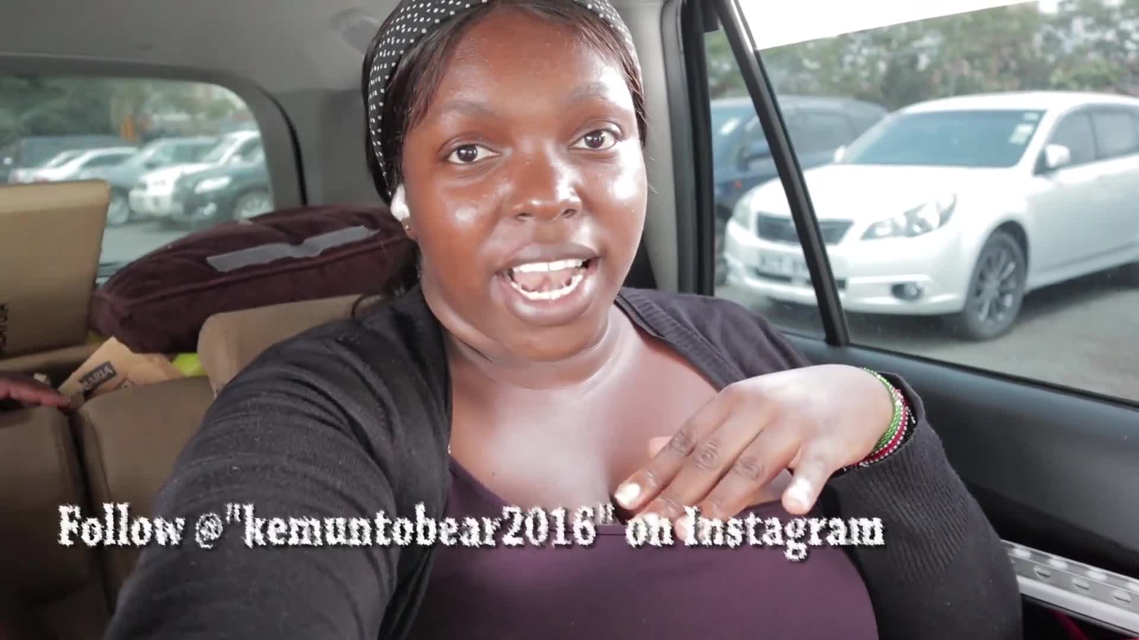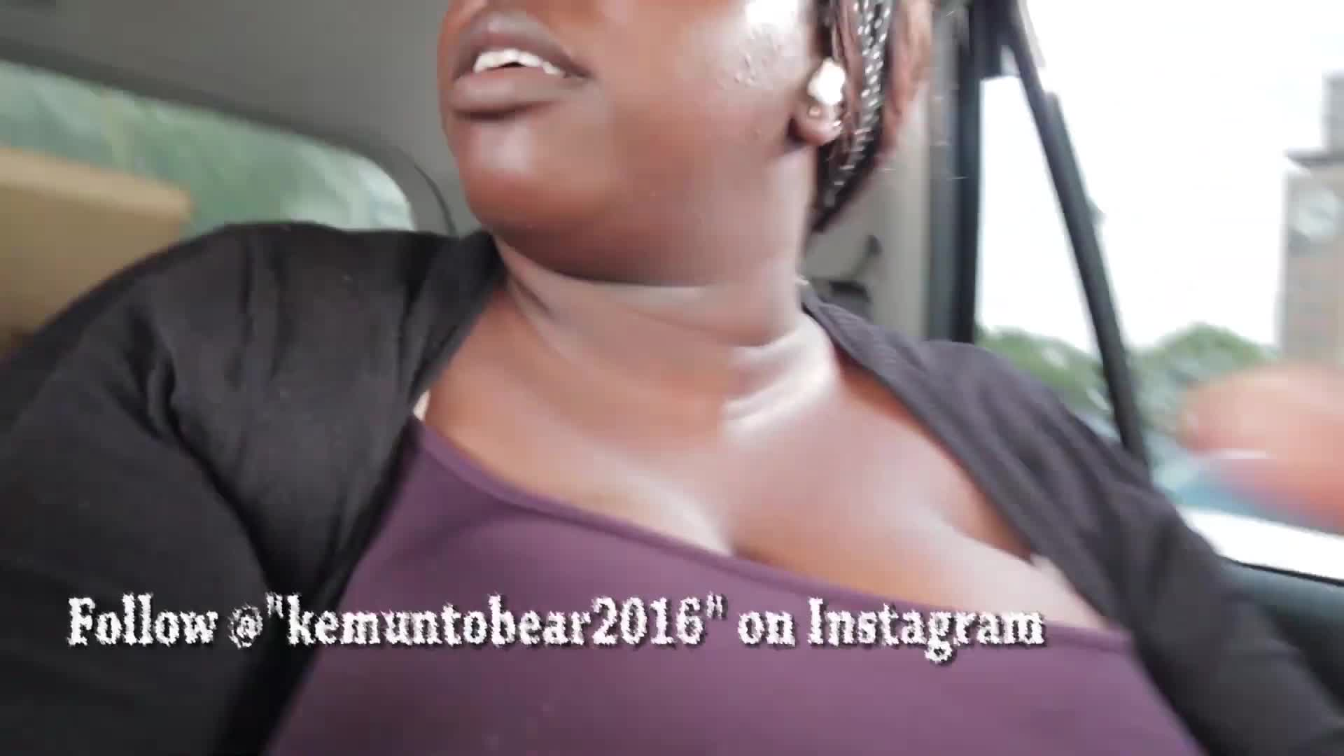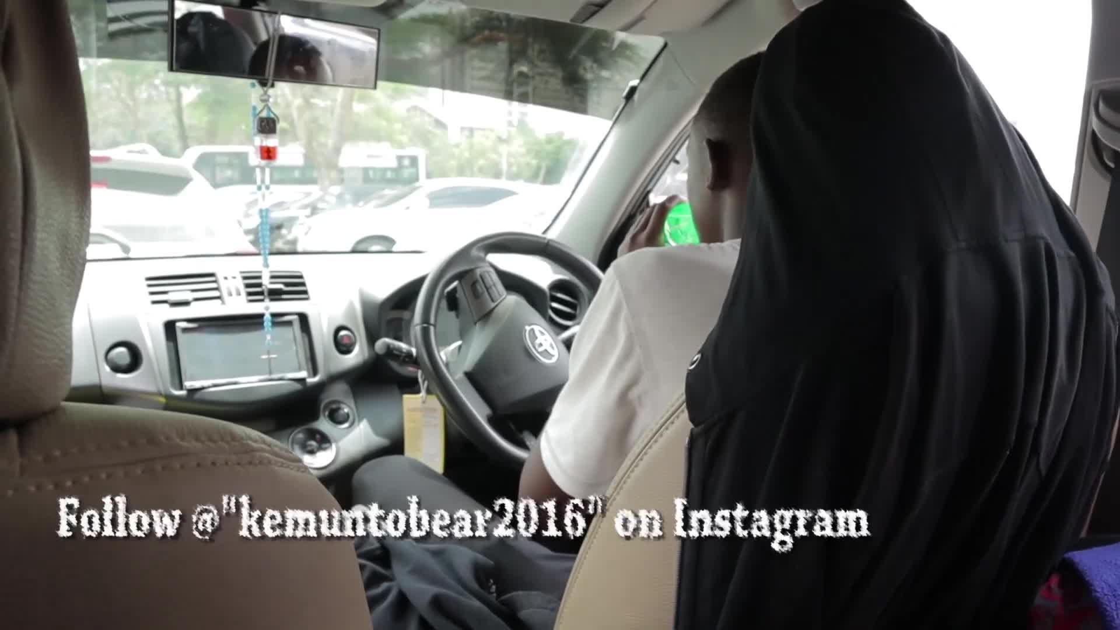
 | Note the forest walk with the narrator and a sister. | 206.68 - 208.68 | 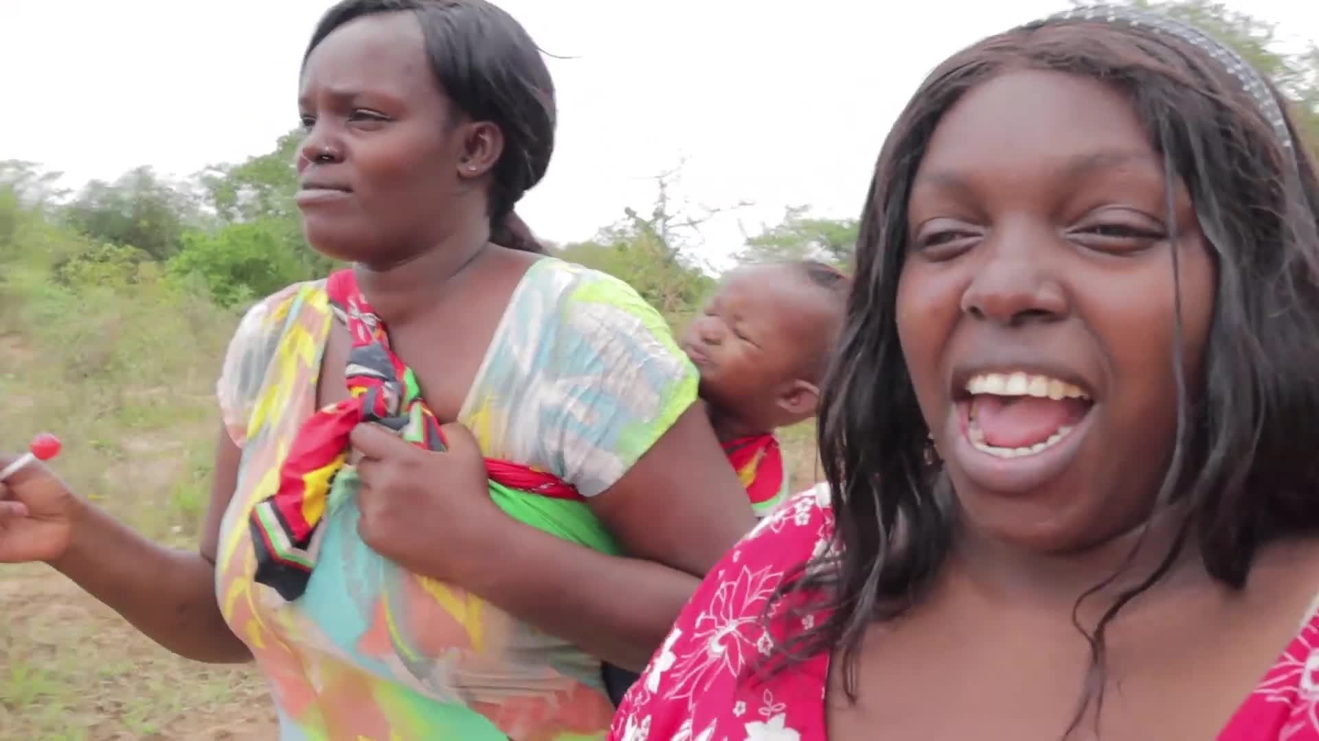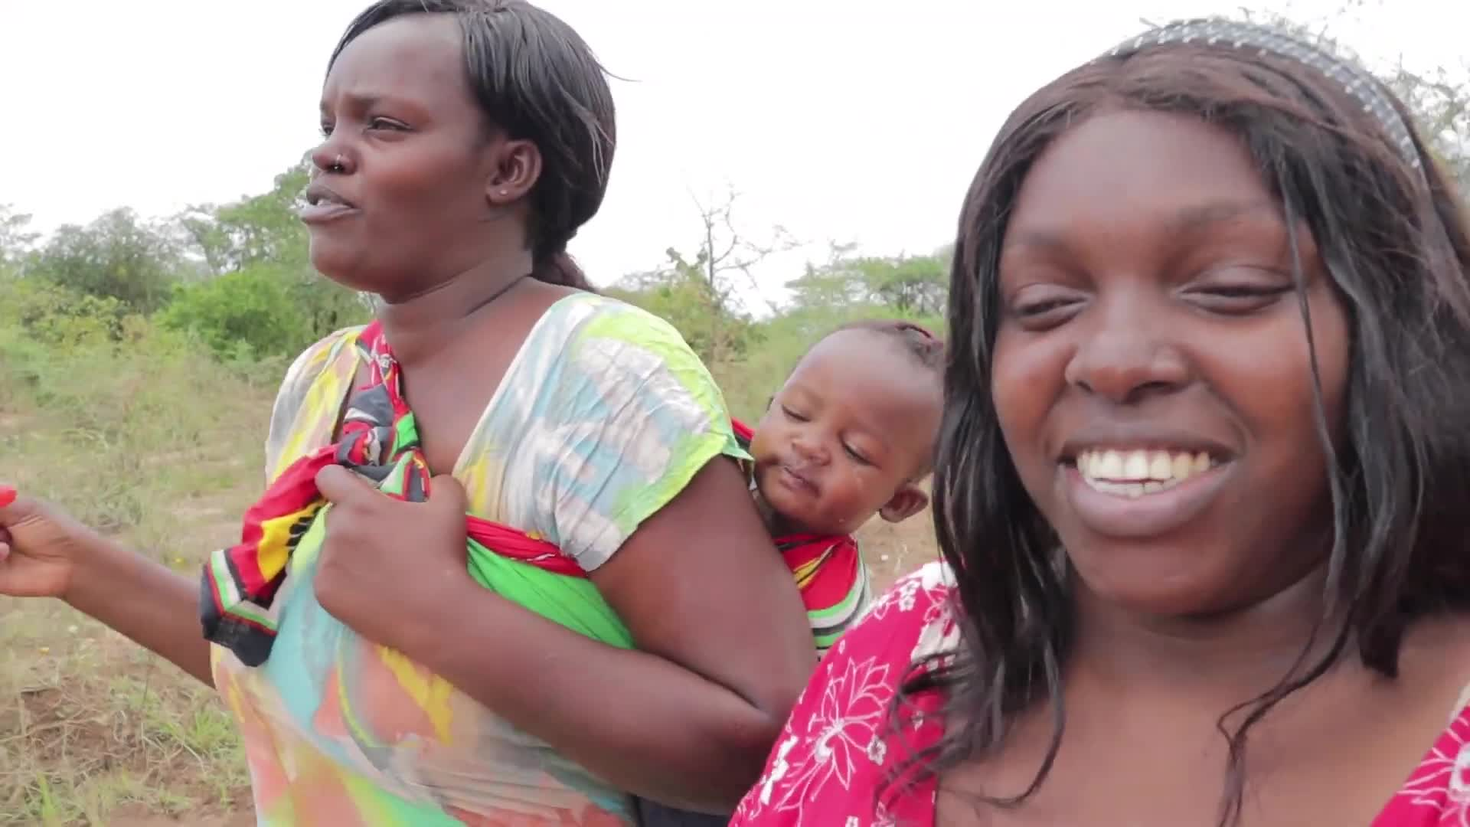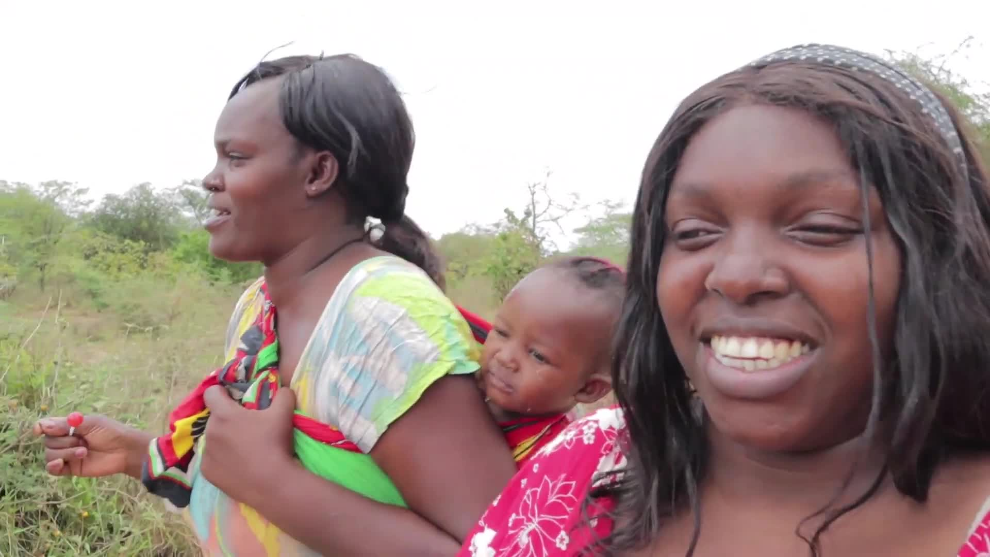
Describe life and daily routines in the village. | Watch people washing clothes for a baby. | 384.54 - 386.7 | 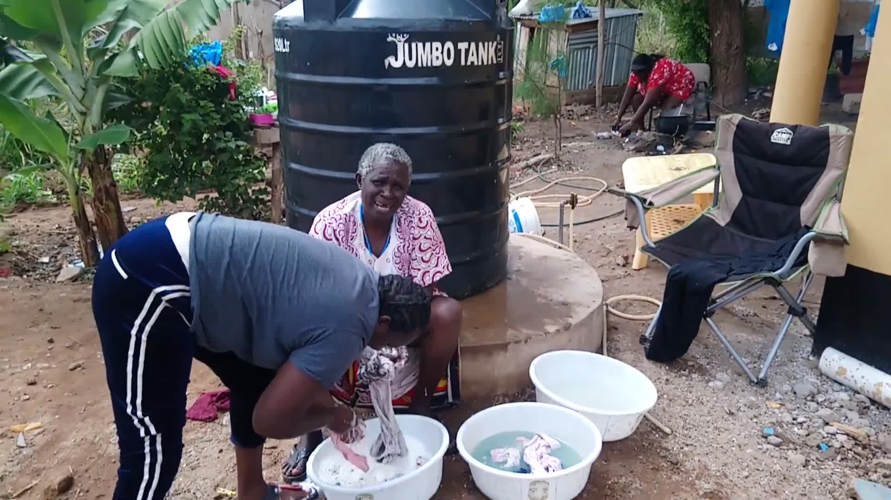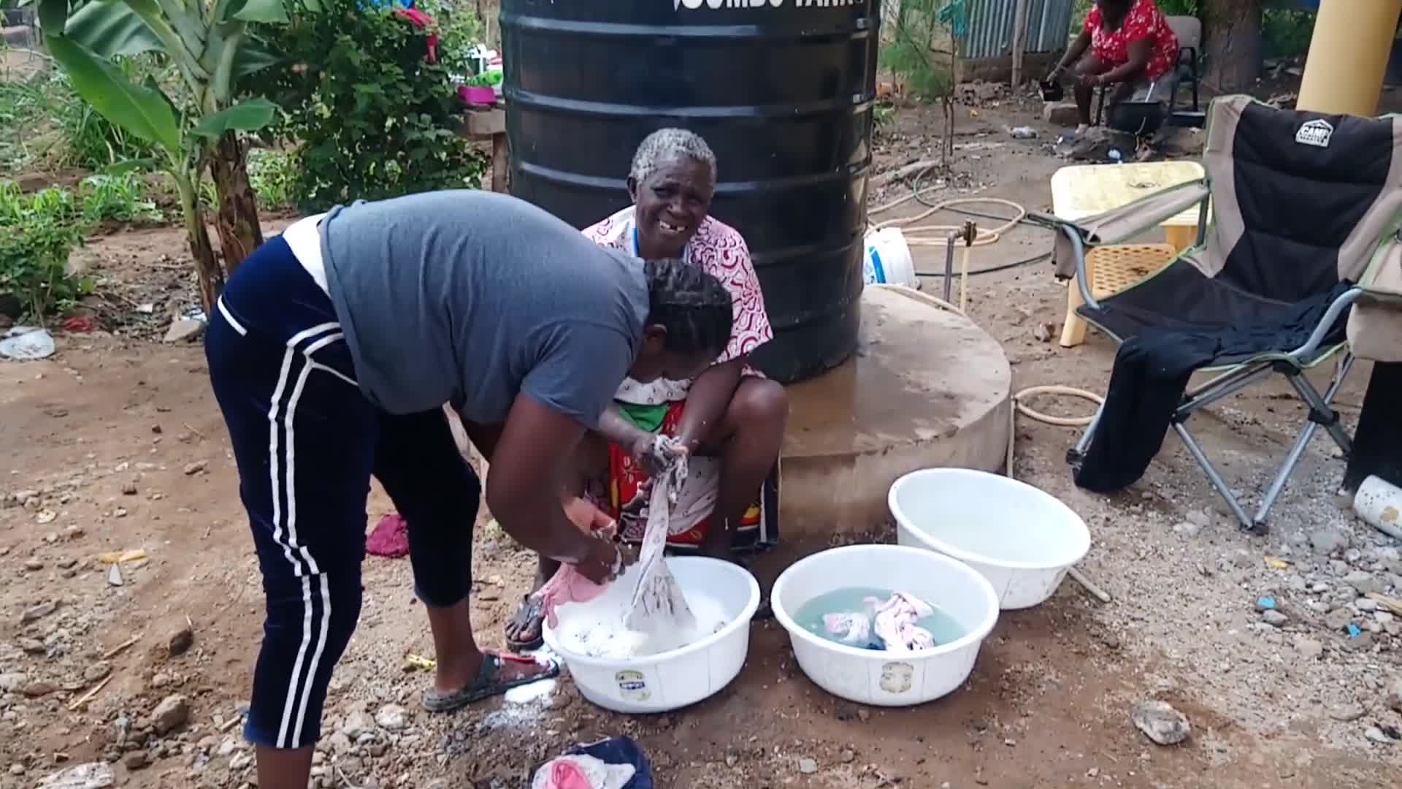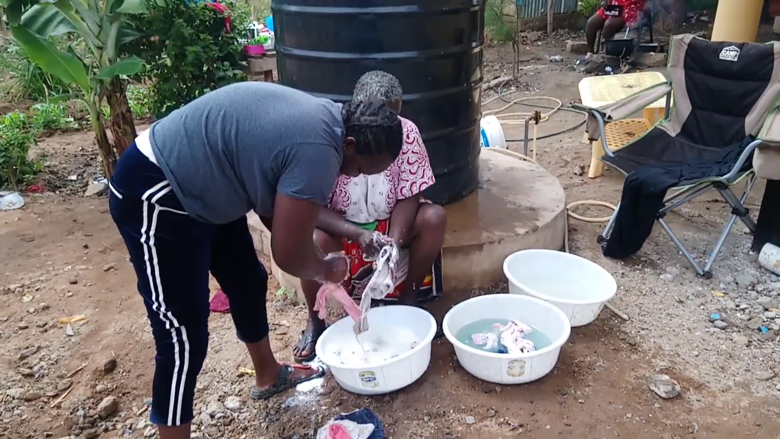
 | Notice a sleeping individual. | 390.3 - 391.84 | 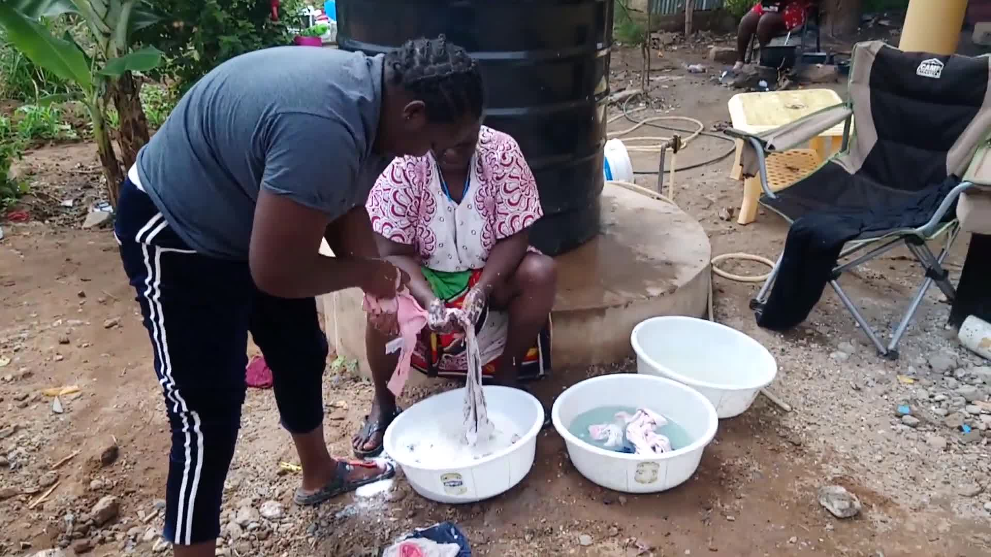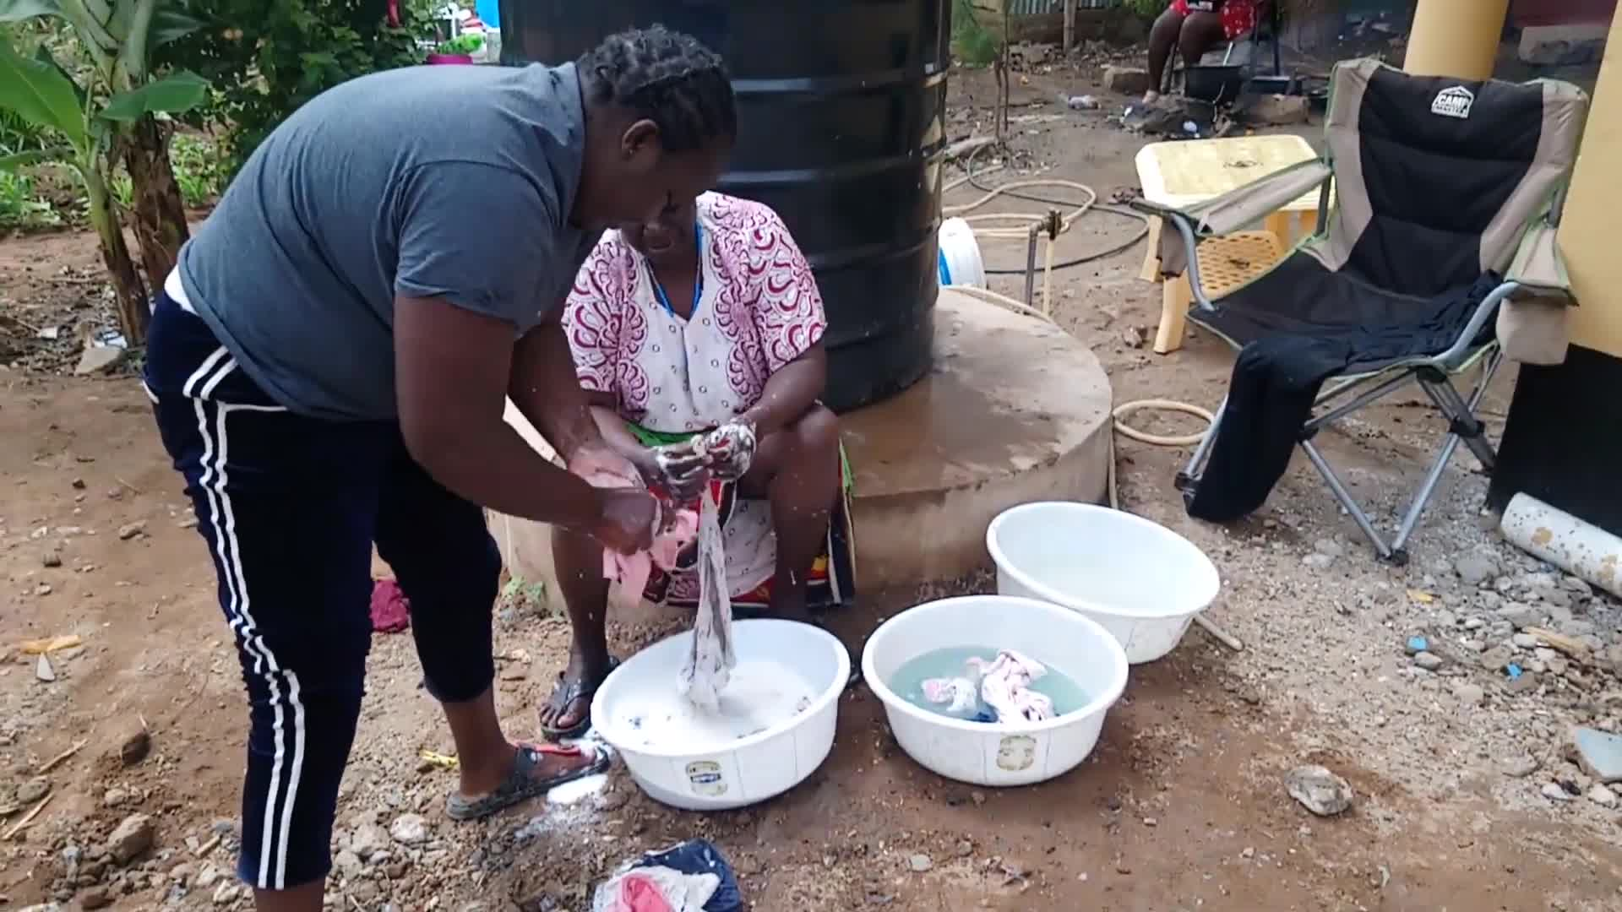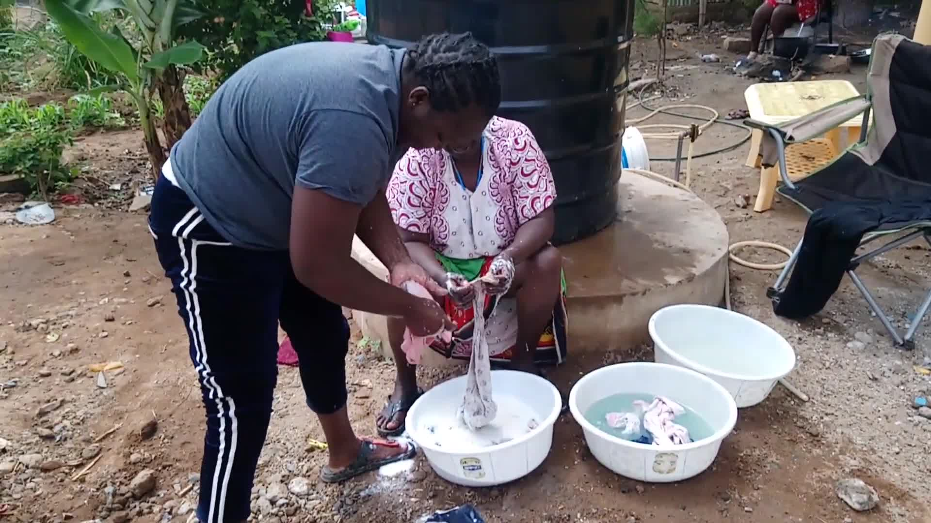
Show cooking techniques and ingredients. | Observe onion sautéing and chicken preparation. | None - None
Highlight the living conditions and challenges. | Mention the use of firewood for cooking. | None - None
 | Describe the cooking process. | 339.76 - 344.28 | 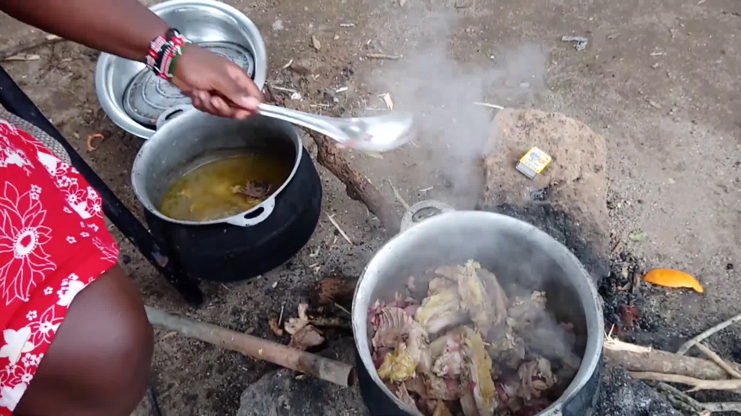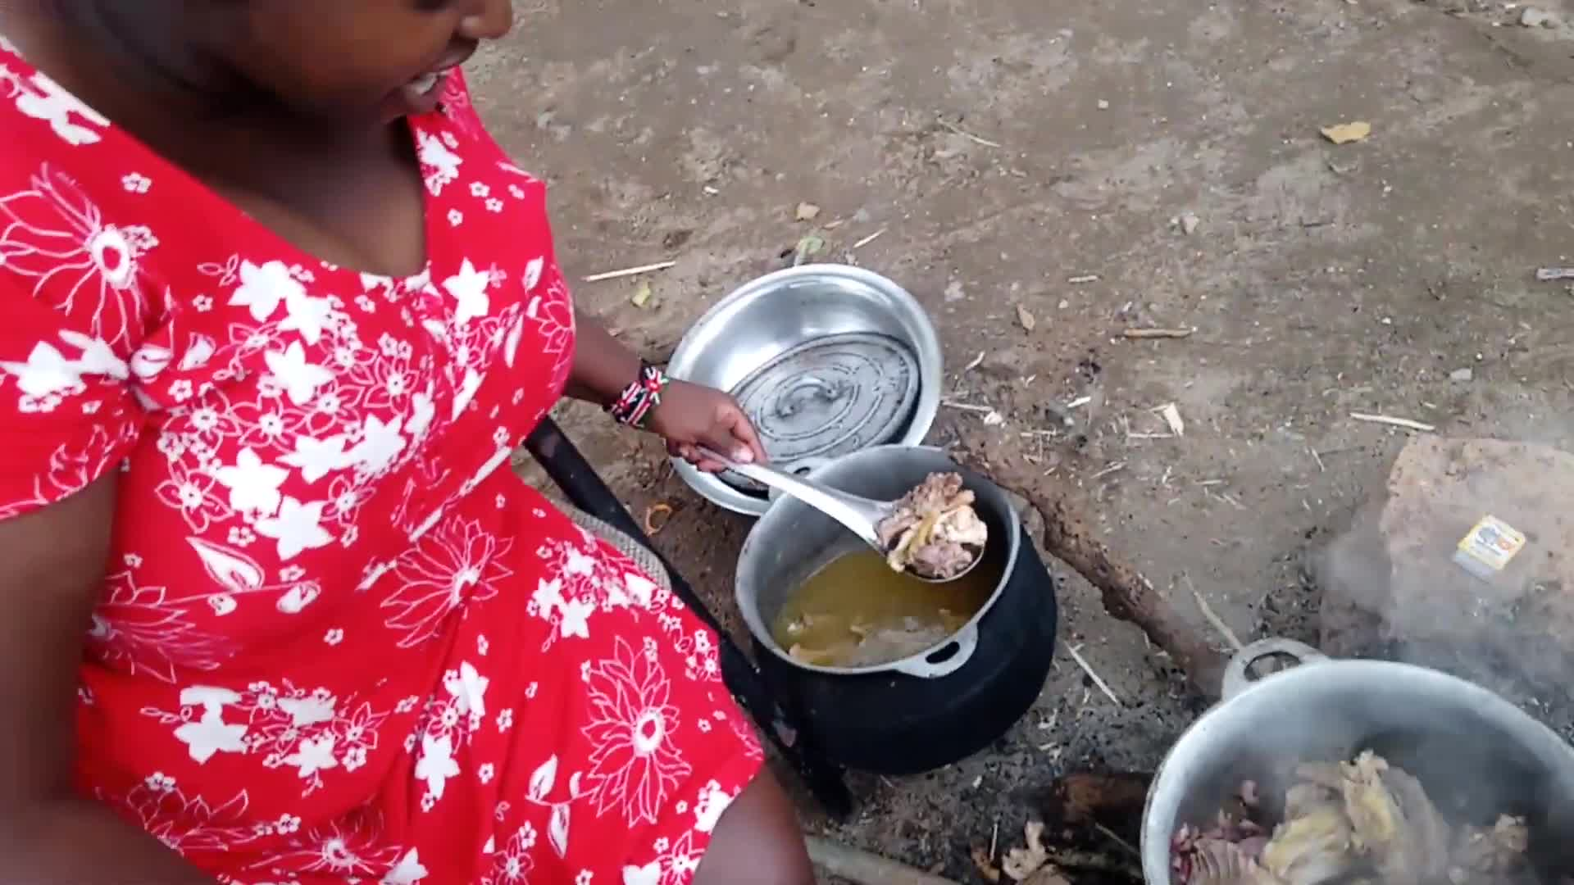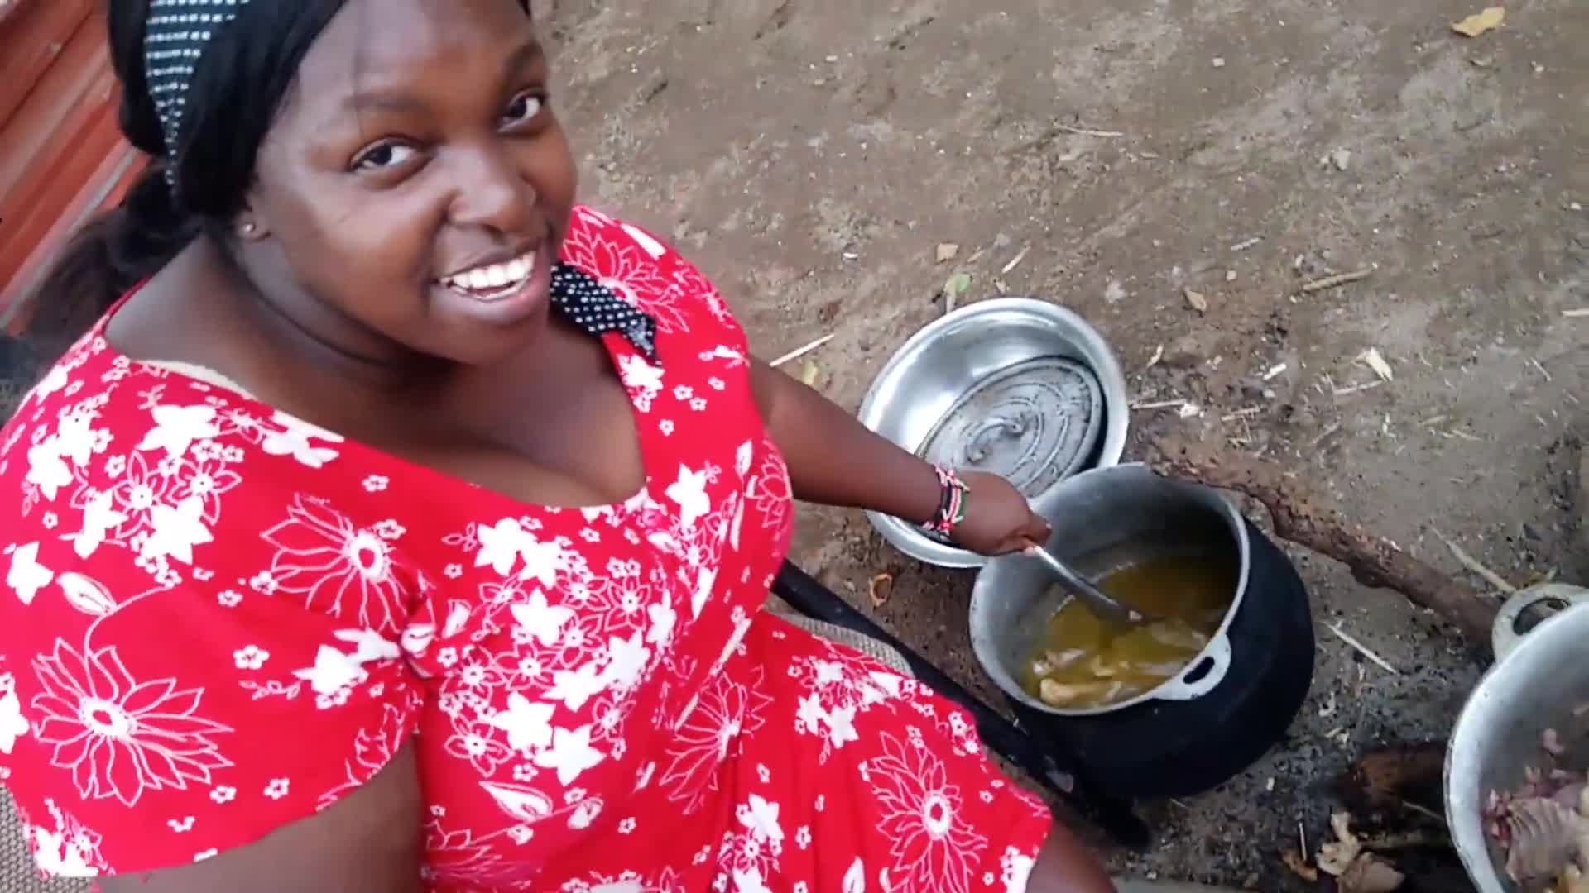
 | Note the organic nature of the chicken. | 344.28 - 370.56 | 