Unique Chinese Pumpkin Farming Techniques
Video ID: -8JUdYeWcEQ
URL: https://www.youtube.com/watch?v=-8JUdYeWcEQ
Task | Subtask | Timestamp | Image
Explain the development of unique pumpkin farming methods by the Chinese. | Observe the world's largest pumpkin that no single man can carry. | 8.00s | 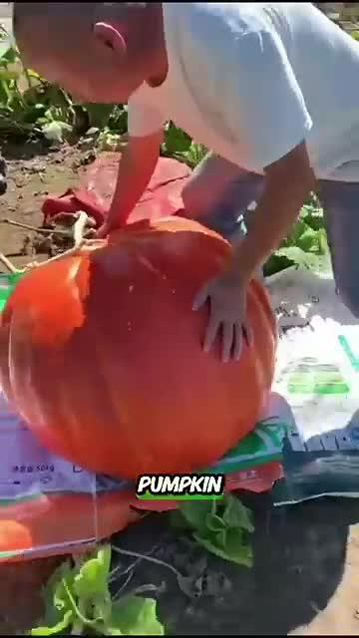
 | Note the smallest pumpkins in the size of a hand. | 12.24s | 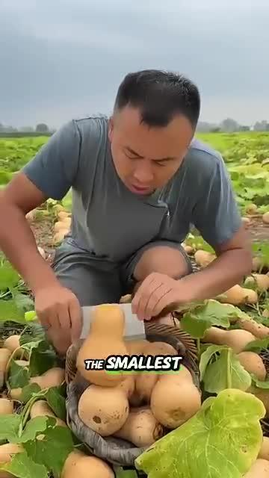
Describe the sale of various pumpkins and fruits. | Look at the tamarind fruit that looks awkward but is very delicious. | 16.40s | 
 | Mention that all these pumpkins and fruits are sold for high prices. | 19.40s | 

