**Cairo University Faculty of Computers and Artificial Intelligence**



**Software Design and Architecture**

**Software design specification document**

**2022**

**Project Team**

| **ID** | **Name** | **Email** |
| --- | --- | --- |
| 20206126 | Mostafa Hesham Allam | mostafa777444333@gmail.com |
| 20206138 | Karim Amr Hamdy | 11410120206138@stud.cu.edu.eg |
| 20206143 | Fares Karim El Kholy | faressskarim@gmail.com |
| 20206152 | Youssef Ahmad Abdulghafar | greatyassoo@gmail.com |

**Contents**

Class diagram design 3

Class diagram Explanation 3

Sequence diagram design 4

Github repository link x

# 

# Class Diagram Design

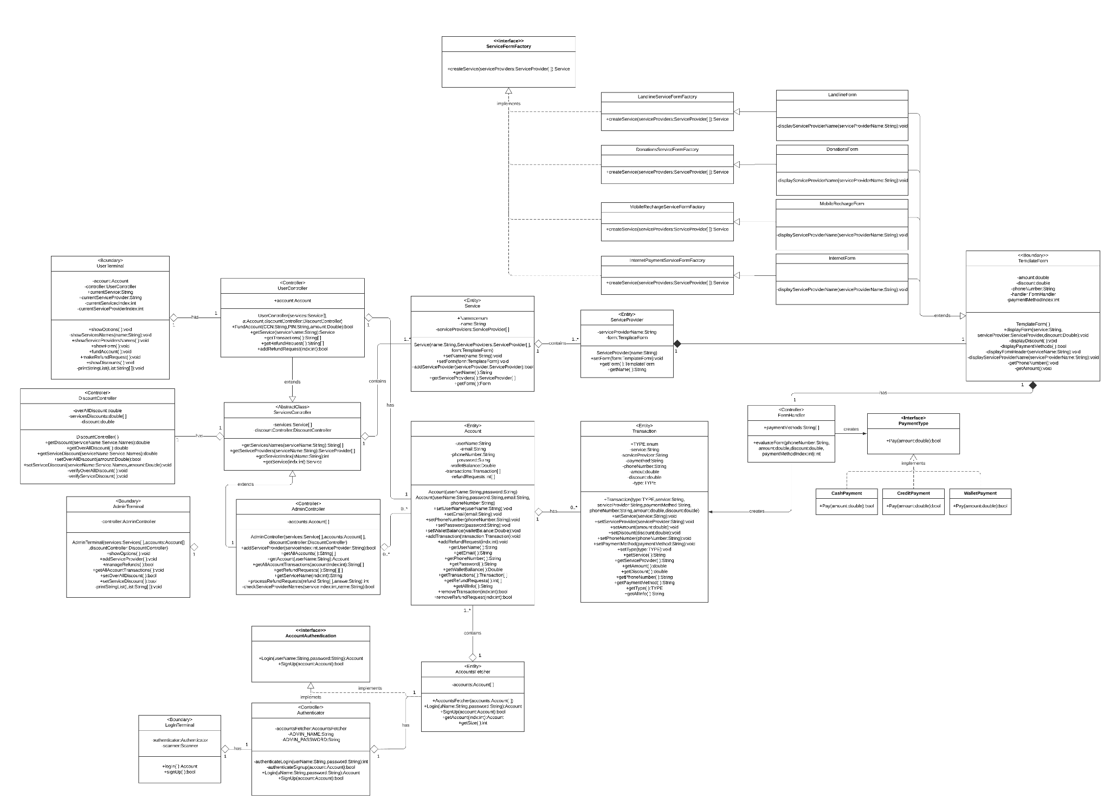

# Class Diagram Explanation

* **Strategy: used in payment methods as they all provide the same functionality “payment”  
  but with different implementations.**
* **Proxy: Authenticator class is a proxy that is used in authenticating user login/signup.**
* **Factory: used in creating multiple services each containing different implementations in terms of service providers forms**
* **Template: used in TemplateForm superclass to unify “display steps” (displayForm()) between all forms. Where the varying step (displayServiceProvider()) is implemented by the different concretions**

# 

# Sequence diagram design

**Wallet Top up sequence**

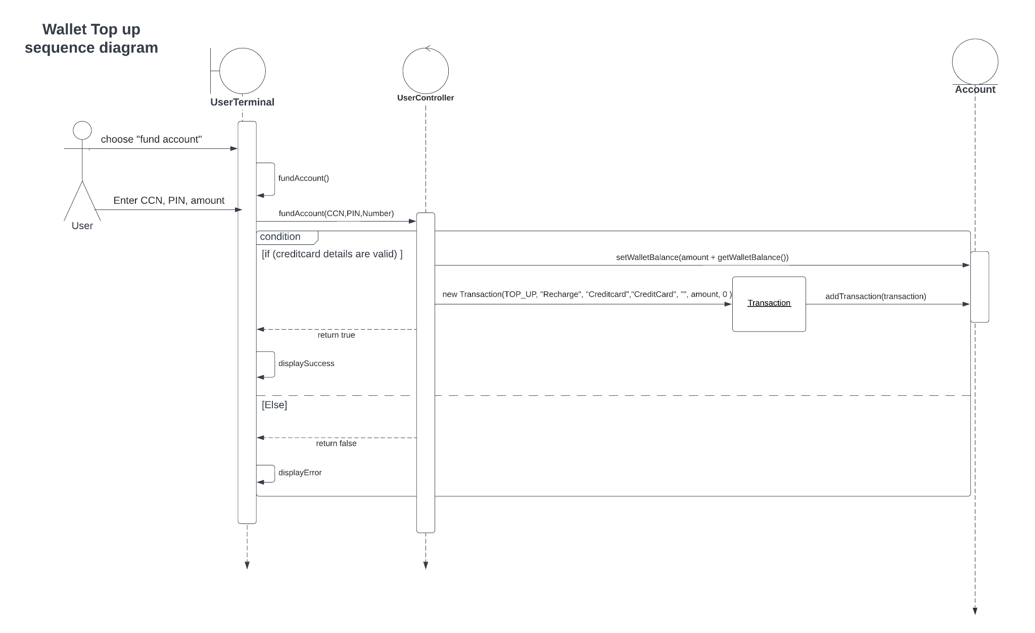

# 

# 

# 

# 

# 

# 

# Login sequence

# 

# 

# 

# User Signup

# 

# Vodafone mobile recharge sequence

# 

# 

# 

# 

# Add Refund Request

# 

# 

# 

# 

# 

# 

# Accept refund sequence

# 

# 

# 

# 

# 

# 

# 

# Adding new service provider sequence

# 

# 

# 

# Admin view user transactions

# 

# 

# Github Repository Link

* **https://github.com/greatyassoo/EPayment**