**UML Documentation**

*Group 14: Barzasi - Bellacoscia - Cai*

**Master**

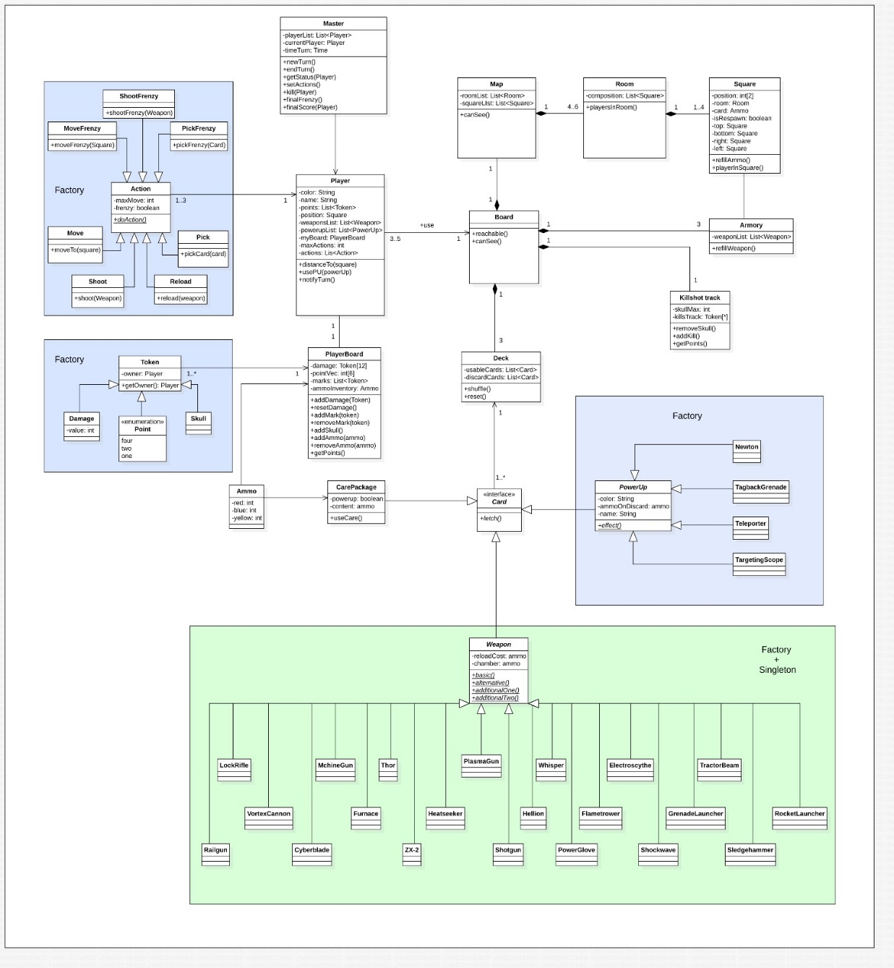Master manages the dynamics of the match, processes turns and manages time, turnTime is the time a player has left to complete his turn. Also initiates final frenzy and calculates the final score.

**Player**

Player represents a player in the game, contains its position and his available assets and resources.

ammoInventory contains available ammunition and is represented with an **Ammo** class which contains three fields of integers each representing one ammunition type (red, blue or yellow)

**Action**

An action represents an action a player performs during the turn, frenzy is a Boolean which when true activates Final Frenzy actions. Actions are instantiated by a factory class which takes player inputs and generates the corresponding action. The same design pattern is applied to the generation of **Tokens** and **Weapons**.[2][3]

**PlayerBoard**

Playerboard contains information about the damage received by the player, his marks and the points given upon his death.

**Token[2]**

Token represents a token of the game which can be a Damage, Mark, Skull or an amount Point (1,2 or 4), each token is assigned to a player’s board when instantiated.

**Room**

Room is the same concept as a room in the game, contains a set of cells (**Square**) which compose the room.

playersInRoom returns a list of players in the room.

**Square**

Square represents a single cell of the map, position is a set of 2 integers which represent its coordinate in the map.

card contains information about the resource card on the cell and refers to a CarePackage[1] object.

isRespawn() specifies if the cell contains a respawning point in which case it will not have resources but will have an armory.

refillAmmo() refills the resources at the end of each turn if grabbed by a player.

**Armory**

Armory contains the set of weapons up for grab in a cell.

refillWeapon() refills the taken weapons if the weapon deck has not run out.

**CarePackage [1]**

CarePackage is a set of three resource units (either three ammunition or two ammunition and one powerup)

content is expressed with an ammo data type, upon grabbing the values are summed to the player’s ammo inventory with a maximum cap of three.

hasPowerup is a Boolean specifying whether the care package contains a power up, if yes the sum of the fields of content will be 2 instead of 3.

**Deck**

The deck keeps track of the **Cards** using an array, the generation of power ups and ammunition are not randomised but pre-determined so if an advanced player decides to count cards the game allows him to do so unlike most casinos.

**Card**

Card is an interface representing a single card of any type.

**Weapon[3]**  
Weapons are implemented using the singleton design pattern because each weapon is unique and two players cannot have the same weapon, reloadCost is the full cost of reloading the weapon while the chamber attribute specifies the chambered ammunition when picked up, pick up cost ill be calculated as (reloadCost – chamber).