Technische Hochschule Mittelhessen (THM)
M.Sc. Business Informatics — Advanced Analytics
Real-Time Risk Dashboard
VaR + KPI Integration Across 15 Stocks and 6 Sectors (2022–2025)
Course: WK_2403 — Applied Quantitative Methods
Course Area: MSc Business Informatics
Moodle: moodle.thm.de/course/view.php?id=7015
Group Members
Guliyev Ruslan
Grebenshchikova Oleksandra
Ogbaka Ogochukwu
Devendran Aishwarya

1. Project Overview
This project delivers an end-to-end quantitative risk analytics pipeline for a 15-stock, 6-sector equity portfolio (2022–2025), covering data acquisition, Value-at-Risk (VaR) modelling, KPI computation, sector clustering, backtesting, and two parallel presentation layers: an interactive Python web dashboard and a Power BI report. The project was developed as coursework for Applied Quantitative Methods (WK_2403) and additionally deployed as a live, publicly accessible web application.
Portfolio composition:
- Financials: JPM, GS, HLI
- Tech: AAPL, PLTR, META
- Healthcare: JNJ, MRK, UNH
- Consumer Staples: MCD, KO
- Beauty: EL, ULTA
- Energy: XOM, CVX

2. Data & Methodology

2.1 Data Source
Historical daily price data (2022–2025) was retrieved via the yfinance API for all 15 tickers and stored locally (data/raw/prices.csv, data/risk_data.db).

2.2 Value-at-Risk (VaR)
Three independent VaR methodologies were implemented and compared at both 95% and 99% confidence levels:
- Historical VaR — empirical percentile taken directly from observed historical returns, no distributional assumption.
- Parametric VaR — assumes normally distributed returns; VaR derived analytically from mean and standard deviation.
- Monte Carlo VaR — thousands of simulated return paths generated from the stock's statistical properties, VaR read from the simulated distribution.

2.3 KPI Suite
For every stock, five core performance/risk KPIs were computed: Sharpe Ratio, Maximum Drawdown, Beta (vs. market), Annualized Volatility, and CAGR.

2.4 Sector Clustering
Stocks were grouped into three behavioural clusters (High Risk/High Return, Balanced, Defensive/Low Risk) based on volatility and Sharpe Ratio, using unsupervised clustering (scikit-learn).

2.5 Backtesting
VaR model accuracy was validated via backtesting — comparing predicted VaR thresholds against actual historical breach frequency for each stock and method.

3. Tools & Technology Stack
- Python: pandas, numpy, scipy, scikit-learn — data processing, statistics, clustering
- yfinance — market data acquisition
- Plotly & Dash — interactive web dashboard (charts, filters, callbacks)
- Matplotlib / Seaborn — static analytical charts (in notebooks and reports)
- SQLite (risk_data.db) — local structured data storage
- Power BI — business-facing interactive report (Risk_AQM.pbix)
- Jupyter Notebooks — step-by-step analytical pipeline (Steps 4 through 14)
- GitHub — version control and source hosting
- Render (cloud PaaS) — public deployment of the live web dashboard

4. Analytical Pipeline (Notebooks)
The analysis was structured as a sequential notebook pipeline, each step building on the previous one's output:
- Step 4–5: Data acquisition and cleaning (returns_clean.csv)
- Step 6: Live price fetch functions (yfinance intraday, 1-minute interval) — later integrated into the live dashboard
- Step 7–9: Historical, Parametric, and Monte Carlo VaR calculation
- Step 10: KPI computation (Sharpe, Drawdown, Beta, Volatility, CAGR)
- Step 11: Sector/risk clustering
- Step 12: Backtesting of VaR models
- Step 13: Power BI data export (powerbi_data.xlsx)
- Step 14: Final visualizations and static chart generation

5. Interactive Dashboard (Python / Dash)
A Dash (Plotly) web application (dashboard/app.py) was built to present all analytical outputs interactively:
- Stock selector (15 tickers) with sector labels
- Confidence Level toggle (95% / 99%)
- VaR Method toggle (Historical / Parametric / Monte Carlo)
- KPI cards (Sharpe, Max Drawdown, Beta, Volatility, CAGR, Sector) per selected stock
- Price history chart per selected stock
- Returns distribution histogram with VaR threshold overlay
- All-3-methods VaR comparison chart across all 15 stocks
- Risk/return clustering scatter plot
- KPI comparison bar charts across all stocks

5.1 New Additions Made During Deployment
Two enhancements were added beyond the original coursework version:
- Live price panel: wired the previously unused auto-refresh timer to a live intraday price fetch (reusing the get_live_prices() logic originally prototyped in Step 6), showing a genuinely real-time updating price badge for the selected stock, refreshed automatically every 60 seconds.
- All Stocks & Sectors Overview section: a normalized (base-100) price comparison chart showing all 15 stocks together colour-coded by sector, plus a full KPI table listing every stock's metrics side-by-side, to complement the original single-stock detail view.

6. Deployment
The dashboard was published as a live, publicly accessible website using the following pipeline:
- Source code hosted on GitHub (public repository)
- Continuous deployment configured on Render (Free tier Web Service)
- Production server: gunicorn, serving the Dash app's underlying Flask instance
- Build command: pip install -r requirements.txt
- Start command: gunicorn --chdir dashboard app:server
GitHub Repository:
https://github.com/grebenshch/risk-dashboard
Live Dashboard URL:

https://risk-dashboard-q894.onrender.com/

7. Results & Key Visuals

7.1 All Stocks — Normalized Price Comparison
The chart below (generated directly from the project's processed price data) compares the growth of all 15 stocks on a common base of 100, colour-coded by sector.
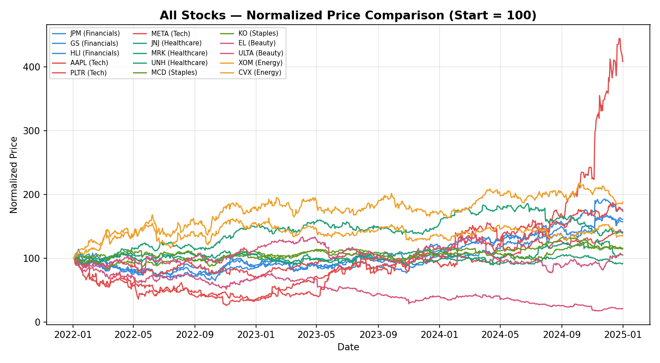
Figure 1 — Normalized price performance, all 15 stocks (2022–2025)

7.2 Value-at-Risk Comparison (95% Confidence)
Historical, Parametric, and Monte Carlo VaR estimates for each stock, computed directly from the project's VaR result files.
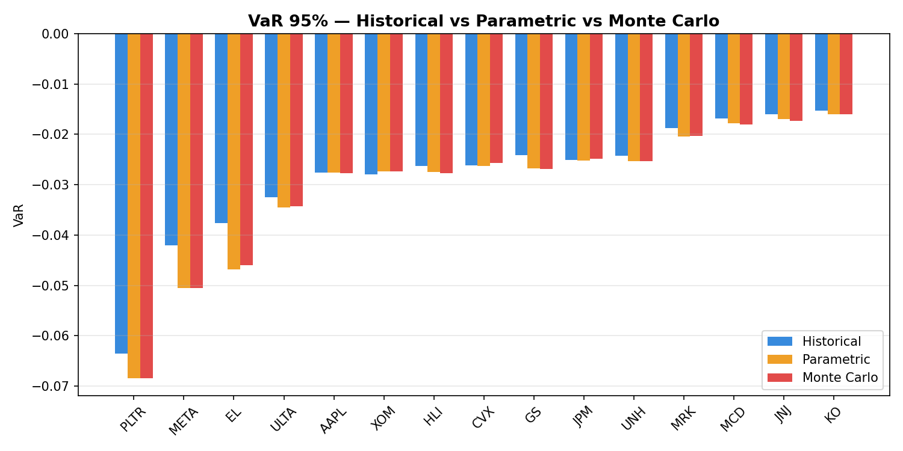
Figure 2 — VaR 95% across three methods, all stocks

7.3 Sector Risk/Return Clustering
Stocks grouped into three risk profiles based on volatility and Sharpe Ratio.
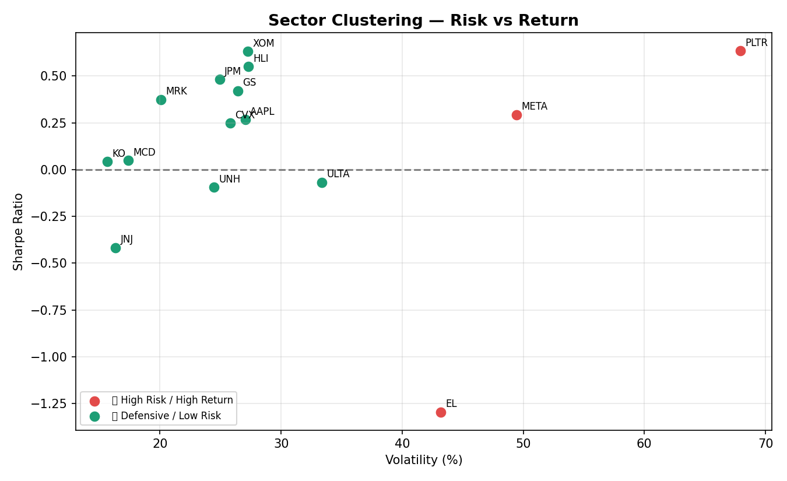
Figure 3 — Risk/return clustering across the portfolio

7.4 Full KPI Table (All Stocks)
Ticker | Sharpe | MaxDD (%) | Beta | Vol (%) | CAGR (%)
AAPL | 0.27 | -30.91 | 1.21 | 27.05 | 11.88
CVX | 0.25 | -24.95 | 0.52 | 25.80 | 10.95
EL | -1.30 | -82.39 | 1.25 | 43.18 | -40.47
GS | 0.42 | -30.51 | 1.00 | 26.43 | 16.32
HLI | 0.55 | -36.57 | 0.90 | 27.31 | 20.93
JNJ | -0.42 | -18.41 | 0.25 | 16.34 | -2.76
JPM | 0.48 | -37.93 | 0.86 | 24.92 | 17.34
KO | 0.04 | -17.27 | 0.39 | 15.66 | 4.76
MCD | 0.05 | -17.23 | 0.46 | 17.36 | 4.97
META | 0.29 | -73.74 | 1.73 | 49.45 | 20.28
MRK | 0.37 | -27.08 | 0.26 | 20.08 | 12.20
PLTR | 0.64 | -67.62 | 2.19 | 67.92 | 60.11
ULTA | -0.07 | -43.48 | 0.89 | 33.38 | 1.73
UNH | -0.09 | -22.05 | 0.44 | 24.45 | 1.70
XOM | 0.63 | -20.51 | 0.47 | 27.24 | 23.57

8. Live Dashboard — Screenshots
The following screenshots should be added from the deployed application to document the final delivered interface.
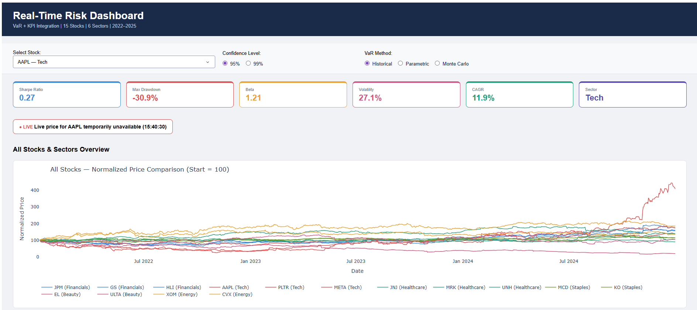

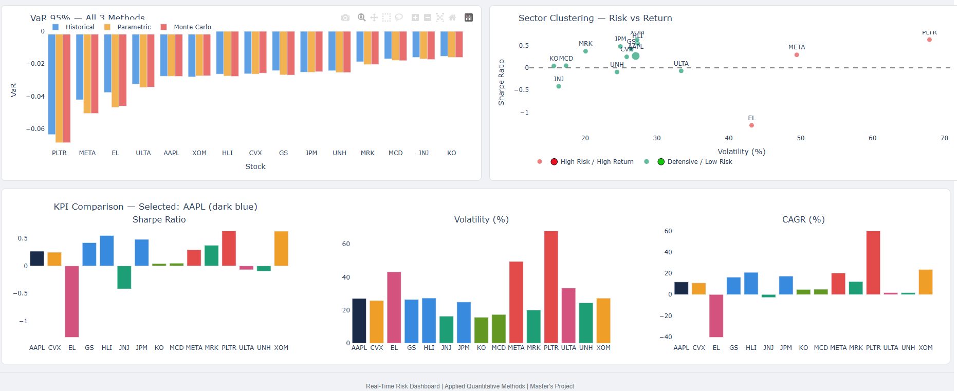

9. Power BI Dashboard
A complementary Power BI report (reports/Risk_AQM.pbix) was built from the same processed dataset (reports/powerbi_data.xlsx), providing an alternative, business-facing view of the same VaR/KPI analytics for stakeholders who prefer a traditional BI interface over a coded web application.
Power BI Public Link:

https://app.powerbi.com/groups/me/reports/eb97e433-a66f-45c2-acf2-7ac1b30143ac/389f8e0c2816fcd49eec?experience=power-bi

10. Challenges & Solutions
- Static vs. live data: the original coursework dashboard read only pre-computed historical CSVs. Live intraday price fetching (Step 6 logic) existed but was not wired into the deployed app — this was integrated during the deployment phase.
- Production hosting: Dash's built-in development server only runs locally; solved by exposing the Flask server object and running it via gunicorn on Render, with host/port correctly bound for a cloud environment.
- Single-stock vs. portfolio-wide view: initial dashboard only allowed viewing one stock at a time; an all-stocks/sectors overview (chart + KPI table) was added to allow full-portfolio comparison.

11. Conclusion
This project demonstrates a complete quantitative risk-analytics workflow — from raw market data through VaR modelling, KPI analysis, and clustering, to two independent, stakeholder-ready presentation layers (an interactive live web dashboard and a Power BI report). The web dashboard is publicly deployed and includes a genuine real-time price component, making the analytics accessible from any device without local software installation.

12. Team Contributions
Each team member brought unique skills:
Ruslan — Lead Data Scientist:
• Designed and built all 3 VaR models (Historical, Parametric, Monte Carlo)
• Backtesting engine + Kupiec test
• KPI computation engine
• K-Means clustering model
• Full data pipeline (collection → cleaning → modelling → storage)
• Power BI data export

Alex — Tech Lead & Developer:
• GitHub repository setup & management
• Live data feed (real-time prices)
• Plotly Dash dashboard frontend
• Cloud deployment on Render.com
• Code review and documentation

Aishwarya
UX/UI & Communication:
• Dashboard wireframe and design
• Presentation slides design
• KPI interpretation & communication
• Report introduction and results sections
• User experience testing

Oggo — Research & Documentation:
• Literature review (VaR methodology)
• Industry context (Basel III research)
• Technical report writing
• References and citations
• Submission coordination

Project Deliverables: ✅ Python codebase (14 notebooks + dashboard) ✅ Live dashboard (Render.com) ✅ Power BI report (4 pages) ✅ GitHub repository (version controlled) ✅ Technical report ✅ This presentation

13. Appendix — Links
GitHub repository:
https://github.com/grebenshch/risk-dashboard
Live dashboard:

https://risk-dashboard-q894.onrender.com/
Course Moodle page:
https://moodle.thm.de/course/view.php?id=7015
Presentation:
https://sharayeh.com/en/public-view/8f98fe4b-8968-4631-bdbc-30c6ccd32b09

