Source Code for the ArrayQueue

public class ArrayQueue<E> {

private E storage[];
private int N;
private int f;
private int r;

//declare the size of the Array
public ArrayQueue(int size) {
N=size;
storage = (E[]) new Object[size]; // compiler may give warning, but this is ok
}
//will return the size of the Array
public int size() {
return (N - f + r) % N;//from page 222 of the textbook of psuedo code
}
//will return if the ArrayQueue is empty.

public Boolean isEmpty() {
return (f == r);//from page 222 of the textbook of psuedo code
}
//will reutrn the front of the ArrayQueue as long as it is not empty.
public E front() {
if (isEmpty()) {
throw new QueueEmptyException("Queue is empty");
}
return storage[f];
}
//will show the top of the ArrayQueue and remove it as long as it is not empty
public E dequeue() {
if (isEmpty()) {
throw new QueueEmptyException("Queue is empty");
}
E temp = storage[f];//from page 222 of the textbook of psuedo code
storage[f] = null;
f=(f+1) % N;
return temp;
}
//will add an element on the ArrayQueue as long as it is not full
public void enqueue(E e){
if(size() == N - 1){

throw new QueueFullException("Queue is full");
}
storage[r] = e;//from page 222 of the textbook of psuedo code
r = (r+1) % N;
}
//toString method to return the elements of ArrayQueue instead of returning the position of the elements in the ArrayQueue
public String toString(){
String str = "";
for(int i = 0; i < r; i++){
str = str + storage[i].toString() + " ";
}
return str;
}

}

Source Code for the NodeQueue

public class NodeQueue<E> {

private int size;
private Node<E> head;
private Node<E> tail;

//will return how many elements are in the NodeQueue.
public int size() {
return size;
}
//will return true if the size of the NodeQueue is 0.
public Boolean isEmpty() {
if (size == 0) {
return true;
} else {
return false;
}
}
//will return the top of NodeQueue as long as the queue is not empty.
public E front() {
if (size == 0){
throw new QueueEmptyException("Queue is empty.");
}
E tmp = head.getElement();
return tmp;
}

//will return the top of the NodeQueue and remove it as long as it is not empty
public E dequeue() throws QueueEmptyException {
if (size == 0){
throw new QueueEmptyException("Queue is empty.");
}
E tmp = head.getElement();
head = head.getNext();
size--;
if (size == 0)
tail = null; // the queue is now empty
return tmp;
}

//will add an element at the NodeQueue.
public void enqueue(E elem){
Node<E> node = new Node<E>();
node.setElement(elem);
node.setNext(null); // node will be new tail node

if (size == 0){
head = node; // special case of a previously empty queue
}else{
tail.setNext(node); // add node at the tail of the list
}
tail = node; // update the reference to the tail node
size++;
}

//toString method to return the elements of NodeQueue instead of returning the position of the elements in the NodeQueue
public String toString() {
String s;
Node<E> tail = null;
s = "[";
int n = size();
if (n > 0) {
tail = head;
s += tail.getElement();
}
if (n > 1)
for (int i = 1; i <= n-1; i++) {
tail = tail.getNext();
s += ", " + tail.getElement();
}
s += "]";
return s;
}
}

Source Code for the QueueDemonstration that Contains the Main Method

public class QueueDemonstration {

public static void main(String[] args) {

Object o;
//output for the ArrayQueue
ArrayQueue<Integer> A = new ArrayQueue<Integer>(3);//size of the array is 3
A.size();
System.out.println("This is the size of the array:" +A);
A.enqueue(5);
System.out.println("Enqueuing a 5 onto the Queue:" +A);
A.size();
System.out.println("This is the size of the array:" +A.size());
A.enqueue(3);
System.out.println("Enqueuing a 3 onto the Queue:" +A);
A.size();
System.out.println("This is the size of the array:" +A.size());
int i1 = A.front();
System.out.println("Testing the front method: " + i1);
int i2 = A.dequeue();
System.out.println("We Just Dequeued a "+ i2);
int i3 = A.dequeue();
System.out.println("We just Dequeued a " + i3);
int i4 = 0;
//will catch a QueueEmptyException
try{
System.out.println("Attempting to dequeue");
i4 = A.dequeue();

}
catch(Exception e){
e.printStackTrace();
System.out.println("Caught a QueueEmptyException");
}
A.enqueue(15);
System.out.println("Enqueuing a 15 onto the Queue");
A.enqueue(30);
System.out.println("Enqueuing a 30 onto the Queue");
//will catch a QueueFullException
try{
A.enqueue(45);
}
catch(Exception e){
e.printStackTrace();
System.out.println("Caught a QueueFullException");
}

System.out.println();
System.out.println();
System.out.println();

System.out.println("Now Testing the NodeQueue");

System.out.println();
//output for the NodeQueue
NodeQueue<String> B = new NodeQueue<String>();
B.enqueue("Computer");
System.out.println("Enqueuing a 'Computer' onto the Queue: " + B);
B.enqueue("Science");
System.out.println("Enqueuing a 'Science' onto the Queue:" + B);
B.enqueue("Is");
System.out.println("Enqueuing a 'Is' onto the Queue:" + B);
B.enqueue("Interesting");
System.out.println("Enqueuing a 'Interesting' onto the Queue:" + B);
B.size();
System.out.println("This is the size of the array:" +B.size());
String s1 = B.front();
System.out.println("Displays the top of the queue which is: " + s1);
String s2 = B.dequeue();
System.out.println("We just dequeued a: " + s2);
String s3 = B.dequeue();
System.out.println("We just dequeued a: " + s3);
String s4 = B.dequeue();
System.out.println("We just dequeued a: " + s4);
String s5 = B.dequeue();
System.out.println("We just dequeued a: " + s5);

String s6 = "";
//will catch the QueueEmptyException
try{
System.out.println("Attempting to dequeue" + s6);
s6 = B.dequeue();
}
catch(Exception e){
e.printStackTrace();
System.out.println("Caught a QueueEmptyException");
}

}

}

Output

Script started on Mon 15 Apr 2013 06:30:18 PM EDT
#]0;landgrebea@aldenv180: ~/cs112/eclipse/Lab7/src#landgrebea@aldenv180:~/cs112/eclipse/Lab7/src$ cd lab7####cs112########java QueueDemonstration ####################c QueueDemonstration.java
#]0;landgrebea@aldenv180: ~/cs112/eclipse/Lab7/src#landgrebea@aldenv180:~/cs112/eclipse/Lab7/src$ javac QueueDemonstration.java#############################cd lab7#[K####cs112########java QueueDemonstration ####################c QueueDemonstration.java##########################[5P QueueDemonstration
This is the size of the array:
Enqueuing a 5 onto the Queue:5
This is the size of the array:1
Enqueuing a 3 onto the Queue:5 3
This is the size of the array:2
Testing the front method: 5
We Just Dequeued a 5
We just Dequeued a 3
Attempting to dequeue
QueueEmptyException: Queue is empty
at ArrayQueue.dequeue(ArrayQueue.java:32)
at QueueDemonstration.main(QueueDemonstration.java:26)
Caught a QueueEmptyException
Enqueuing a 15 onto the Queue
Enqueuing a 30 onto the Queue
QueueFullException: Queue is full
at ArrayQueue.enqueue(ArrayQueue.java:42)
at QueueDemonstration.main(QueueDemonstration.java:38)
Caught a QueueFullException

Now Testing the NodeQueue

Enqueuing a 'Computer' onto the Queue: [Computer]
Enqueuing a 'Science' onto the Queue:[Computer, Science]
Enqueuing a 'Is' onto the Queue:[Computer, Science, Is]
Enqueuing a 'Interesting' onto the Queue:[Computer, Science, Is, Interesting]
This is the size of the array:4
Displays the top of the queue which is: Computer
We just dequeued a: Computer
We just dequeued a: Science
We just dequeued a: Is
We just dequeued a: Interesting
Attempting to dequeue
QueueEmptyException: Queue is empty.
at NodeQueue.dequeue(NodeQueue.java:32)
at QueueDemonstration.main(QueueDemonstration.java:78)
Caught a QueueEmptyException
#]0;landgrebea@aldenv180: ~/cs112/eclipse/Lab7/src#landgrebea@aldenv180:~/cs112/eclipse/Lab7/src$ exit
exit
Script done on Mon 15 Apr 2013 06:30:33 PM EDT

Source Code for the Junit Testing of the ArrayQueue

import static org.junit.Assert.*;
import org.junit.Test;

public class TestArrayQueue {

@Test
public void test() {
ArrayQueue<Integer> A = new ArrayQueue<Integer>(1000);
int i1 = A.size();
assertEquals(0,i1);
A.enqueue(5);
A.enqueue(3);
int i2 = A.front();
assertEquals(5,i2);
int i3 = A.dequeue();
assertEquals(5,i3);
}

@Test(expected=QueueFullException.class)
public void testFull() {
ArrayQueue<Integer> B = new ArrayQueue<Integer>(10);
for (int i=0;i<=20;i++){
B.enqueue(i);
}
}

@Test(expected=QueueEmptyException.class)
public void testEmpty() {
ArrayQueue<Integer> C = new ArrayQueue<Integer>(5);
int b1 = C.size();
assertEquals(0, b1);
C.enqueue(15);
C.enqueue(30);
int b2 = C.dequeue();
assertEquals(15, b2);
int b3 = C.dequeue();
assertEquals(30, b3);
int b4 = C.dequeue();
assertEquals(0, b4);
}

}

Junit Testing of the ArrayQueue
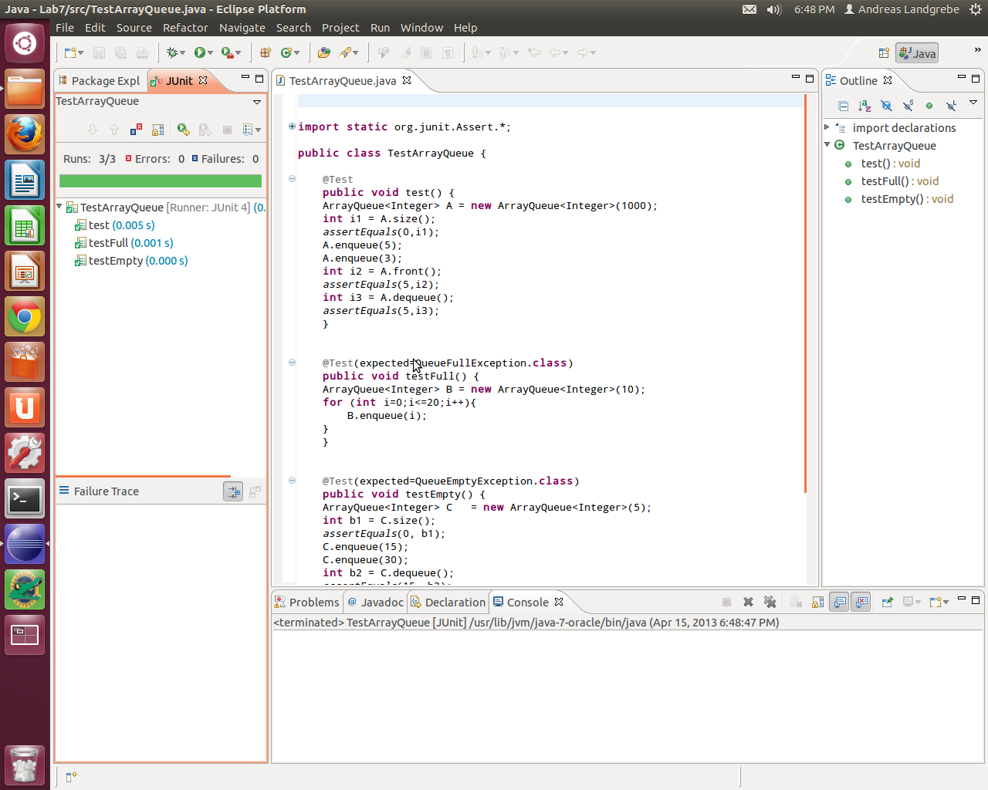

Source Code for the Junit Testing of the NodeQueue

import static org.junit.Assert.*;
import org.junit.Test;

public class TestNodeQueue {

@Test
public void test() {
NodeQueue<String> B = new NodeQueue<String>();
int s1 = B.size();
assertEquals(0,s1);
B.enqueue("Computer");
B.enqueue("Science");
B.enqueue("is");
B.enqueue("interesting");
String s2 = B.front();
assertEquals("Computer", s2);
String s3 = B.dequeue();
assertEquals("Computer", s3);

}

@Test (expected=QueueEmptyException.class)
public void emptyQueueTest () {
NodeQueue<String> B = new NodeQueue<String>();
int s1 = B.size();
assertEquals(0,s1);
B.enqueue("Computer");
B.enqueue("Science");
B.enqueue("is");
B.enqueue("interesting");
String s3 = B.dequeue();
s3 = B.dequeue();
s3 = B.dequeue();
s3 = B.dequeue();
s3 = B.dequeue();
}

}

Junit testing for the NodeQueue
