Andreas Landgrebe
November 18, 2013

Source Code for Part 4:
# Andreas Landgrebe
# Novmeber 18, 2013
# Part 4 of the Take Home Exam
# This mips program will take two functions of f and g and read two integer arguments
# this will pass thrgough the $a0 and $a1 registers. After this, the functiosn will return an int result.
# this int result has to be returned to the $v0 register.
# this program will compute the following:
# f(a,b): 3a + b
# g(a,b) = 2f(b-1,a-1) +a + b.
# load the first integers into a0 and a1, call function g and print out the result.

.data
.align 2

.text
.globl main
main: li $a0, -7 #loads a value into $a0
li $a1, 0 #loads a value into $a1
jal g #jump and link to g
addi $a0, $v0, 0 # converts what is in register $v0 into $a0.
li $v0, 1 #print out the result as a integer.
syscall

li $v0,10 #exit the program
syscall

f: add $v0,$a0,$a0 #computes 2a
add $v0,$v0,$a0 #computes 3a
add $v0,$v0,$a1 #computers 3a +b
jr $ra #jump the register to the return address.

g: addiu $sp,$sp,-12 # allocate memory to the stack points
sw $a0,0($sp) #save what is in #a0 into the stack poiner
sw $a1,4($sp) #save what is in #a1 into the stack pointer
sw $ra,8($sp) #save ther return address into the stack pointer

subi $a1,$a0,1 #a1 = a - 1
lw $a0,4($sp) #a0 = b
subi $a0,$a0,1 #a0 = b - 1
jal f #jump and link to f

add $v0,$v0,$v0 #v0 = 2 * f(b-1,a-1)
lw $a0,0($sp) # loading a from the stack
add $v0,$v0,$a0 #add 2f(b-1,a-1) + a
lw $a1,4($sp) # loading b from the stack
add $v0,$v0,$a1 #add 2f(b - 1, a -1) + a + b

lw $a0,0($sp) #load a0 in the stack pointer
lw $a1,4($sp) #load a1 in the stack pointer
lw $ra,8($sp) #load the return address in the stack pointer
addiu $sp,$sp,12 #add memory to the stack pointer.
jr $ra #jump the register to the return address.

Output of Part 4:
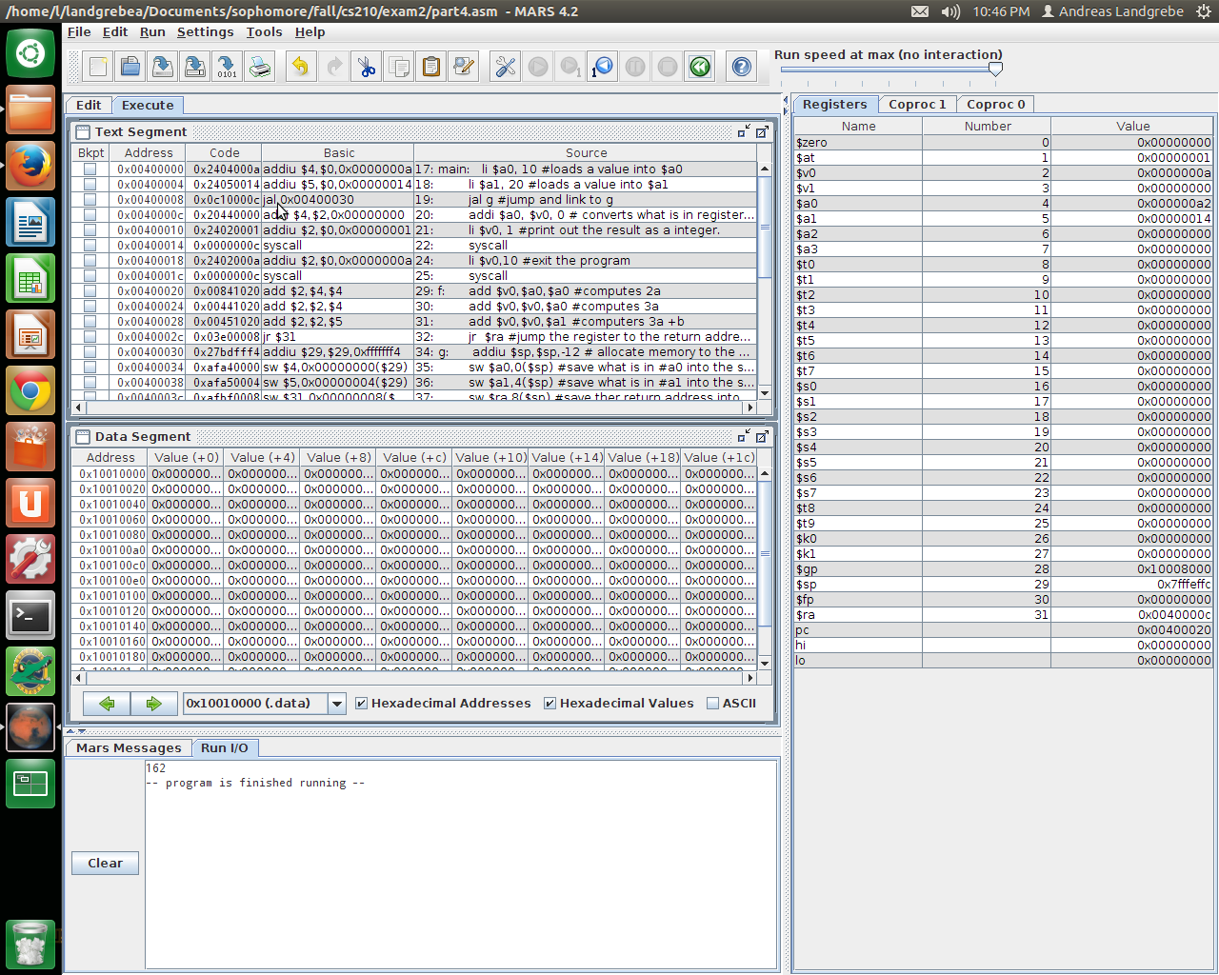
Results from running when a = 10 and b = 20

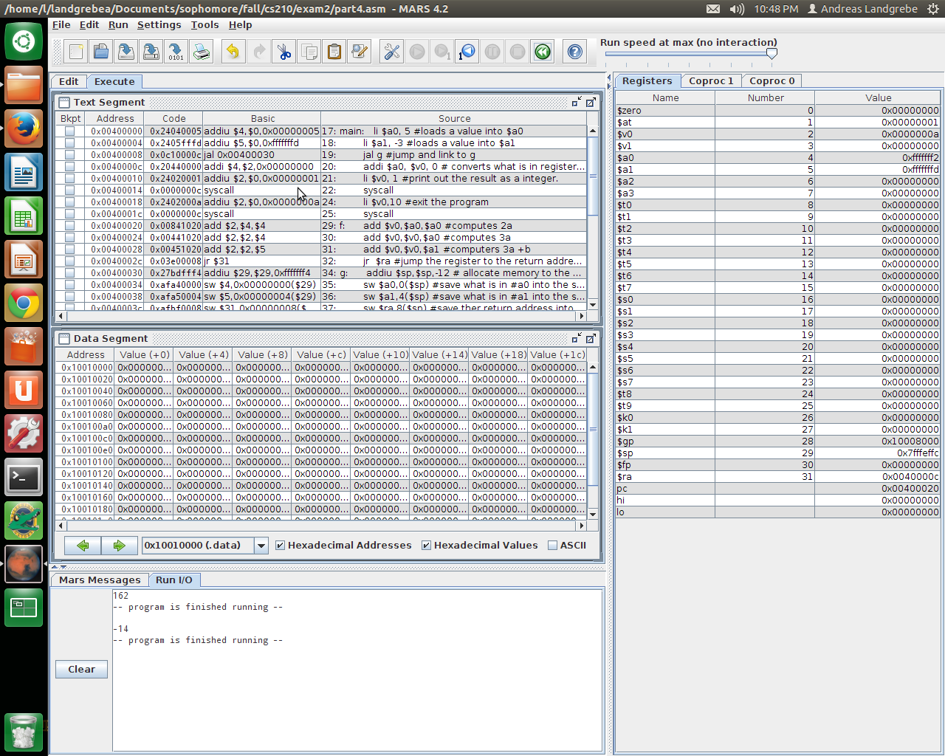
Results from running when a = 5 and b = -3
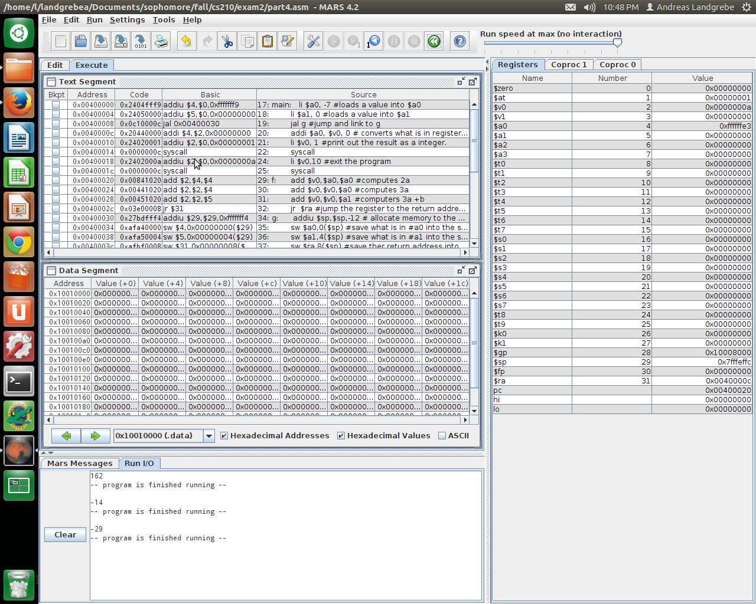
Results from running when a = -7 and b = 0

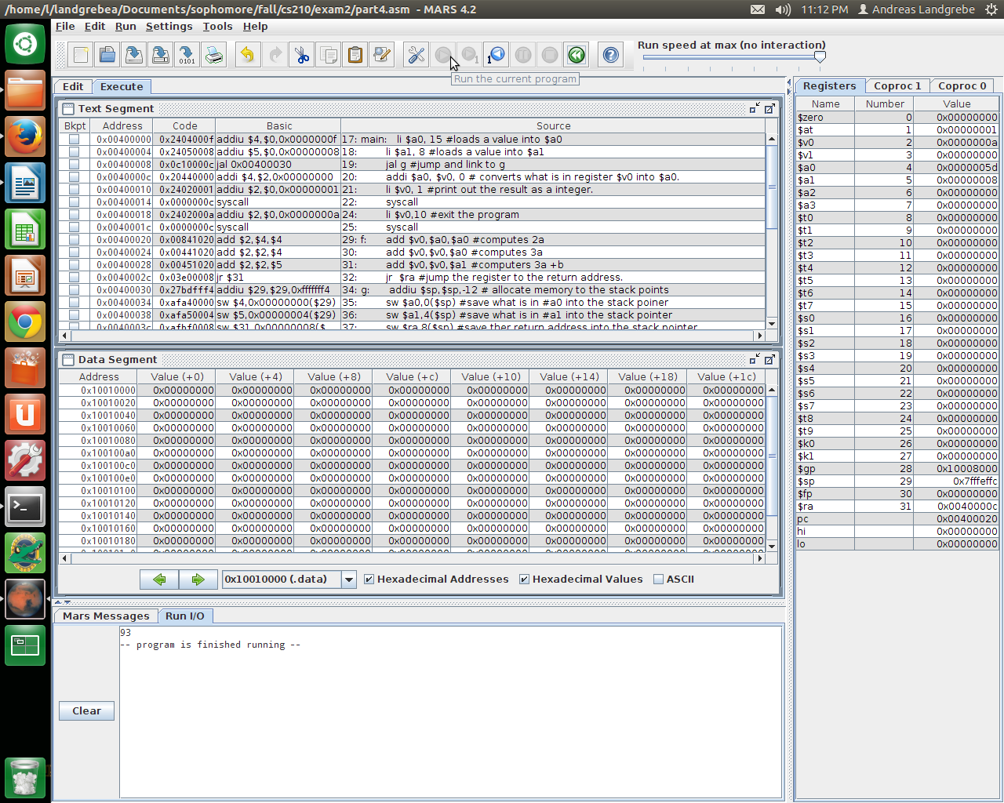
Results from running when a = 15 and b = 8

Source Code for Part 5:

/*
Andreas Landgrebe
November 18, 2013
Part 5 of the Take Home Exam
This program will write a C program that creates a double array called f which has the size of 21. The array represents the tabulated values of the function f(x) at 21 consecutive integer values.
This program will also hold a function called fill that will take a double f and two int parameters called low and high. The low and high values represent the range of integers being listed. Then create double pointer varible called f2 and set it equal to an address obtained by adding to f's address.
*/

#include <stdio.h>
#include <math.h>

main(){

void fill(double f[], int low, int high){

double * f2; //declaring the f2 pointer
f2 = &f[-low]; //assigned f2 to the address of the array f[-low]
int x; //declaring an integer
for(x = low; x <=high; x++){ // x will go through the low to the value of high
f2[x] =(double)x * sin(x) + x * cos(x); //f2[x] is equal to the double of x*sin(x) + x*cos(x) which changes the orignal f since f2 is assigned to the address of f[-low]

}
}

double f [21]; //declaring the size of the array f.
int low = -5; //declaring the size of low.
int high = 15; //declaring the size of high.
int x;
fill(f, low, high); //calling the fill function with the assigned values listed before.

printf(" x f(x)\n"); //prints the format for the output
printf("----- ----------\n"); //prits the format for the output
for(x = low; x <= high; x++){ //x goes through the values of low to the values of high
printf("%d %f\n",x,f[x-low]); //prints the format of the integers of x and doubles of f[x-low]
}

}

Output for Part 5:
This is from having the low to be -10 and the high to be 10.
Script started on Mon 18 Nov 2013 10:52:30 PM EST
#]0;landgrebea@aldenv102: ~/Documents/sophomore/fall/cs210/exam2#landgrebea@aldenv102:~/Documents/sophomore/fall/cs210/exam2$ ./part5
x f(x)
----- ----------
-10 2.950504
-9 11.909239
-8 9.078866
-7 -0.678410
-6 -7.437515
-5 -6.212932
-4 -0.412635
-3 3.393338
-2 2.650889
-1 0.301169
0 0.000000
1 1.381773
2 0.986301
3 -2.546617
4 -5.641784
5 -3.376310
6 4.084529
7 9.876222
8 6.750866
9 -4.491106
10 -13.830926
#]0;landgrebea@aldenv102: ~/Documents/sophomore/fall/cs210/exam2#landgrebea@aldenv102:~/Documents/sophomore/fall/cs210/exam2$ exit
exit
Script done on Mon 18 Nov 2013 10:52:40 PM EST

This is from having the low to be 1 and the high to be 21
Script started on Mon 18 Nov 2013 10:55:55 PM EST
#]0;landgrebea@aldenv102: ~/Documents/sophomore/fall/cs210/exam2#landgrebea@aldenv102:~/Documents/sophomore/fall/cs210/exam2$ ./part5
x f(x)
----- ----------
1 1.381773
2 0.986301
3 -2.546617
4 -5.641784
5 -3.376310
6 4.084529
7 9.876222
8 6.750866
9 -4.491106
10 -13.830926
11 -10.951210
12 3.687372
13 17.258980
14 15.782824
15 -1.641001
16 -19.929005
17 -21.021534
18 -1.632070
19 21.633055
20 26.420546
21 6.067454
#]0;landgrebea@aldenv102: ~/Documents/sophomore/fall/cs210/exam2#landgrebea@aldenv102:~/Documents/sophomore/fall/cs210/exam2$ exit
exit

This is from having the low to be -5 and the high to be 15.
Script done on Mon 18 Nov 2013 10:56:01 PM EST
Script started on Mon 18 Nov 2013 10:57:07 PM EST
#]0;landgrebea@aldenv102: ~/Documents/sophomore/fall/cs210/exam2#landgrebea@aldenv102:~/Documents/sophomore/fall/cs210/exam2$ exit####./part5
x f(x)
----- ----------
-5 -6.212932
-4 -0.412635
-3 3.393338
-2 2.650889
-1 0.301169
0 0.000000
1 1.381773
2 0.986301
3 -2.546617
4 -5.641784
5 -3.376310
6 4.084529
7 9.876222
8 6.750866
9 -4.491106
10 -13.830926
11 -10.951210
12 3.687372
13 17.258980
14 15.782824
15 -1.641001
#]0;landgrebea@aldenv102: ~/Documents/sophomore/fall/cs210/exam2#landgrebea@aldenv102:~/Documents/sophomore/fall/cs210/exam2$ exuit##[K##[K##[Kit
exit
Script done on Mon 18 Nov 2013 10:57:12 PM EST

