Source Code for Part 1:
#Andreas Landgrebe
#November 16, 2013
#Take-Home Exam
#Part 1 of the Exam where I will
#Place an integer n into the $a0 register, if it is even, compute n/2 and display the result.
#if it is odd, compute 3n + 1 and display the result.
.data
.align 2
inp: .asciiz "Please enter an integer: "

.text
.globl main
main: la $a0, inp #load the address of the string int into $a0
li $v0, 4 #print out the string
syscall

li $v0, 5 #read in an integer
syscall

add $a0, $v0, $zero #load what is in $v0 and load it in $a0
andi $a2, $a0, 1 # using boolean algebra, performing the task $a0 AND 1, and put the result into $a2
# a2 1 ueven a2 0 even
beqz $a2, even #if the last bit number in $a2 is 0, then jump to even. If it is odd, then perform continue down in the program.

add $a1,$a0,$a0 #add $a0 and $a0 together and put the result in $a1.
add $a1, $a1, $a0 #add $ a0 to %a1 and store it into $a1, this is the process to do instead of multiply numbers together to compute 3 * n.
addi $a0,$a1,1 #add 1 to $a1 into $a0, this process will compute 3n + 1 when the integer read in is odd.
j result

even: srl $a0,$a0,1 #to divide a number by 2, all one needs to do is to shift all of the bits to the right once. This will compute n / 2.

result: li $v0,1 #display the result of whether the integer read in is even or odd.
syscall

li $v0,10 #exit the program.
syscall

Output for the value of 1:
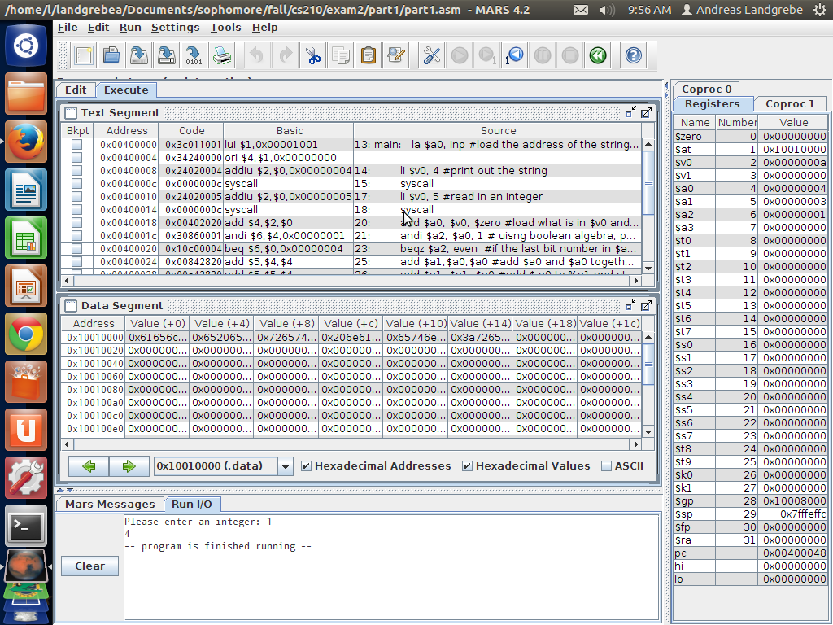

The result is 4

Output for the value of 2:
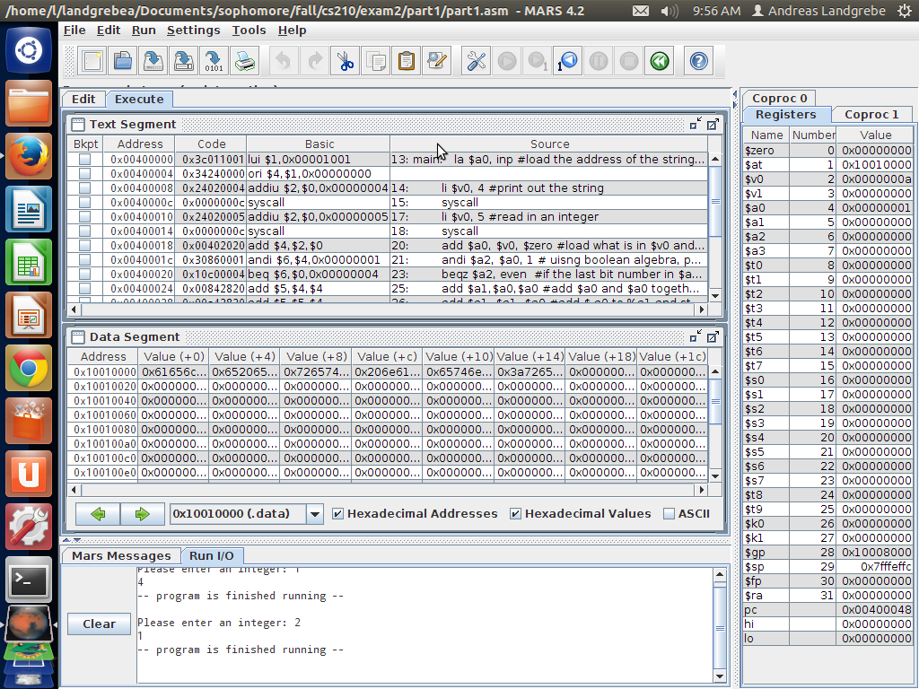

The result is 1

Output for the value of 3:
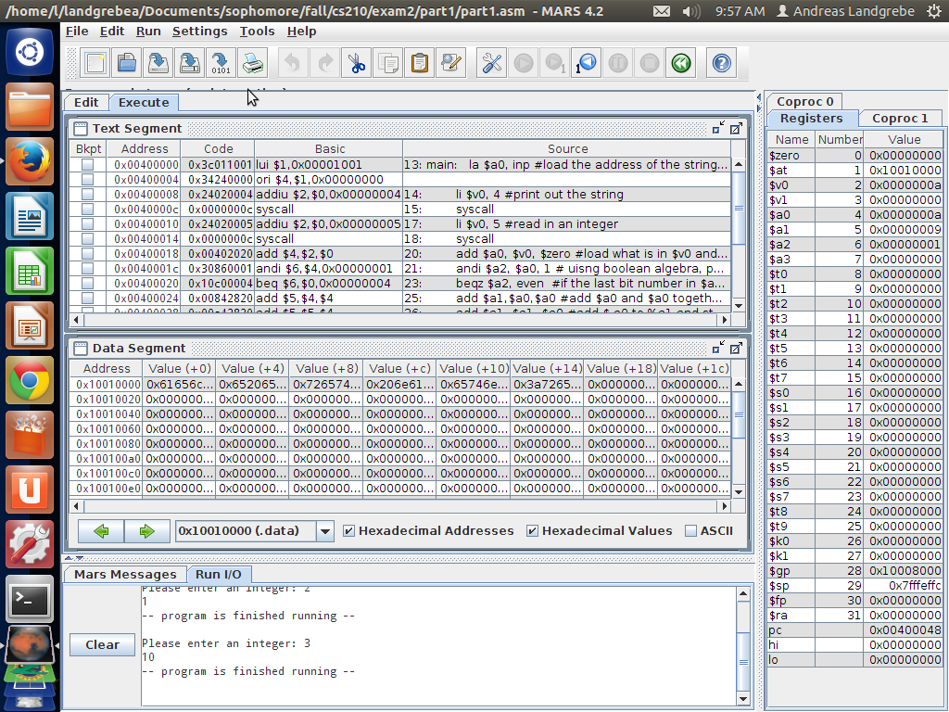
The result is 10

Output for the value of 4:
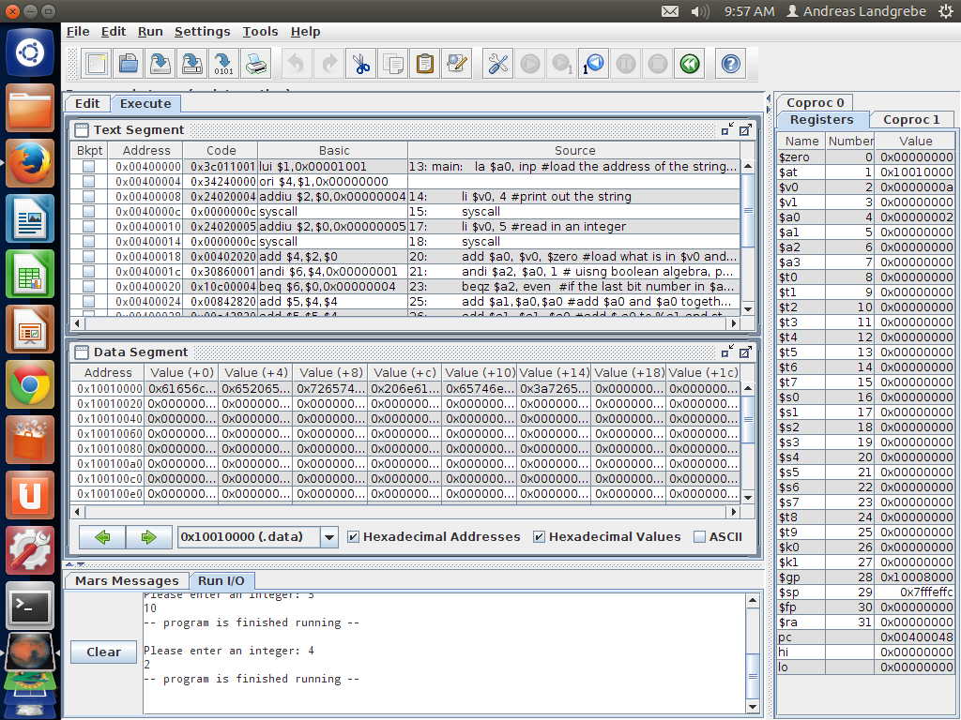
The result is 2

Output for the value of 5
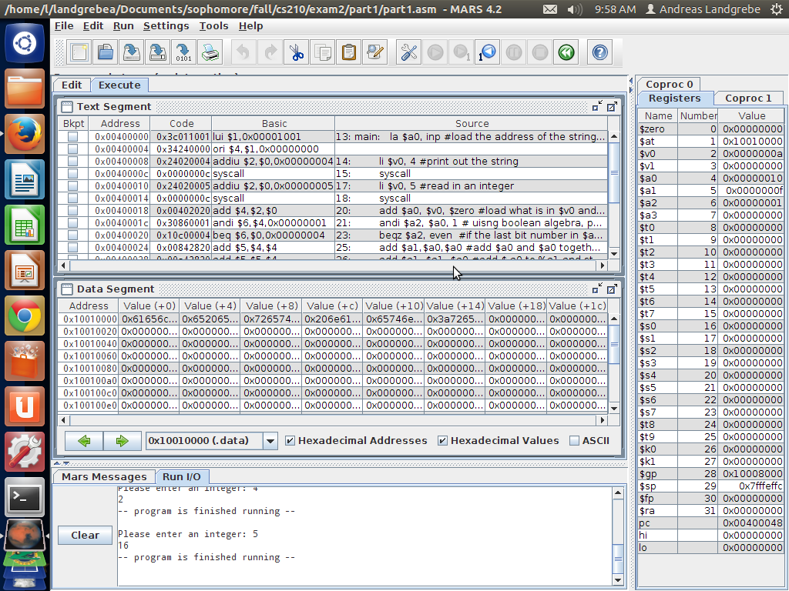

The result is 16

Output for the value of 15
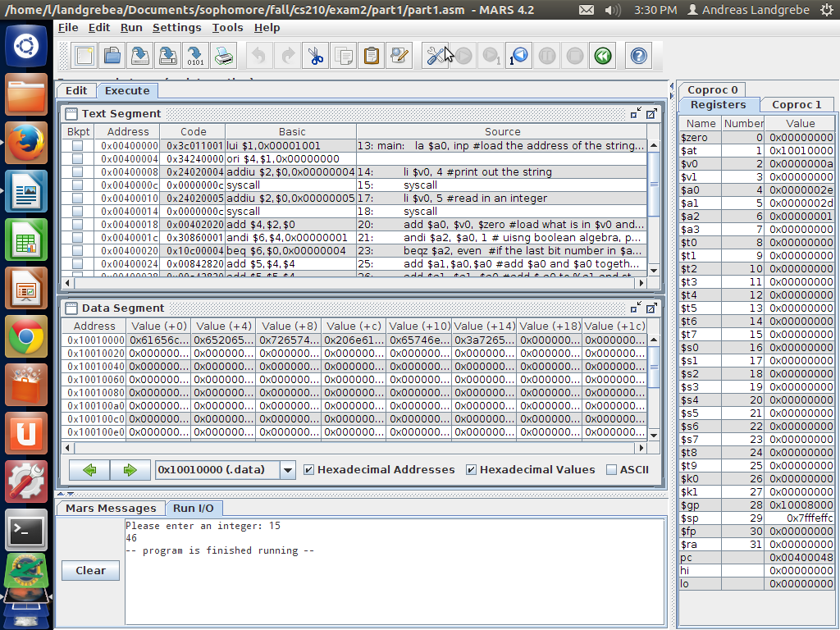
The result is 46

Source Code for Part 2:

#Andreas Landgrebe
#November 19, 2013
#Part 2 of the Take Home Exam
# In this mips program, load a hexadecimal constant into a register.
#Extract 8 bits in positions 30-23 and shift them to the right
#Subtract 127 from the result and then print out the result.

.data
.align 2

.text
.globl main
main: li $s0, 0x9F500000 #this is the hexadecimal number being called in
li $s1, 0x7F800000
#this is the hexadecimal number being used to extract 8 bits from 30-23.
#This hexadecimal is where from bits 30-23, each bit will have a 1 in it.
and $s2, $s0, $s1 #perform boolean algebra between what is in $s0 and $s1 and put the result in register $s2
srl $s2, $s2, 23 #shift right 23 spaces and save it in $s2
subi $a0, $s2, 127 #subtract 127 from $s2 and put the result in $a0.
li $v0, 1 #print out the integer
syscall

li $v0,10 #exit the program
syscall

Output when determining the power of 2 when using the hexadecimal 0x732A00FB:
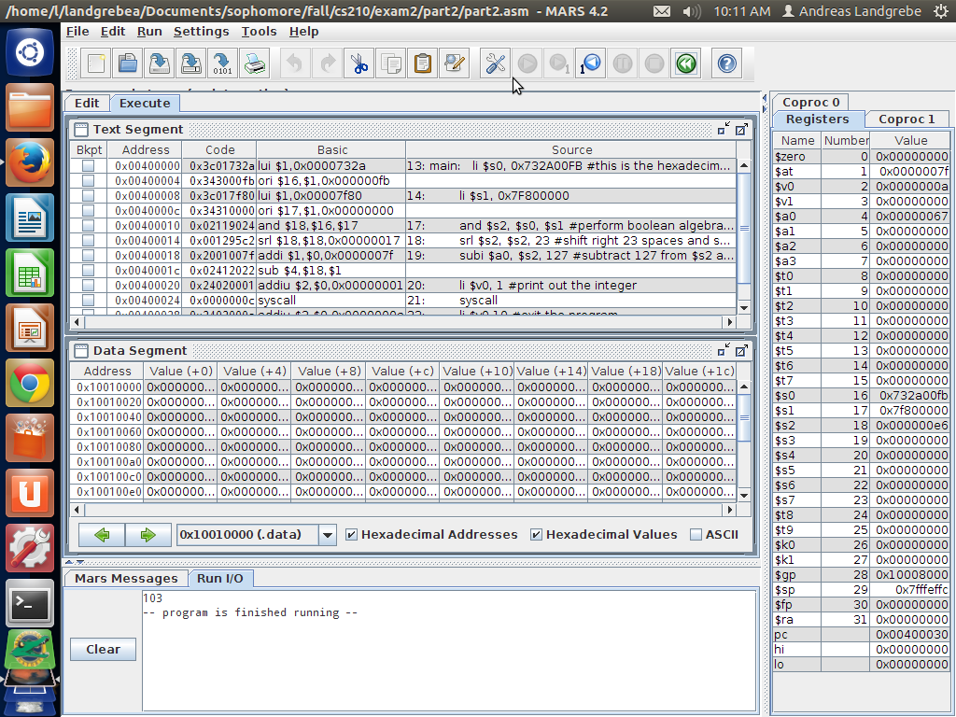

The Result is 103

Output when determining the power of 2 for the hexadecimal 0x4A2FE484
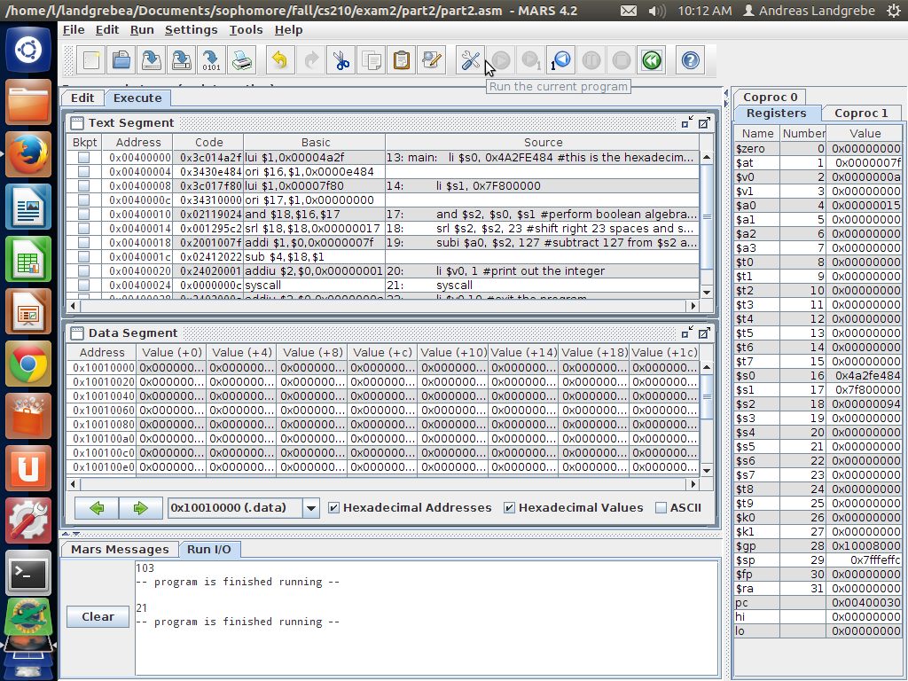

The Result is 21

Output when determining the power of 2 for the hexadecimal
0xB9C8B587
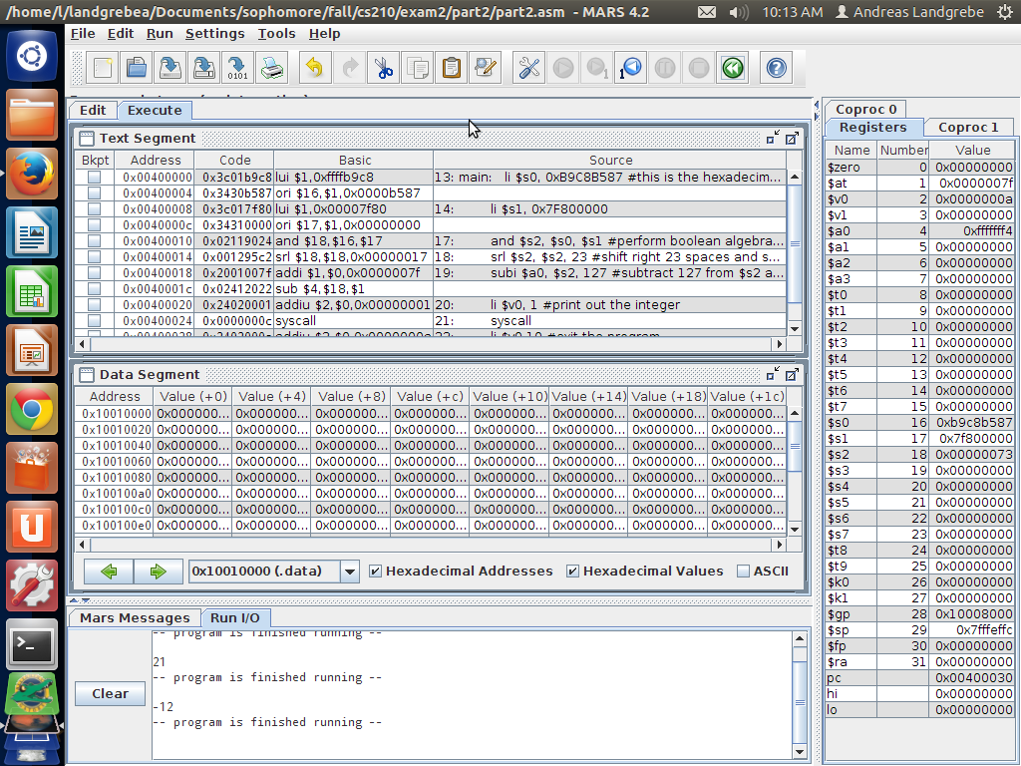

The result is -12

Output for determining the power of 2 for the hexadecimal 0x80000000
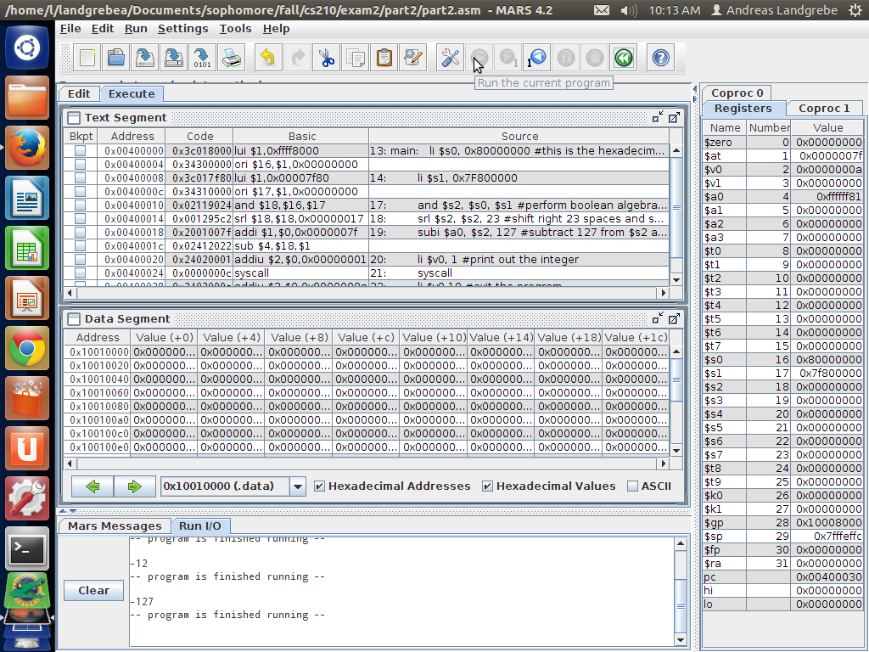

The result is -127

Output for determining the power of 2 for the hexadecimal 0x9F500000
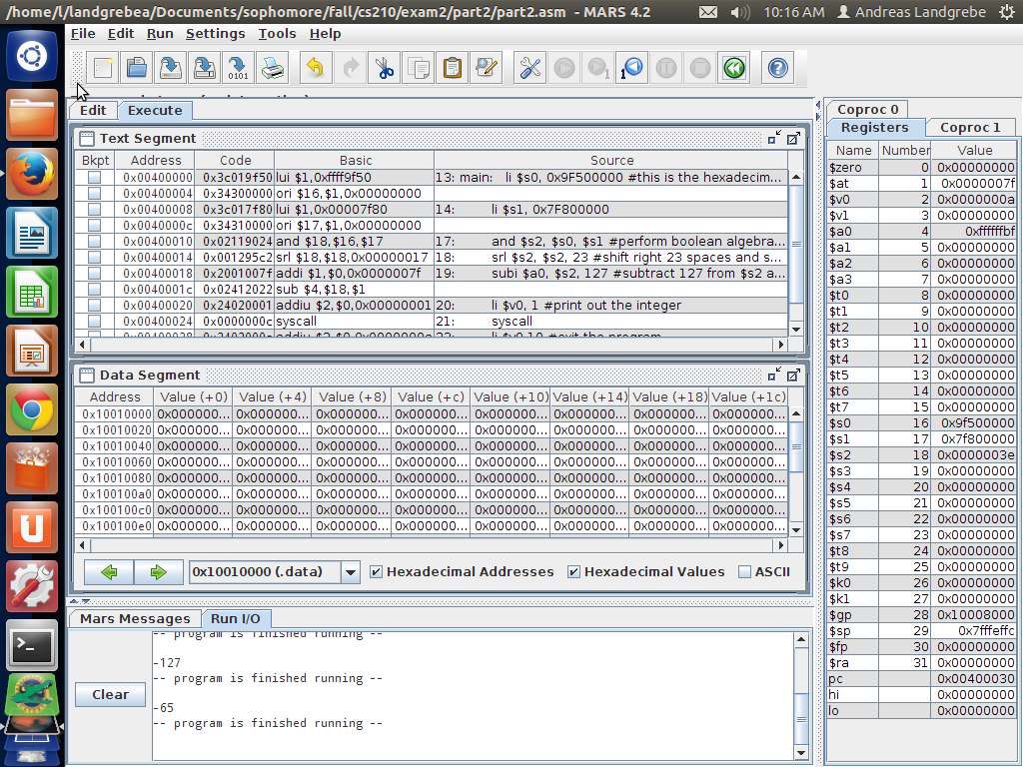
The result is -65

Source Code for Part 3:
/*Andreas Landgrebe
November 19, 2013
Part 3 of the Take Home Exam
This C program will input 2 intger values and determine how many bits these two values have in common.
*/

#include <stdio.h>
#include <math.h>

main(){
int i1; //read in the first integer
int i2; //read in the second integer
printf("Please enter the first interger: ");
scanf("%d", &i1); //scans the first integer by looking at the address of the i1 interger value being scanned in.
printf("Please enter the second integer: ");
scanf("%d", &i2); //scans the second integer by lookingat the address of the i2 integer value being scanned in

printf("%x %x \n", i1, i2); //prints the hexadecimal of i1 and i2
int countcommon = 0; //
int mask = 1; //
int position; //counter to change the position
for(position = 0; position <= 31; position++){ //counter to be able to chagne the bit postion of the integers being read in.
if(((i1 ^ i2) & mask) == 0){ //if i1 xor i2 and mask is equal to zero, then the bits are equal to each other.
countcommon++;
}
mask = mask << 1; //change the bit position
}
printf("%d and %d have %d bits in common", i1, i2, countcommon);
//prints out the 2 intergers being read in and how many bits they are in common.
printf("\n"); //create a new line
}

Output for Part 3:

Script started on Tue 19 Nov 2013 09:52:19 AM EST
#]0;landgrebea@aldenv151: ~/Documents/sophomore/fall/cs210/exam2#landgrebea@aldenv151:~/Documents/sophomore/fall/cs210/exam2$ exit#####[2P18##./part3
Please enter the first interger: 1
Please enter the second integer: -1
1 ffffffff fffffffe
1 and -1 have 1 bits in common
#]0;landgrebea@aldenv151: ~/Documents/sophomore/fall/cs210/exam2#landgrebea@aldenv151:~/Documents/sophomore/fall/cs210/exam2$ ./part3
Please enter the first interger: 201
Please enter the second integer: 32767
c9 7fff 7f36
201 and 32767 have 21 bits in common
#]0;landgrebea@aldenv151: ~/Documents/sophomore/fall/cs210/exam2#landgrebea@aldenv151:~/Documents/sophomore/fall/cs210/exam2$ ./part3
Please enter the first interger: 15
Please enter the second integer: 30
f 1e 11
15 and 30 have 30 bits in common
#]0;landgrebea@aldenv151: ~/Documents/sophomore/fall/cs210/exam2#landgrebea@aldenv151:~/Documents/sophomore/fall/cs210/exam2$ ./part3
Please enter the first interger: 18
Please enter the second integer: 100
12 64 76
18 and 100 have 27 bits in common
#]0;landgrebea@aldenv151: ~/Documents/sophomore/fall/cs210/exam2#landgrebea@aldenv151:~/Documents/sophomore/fall/cs210/exam2$ exit##[K##[K##[K##[K####./part3
Please enter the first interger: -1
Please enter the second integer: 0
ffffffff 0 ffffffff
-1 and 0 have 0 bits in common
#]0;landgrebea@aldenv151: ~/Documents/sophomore/fall/cs210/exam2#landgrebea@aldenv151:~/Documents/sophomore/fall/cs210/exam2$ exit
exit
Script done on Tue 19 Nov 2013 09:53:24 AM EST

Source Code for Part 4:
# Andreas Landgrebe
# Novmeber 18, 2013
# Part 4 of the Take Home Exam
# This mips program will take two functions of f and g and read two integer arguments
# this will pass thrgough the $a0 and $a1 registers. After this, the functiosn will return an int result.
# this int result has to be returned to the $v0 register.
# this program will compute the following:
# f(a,b): 3a + b
# g(a,b) = 2f(b-1,a-1) +a + b.
# load the first integers into a0 and a1, call function g and print out the result.

.data
.align 2

.text
.globl main
main: li $a0, -7 #loads a value into $a0
li $a1, 0 #loads a value into $a1
jal g #jump and link to g
addi $a0, $v0, 0 # converts what is in register $v0 into $a0.
li $v0, 1 #print out the result as a integer.
syscall

li $v0,10 #exit the program
syscall

f: add $v0,$a0,$a0 #computes 2a
add $v0,$v0,$a0 #computes 3a
add $v0,$v0,$a1 #computers 3a +b
jr $ra #jump the register to the return address.

g: addiu $sp,$sp,-12 # allocate memory to the stack points
sw $a0,0($sp) #save what is in #a0 into the stack poiner
sw $a1,4($sp) #save what is in #a1 into the stack pointer
sw $ra,8($sp) #save ther return address into the stack pointer

subi $a1,$a0,1 #a1 = a - 1
lw $a0,4($sp) #a0 = b
subi $a0,$a0,1 #a0 = b - 1
jal f #jump and link to f

add $v0,$v0,$v0 #v0 = 2 * f(b-1,a-1)
lw $a0,0($sp) # loading a from the stack
add $v0,$v0,$a0 #add 2f(b-1,a-1) + a
lw $a1,4($sp) # loading b from the stack
add $v0,$v0,$a1 #add 2f(b - 1, a -1) + a + b

lw $a0,0($sp) #load a0 in the stack pointer
lw $a1,4($sp) #load a1 in the stack pointer
lw $ra,8($sp) #load the return address in the stack pointer
addiu $sp,$sp,12 #add memory to the stack pointer.
jr $ra #jump the register to the return address.

Output of Part 4:
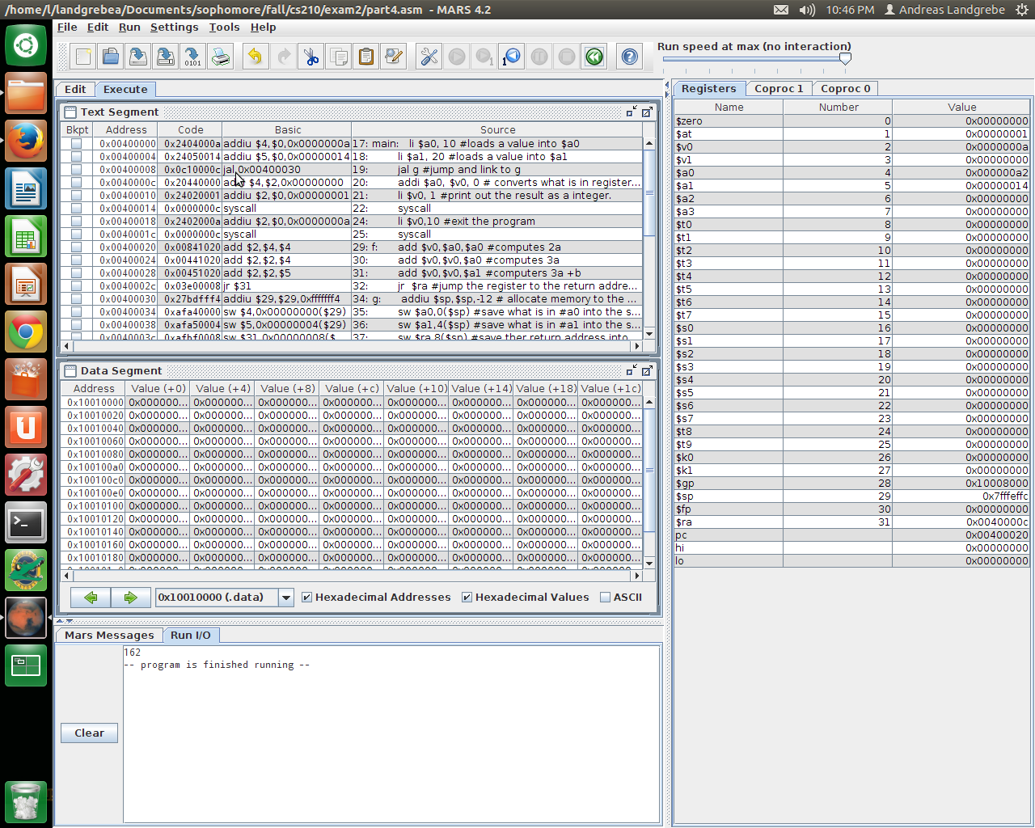
Results from running when a = 10 and b = 20 which is 162

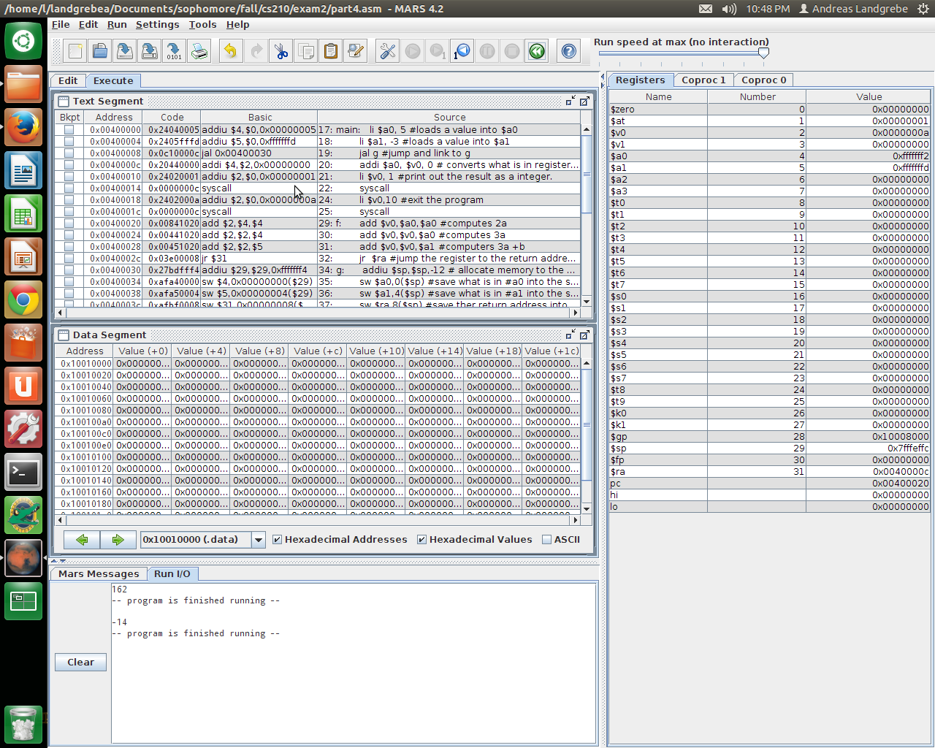
Results from running when a = 5 and b = -3 which is -14
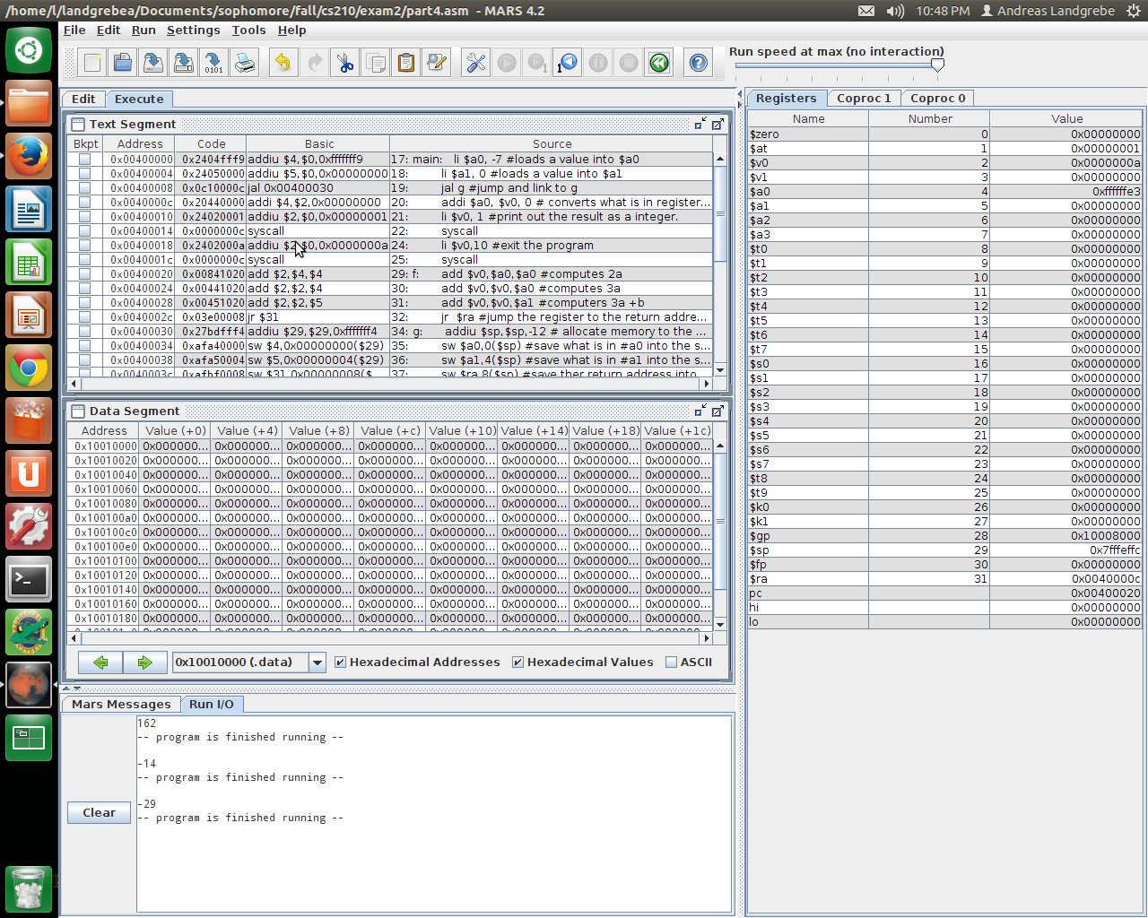
Results from running when a = -7 and b = 0 which is -29

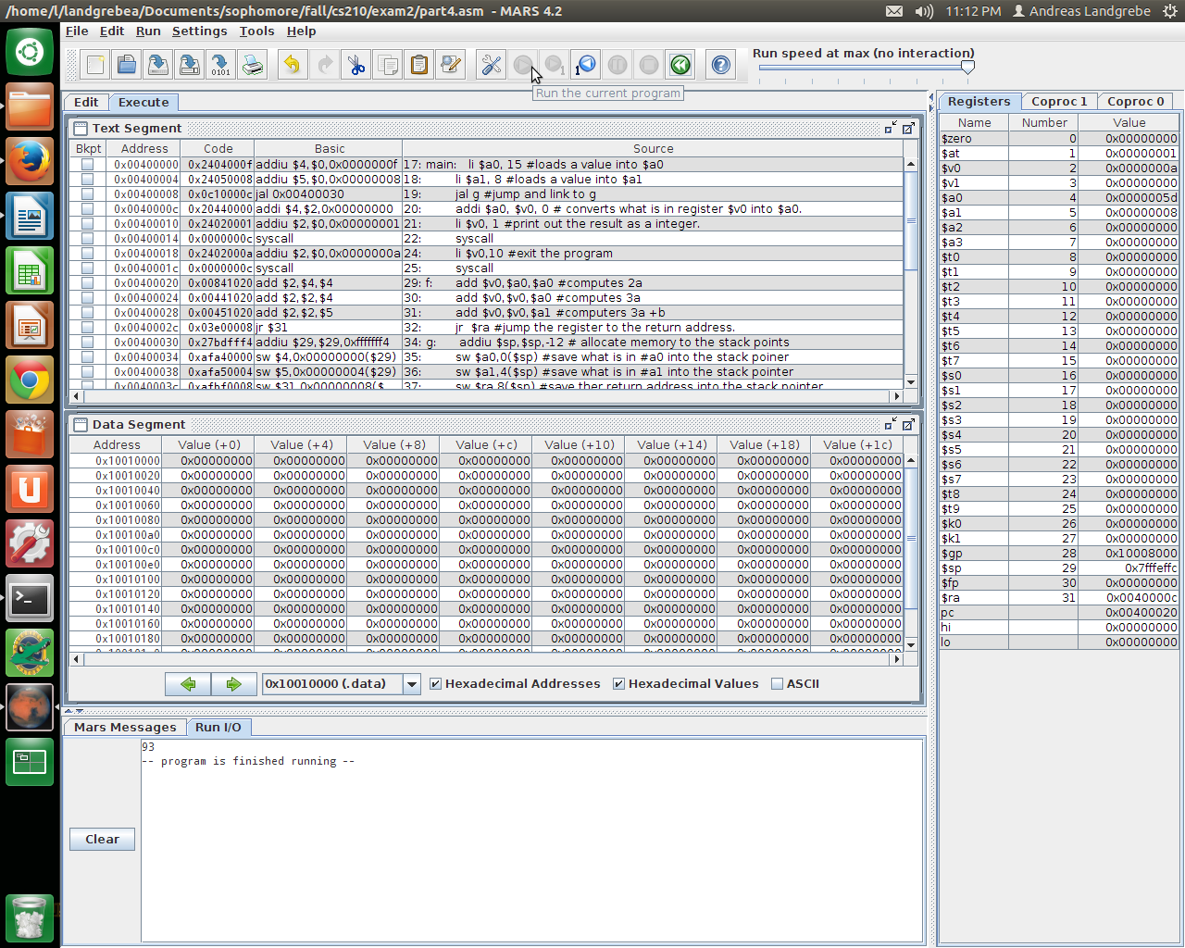
Results from running when a = 15 and b = 8 which is 93

Source Code for Part 5:

/*
Andreas Landgrebe
November 18, 2013
Part 5 of the Take Home Exam
This program will write a C program that creates a double array called f which has the size of 21. The array represents the tabulated values of the function f(x) at 21 consecutive integer values.
This program will also hold a function called fill that will take a double f and two int parameters called low and high. The low and high values represent the range of integers being listed. Then create double pointer varible called f2 and set it equal to an address obtained by adding to f's address.
*/

#include <stdio.h>
#include <math.h>

main(){

void fill(double f[], int low, int high){

double * f2; //declaring the f2 pointer
f2 = &f[-low]; //assigned f2 to the address of the array f[-low]
int x; //declaring an integer
for(x = low; x <=high; x++){ // x will go through the low to the value of high
f2[x] =(double)x * sin(x) + x * cos(x); //f2[x] is equal to the double of x*sin(x) + x*cos(x) which changes the orignal f since f2 is assigned to the address of f[-low]

}
}

double f [21]; //declaring the size of the array f.
int low = -5; //declaring the size of low.
int high = 15; //declaring the size of high.
int x;
fill(f, low, high); //calling the fill function with the assigned values listed before.

printf(" x f(x)\n"); //prints the format for the output
printf("----- ----------\n"); //prits the format for the output
for(x = low; x <= high; x++){ //x goes through the values of low to the values of high
printf("%d %f\n",x,f[x-low]); //prints the format of the integers of x and doubles of f[x-low]
}

}

Output for Part 5:
This is from having the low to be -10 and the high to be 10.
Script started on Mon 18 Nov 2013 10:52:30 PM EST
#]0;landgrebea@aldenv102: ~/Documents/sophomore/fall/cs210/exam2#landgrebea@aldenv102:~/Documents/sophomore/fall/cs210/exam2$ ./part5
x f(x)
----- ----------
-10 2.950504
-9 11.909239
-8 9.078866
-7 -0.678410
-6 -7.437515
-5 -6.212932
-4 -0.412635
-3 3.393338
-2 2.650889
-1 0.301169
0 0.000000
1 1.381773
2 0.986301
3 -2.546617
4 -5.641784
5 -3.376310
6 4.084529
7 9.876222
8 6.750866
9 -4.491106
10 -13.830926
#]0;landgrebea@aldenv102: ~/Documents/sophomore/fall/cs210/exam2#landgrebea@aldenv102:~/Documents/sophomore/fall/cs210/exam2$ exit
exit
Script done on Mon 18 Nov 2013 10:52:40 PM EST

This is from having the low to be 1 and the high to be 21
Script started on Mon 18 Nov 2013 10:55:55 PM EST
#]0;landgrebea@aldenv102: ~/Documents/sophomore/fall/cs210/exam2#landgrebea@aldenv102:~/Documents/sophomore/fall/cs210/exam2$ ./part5
x f(x)
----- ----------
1 1.381773
2 0.986301
3 -2.546617
4 -5.641784
5 -3.376310
6 4.084529
7 9.876222
8 6.750866
9 -4.491106
10 -13.830926
11 -10.951210
12 3.687372
13 17.258980
14 15.782824
15 -1.641001
16 -19.929005
17 -21.021534
18 -1.632070
19 21.633055
20 26.420546
21 6.067454
#]0;landgrebea@aldenv102: ~/Documents/sophomore/fall/cs210/exam2#landgrebea@aldenv102:~/Documents/sophomore/fall/cs210/exam2$ exit
exit

This is from having the low to be -5 and the high to be 15.
Script done on Mon 18 Nov 2013 10:56:01 PM EST
Script started on Mon 18 Nov 2013 10:57:07 PM EST
#]0;landgrebea@aldenv102: ~/Documents/sophomore/fall/cs210/exam2#landgrebea@aldenv102:~/Documents/sophomore/fall/cs210/exam2$ exit####./part5
x f(x)
----- ----------
-5 -6.212932
-4 -0.412635
-3 3.393338
-2 2.650889
-1 0.301169
0 0.000000
1 1.381773
2 0.986301
3 -2.546617
4 -5.641784
5 -3.376310
6 4.084529
7 9.876222
8 6.750866
9 -4.491106
10 -13.830926
11 -10.951210
12 3.687372
13 17.258980
14 15.782824
15 -1.641001
#]0;landgrebea@aldenv102: ~/Documents/sophomore/fall/cs210/exam2#landgrebea@aldenv102:~/Documents/sophomore/fall/cs210/exam2$ exuit##[K##[K##[Kit
exit
Script done on Mon 18 Nov 2013 10:57:12 PM EST

