Andreas Landgrebe
December 9, 2013
Source Code for Part 1
#Andreas Landgrebe
#Part 1 of the CS210 Final Project
#I will have this program to write A in the mars bot to be 5 x 5
#I will make sure that this A's being drawn are disconnected and it is a repated pattern.
.data
HEADING: .word 0xffff8010 # set by program
LEAVETRK: .word 0xffff8020 # set by program
WHEREX: .word 0xffff8030 # read by program
WHEREY: .word 0xffff8040 # read by program
MOVE: .word 0xffff8050 # set by program

.text
.globl main
main:

li $a0,0 # $a0: x-position
li $a1,0 # $a1: y-position

branch:
bge $a1,500,branch2 #if a1 is greater than or equal to 300, then exit the progran. Else, continue the program to the branch2 function.
jal a #jump the link to the a function to be able to call a return address
addi $a1,$a1,100 #add 100 to the a1 register
j branch #jump the branch function

branch2:
li $a1,0 # load 0 onto the A1 register the set up that next column can be drawn.
bge $a0,400,endloop # branch to exit the program if a0 is 400
addi $a0,$a0,110 #add 100 so after A's are drawn, it will go the next column and continue drawing these A's.
j branch #jump to the branch function
endloop:

li $v0,10 #exit the program
syscall

a:

addi $sp,$sp,-12 #allocate memory to the stack pointer
sw $a0,0($sp) #save position 0 onto the stack with the a0 register
sw $a1,4($sp) #save position 4 onto the stack with the a1 register
sw $ra,8($sp) #save position 8 onto the stack with the return address

lw $a0,0($sp) #load position 0 from the stack
addi $a0,$a0,0 #add 0 onto the a0 register, I don't need this line but I just still write it for consistency

li $a1,0 #dont draw the line but go to the point
jal horiz #jump and link to the horizontal method written below

lw $a0,4($sp) #load position 4 from the stack
addi $a0,$a0,100 #add 100 onto the a0 register

li $a1,0 #dont draw the line but go to the point being called
jal vert #jump and link to the vertical function to be able to set up a return address.

lw $t0,LEAVETRK # turn off drawing to set endpoint
sw $zero,0($t0)

lw $a0,0($sp) #load position 0 from the stack
addi $a0,$a0,50 #add 50 onto the a0 register

li $a1,1 #draw the line from the horizontal parameter set above
jal horiz #jump and link to the horizontal function to be able to set up a return address.

lw $a0,4($sp) #load position 4 from the stack
addi $a0,$a0,0 #add 0 onto the a0 register, this is not necessary but I am still adding 0 to have consistency in this program.

li $a1,1 #draw the line from the vertical parameter set above
jal vert #jump and link to the vertical function to be able to the set up a return address.

lw $t0,LEAVETRK # turn off drawing to set endpoint
sw $zero,0($t0)

lw $a0,0($sp) #load position 0 from the stack
addi $a0, $a0, 100 #add 100 onto the a0 register

li $a1,1 #draw the line from the horizontal position being assigned above
jal horiz #jump and link to the horizontal function written below.

lw $a0,4($sp) #load position 4 from the stack
addi $a0,$a0,100 #add 100 onto a0 to be later have the line to be drawn

li $a1,1 #draw the line
jal vert #jump and link to the vertical function written below

lw $t0,LEAVETRK #turn off drawing to set endpoint
sw $zero,0($t0)

lw $a0,0($sp) #load from position 0 of the stack
addi $a0,$a0,75 #add 75 to the a0 register

li $a1,0 #don't draw the line, but go to the point
jal horiz #jump and link to the horizontal function written below

lw $a0, 4($sp) #load from position 4 of the stack
addi $a0,$a0,50 #add 50 to the a0 register to be able to go to this specific position

li $a1,0 #don't draw the line but go to the point
jal vert #jump and link to the vertical function written below

lw $t0,LEAVETRK #turn off drawing to set endpoint
sw $zero,0($t0)

lw $a0, 0($sp) #load from position 0 of the stack pointer
addi $a0,$a0,25 #add 25 onto a0 to be able to go to this point

li $a1,1 # draw the line to where a0 is being set to
jal horiz #jump and link the horiz function written

lw $t0, LEAVETRK #turn off drawing to set endpoint
sw $zero,0($t0)

lw $a0,0($sp) #load what is in position 0 from the stack
lw $a1,4($sp) #load what is in position 4 from the stack
lw $ra,8($sp) #load what is in position 8 from the stack
addi $sp,$sp,12 #add the allocated memory back from the stack pointer
jr $ra #jump register to the return address

##################################################
# horiz -- move horizontally to given x-value
# $a0 = goal x-value
# $a1 = true if we should leave a track, false otherwise
##################################################
horiz: # Preserve registers (in case they're being used elsewhere!)
addi $sp,$sp,-16

sw $s0,0($sp)
sw $s1,4($sp)
sw $s2,8($sp)
sw $s3,12($sp)

lw $s0,HEADING # MMIO address for heading
lw $s1,WHEREX # MMIO address for x-value
lw $s2,MOVE # MMIO address for move command
lw $s3,LEAVETRK # MMIO address for leave track

# Loop until we reach goal value
xloop: lw $t0,0($s1) # t0 = current x location
beq $t0,$a0,donex # "Are we there yet?"...

# ... No. See if we have to move left or right:
sw $a1,0($s3) # set "leave track" as specified
blt $t0,$a0,h90 # if current < goal, move right (heading 90)

h270: # We have to move left (heading 270):
li $t0,270 # store the heading (270)...
sw $t0,0($s0) # ... in the appropriate MMIO address
li $t0,1 # t0 = "true"
sw $t0,0($s2) # start moving
busyX1: lw $t0,0($s1) # Get current location
ble $t0,$a0,donex # "Are we there yet?"
j busyX1

h90: # We have to move right (heading 90):
li $t0,90 # store the heading (90)...
sw $t0,0($s0) # ... in the appropriate MMIO address
li $t0,1 # t0 = "true"
sw $t0,0($s2) # start moving
busyX2: lw $t0,0($s1) # Get current location
bge $t0,$a0,donex # "Are we there yet?"
j busyX2

donex: sw $zero,0($s2) # stop moving

lw $s0,0($sp) # restore registers
lw $s1,4($sp)
lw $s2,8($sp)
lw $s3,12($sp)
addi $sp,$sp,16
jr $ra

##################################################
# vert -- move vertically to given x-value
# $a0 = goal y-value
# $a1 = true if we should leave a track, false otherwise
##################################################
vert: # Preserve registers (in case they are being used)
addi $sp,$sp,-16

sw $s0,0($sp)
sw $s1,4($sp)
sw $s2,8($sp)
sw $s3,12($sp)

lw $s0,HEADING # MMIO address for heading
lw $s1,WHEREY # MMIO address for y-value
lw $s2,MOVE # MMIO address for move command
lw $s3,LEAVETRK # MMIO address for leave track

yloop: lw $t0,0($s1) # t0 = current y location
beq $t0,$a0,doney # "Are we there yet?"...

# ... No. See if we have to move up or down:
sw $a1,0($s3) # set "leave track" as specified
blt $t0,$a0,h180 # if current < goal, move down (heading 180)
h0: # We have to move up (heading 0):
li $t0,0 # store the heading (0)...
sw $t0,0($s0) # ... in the appropriate MMIO address
li $t0,1 # t0 = "true"
sw $t0,0($s2) # start moving
busyY1: lw $t0,0($s1) # Get current location
ble $t0,$a0,doney # "Are we there yet?"
j busyY1
h180: # We have to move down (heading 180):
li $t0,180 # store the heading (180)...
sw $t0,0($s0) # ... in the appropriate MMIO address
li $t0,1 # t0 = "true"
sw $t0,0($s2) # start moving
busyY2: lw $t0,0($s1) # Get current location
bge $t0,$a0,doney # "Are we there yet?"
j busyY2
doney: sw $zero,0($s2) # stop moving

lw $s0,0($sp) # restore registers
lw $s1,4($sp)
lw $s2,8($sp)
lw $s3,12($sp)
addi $sp,$sp,16
jr $ra
Output for Part 1:
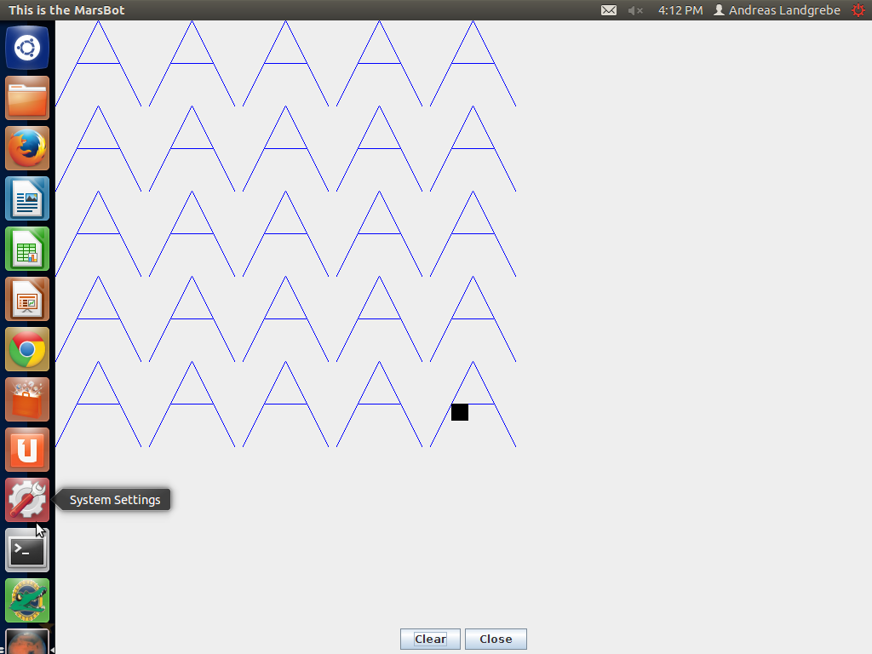

Source Code for Part 2:#Andreas Landgrebe
#CS210 final project part 2
#This mips program will have four operations of move, rmoveto,
#lineto, and rlineto
#The moveto function will move to a location leaving no track
#The rmove to function will move a distance will no track.
#The lineto function will draw a line to a location
#The rlineto function will draw for a distance which will leave a track.
#The r means relative which signifies that the argument
#show points to the starting position. These are not absolute coordinates.

.data
HEADING: .word 0xffff8010 # set by program
LEAVETRK: .word 0xffff8020 # set by program
WHEREX: .word 0xffff8030 # read by program
WHEREY: .word 0xffff8040 # read by program
MOVE: .word 0xffff8050 # set by program

.text
.globl main
main:

li $a0,100 # $a0: x-position
li $a1,0 # $a1: y-position
jal moveto #jump and link to the moveto function to set up the return address

li $a0,200 #set the x position to 200
li $a1,100 #set the y position to 100
jal lineto #jump and link to the lineto function to set up the return address

li $a0, 100 #set the x position to 100
li $a1, 200 #set the y position to 200
jal lineto #jump and link to the lineto function to set up the return address

li $a0,0 #set the x position to 0
li $a1, 100 #set the y position to 100
jal lineto #jump and link to the lineto function to set up the return address

li $a0,100 #set the x position to 100
li $a1, 0 #set the y position to 0
jal lineto #jump and link to the lineto function to set up the return address

#starting from here, it the going to draw a new figure where it is going to be triangle where one of the sides
#is not drawn to properly show the function written are performing correctly.

li $a0, 300 #set the x position to 300
li $a1, 300 #set the y position to 300
jal moveto #jump and link to the moveto function to set up the return address

li $a0, 50 #set the x position to 50
li $a1, 100 #set the y position to 100
jal rlineto #jump and link to the rlineto function to set up the return address

li $a0, -50 #set the x position to -50. It is going to be negative to subtract the x-position to be in a relative position
li $a1, 0 #set the y position to be 0
jal rmoveto #jump and link to the rmoveto function to set up the return address

li $a0,0 #set the x position to be 0
li $a1, -100
#set the y position to be -100. It is going to be negative to draw the line while decreasing the x-position to be in a relative position
jal rlineto #jump and link to the rlinto function to set up the return address

endloop:

li $v0,10 #exit the program
syscall

moveto: #this will move to a location that will leave no track
addi $sp,$sp, -12 #allocate memory to the stack
sw $a0,0($sp) #store register $a0 onto position 0 on the stack
sw $a1,4($sp) #store register $a1 onto position 4 on the stack
sw $ra,8($sp) #store the return address onto position 8 on the stack

addi $t0,$zero,0 #set up the t0 register to not leave a track
lw $t1, LEAVETRK #load the LEAVETRK onto t1
sw $t0, 0($t1) #save what is in t1 onto t0 so it does not leave a track

jal justmove #jump and link to the just move function to set up the return address

lw $a0,0($sp) #load what is in register a0 onto position 0 on the stack
lw $a1,4($sp) #load what is in register a1 onto position 4 on the stack
lw $ra,8($sp) #load the return address in position 8 on the stack
addi $sp,$sp,12 #add back the memory used for the stack

jr $ra #jump to the return address

rmoveto: #this will to a relative location that will leave no track

addi $sp,$sp, -12 #allocate memory to the stack
sw $a0,0($sp) # store register a0 onto the stack at position 0
sw $a1,4($sp) # store register a1 onto the stack at position 4
sw $ra,8($sp) # store the return address onto the stack at position 8.

lw $t0,WHEREX #load where is x in t0
lw $t2,0($t0) #load what is in t0 into t2
lw $t1,WHEREY #load where is y in t3
lw $t3,0($t1) #load what is in t1 into t2

add $a0,$a0,$t2 #add what is in t2 into a0
add $a1,$a1,$t3 #add what is in t3 into a1

jal moveto #jump and link to the moveto function to set up the return address

lw $a0,0($sp) #load the a0 register onto the stack at position 0
lw $a1,4($sp) #load the a1 register onto the stack at position 4
lw $ra,8($sp) #load the return address onto the stack at position 8
addi $sp,$sp,12 #add back the memory used for the stack
jr $ra #jump to the return address

lineto: #this will draw a line to a location

addi $sp,$sp, -12 #add memory to the stack
sw $a0,0($sp) #store the a0 register onto the stack at position 0
sw $a1,4($sp) #store the a1 register onto the stack at position 4
sw $ra,8($sp) # store the return address onto the stack at position 8

addi $t0,$zero,1 #add 1 onto to t0 so it is able to leave to track to draw a line
lw $t1,LEAVETRK #load LEAVETRK to the t1 register
sw $t0,0($t1) #load what is in t1 into t0 so it is able to draw a line

jal justmove #jump and link to the justmove function to set up a return address

addi $t0,$zero,0 #add 0 onto t0 so it can terminate to draw a line
lw $t1,LEAVETRK #load LEAVETRK into the t1 register
sw $t0,0($t1) #store what is in the t1 register and put it in the t0 register

lw $a0,0($sp) #load the a0 register onto the stack at position 0
lw $a1,4($sp) #load the a1 register onto the stack at position 4
lw $ra,8($sp) #load the return address onto the stack at position 8
addi $sp,$sp,12 #add back the memory used for the stack
jr $ra #jump for the return address

rlineto: #draw for a distance relative to leave a track

addi $sp,$sp, -12 #add memory to the stack
sw $a0,0($sp) #store register a0 onto the stack at position 0
sw $a1,4($sp) #store register a1 onto the stack at posiiton 4
sw $ra,8($sp) #store the return address onto the stack at position 8

lw $t0,WHEREX #load where is x into register t0
lw $t2,0($t0) #load what is in t0 into t2
lw $t1,WHEREY #load where is y into register t1
lw $t3,0($t1) #load what is in t1 into t3

add $a0,$a0,$t2 #add what is in t2 into a0
add $a1,$a1,$t3 #add what is in t3 into a1

jal lineto #jump and link to the lineto function to set up the return address

lw $a0,0($sp) #load the a0 register onto the stack at position 0
lw $a1,4($sp) #load the a1 register onto the stack at position 4
lw $ra,8($sp) #load the return address onto the stack at position 8
addi $sp,$sp,12 #add back the memory used for the stack
jr $ra #jump to the return address

justmove:
addi $sp,$sp, -12 #allocate memory to the stack
sw $a0,0($sp)#a0 is the x address
sw $a1,4($sp)#a1 is the y address
sw $ra,8($sp) #set the return address onto position 8 on the stack

lw $t0, LEAVETRK
lw $a1, 0($t0)
jal horiz #jump and link to the horiz to set up the return address

lw $a0, 4($sp)
lw $t0, LEAVETRK
lw $a1, 0($t0)
jal vert #jump and link to the vert function to set up the return address

lw $a0,0($sp) #load register a0 onto position 0 on the stack
lw $a1,4($sp) #load register a1 onto position 4 on the stack
lw $ra,8($sp) #load the return address onto position 8 on the stack
addi $sp,$sp,12 #add back the memory used for the stack
jr $ra #jump to the return address

##################################################
# horiz -- move horizontally to given x-value
# $a0 = goal x-value
# $a1 = true if we should leave a track, false otherwise
##################################################
horiz: # Preserve registers (in case they're being used elsewhere!)
addi $sp,$sp,-16

sw $s0,0($sp)
sw $s1,4($sp)
sw $s2,8($sp)
sw $s3,12($sp)

lw $s0,HEADING # MMIO address for heading
lw $s1,WHEREX # MMIO address for x-value
lw $s2,MOVE # MMIO address for move command
lw $s3,LEAVETRK # MMIO address for leave track

# Loop until we reach goal value
xloop: lw $t0,0($s1) # t0 = current x location
beq $t0,$a0,donex # "Are we there yet?"...

# ... No. See if we have to move left or right:
sw $a1,0($s3) # set "leave track" as specified
blt $t0,$a0,h90 # if current < goal, move right (heading 90)

h270: # We have to move left (heading 270):
li $t0,270 # store the heading (270)...
sw $t0,0($s0) # ... in the appropriate MMIO address
li $t0,1 # t0 = "true"
sw $t0,0($s2) # start moving
busyX1: lw $t0,0($s1) # Get current location
ble $t0,$a0,donex # "Are we there yet?"
j busyX1

h90: # We have to move right (heading 90):
li $t0,90 # store the heading (90)...
sw $t0,0($s0) # ... in the appropriate MMIO address
li $t0,1 # t0 = "true"
sw $t0,0($s2) # start moving
busyX2: lw $t0,0($s1) # Get current location
bge $t0,$a0,donex # "Are we there yet?"
j busyX2

donex: sw $zero,0($s2) # stop moving

lw $s0,0($sp) # restore registers
lw $s1,4($sp)
lw $s2,8($sp)
lw $s3,12($sp)
addi $sp,$sp,16
jr $ra

##################################################
# vert -- move vertically to given x-value
# $a0 = goal y-value
# $a1 = true if we should leave a track, false otherwise
##################################################
vert: # Preserve registers (in case they are being used)
addi $sp,$sp,-16

sw $s0,0($sp)
sw $s1,4($sp)
sw $s2,8($sp)
sw $s3,12($sp)

lw $s0,HEADING # MMIO address for heading
lw $s1,WHEREY # MMIO address for y-value
lw $s2,MOVE # MMIO address for move command
lw $s3,LEAVETRK # MMIO address for leave track

yloop: lw $t0,0($s1) # t0 = current y location
beq $t0,$a0,doney # "Are we there yet?"...

# ... No. See if we have to move up or down:
sw $a1,0($s3) # set "leave track" as specified
blt $t0,$a0,h180 # if current < goal, move down (heading 180)
h0: # We have to move up (heading 0):
li $t0,0 # store the heading (0)...
sw $t0,0($s0) # ... in the appropriate MMIO address
li $t0,1 # t0 = "true"
sw $t0,0($s2) # start moving
busyY1: lw $t0,0($s1) # Get current location
ble $t0,$a0,doney # "Are we there yet?"
j busyY1
h180: # We have to move down (heading 180):
li $t0,180 # store the heading (180)...
sw $t0,0($s0) # ... in the appropriate MMIO address
li $t0,1 # t0 = "true"
sw $t0,0($s2) # start moving
busyY2: lw $t0,0($s1) # Get current location
bge $t0,$a0,doney # "Are we there yet?"
j busyY2
doney: sw $zero,0($s2) # stop moving

lw $s0,0($sp) # restore registers
lw $s1,4($sp)
lw $s2,8($sp)
lw $s3,12($sp)
addi $sp,$sp,16
jr $ra

Output for Part 2:
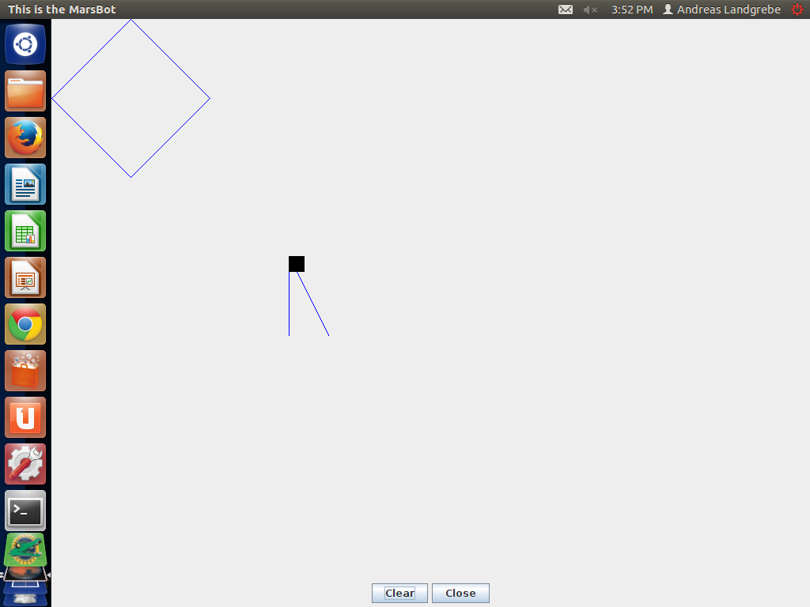
Source Code for Part 3:
#Andreas Landgrebe
#Part 3 of the Final Project for Computer Science 210
#This mips program will draw a diamond by set the positions of where the line should point to instead of just writing x and y values to go to a particular line. This program will have angle degrees to be set and the diamond shape will be set that way.
.data
HEADING: .word 0xffff8010 # set by program
LEAVETRK: .word 0xffff8020 # set by program
WHEREX: .word 0xffff8030 # read by program
WHEREY: .word 0xffff8040 # read by program
MOVE: .word 0xffff8050 # set by program

.text
.globl main
main:

li $a0,100 # $a0: x-position
li $a1,0 # $a1: no line
jal horiz

lw $s0,HEADING # MMIO address for heading
lw $s1,WHEREX # MMIO address for x-value
lw $s2,MOVE # MMIO address for move command
lw $s3,LEAVETRK # MMIO address for leave track

li $a1,1 #load 1 into the a1 register to be able to draw a line
sw $a1, 0($s3) #store what is in s3 register which is the LEAVETRK into a1 so it will draw a line
li $a0,200 #this is the x position to go to
li $t0,135 #this is the angle degrees being used to draw first part of the diamond
sw $t0, 0($s0) #store what is in s0 where is the heading into the t0 register.
li $t0,1 #load 1 into the t1 register
sw $t0, 0($s2) #store the MOVE register into the t0
busy1:
lw $t0, 0($s1) #load the HEADING register into t0
blt $t0, $a0, busy1 #branch to busy1 if t0 is greater than a0
li $a1,0 #load 0 into a0 to end the drawing
sw $a1, 0($s3) #load LEAVETRK register into a1 to stop drawing
sw $zero,0($s2) # stop moving

li $a1,1 #load 1 into the a1 register to be able to draw a line
sw $a1, 0($s3) #store what is in s3 register which is the LEAVETRK into a1 so it will draw a line
li $a0,100 #this is the x position to go to
li $t0,225 #this is the angle degrees being used to draw second part of the diamond
sw $t0, 0($s0) #store what is in s0 where is the heading into the t0 register.
li $t0,1 #load 1 into the t1 register
sw $t0, 0($s2) #store the MOVE register into the t0
busy2:
lw $t0, 0($s1) #load the HEADING register into t0
bgt $t0, $a0, busy2 #branch to busy2 if t0 is greater than a0
li $a1,0 #load 0 into a0 to end the drawing
sw $a1, 0($s3) #load LEAVETRK register into a1 to stop drawing
sw $zero,0($s2) # stop moving

li $a1,1 #load 1 into the a1 register to be able to draw a line
sw $a1, 0($s3) #store what is in s3 register which is the LEAVETRK into a1 so it will draw a line
li $a0,0 #this is the x position to go to
li $t0,315 #this is the angle degrees being used to draw third part of the diamond
sw $t0, 0($s0) #store what is in s0 where is the heading into the t0 register.
li $t0,1 #load 1 into the t1 register
sw $t0, 0($s2) #store the MOVE register into the t0
busy3:
lw $t0, 0($s1) #load the HEADING register into t0
bgt $t0, $a0, busy3 #branch to busy3 if t0 is greater than a0
li $a1,0 #load 0 into a0 to end the drawing
sw $a1, 0($s3) #load LEAVETRK register into a1 to stop drawing
sw $zero,0($s2) # stop moving

li $a1,1 #load 1 into the a1 register to be able to draw a line
sw $a1, 0($s3) #store what is in s3 register which is the LEAVETRK into a1 so it will draw a line
li $a0,100 #this is the x position to go to
li $t0,45 #this is the angle degrees being used to draw last part of the diamond
sw $t0, 0($s0) #store what is in s0 where is the heading into the t0 register.
li $t0,1 #load 1 into the t1 register
sw $t0, 0($s2) #store the MOVE register into the t0
busy4:
lw $t0, 0($s1) #load the HEADING register into t0
blt $t0, $a0, busy4 #branch to busy4 if t0 is greater than a0
li $a1,0 #load 0 into a0 to end the drawing
sw $a1, 0($s3) #load LEAVETRK register into a1 to stop drawing
sw $zero,0($s2) # stop moving

endloop:

li $v0,10 #exit the program
syscall

##################################################
# horiz -- move horizontally to given x-value
# $a0 = goal x-value
# $a1 = true if we should leave a track, false otherwise
##################################################
horiz: # Preserve registers (in case they're being used elsewhere!)
addi $sp,$sp,-16

sw $s0,0($sp)
sw $s1,4($sp)
sw $s2,8($sp)
sw $s3,12($sp)

lw $s0,HEADING # MMIO address for heading
lw $s1,WHEREX # MMIO address for x-value
lw $s2,MOVE # MMIO address for move command
lw $s3,LEAVETRK # MMIO address for leave track

# Loop until we reach goal value
xloop: lw $t0,0($s1) # t0 = current x location
beq $t0,$a0,donex # "Are we there yet?"...

# ... No. See if we have to move left or right:
sw $a1,0($s3) # set "leave track" as specified
blt $t0,$a0,h90 # if current < goal, move right (heading 90)

h270: # We have to move left (heading 270):
li $t0,270 # store the heading (270)...
sw $t0,0($s0) # ... in the appropriate MMIO address
li $t0,1 # t0 = "true"
sw $t0,0($s2) # start moving
busyX1: lw $t0,0($s1) # Get current location
ble $t0,$a0,donex # "Are we there yet?"
j busyX1

h90: # We have to move right (heading 90):
li $t0,90 # store the heading (90)...
sw $t0,0($s0) # ... in the appropriate MMIO address
li $t0,1 # t0 = "true"
sw $t0,0($s2) # start moving
busyX2: lw $t0,0($s1) # Get current location
bge $t0,$a0,donex # "Are we there yet?"
j busyX2

donex: sw $zero,0($s2) # stop moving

lw $s0,0($sp) # restore registers
lw $s1,4($sp)
lw $s2,8($sp)
lw $s3,12($sp)
addi $sp,$sp,16
jr $ra

##################################################
# vert -- move vertically to given x-value
# $a0 = goal y-value
# $a1 = true if we should leave a track, false otherwise
##################################################
vert: # Preserve registers (in case they are being used)
addi $sp,$sp,-16

sw $s0,0($sp)
sw $s1,4($sp)
sw $s2,8($sp)
sw $s3,12($sp)

lw $s0,HEADING # MMIO address for heading
lw $s1,WHEREY # MMIO address for y-value
lw $s2,MOVE # MMIO address for move command
lw $s3,LEAVETRK # MMIO address for leave track

yloop: lw $t0,0($s1) # t0 = current y location
beq $t0,$a0,doney # "Are we there yet?"...

# ... No. See if we have to move up or down:
sw $a1,0($s3) # set "leave track" as specified
blt $t0,$a0,h180 # if current < goal, move down (heading 180)
h0: # We have to move up (heading 0):
li $t0,0 # store the heading (0)...
sw $t0,0($s0) # ... in the appropriate MMIO address
li $t0,1 # t0 = "true"
sw $t0,0($s2) # start moving
busyY1: lw $t0,0($s1) # Get current location
ble $t0,$a0,doney # "Are we there yet?"
j busyY1
h180: # We have to move down (heading 180):
li $t0,180 # store the heading (180)...
sw $t0,0($s0) # ... in the appropriate MMIO address
li $t0,1 # t0 = "true"
sw $t0,0($s2) # start moving
busyY2: lw $t0,0($s1) # Get current location
bge $t0,$a0,doney # "Are we there yet?"
j busyY2
doney: sw $zero,0($s2) # stop moving

lw $s0,0($sp) # restore registers
lw $s1,4($sp)
lw $s2,8($sp)
lw $s3,12($sp)
addi $sp,$sp,16
jr $ra

Output for Part 3:
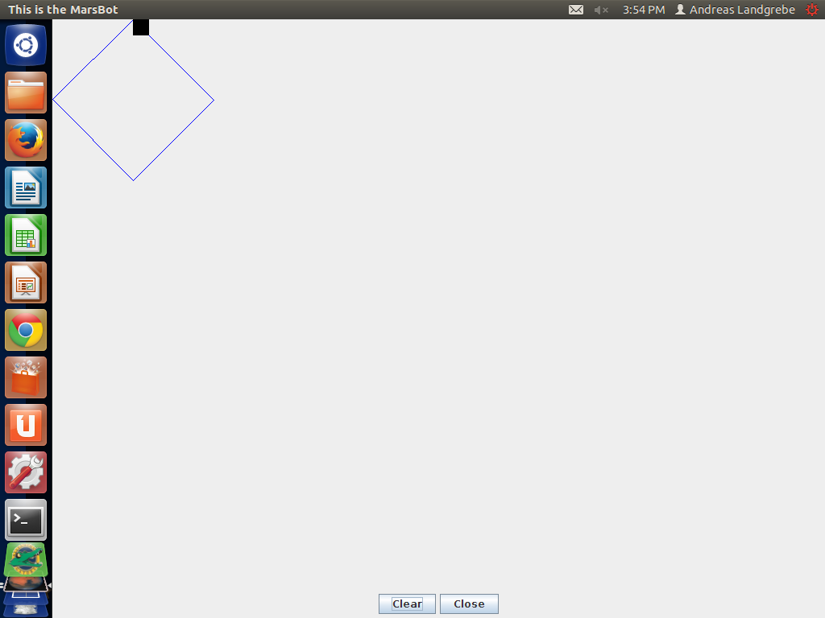

Source Code for Part 4:
#Andreas Landgrebe
#Part 4 of the Final Project for Computer Science 210
#This program will output a circle when it starts to the x,y coordinates (200,200)
.data
HEADING: .word 0xffff8010 # set by program
LEAVETRK: .word 0xffff8020 # set by program
WHEREX: .word 0xffff8030 # read by program
WHEREY: .word 0xffff8040 # read by program
MOVE: .word 0xffff8050 # set by program

.text
.globl main
main:

# $s4: angle
# $s5: waittime
# $s6: count

lw $s0,HEADING # MMIO address for heading
lw $s2,MOVE # MMIO address for move command
lw $s3,LEAVETRK # MMIO address for leave track

li $a0,200 # move to starting point
li $a1,0 # $a1: no line
jal horiz
jal vert # let us start at 200,200

li $s5, 100000 # waittime = 100000;
li $s4,0 # angle = 0
loopforangle: # for angle=0 to 360 step 3
li $t0, 360
bgt $s4,$t0,exitangleloop

sw $s4, 0($s0) #set HEADING to angle

li $t0,1
sw $t0, 0($s3) # set LEAVE-TRACK to true

li $t0, 1
sw $t0, 0($s2) # set MOVE to true

li $s6,0 # count = 0
loopforcount: # for count = 0 to waittime
bgt $s6,$s5, exitcountloop
addi $s6,$s6,3 #add the count in increments of 3.
j loopforcount #jump to the loopforcount function
exitcountloop:

li $t0, 0
sw $t0, 0($s3) # set LEAVE-TRACK to false

li $t0, 0
sw $t0, 0($s2) # set MOVE to false

addi $s4, $s4, 3
j loopforangle

exitangleloop:

endloop:

li $v0,10 #exit the program
syscall

##################################################
# horiz -- move horizontally to given x-value
# $a0 = goal x-value
# $a1 = true if we should leave a track, false otherwise
##################################################
horiz: # Preserve registers (in case they're being used elsewhere!)
addi $sp,$sp,-16

sw $s0,0($sp)
sw $s1,4($sp)
sw $s2,8($sp)
sw $s3,12($sp)

lw $s0,HEADING # MMIO address for heading
lw $s1,WHEREX # MMIO address for x-value
lw $s2,MOVE # MMIO address for move command
lw $s3,LEAVETRK # MMIO address for leave track

# Loop until we reach goal value
xloop: lw $t0,0($s1) # t0 = current x location
beq $t0,$a0,donex # "Are we there yet?"...

# ... No. See if we have to move left or right:
sw $a1,0($s3) # set "leave track" as specified
blt $t0,$a0,h90 # if current < goal, move right (heading 90)

h270: # We have to move left (heading 270):
li $t0,270 # store the heading (270)...
sw $t0,0($s0) # ... in the appropriate MMIO address
li $t0,1 # t0 = "true"
sw $t0,0($s2) # start moving
busyX1: lw $t0,0($s1) # Get current location
ble $t0,$a0,donex # "Are we there yet?"
j busyX1

h90: # We have to move right (heading 90):
li $t0,90 # store the heading (90)...
sw $t0,0($s0) # ... in the appropriate MMIO address
li $t0,1 # t0 = "true"
sw $t0,0($s2) # start moving
busyX2: lw $t0,0($s1) # Get current location
bge $t0,$a0,donex # "Are we there yet?"
j busyX2

donex: sw $zero,0($s2) # stop moving

lw $s0,0($sp) # restore registers
lw $s1,4($sp)
lw $s2,8($sp)
lw $s3,12($sp)
addi $sp,$sp,16
jr $ra

##################################################
# vert -- move vertically to given x-value
# $a0 = goal y-value
# $a1 = true if we should leave a track, false otherwise
##################################################
vert: # Preserve registers (in case they are being used)
addi $sp,$sp,-16

sw $s0,0($sp)
sw $s1,4($sp)
sw $s2,8($sp)
sw $s3,12($sp)

lw $s0,HEADING # MMIO address for heading
lw $s1,WHEREY # MMIO address for y-value
lw $s2,MOVE # MMIO address for move command
lw $s3,LEAVETRK # MMIO address for leave track

yloop: lw $t0,0($s1) # t0 = current y location
beq $t0,$a0,doney # "Are we there yet?"...

# ... No. See if we have to move up or down:
sw $a1,0($s3) # set "leave track" as specified
blt $t0,$a0,h180 # if current < goal, move down (heading 180)
h0: # We have to move up (heading 0):
li $t0,0 # store the heading (0)...
sw $t0,0($s0) # ... in the appropriate MMIO address
li $t0,1 # t0 = "true"
sw $t0,0($s2) # start moving
busyY1: lw $t0,0($s1) # Get current location
ble $t0,$a0,doney # "Are we there yet?"
j busyY1
h180: # We have to move down (heading 180):
li $t0,180 # store the heading (180)...
sw $t0,0($s0) # ... in the appropriate MMIO address
li $t0,1 # t0 = "true"
sw $t0,0($s2) # start moving
busyY2: lw $t0,0($s1) # Get current location
bge $t0,$a0,doney # "Are we there yet?"
j busyY2
doney: sw $zero,0($s2) # stop moving

lw $s0,0($sp) # restore registers
lw $s1,4($sp)
lw $s2,8($sp)
lw $s3,12($sp)
addi $sp,$sp,16
jr $ra

Output for Part 4:

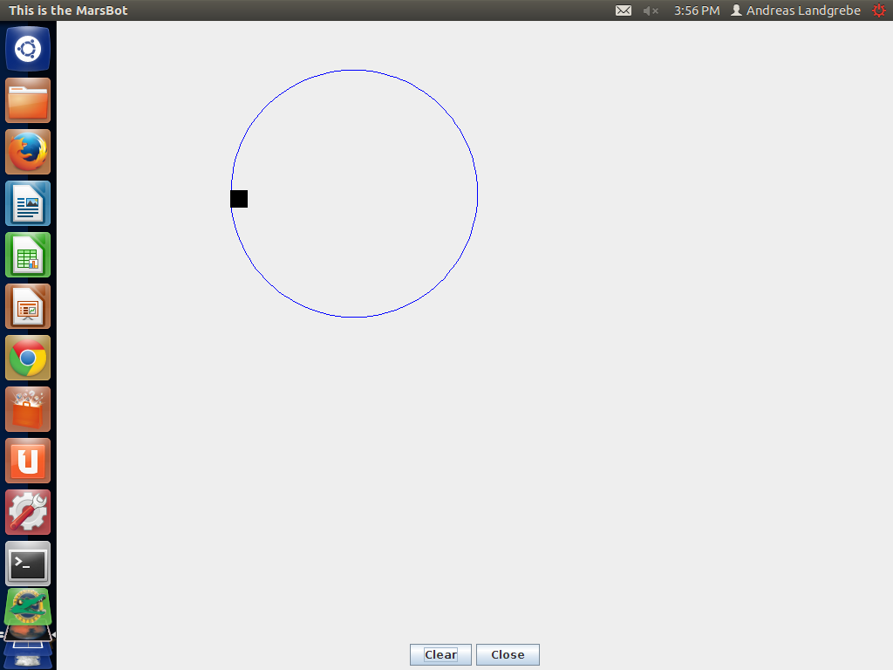

Optional: Part 5: I decided to do this part because I wanted to be able to write a little bit of C for this project, if you could critique my work for this part, I would really appreciate it.

Source Code for Part 5:
//Andreas Landgrebe
//Part 5 of the Computer Science 210 Final Project
//This C program will be able to list mips assembly language as output from a list of coordinates given in a text file. In the terminal, I have written the command: ./Part5 <Part5Coordinates.txt so my code will print out mips instruction from the list of coordinates in the text file.

#include <stdio.h>

main(){

int x; //x coordinate
int y; //y coordinate
int penUp = 0;
while(scanf("%d %d ", &x, &y) == 2){
if (penUp == 0){ //If it the first list of coordinate being called, print out to go to the first vertex.
printf("main: \n");
printf("\t\t# Get to first vertex, (%d,%d)\n",x,y);//print out the first list of instructions
}else{
printf("\n");
printf("\t\t# Now draw to (%d,%d) \n",x,y); //print out the rest of the list of instructions with Now draw to instead of writing Get to first vertex.
}

printf("\tli \t $a0,%d \n", x);
printf("\tli \t $a1,%d \t \n", penUp); //the penUp will write either a 0 or 1 depending on whether to draw a line or not.
printf("\tjal \t horiz \n");
printf("\n");
printf("\tli \t $a0,%d \n", y);
printf("\tli \t $a1,%d \t \n", penUp); //the penUp will write either a 0 or 1 depending on whether to draw a line or not.
printf("\tjal \t vert \n");

penUp = 1; //change the value of penUp to 1 instead of 0, so the value of a1 will be 1 to be able to draw a line in mips.

}

printf("\tli \t $v0,10 \n");
printf("\tsyscall \n");
}

Here is the txt file I used to compute specific coordinates:
100 100
200 100
271 171
200 242
100 242
29 171
100 100

Here is the output for Part 5:
Script started on Mon 09 Dec 2013 08:58:29 PM EST
#]0;landgrebea@aldenv102: ~/Documents/sophomore/fall/cs210/finalProject#landgrebea@aldenv102:~/Documents/sophomore/fall/cs210/finalProject$ cs##[K##[K./Part5 ,##[K<Par
main:
# Get to first vertex, (100,100)
li $a0,100
li $a1,0
jal horiz

li $a0,100
li $a1,0
jal vert

# Now draw to (200,100)
li $a0,200
li $a1,1
jal horiz

li $a0,100
li $a1,1
jal vert

# Now draw to (271,171)
li $a0,271
li $a1,1
jal horiz

li $a0,171
li $a1,1
jal vert

# Now draw to (200,242)
li $a0,200
li $a1,1
jal horiz

li $a0,242
li $a1,1
jal vert

# Now draw to (100,242)
li $a0,100
li $a1,1
jal horiz

li $a0,242
li $a1,1
jal vert

# Now draw to (29,171)
li $a0,29
li $a1,1
jal horiz

li $a0,171
li $a1,1
jal vert

# Now draw to (100,100)
li $a0,100
li $a1,1
jal horiz

li $a0,100
li $a1,1
jal vert
li $v0,10
syscall
#]0;landgrebea@aldenv102: ~/Documents/sophomore/fall/cs210/finalProject#landgrebea@aldenv102:~/Documents/sophomore/fall/cs210/finalProject$ exit
exit
Script done on Mon 09 Dec 2013 08:58:58 PM EST

