Andreas Landgrebe
Lab 3
Computer Science 210
9/24/2013

Part 1

#include <stdio.h>

main(){

int x;
int y;
int z;

printf("Enter the two values to be added: ");
scanf("%d %d", &x, &y); //scan in x and y as integer to be later on added
z = x + y;
printf("The sum of %d", x); //print out x
printf(" and %d", y); //print out y
printf(" is %d\n", z); //print out the result when x is added to y
}

Output for Part 1

Script started on Tue 24 Sep 2013 10:34:57 AM EDT
#]0;landgrebea@aldenv151: ~/Documents/sophomore/fall/cs210/labs/lab3#landgrebea@aldenv151:~/Documents/sophomore/fall/cs210/labs/lab3$ gcc lab3.c -o l
#]0;landgrebea@aldenv151: ~/Documents/sophomore/fall/cs210/labs/lab3#landgrebea@aldenv151:~/Documents/sophomore/fall/cs210/labs/lab3$ ./lab3
Enter the two values to be added: 40
50
The sum of 40 and 50 is 90
#]0;landgrebea@aldenv151: ~/Documents/sophomore/fall/cs210/labs/lab3#landgrebea@aldenv151:~/Documents/sophomore/fall/cs210/labs/lab3$ exit
exit
Script done on Tue 24 Sep 2013 10:35:16 AM EDT

Part 2:
.data
.align 2
x: .space 4 #byte depth
y: .space 4 # byte depth
z: .space 4 # byte depth
p1: .asciiz "Enter 1st value to be entered: "
p2: .asciiz "Enter 2nd value to be entered: "
sum: .asciiz "The sum of the two values is: "
nl: .asciiz "\n"

.align 2
.text
.globl main
main: li $v0, 4 #load the string
la $a0, p1 #load the string into p1
syscall #system call

li $v0,5 #read an interger
syscall
sw $v0,x #store the integer into x

li $v0,4 #load a string
la $a0,p2 #load the address of a string into p2
syscall

li $v0,5 # load an interger
syscall
sw $v0,y #store the word into y

lw $s0,x #load the integer of x
lw $s1,y #load the interger of y
add $t0, $s0, $s1 # add x and y and store into $t0
sw $t0,z #store the result into z
li $v0,4 #load a string
la $a0,sum #load the address into sum
syscall
li $v0,1 #print the interger
lw $a0,z #load and print the integer that is in z
syscall
li $v0,4 #load a string
la $a0,nl # load the new line
syscall

li $v0,10 #terminate the program
syscall

Screen shot for Part 2

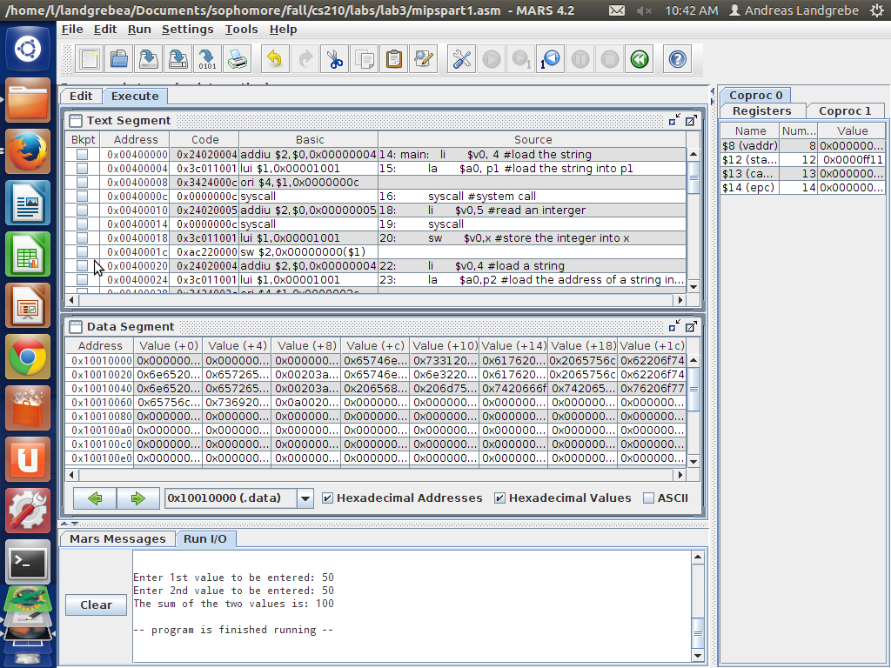

Part 3
#include <stdio.h>
#define MAXSTRING 20 //the maxstring will be 20 characters

main(){

char x[MAXSTRING];//call in the max string for x
char y[MAXSTRING];//call in the max string for y

printf("First name: ");
scanf("%s", x); //scan in the string of x to be the first name

printf("Last name: ");
scanf("%s", y); //scan in the string of y to be the last name

printf("Hello, %s %s!\n", x, y); //print out the strings of x and y that I have scanned in

}

Output from Part 3

Script started on Tue 24 Sep 2013 10:36:01 AM EDT
#]0;landgrebea@aldenv151: ~/Documents/sophomore/fall/cs210/labs/lab3#landgrebea@aldenv151:~/Documents/sophomore/fall/cs210/labs/lab3$ gcc pab3##[K##[K##[K##[Klab3part2.c
#]0;landgrebea@aldenv151: ~/Documents/sophomore/fall/cs210/labs/lab3#landgrebea@aldenv151:~/Documents/sophomore/fall/cs210/labs/lab3$ ./lab3part2
First name: Andreas
Last name: Landgrebe
Hello, Andreas Landgrebe!
#]0;landgrebea@aldenv151: ~/Documents/sophomore/fall/cs210/labs/lab3#landgrebea@aldenv151:~/Documents/sophomore/fall/cs210/labs/lab3$ exit
exit
Script done on Tue 24 Sep 2013 10:36:33 AM EDT

Part 4:
.data
.align 2
len: .word 20
s1: .space 20
len2: .word 20
s2: .space 20

p1: .asciiz "First name: "
p2: .asciiz "Last name: "
l1: .asciiz "Hello, "
l2: .asciiz "!"
nl: .asciiz "\n"

.text
.globl main
main: li $v0,4 # print a string
la $a0,p1 # load the address into p1
syscall

li $v0,8 #read a string
la $a0,s1 #load the address into s1
lw $a1,len #sload the string into len
syscall

li $v0,4 # print a string
la $a0,p2 # load the address into p2
syscall

li $v0,8 # load a string
la $a0,s2 # load the address of the printer string into s2
lw $a1,len2 #load the string into len2
syscall

li $v0,4 # print a string
la $a0,l1 # load the address into l1
syscall

li $v0,4 # print a string
la $a0,s1 #load the string into s1
syscall

li $v0,4 #print a string
la $a0,s2 #load the string address into s2
syscall

li $v0,4 #print a string
la $a0,nl #print out so it starts a new line

li $v0,10
syscall # terminate the program

Screen shot of output from part 4:
