Laboratory Assignment #5

Using Simulation to Evaluate Scheduling Algorithms

Andreas Landgrebe - DATE \@ "MMMM d, y" March 3, 2014

1. A screenshot demonstrating that you were able to correctly configure and use the simulator

This figure demo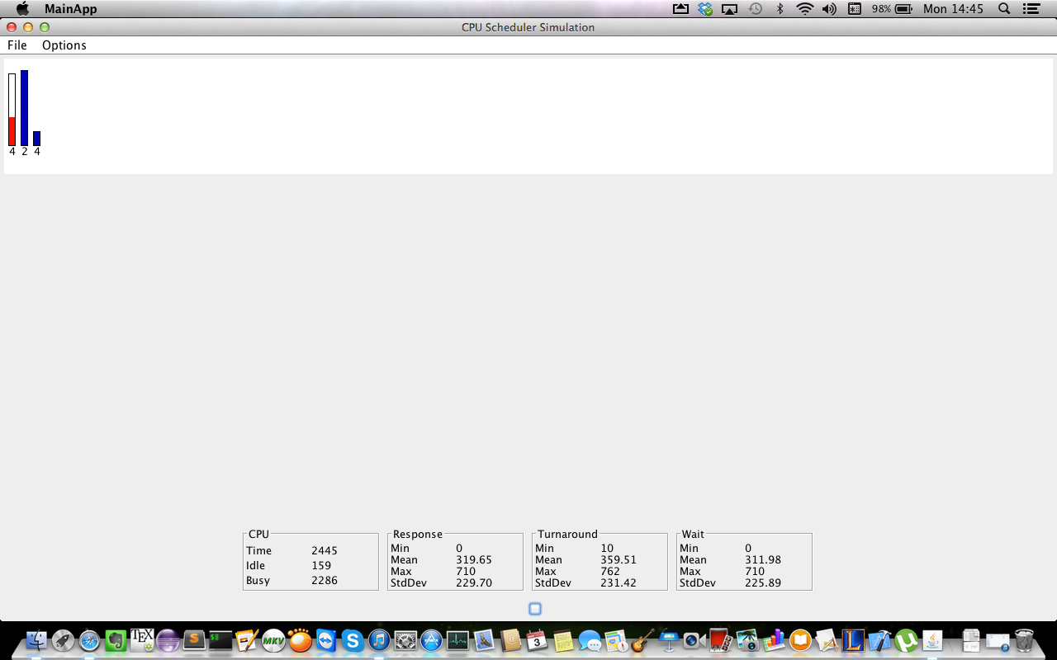nstrates that I was able to correctly configure and use the simulator for this laboratory assignment.

2. All of the .dat files used in the simulation studies that you conducted your experiments

From the jobList.dat:

10 5 1

100 5 2

10 5 3

From the jobList2.dat:

50 5 1

100 50 4

62 10 2

74 5 3

50 5 5

10 5 1

45 8 4

1000 15 2

59 5 3

72 5 4

43 6 1

18 3 4

38 2 5

23 5 2

19 5 1

15 5 4

95 3 2

84 4 3

87 2 2

24 1 1

3. A comprehensive report on all of the runs of the scheduling simulator that includes:

1. A clear description of the behavior of each of the scheduling algorithms

Each of the scheduling algorithms perform the processes of the CPU in a different fashion, but will have the same results. For the First Come First Serve (FCFS) algorithm, whatever is next in line for the processes that the CPU is going to run, the CPU will just runs the processes in whatever order they come in. No matter what the priority is on the processes or how large the process is, the CPU will pick whatever process is next in line. This causes the problem where you could not pick whether to perform preemption or priority to further experiment this scheduler.

For the shortest job first, the CPU will see what process is next to run and the CPU will pick to choose