Case :

//save

<http://localhost:8999/employees/save>

input:

{

    "empName": "gopi",

    "empSal": "5600.00",

        "empDept": "developer"

}

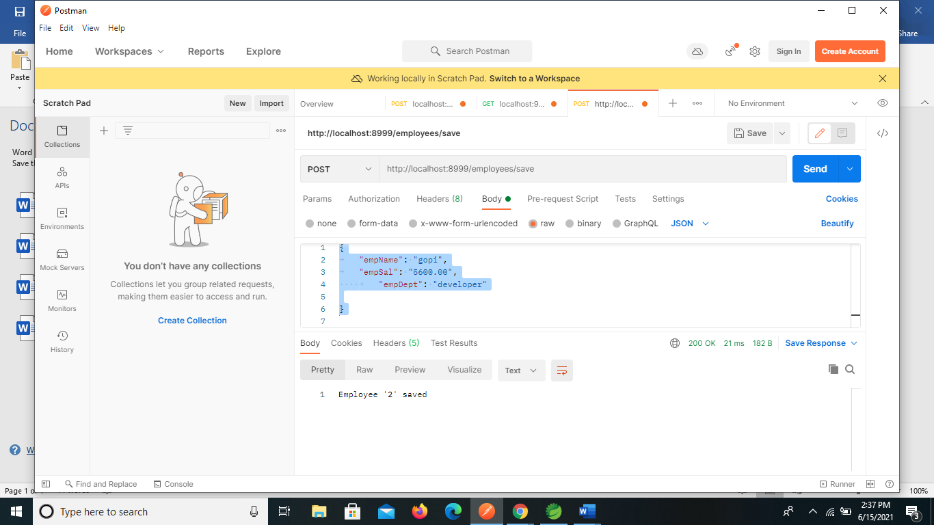

o/p

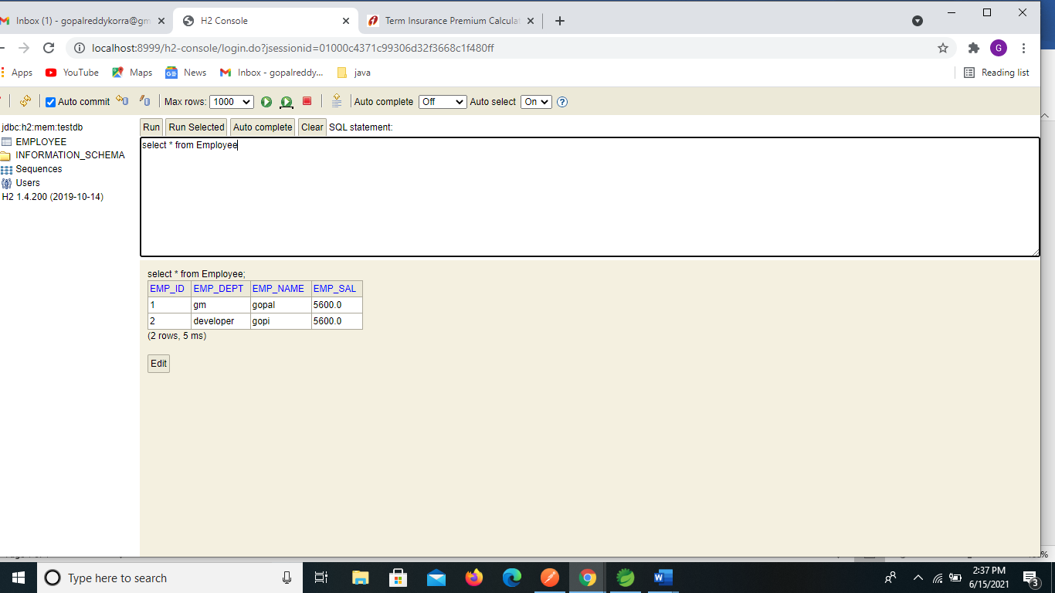

Case 2: GET

url : localhost:8999/employees/all

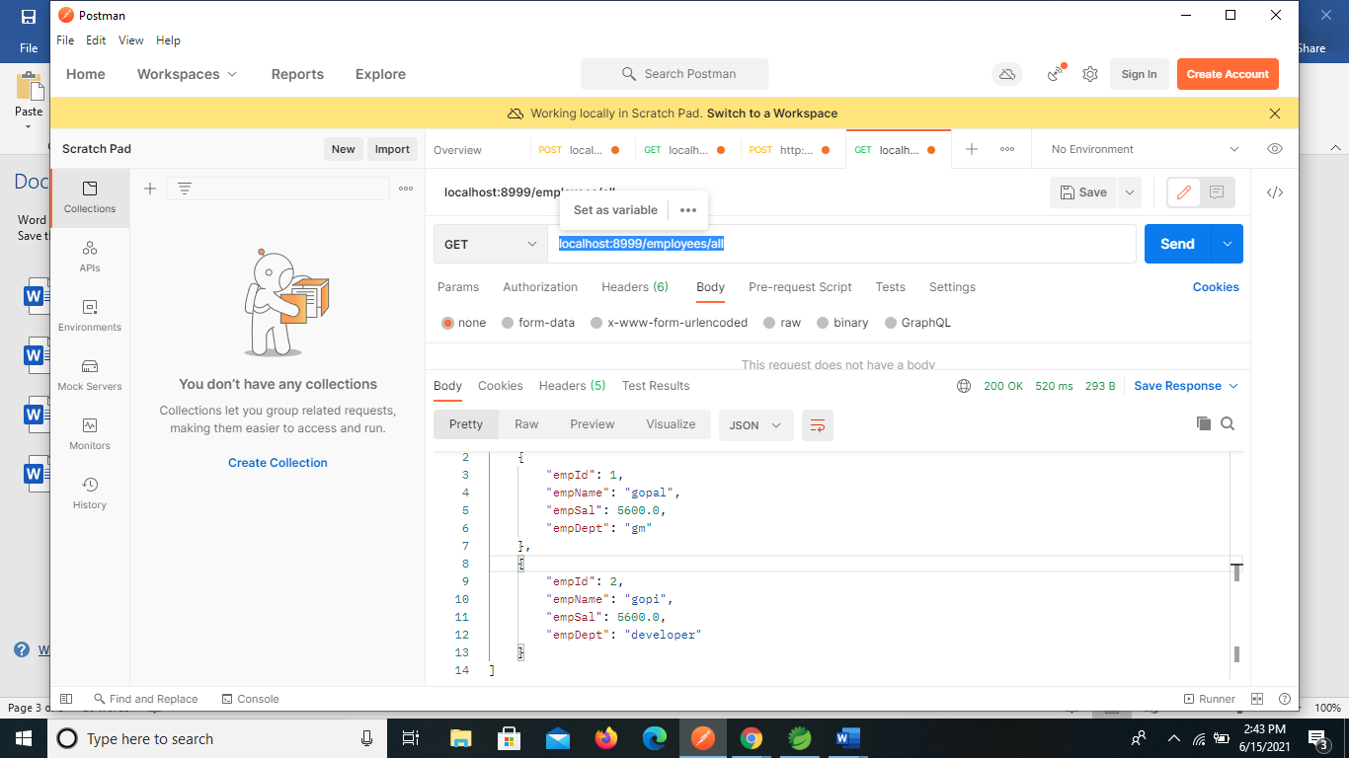

Delete :

Before update db

Delete : localhost:8999/employees/remove/2

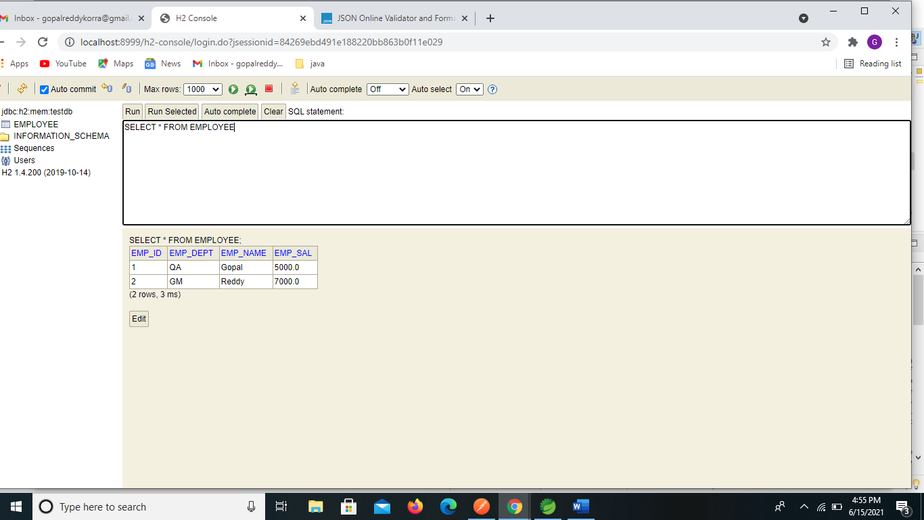

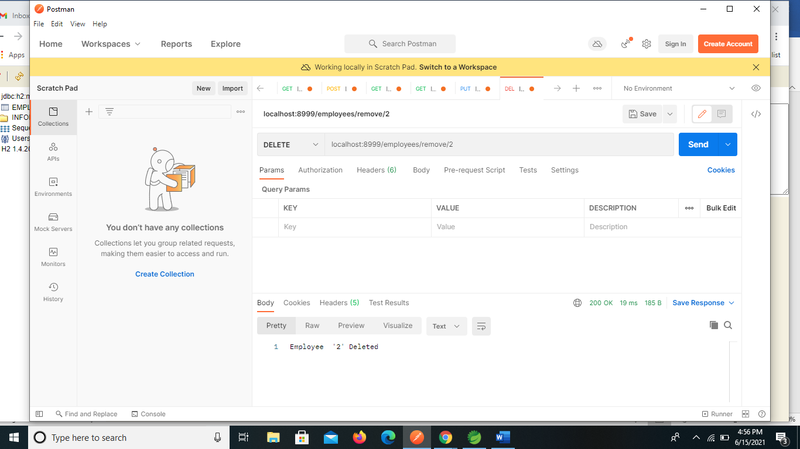

After updating done from db:

