## Frontend Class Diagram

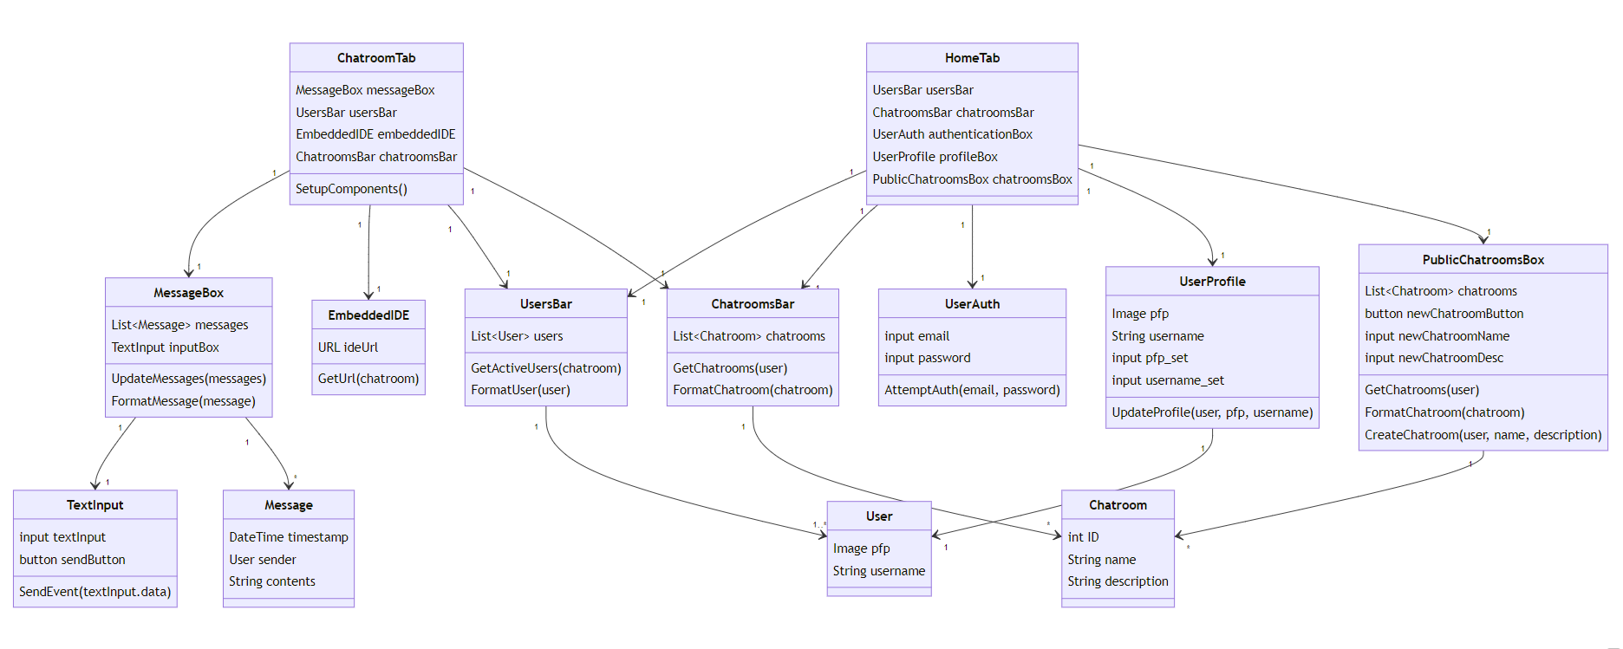

## Backend Class Diagram

## Sequence Diagrams

Code Compilation Sequence

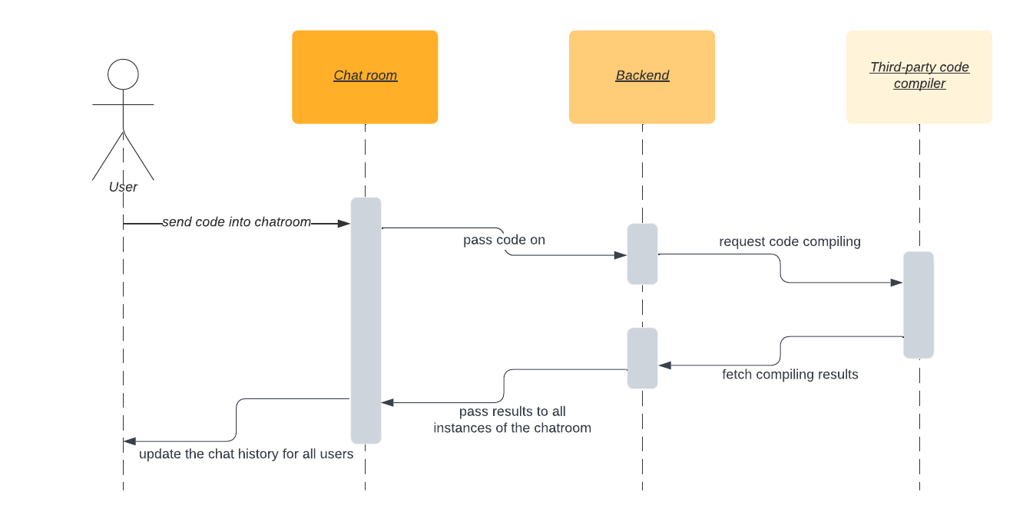

Login Sequence

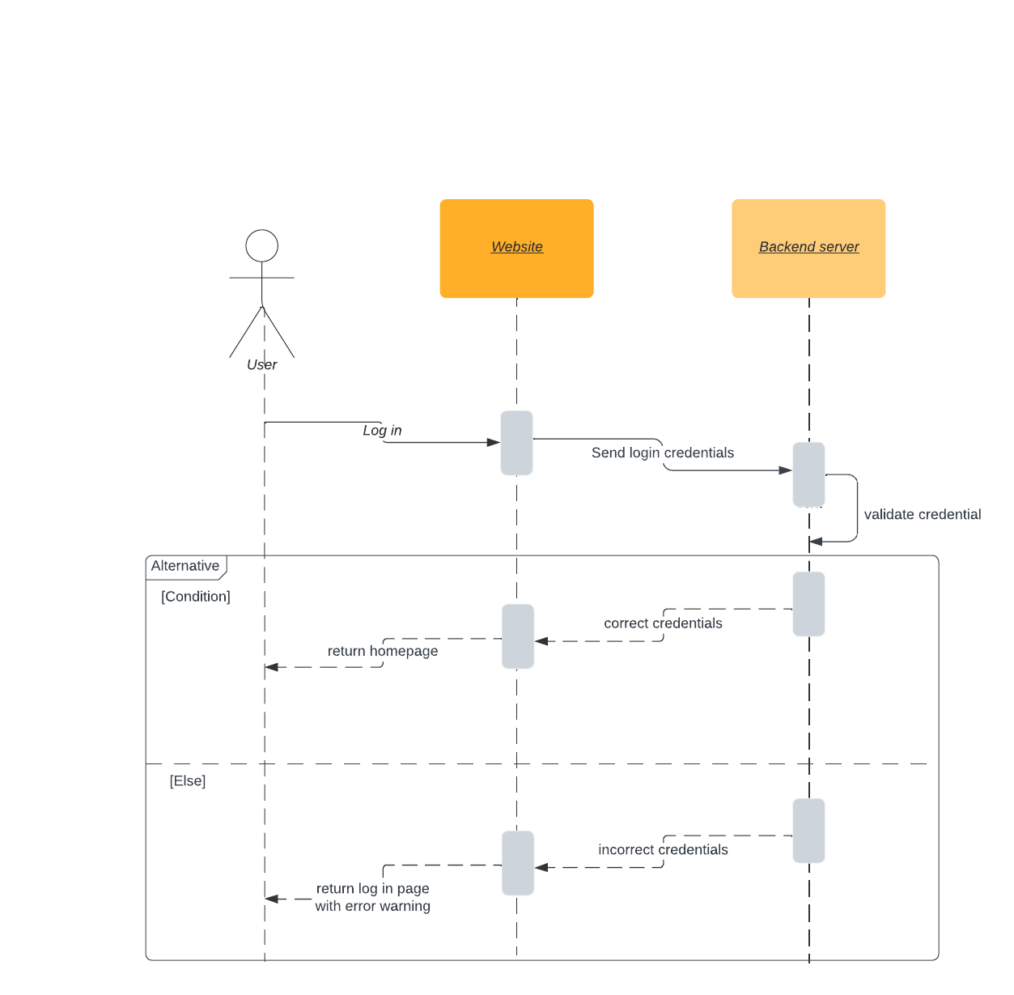

Send Message Sequence

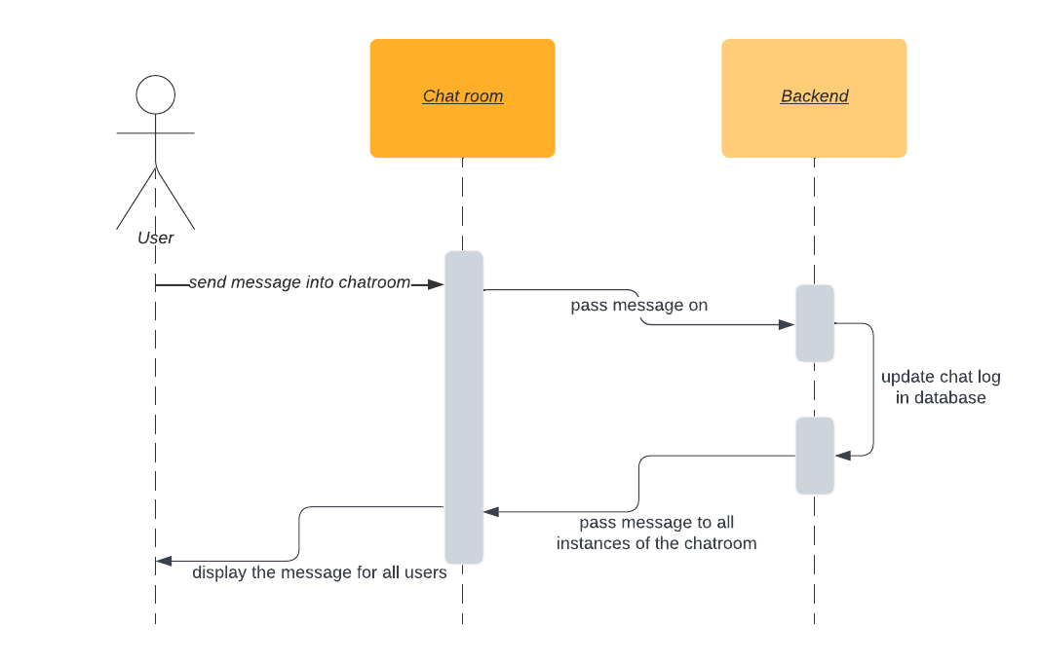

## Additional Diagrams

Frontend Flowchart and Backend Calls

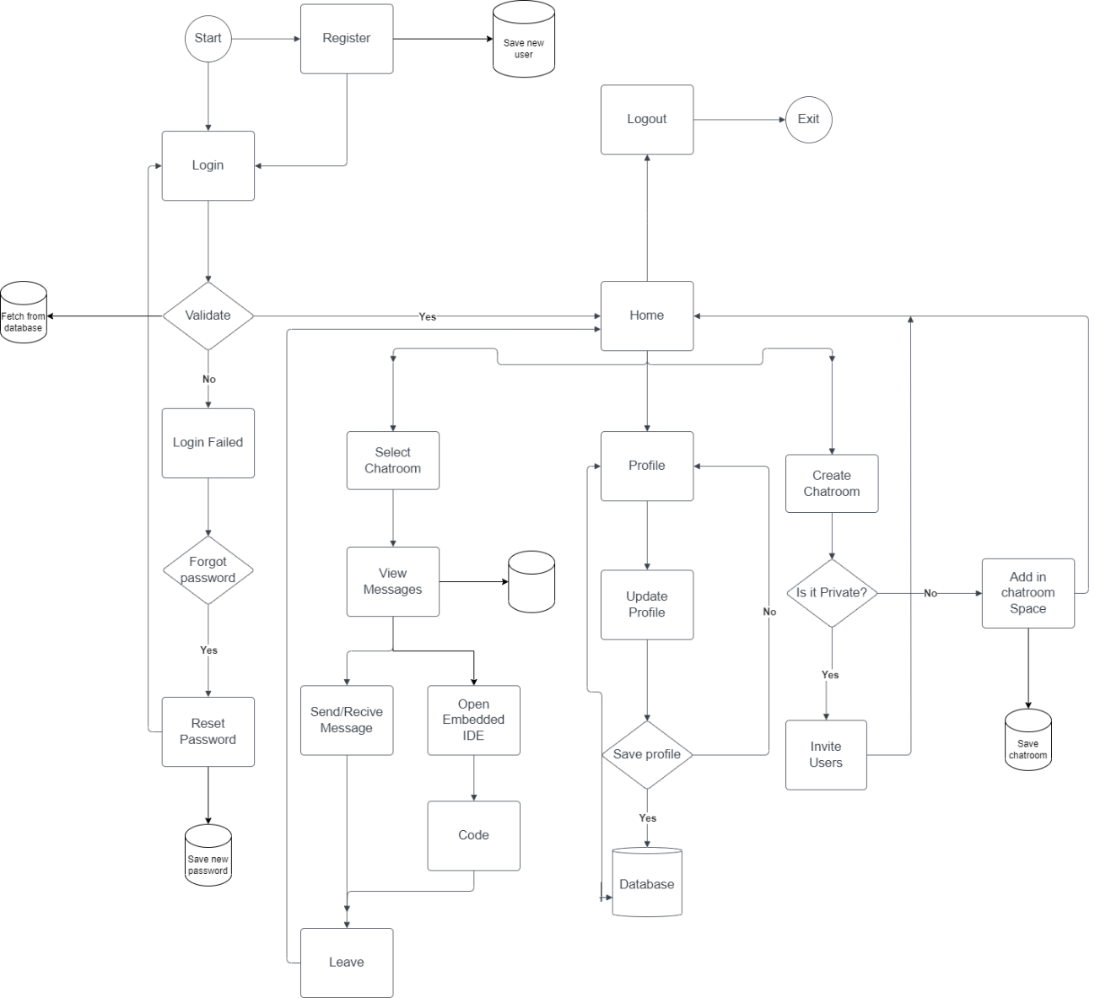

Entity Relationship Diagram

