**Name: Shraddha Ashok Manchekar**

**UID: 004945217**

**Stats 202A: Assignment 6**

Q4: Comparison of R and Rcpp

1. Sweep using R

[1] "Execution time for N= 20 P= 500"

[1] "R"

user system elapsed

398.72 0.31 404.27

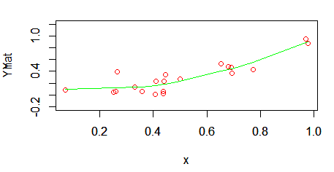

2. Sweep using Rcpp

[1] "Execution time for N= 20 P= 500"

[1] "Rcpp"

user system elapsed

0.72 0.03 0.83

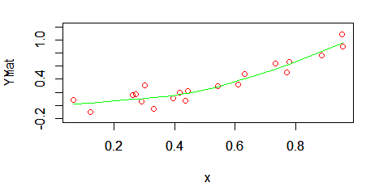

3. QR using R

[1] "Execution time for N= 20 P= 500"

[1] "R"

user system elapsed

2.50 0.39 2.91

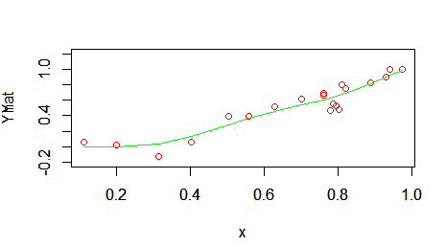

4. QR using Rcpp

[1] "Execution time for N= 20 P= 500"

[1] "Rcpp"

user system elapsed

1.22 0.44 1.68

