**Name: Shraddha Ashok Manchekar**

**UID: 004945217**

**Stats 202A: Assignment 6**

**Plots of the learned spline curves for different values of lambda:**

**Lambda = 0.0001**

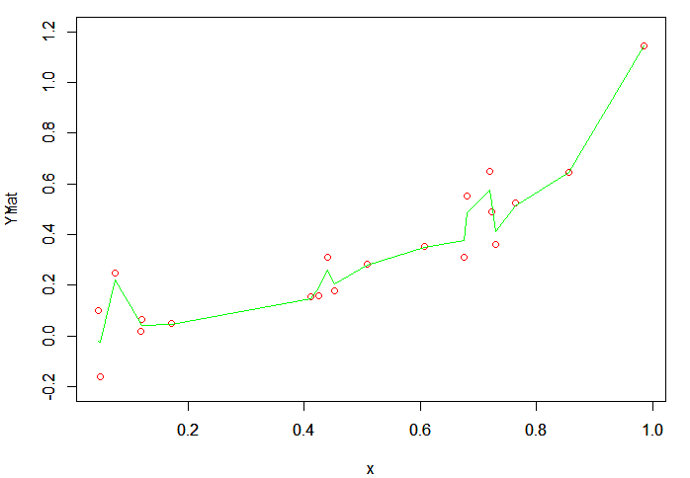

**Lambda = 0.001**

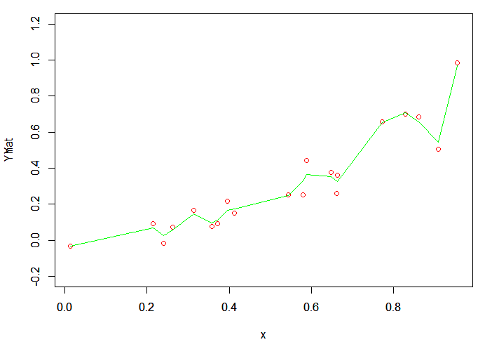

**Lambda = 0.01**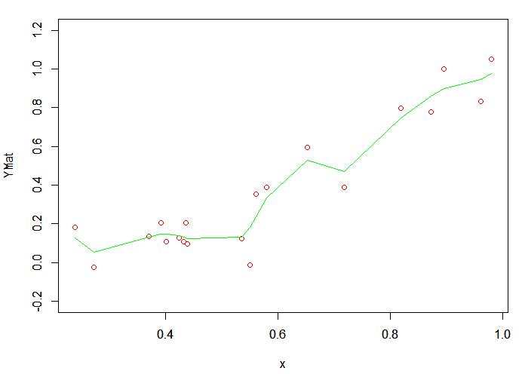

**Lambda = 0.1**

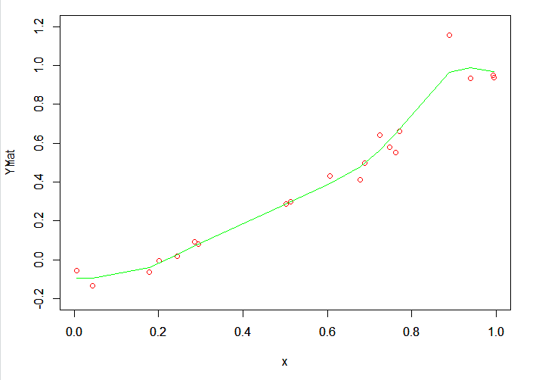

**Lambda = 0.5**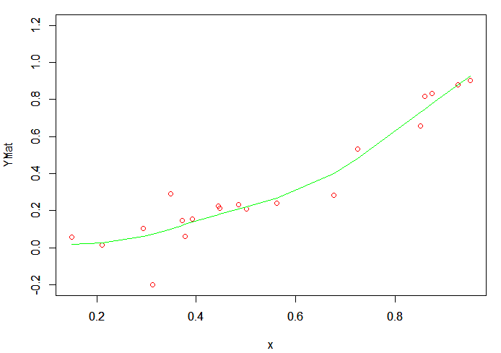

**Lambda = 1**

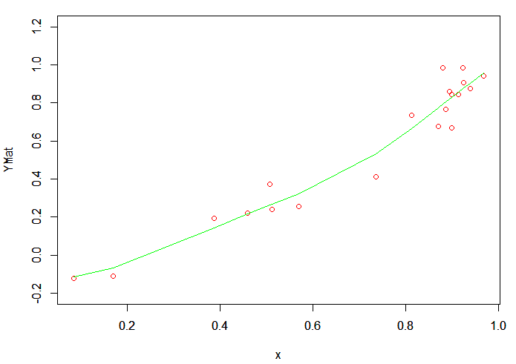

**Lambda = 10**

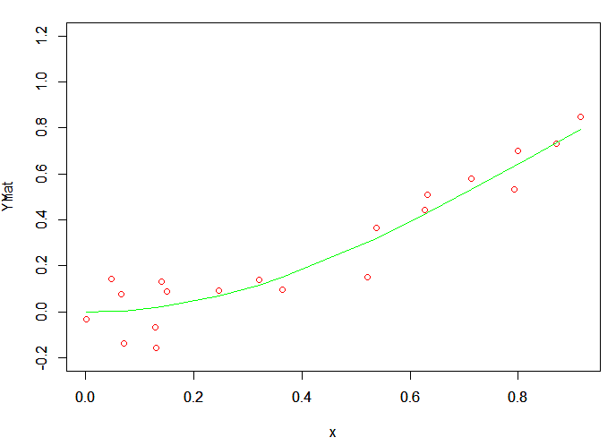

**Lambda = 25**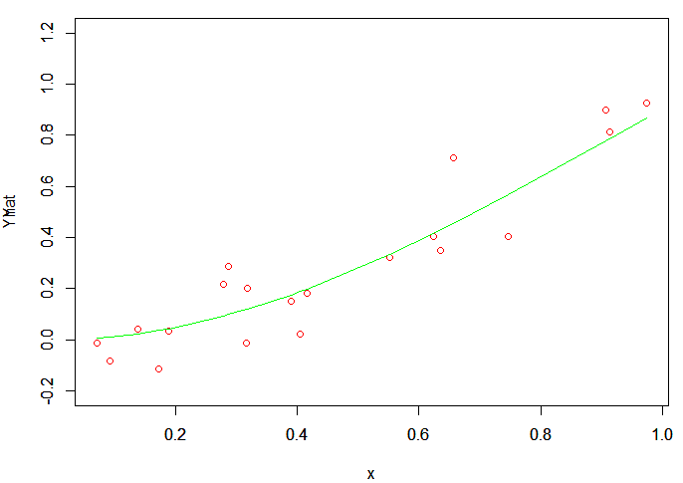

**Lambda = 50**

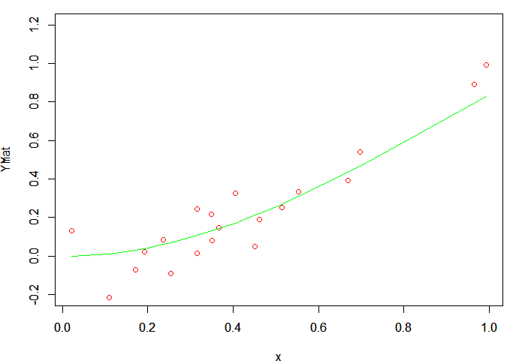

**Lambda = 100**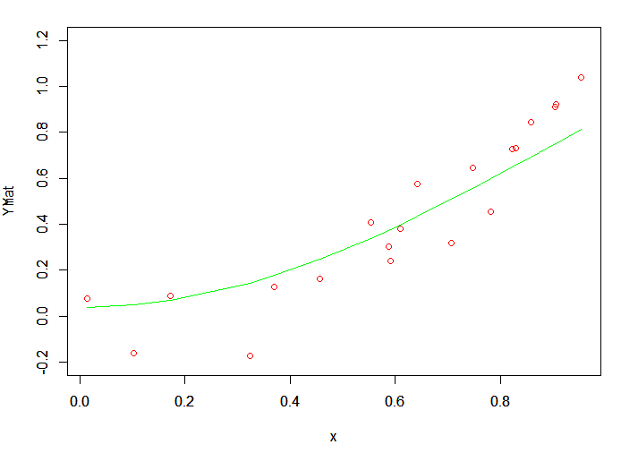

**Training and Testing Plots for Spline Curves:**

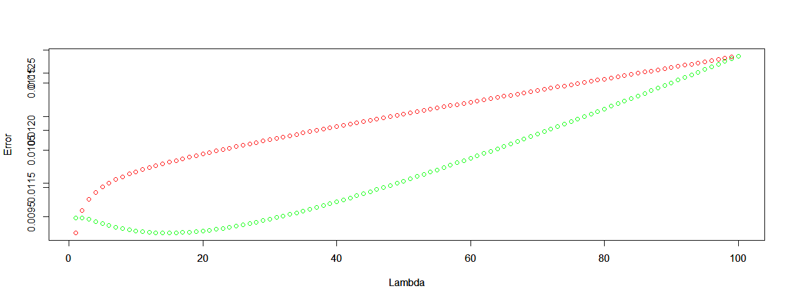

**Green is the Testing Error and Red is the Training Error.**

At a lower value of Lambda, the model is overfitting the data. Later the model improves. Towards the very end, it again starts under fitting.