Sweep R

[1] "Execution time for N= 20 P= 500"

[1] "R"

user system elapsed

398.72 0.31 404.27

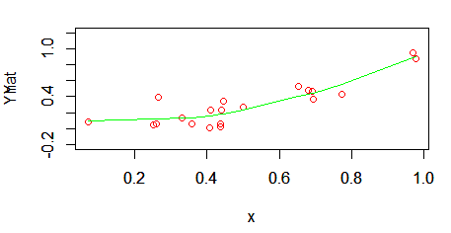

Sweep Rcpp

[1] "Execution time for N= 20 P= 500"

[1] "Rcpp"

user system elapsed

0.72 0.03 0.83

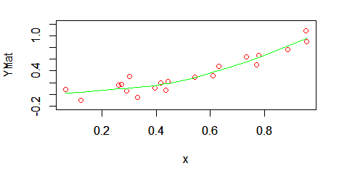

QR R

[1] "Execution time for N= 20 P= 500"

[1] "R"

user system elapsed

2.50 0.39 2.91

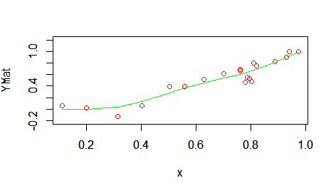

QR Rcpp

[1] "Execution time for N= 20 P= 500"

[1] "Rcpp"

user system elapsed

1.22 0.44 1.68

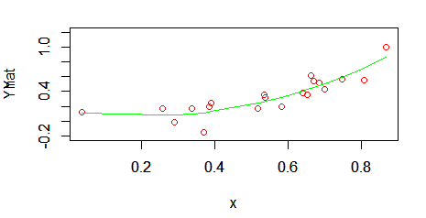

Lambda = 0.0001

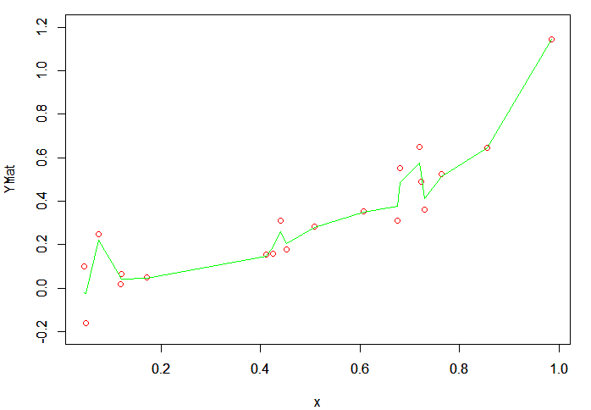

Lambda = 0.001

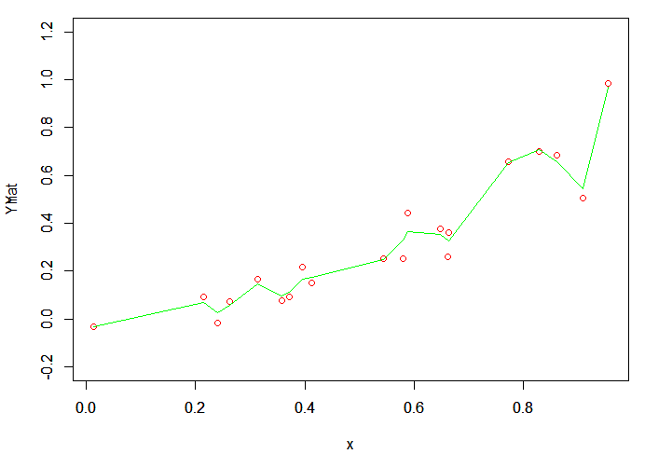

Lambda = 0.01

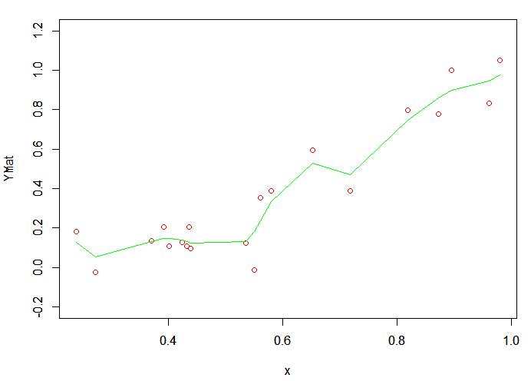

Lambda = 0.1

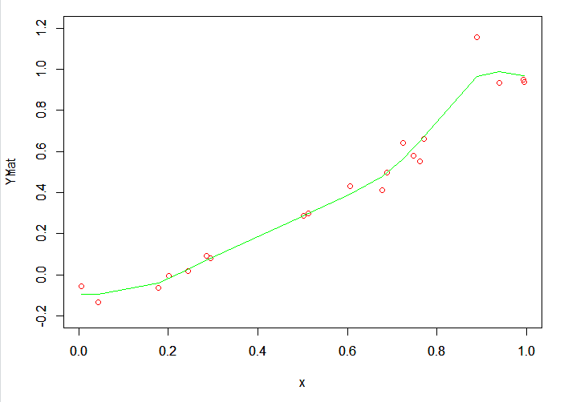

Lambda = 0.5

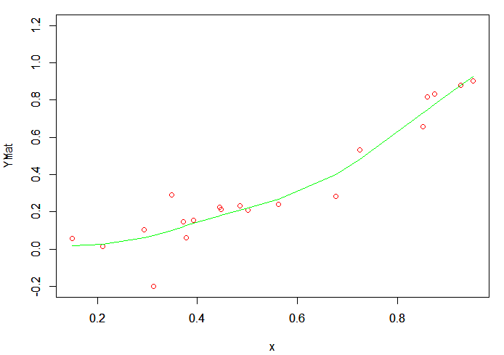

Lambda = 1

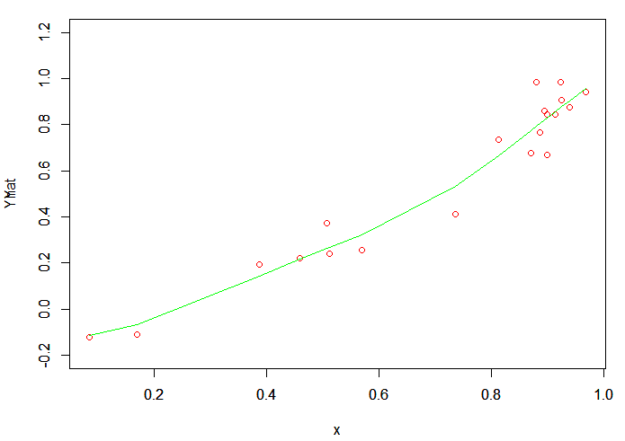

Lambda = 10

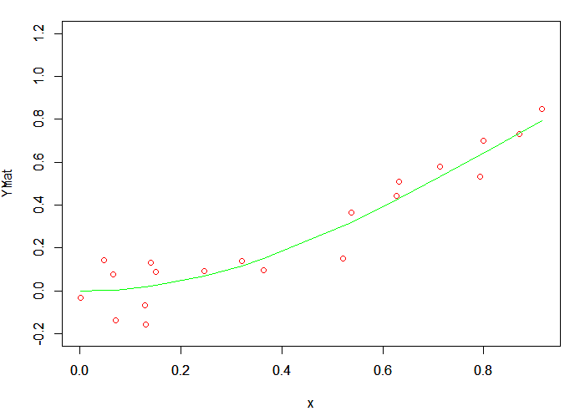

Lambda = 25

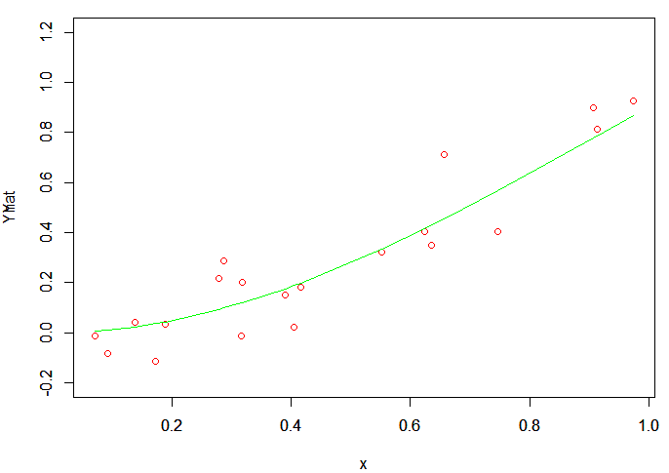

Lambda = 50

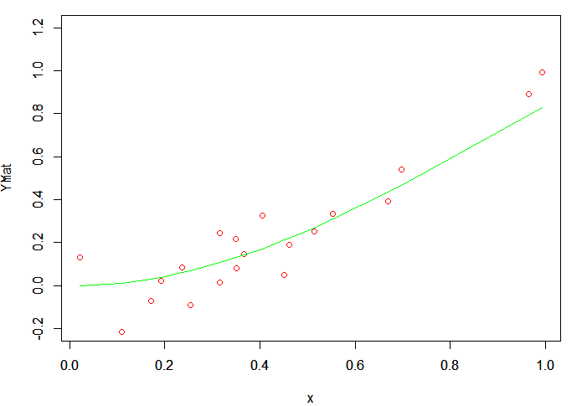

Lambda = 100

