**Q2: Plot of the estimation error over the different values of lambda (Lasso).**

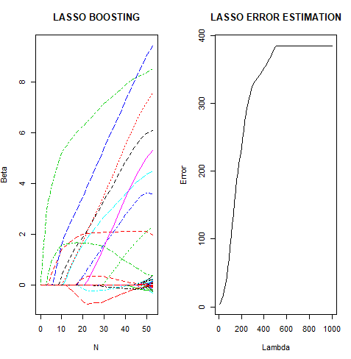

**Q3: Analysis of package functions over real datasets available in R**

**PCA**

Dataset used: iris

It gives the measurements in centimeters of the variables sepal length and width and petal length and width, respectively, for 50 flowers from each of 3 species of iris. The species are *Iris setosa*, *versicolor*, and *virginica*.

> iris = datasets::iris

> head(iris)

Sepal.Length Sepal.Width Petal.Length Petal.Width Species

1 5.1 3.5 1.4 0.2 setosa

2 4.9 3.0 1.4 0.2 setosa

3 4.7 3.2 1.3 0.2 setosa

4 4.6 3.1 1.5 0.2 setosa

5 5.0 3.6 1.4 0.2 setosa

6 5.4 3.9 1.7 0.4 setosa

> a = as.matrix(iris[, 1:4])

> p = PCA(a)

> p

$D

[1] 9208.30507 315.45432 11.97804 3.55257

$V

[,1] [,2] [,3] [,4]

[1,] -0.7511082 -0.2841749 0.50215472 0.3208143

[2,] -0.3800862 -0.5467445 -0.67524332 -0.3172561

[3,] -0.5130089 0.7086646 -0.05916621 -0.4807451

[4,] -0.1679075 0.3436708 -0.53701625 0.7518717

> e = eigen(t(a)%*%a)

> e

eigen() decomposition

$values

[1] 9208.30507 315.45432 11.97804 3.55257

$vectors

[,1] [,2] [,3] [,4]

[1,] -0.7511082 0.2841749 -0.50215472 0.3208143

[2,] -0.3800862 0.5467445 0.67524332 -0.3172561

[3,] -0.5130089 -0.7086646 0.05916621 -0.4807451

[4,] -0.1679075 -0.3436708 0.53701625 0.7518717

**Logistic Regression**

Dataset used: binary.csv

It calculates if it’s an admit or not using gre, gpa and rank data.

> mydata <- read.csv("https://stats.idre.ucla.edu/stat/data/binary.csv")

> head(mydata)

admit gre gpa rank

1 0 380 3.61 3

2 1 660 3.67 3

3 1 800 4.00 1

4 1 640 3.19 4

5 0 520 2.93 4

6 1 760 3.00 2

> x = as.matrix(mydata[,2:4])

> y = as.matrix(mydata[,1])

> x[,1] = (x[,1] - mean(x[,1]))/sd(x[,1])

> x[,2] = (x[,2] - mean(x[,2]))/sd(x[,2])

> x[,3] = (x[,3] - mean(x[,3]))/sd(x[,3])

> LogisticRegression(x, y)

$coefficients

gre gpa rank

0.2233584 0.2510192 -0.4472078

$standard_error

gre gpa rank

0.1147555 0.1140612 0.1082179

> print(glm(formula = y ~ x + 0, family="binomial"))

Call: glm(formula = y ~ x + 0, family = "binomial")

Coefficients:

xgre xgpa xrank

0.2217 0.2500 -0.4453

Degrees of Freedom: 400 Total (i.e. Null); 397 Residual

Null Deviance: 554.5

Residual Deviance: 519.9 AIC: 525.9

**Linear Regression**

Dataset used: swiss

Standardized fertility measure and socio-economic indicators for each of 47 French-speaking provinces of Switzerland at about 1888.

> swiss = datasets::swiss

> head(swiss)

Fertility Agriculture Examination Education Catholic Infant.Mortality

Courtelary 80.2 17.0 15 12 9.96 22.2

Delemont 83.1 45.1 6 9 84.84 22.2

Franches-Mnt 92.5 39.7 5 5 93.40 20.2

Moutier 85.8 36.5 12 7 33.77 20.3

Neuveville 76.9 43.5 17 15 5.16 20.6

Porrentruy 76.1 35.3 9 7 90.57 26.6

> x = as.matrix(swiss[, 2:6])

> y = as.matrix(swiss[, 1])

> LinearRegression(x, y)

$coefficients

Agriculture Examination Education Catholic Infant.Mortality

66.9151817 -0.1721140 -0.2580082 -0.8709401 0.1041153 1.0770481

$standard_error

Agriculture Examination Education Catholic Infant.Mortality

10.70603759 0.07030392 0.25387820 0.18302860 0.03525785 0.38171965

> coef(lm(y ~ x))

(Intercept) xAgriculture xExamination xEducation xCatholic xInfant.Mortality

66.9151817 -0.1721140 -0.2580082 -0.8709401 0.1041153 1.0770481

|  |
| --- |
| > plot(x[, 1], y, xlab='Agriculture', ylab='Fertility', col='blue') |
|  |
| |  | | --- | |  | |

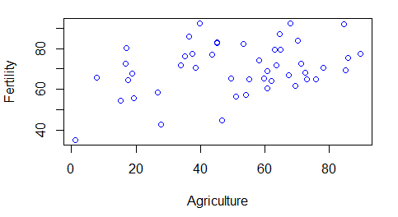

We can observe a positive correlation between Agriculture and Fertility

|  |
| --- |
| > plot(x[, 2], y, xlab='Examination', ylab='Fertility', col='blue') |
|  |
| |  | | --- | |  | |

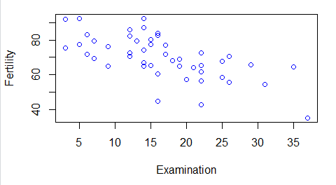

We can observe a negative correlation between Examination and Fertility

> plot(x[, 3], y, xlab='Agriculture', ylab='Fertility', col='blue')

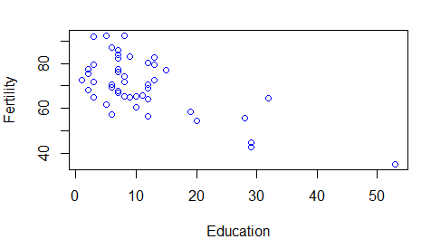

|  |
| --- |
| > plot(x[, 4], y, xlab='Catholic', ylab='Fertility', col='blue') |
|  |
| |  | | --- | |  | |

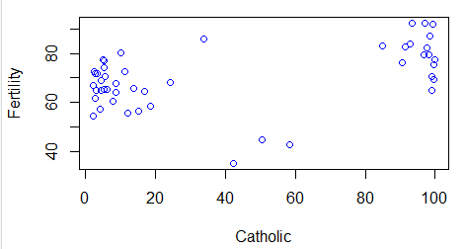

|  |
| --- |
| > plot(x[, 5], y, xlab='Infant.Mortality', ylab='Fertility', col='blue') |
|  |
| **Ridge Regression**  Dataset used: swiss  Standardized fertility measure and socio-economic indicators for each of 47 French-speaking provinces of Switzerland at about 1888.  > swiss <- datasets::swiss  > head(swiss)  Fertility Agriculture Examination Education Catholic Infant.Mortality  Courtelary 80.2 17.0 15 12 9.96 22.2  Delemont 83.1 45.1 6 9 84.84 22.2  Franches-Mnt 92.5 39.7 5 5 93.40 20.2  Moutier 85.8 36.5 12 7 33.77 20.3  Neuveville 76.9 43.5 17 15 5.16 20.6  Porrentruy 76.1 35.3 9 7 90.57 26.6  > x = model.matrix(Fertility~., swiss)[,-1]  > y = swiss$Fertility  > lambda = 10^seq(10, -2, length = 100)  > library(glmnet)  > set.seed(489)  > train = sample(1:nrow(x), nrow(x)/2)  > test = (-train)  > ytest = y[test]  > swisslm = lm(Fertility~., data = swiss)  > coef(swisslm)  (Intercept) Agriculture Examination Education Catholic  66.9151817 -0.1721140 -0.2580082 -0.8709401 0.1041153  Infant.Mortality  1.0770481  > lambda = 0.1  > ridge_R = glmnet(x[train,], y[train], alpha = 0, lambda= lambda)  > ridge_P = myRidge(x[train,],y[train],lambda)  > source('C:/Users/shraddha_m26/Desktop/Stats Programming/Assignments/6/Ridge_Spline.R')  > ridge_P = myRidge(x[train,],y[train],lambda)  > ridge_R  Call: glmnet(x = x[train, ], y = y[train], alpha = 0, lambda = lambda)  Df %Dev Lambda  [1,] 5 0.8002 0.1  > ridge_P  Agriculture Examination Education Catholic  74.64436146 -0.27807670 -0.93900466 -0.35978119 0.06500147  Infant.Mortality  1.37552338  > coef(ridge_R)  6 x 1 sparse Matrix of class "dgCMatrix"  s0  (Intercept) 73.36350615  Agriculture -0.26542433  Examination -0.89519263  Education -0.36435849  Catholic 0.06570399  Infant.Mortality 1.37394755  Observation: Ridge regression performs better than Linear Regression because of the regularization.  **Lasso**  Dataset used: swiss  Standardized fertility measure and socio-economic indicators for each of 47 French-speaking provinces of Switzerland at about 1888.  > swiss <- datasets::swiss  > x <- model.matrix(Fertility~., swiss)[,-1]  > y <- swiss$Fertility  > lambda <- 10^seq(10, -2, length = 100)  > library(Stats202A)  > cv.out <- cv.glmnet(x[train,], y[train], alpha = 0)  > bestlam <- cv.out$lambda.min  > lasso.mod <- glmnet(x[train,], y[train], alpha = 1, lambda = lambda)  > lasso.pred <- predict(lasso.mod, s = bestlam, newx = x[test,])  > mean((lasso.pred-ytest)^2)  [1] 113.7041  > lasso.coef <- predict(lasso.mod, type = 'coefficients', s = bestlam)[1:6,]  > lasso.coe  (Intercept) Agriculture Examination  57.85476722 -0.06225277 -0.50145205  Education Catholic Infant.Mortality  -0.12425311 0.04456320 1.25231604  > res <- Lasso(x[train,], y[train], lambda)  > plot(lasso.mod)    > matplot(t(matrix(rep(1, p), nrow = 1)%*%abs(beta_all)), t(beta_all), type = 'l',main='LASSO BOOSTING',xlab='N',ylab='Beta') |