**Homework 8**

Name: Shraddha Manchekar

UID: 004945217

**UNIX Commands**

**1.1 Listing files and directories**

ls : lists the contents of the current working directory

ls -a: lists the files that are normally hidden

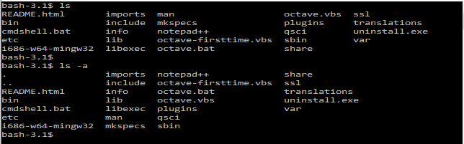

**1.2 Making directories**

mkdir: creates a directory

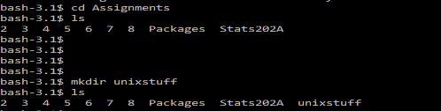

**1.3 Changing directories**

cd : changes the directory



**1.4 The directories . and ..**

. represents the current directory

.. represents the parent directory

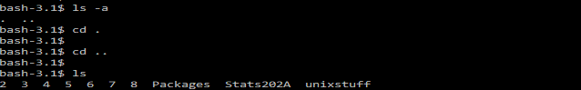

**1.5 Pathnames**

pwd: prints the present working directory



**1.6 Home directories and pathnames**

~ represents the home directory



**2.1 Copying files**

cp file1 file2: copies file1 in the current working directory and call it file2



**2.2 Moving files**

mv file1 file2: moves or renames file1 to file2

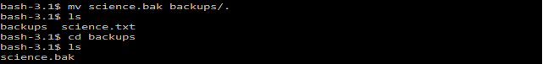

**2.3 Removing files and directories**

rm filename: removes file

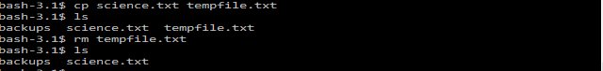

rmdir dirname: removes directory

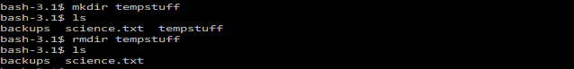

**2.4 displaying the contents of a file on the screen**

cat filename.ext: displays the contents of the file

less science.txt: writes the contents of a file onto the screen a page at a time

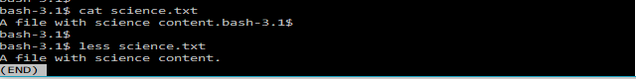

head: writes the first ten lines of a file to the screen.

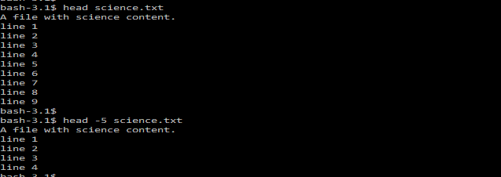

tail: writes the last ten lines of a file to the screen.

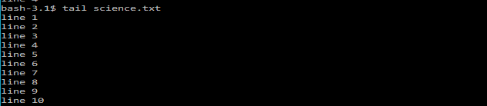

**2.5 searching the contents of a file**

less science.txt: this allows you to search though a text file for a keyword (pattern).When still in less, type a forward slash [**/**] followed by the word to search [/science]

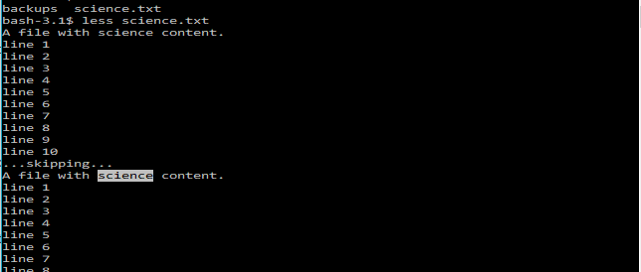

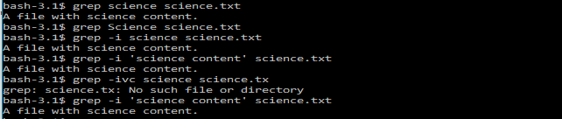

wc -w filename: gives the word count of the file

wc -l filename: gives the line count of the file

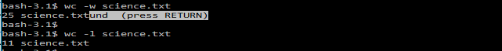

**3.1 Redirection**

cat: it reads the standard input (the keyboard), and on receiving the 'end of file' (**^D**), copies it to the standard output (the screen).

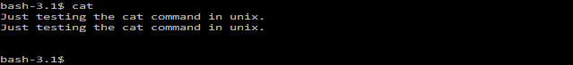

**3.2 Redirecting the output**

cat > file: reads the standard input and redirects the output to the specified file

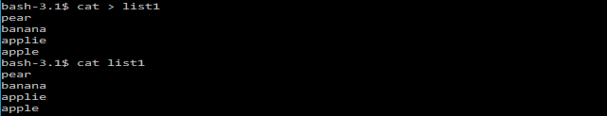

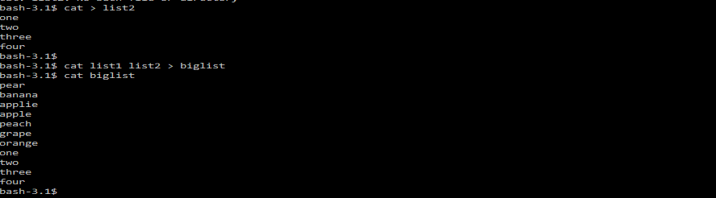

**3.3 Redirecting the input**

sort < filename: the sorted list with be output to the screen

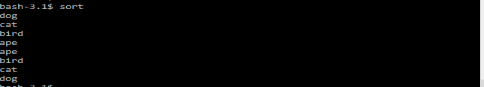

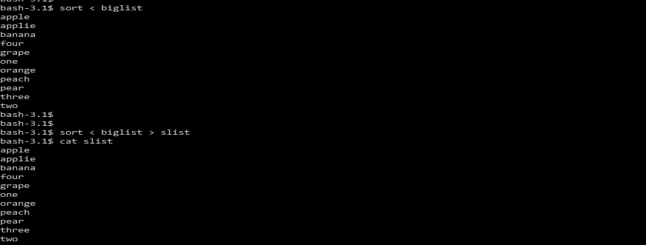

**4.1 The * and ? wildcard**

* represents match any number of characters

? represents match one character

ls list*: lists all the files in the current directory starting with list…

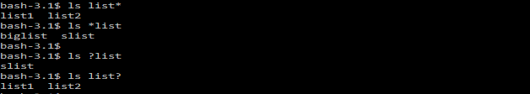

**Git Commands**

First, setup a GitHub account and download and install git on the machine.

**My Github Profile:**

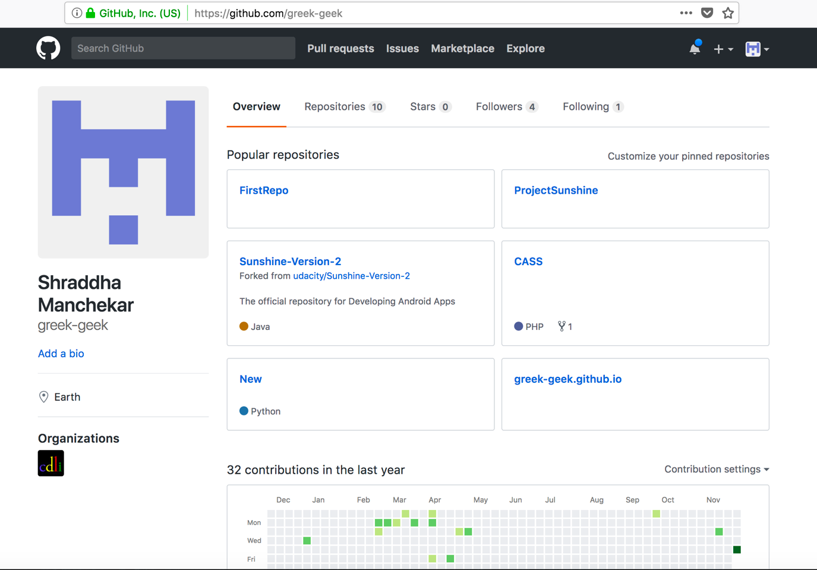

Setting up git with our username and emails



Setting up the SSH connection with public key generation

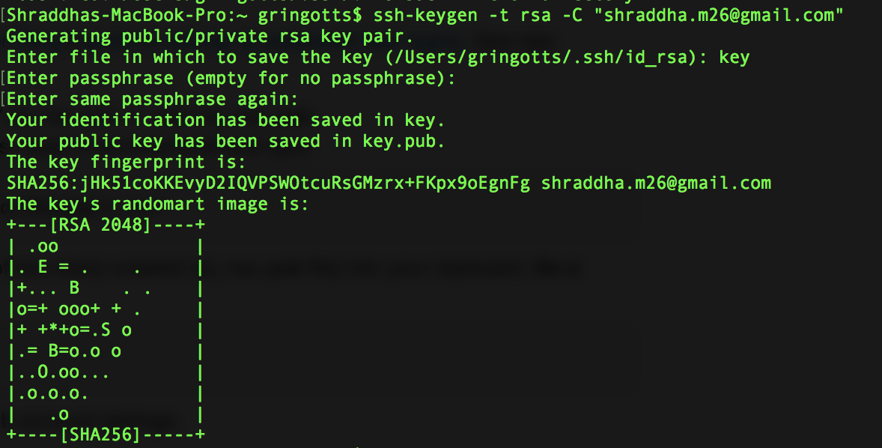

Adding the SSH public key generated in the account settings

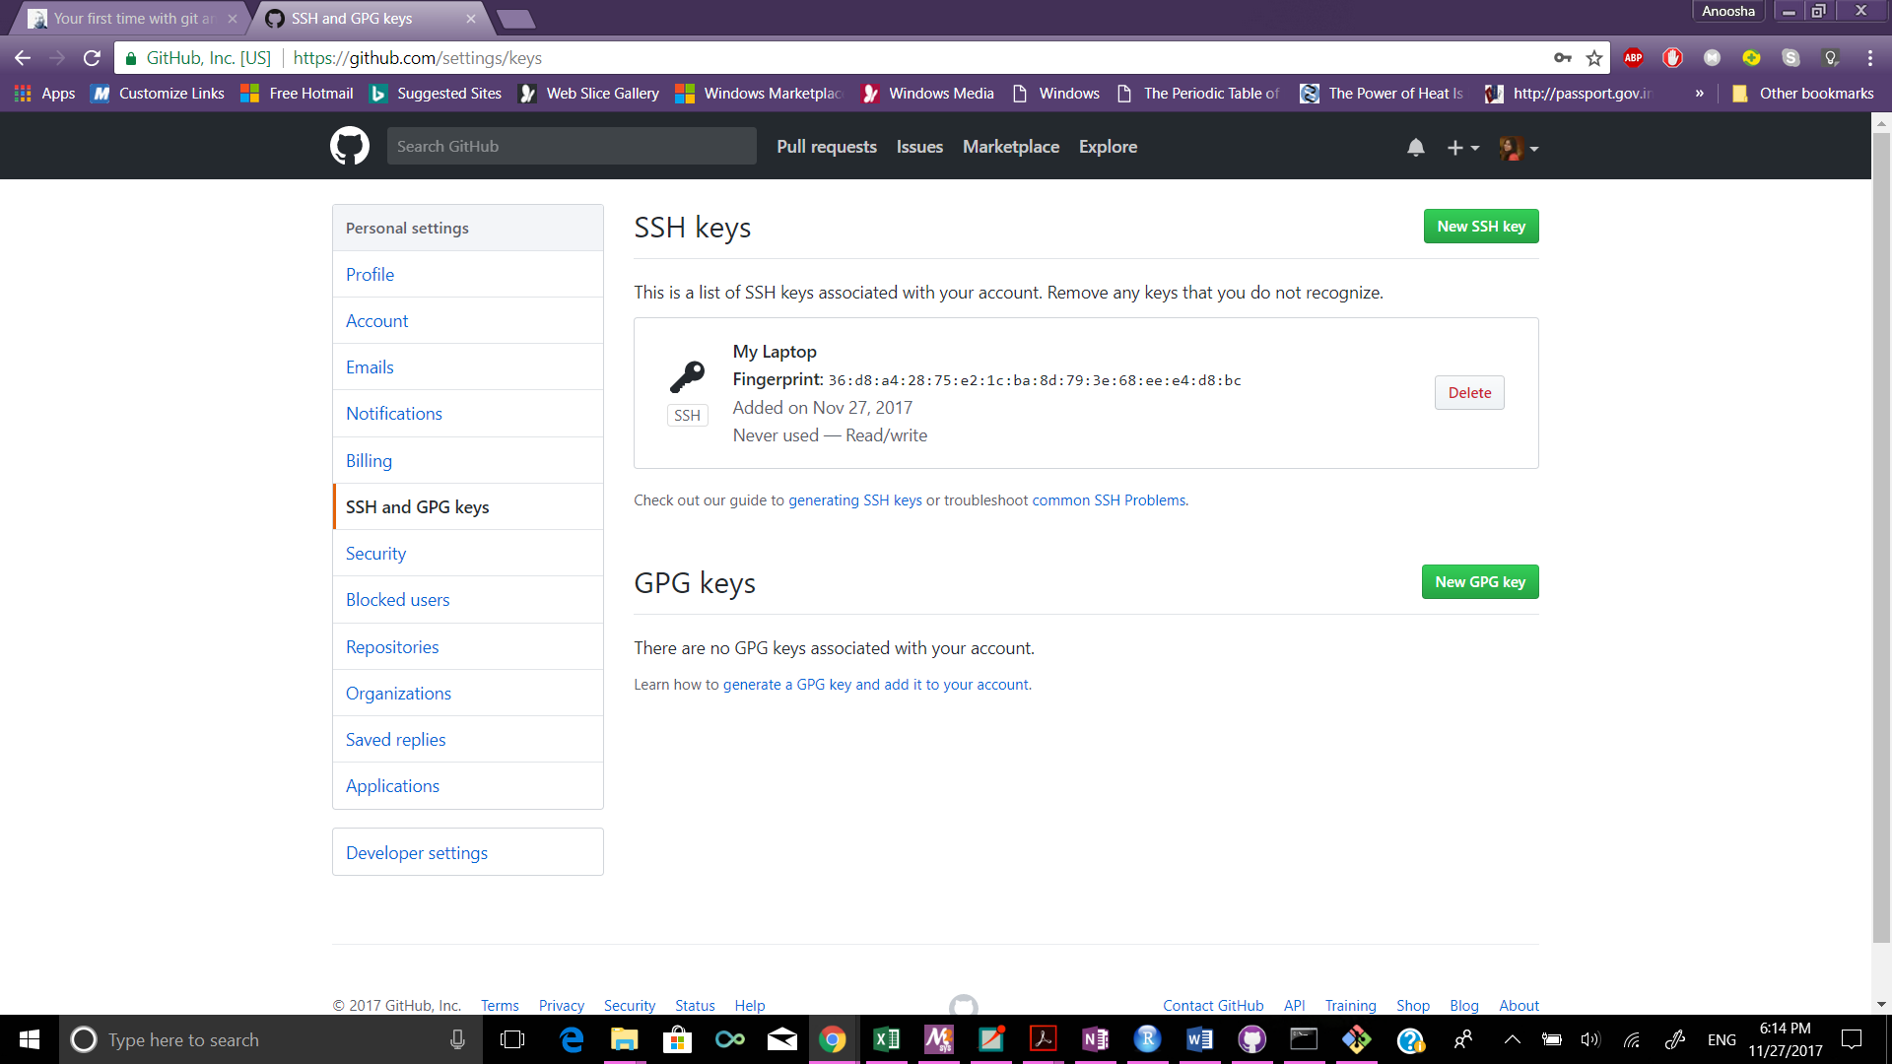

Making the SSH connection with the github server



Starting a new repository

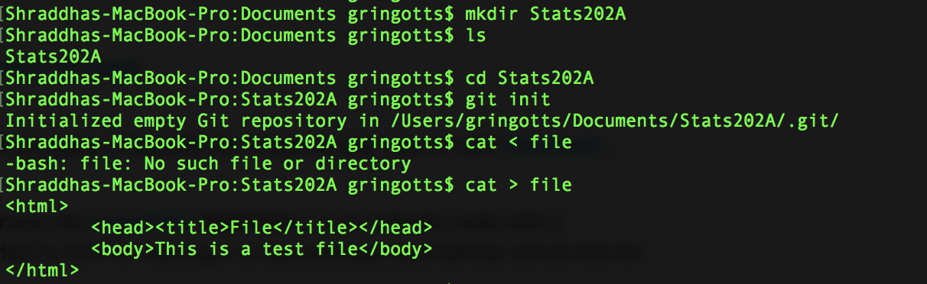

Added repository to GitHub

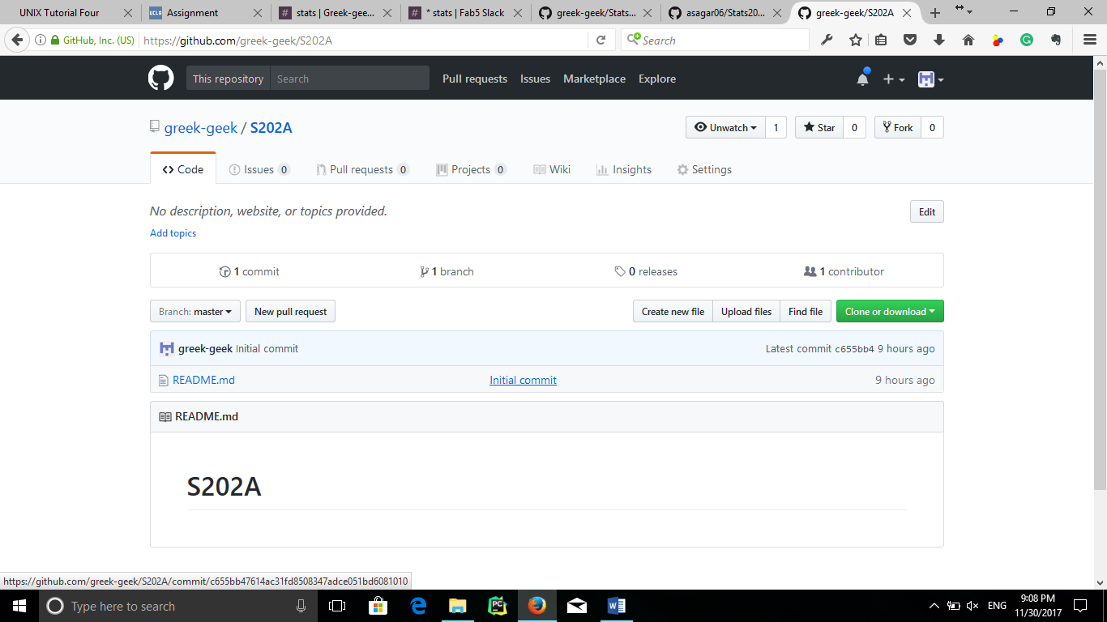

Connecting it to GitHub

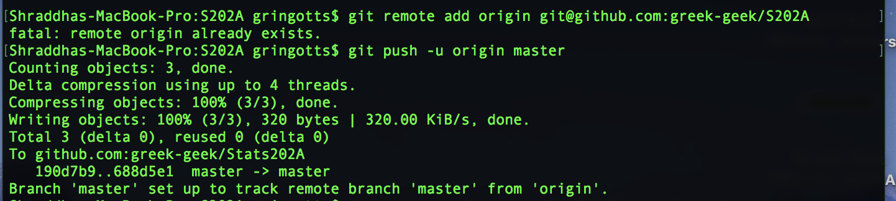

git status command

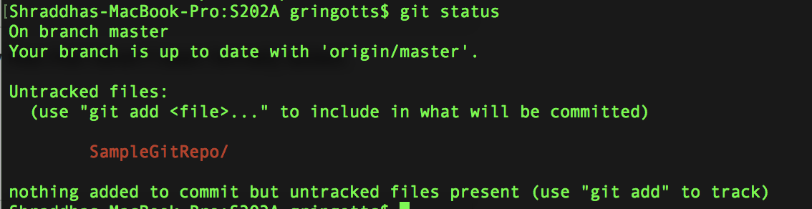

git diff command

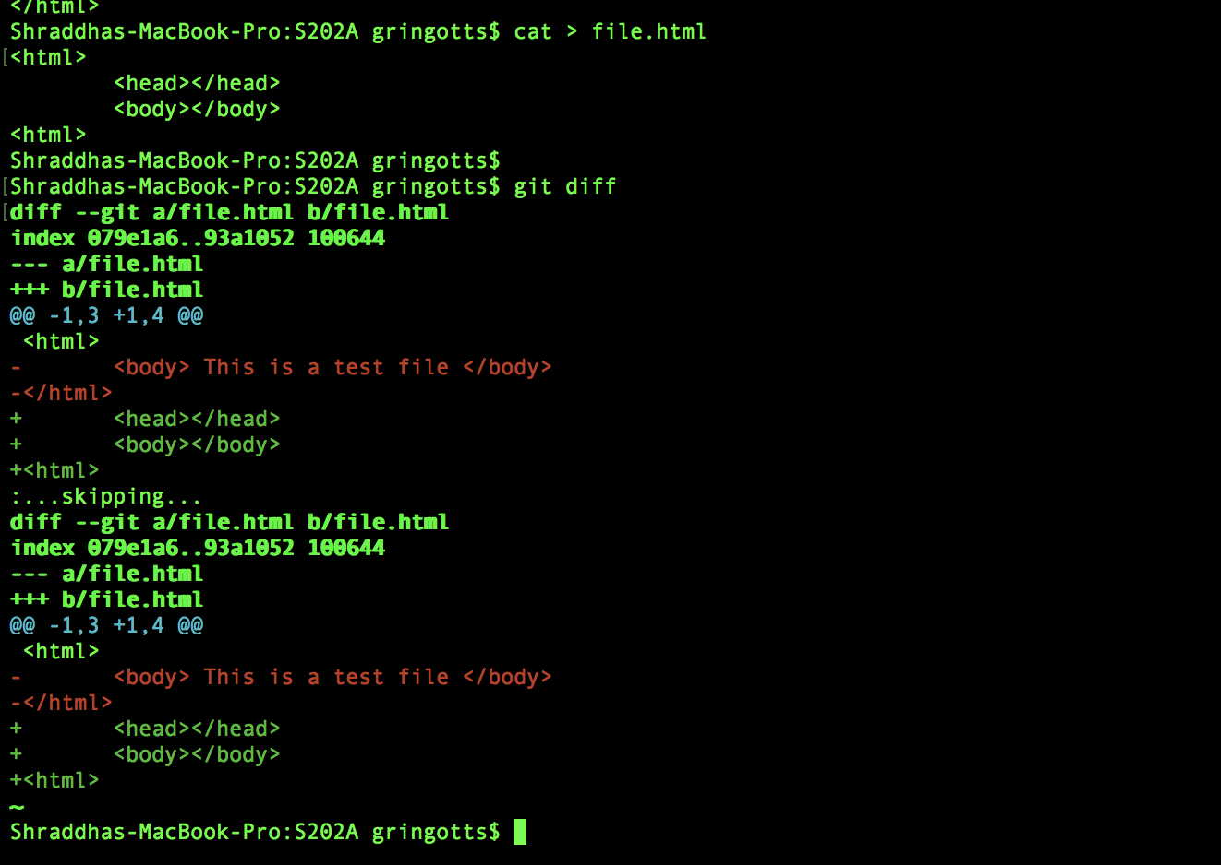

Contributing to someone’s repository

Forking the other person’s repository on GitHub

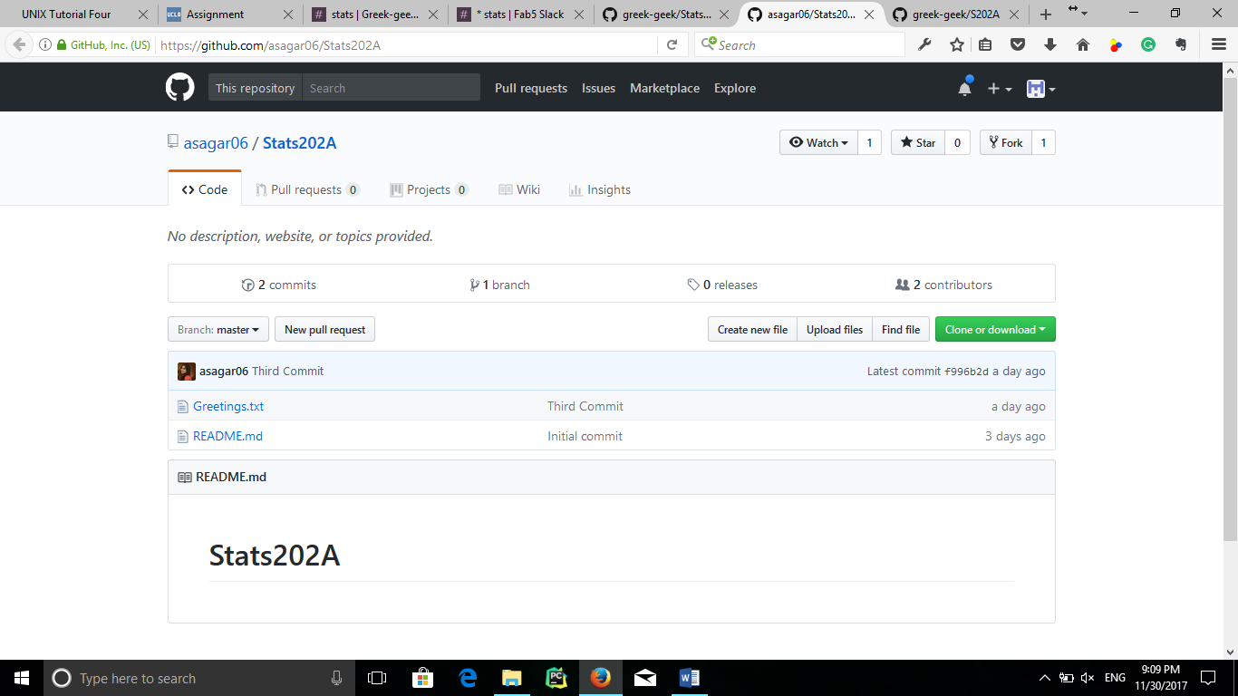

Cloning it on the local machine

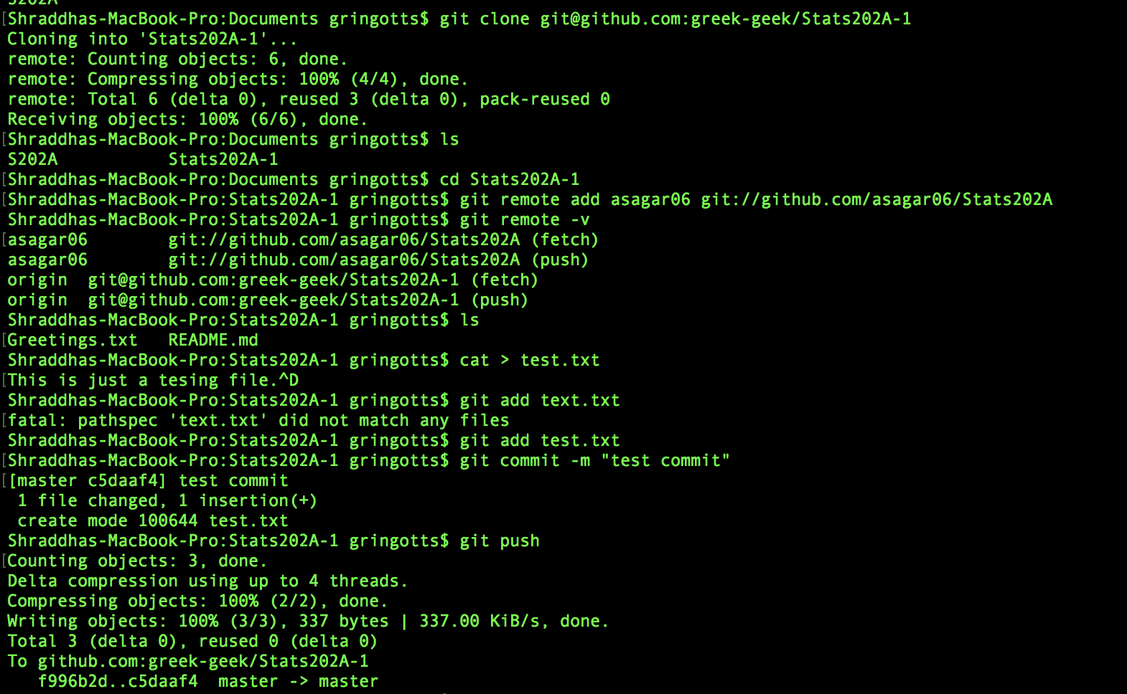

Pulling others’ changes

