LAN Network Setup 
TERM | NAME – Student ID | COURSE CODE | WEIGHT
 | Greemesh Basnet - 130525223 | CSN105 | 8%
Lab Objectives
Upon completion of this lab, you will be able to perform the following:
- Configure a wireless router
- Assign static and dynamic IP addressing
- Secure wireless LAN connectivity
- Troubleshoot and resolve network connectivity issues
Lab Materials
- Pre-Lab Video: Explanation
- Cisco Packet Tracer
- IP address and subnet mask from Blackboard
  - “X” will be used in the lab to indicate your unique IP address and subnet mask
Lab Instructions
- Launch software and perform lab
- Enter your name and student ID above (Example: david – dtrinh)
- Answer questions and add screenshots into the corresponding textboxes
- Save the file on your computer for future reference
- Save the file again as a “.pdf” file
- Submit the PDF file for grading

Part 1: Planning your Network
You have moved into a new house and need to setup internet access for your family and friends. There are various devices that everyone will be using to connect to the internet, but you don’t expect to have more than 20 devices connected on the network at the same time. Some devices you expect include PCs, Printer, File Server, Laptops, and Smart Phones.
You decide to subscribe to Seneca College’s Internet services. They provide you with a cable modem that only provides a single ethernet port. Since multiple devices will need to connect to the internet, you purchase a wireless router to allow for additional devices to share the internet connection.
Part 2: Physical Network Topology
Recall the physical network topology represents how the devices are physically connected on a network whereas the logical network topology represents how the data is transmitted within a network.
Setup the physical network topology using the following devices:
Under End Devices > End Devices
- PC
- Printer
- Server
Under Network Devices > Wireless Devices
- Home Router
Screenshot 2.0: Network Topology [1 mark]



Part 3: PC and Router Configuration
- Connect the PC to one of the router’s Ethernet ports.

Do not connect to the internet port!
- Open the PC properties by clicking on the PC and navigate to the “Desktop” tab and launch “IP Configuration”.
- Type in the command:
  - ipconfig
Notice an IP address is not assigned to the interface. The PC should receive an IP address automatically from the router, but the PC is not configured to receive IP addresses via DHCP.
- Navigate back to the “Desktop” tab and launch “IP Configuration”.
- Ensure the “FastEthernet0” interface is selected and the IP Configuration is set to “DHCP”.
- Close the “IP Configuration” and launch “Command Prompt”.
- In the command prompt, type in the command:
  - ipconfig
The PCs IP Address, Subnet Mask, and Default Gateway will appear.
- Record the gateway and close the command prompt.
- Navigate to the “Web Browser” and enter in the default gateway into the URL field to receive a prompt for a username and password:
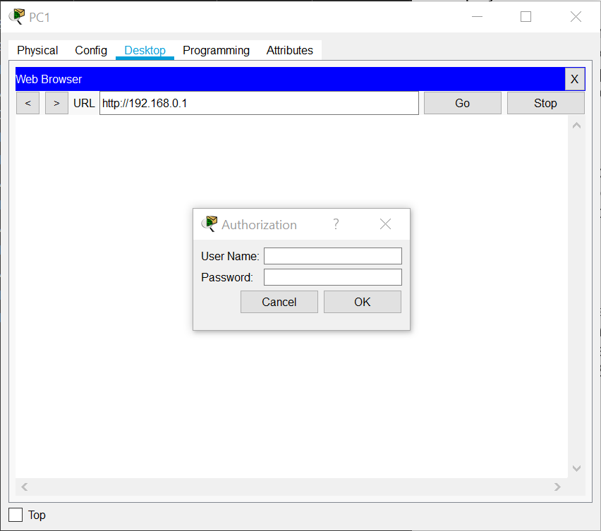
- Typically, new routers are pre-configured with a default username and password which is used to access the router. Use the following credentials:
  - User Name: admin
  - Password: admin
- To secure the access to the router, change the default password to another password. Navigate to the “Administration” tab and under “Router Access”, set a new password.
Part 4: DHCP Server Settings
- Since we determined there would be no more than 20 devices connected to this network, navigate to the “Setup” tab under the “Basic Setup” subtab.
- Under the “DHCP Server Settings”, configure the “Maximum number of Users” to 20. Note that the “Start IP Address” is 100 which means IP address ranging from 192.168.0.100 to 192.168.0.119 will be assigned to devices.
- Change the “Router IP” IP address assigned to you in Blackboard.
- Change the “Subnet Mask” to the Subnet mask assigned to you in Blackboard.
- Save the settings and allow the router to process the changes.
- You will need to log back into the router using the new IP address you configured.
Screenshot 4.0: DHCP Server Settings [1 mark]

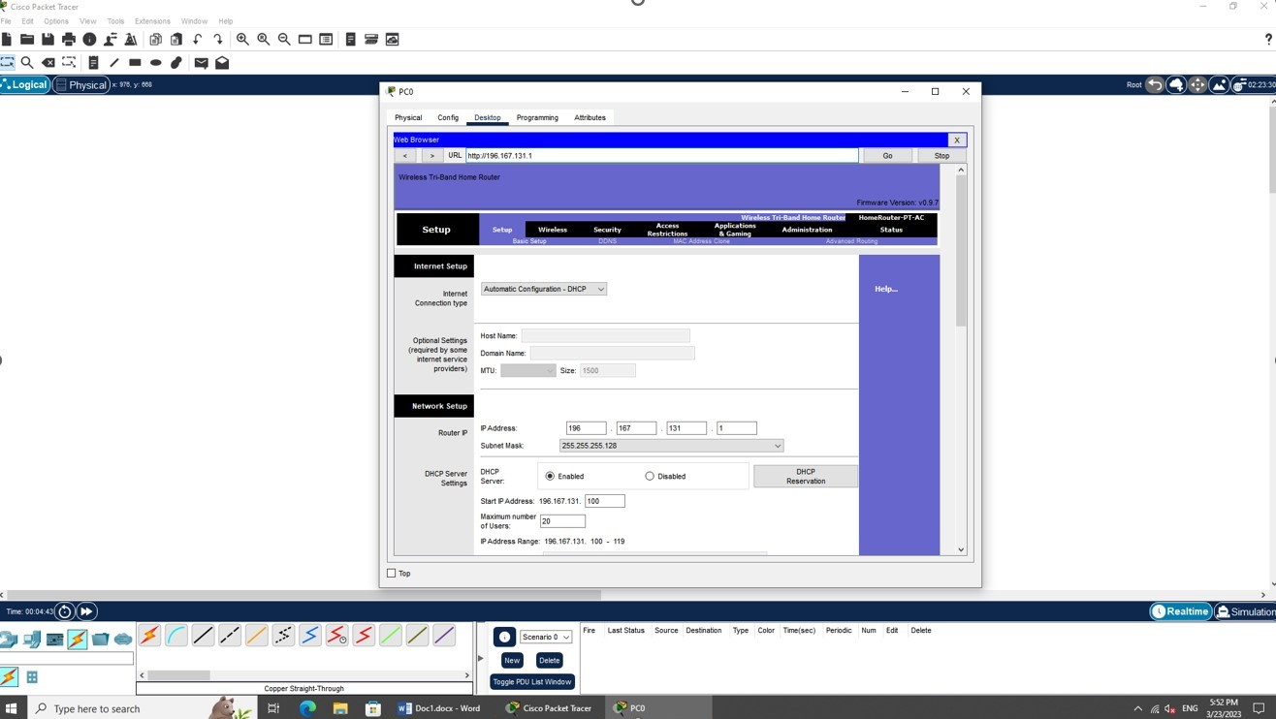

Part 5: Server Configuration
Servers are critical components in providing services to computers in a client-server network. Servers need a static IP address to ensure clients can consistently connect to the server. Our file server needs to have a static IP address configured. At the same time, our DHCP server (router) will need to reserve this IP address for the server to prevent assigning the IP address to another device on the network.
- Open the Server properties and navigate to the “Desktop” tab.
- Launch the “IP Configuration” and set the “IP Configuration” to “Static”.
- Recall the range of IP addresses is X.X.X.100 – X.X.X.119. We will assign the first available IP address to the server.
  - IP Address: X.X.X.100
  - Subnet Mask: 255.255.255.X
  - Default Gateway: X.X.X.1
*Note: “X” represents your unique IP address and subnet mask assigned to you in Blackboard.
Screenshot 5.0: Server IP Configuration [1 mark]

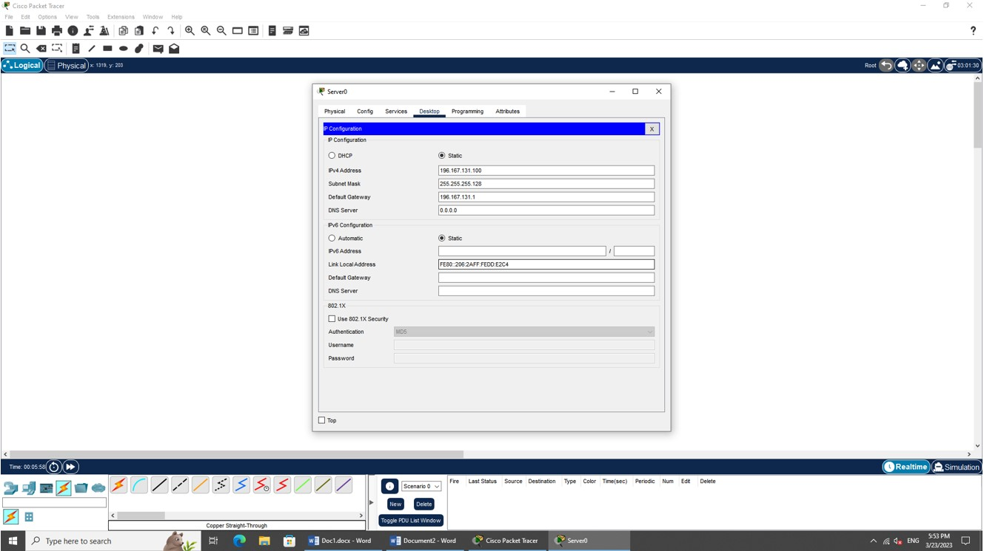

- Navigate to the “Config” tab and under “Settings”, record the “Display Name”.
- Navigate to the “FastEthernet0” interface and record the “MAC Address”
- Close the Server properties and open the PC properties to log back into the router.
- Under the “Setup” tab and “Basic Setup” subtab, go to the “DHCP Server Settings” and click on “DHCP Reservation”
- Manually add the Server into the reservation list and save the settings.

Ensure the MAC Address is entered in the correct format.
- Close the PC properties.
- Select an appropriate network cable to connect the Server to the Router.

Remember to connect to one of the router’s available Gigabit Ethernet ports.
- Open the PC properties and open a command prompt.
- Attempt to send a packet to the server using the following command:
  - ping X.X.X.100
Screenshot 5.1: “ping” command [1 mark]

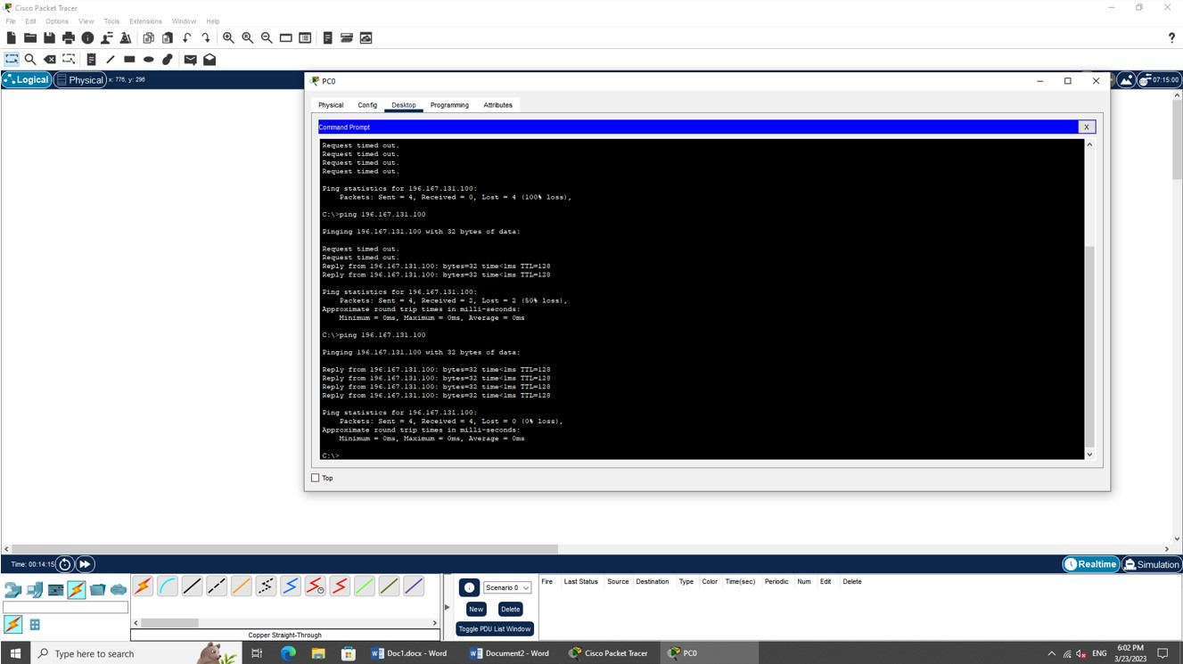

Part 6: Printer Configuration
Printers are also configured the same way as servers where a static IP address is configured. Use the same process to configure the printer’s IP address. Assign the last IP address to the printer.
Explain what would happen to both the server and printer if we set their IP Configurations to “DHCP”. [1 mark]

If I set the IP Configuration of both the server and printer to DHCP then it denotes that server and printer will receive a dynamically assigned IP address from DHCP server.

When I set the IP Configuration of the server to DHCP then it will ask the DHCP server of network for IP address. Likewise, when I set the printer’s IP settings to DHCP then it will also ask the DHCP server for IP address.

Part 7: Wireless Configuration
Another method of connecting to the router is using a wireless connection. Some routers come with multiple wireless antennas. In our case, this router comes with 3 antennas which transmit data on the 2.4 GHz and 5 GHz bands. To tailor to the various devices that will connect to our network, we will enable all the bands available on this router.
- Launch the PC properties and login to the router.
- Navigate to the “Wireless” tab and under the “Basic Wireless Settings” subtab, confirm the “Network Mode” is enabled for all bands.
Wireless connectivity is now enabled and any device close enough to the router will obtain an IP address from the router. This could be dangerous as strangers can find the Wi-Fi connection and connect to your personal network. There are a few ways to secure wireless access to your router.
SSID Broadcast
By default, the SSID (Service Set Identifier) is enabled which advertises the network to any wireless device within range of the router. This means anyone can find the network simply by viewing the Wi-Fi networks available on their device. We can disable the SSID broadcast.
- Navigate back to the “Basic Wireless Settings” subtab and disable the “SSID Broadcast” for each band. Rename each band’s SSID to your student ID and band frequency.
  - Example:
    - 2.4 GHz: SSID = dtrinh_2.4
    - 5 GHz – 1 = dtrinh_5a
    - 5 GHz – 2 = dtrinh_5b
Screenshot 7.0: SSID Broadcast Configuration [1 mark]

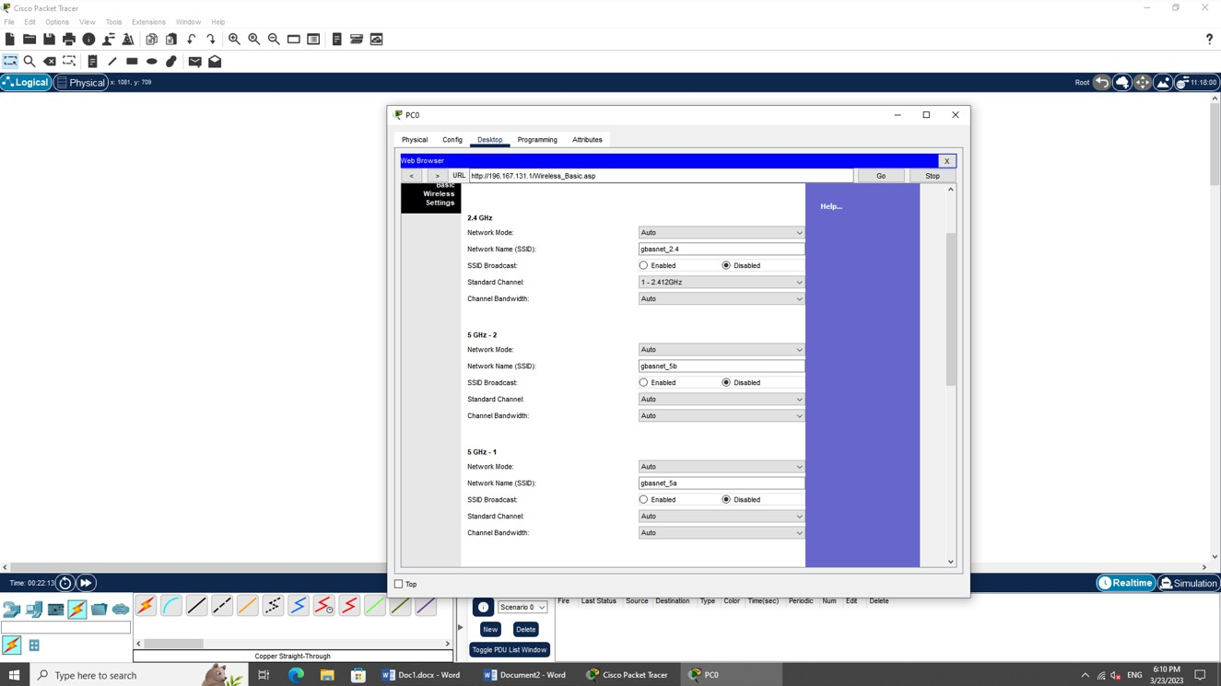

Authentication and Encryption
Although the SSID is no longer broadcasted to all devices, we can add another layer of security by setting a password to our Wi-Fi connection. This router offers different security protocols for authentication:
- WEP – Wired Equivalent Privacy
- WPA / WPA2 – Wireless Protected Access / WPA version 2
  - Personal mode
  - Enterprise mode
WPA is succeeded by WPA2 which is more secure than WPA due to the encryption used by the protocol. There are personal and enterprise modes for each WPA and WPA2. In personal mode, a pre-shared key or passphrase for authentication. In enterprise mode, a RADIUS server is required to manage authentication to the network.
In addition to using security protocols for authentication, we want to protect the data being transmitted using encryption. There are 2 types of encryption offered by this router:
- TKIP – Temporal Key Integrity Protocol
- AES – Advanced Encryption Standard
AES provides more secure encryption than TKIP and is used in both the WPA and WPA2 security protocols. Note that WPA also offers TKIP encryption but WPA2 only offers AES. Consequently, WPA2 provides more security than WPA.
- Under the “Wireless” and “Wireless Security” subtab, set all the encryption modes to “WPA2 Personal” with AES encryption
- Assign your student number for each Passphrase
Screenshot 7.1: Authentication and Encryption Configuration [1 mark]

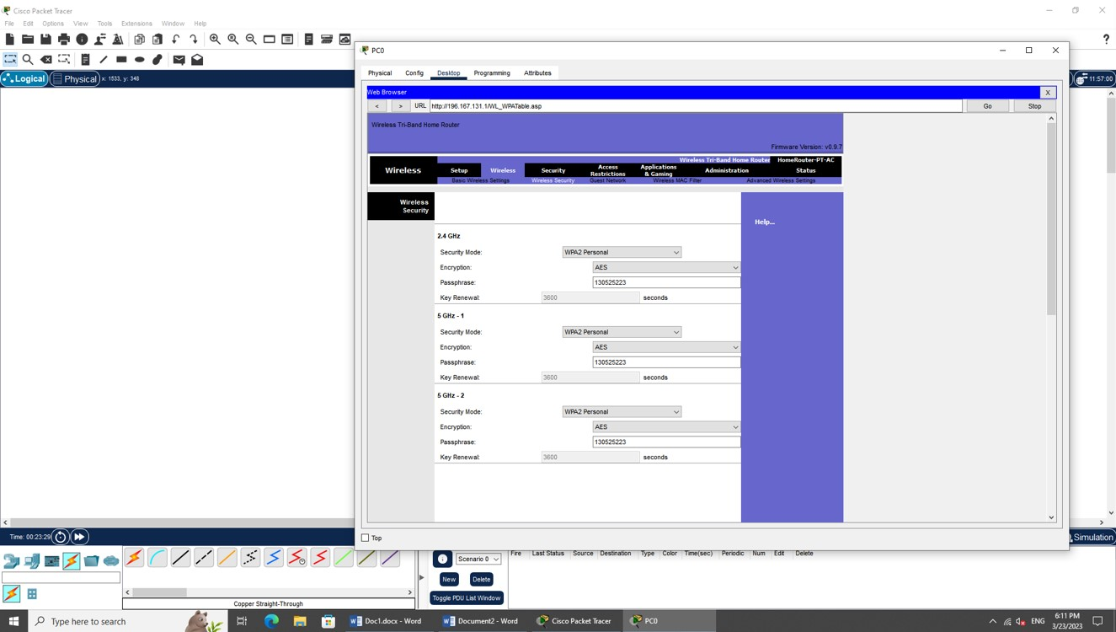

Guest Network
We have secured our wireless network by removing the SSID broadcast and requiring authentication to our network. We have also encrypted our wireless data transmission. Although these settings are sufficient for a typical home network, if you plan on providing internet access to your friends but restrict them from accessing your personal network (example: Printer, File Server, etc), we can enable a feature called “Guest Network”.
The “Guest Network” allows us to create a “separate” network for our guests where the bands, SSID broadcast, authentication method, and encryption settings can also be configured.
Your friends are bringing their laptops to your new house to play the latest game. You want to restrict your friends’ wireless connection to 2.4 GHz. To prevent your friends from knowing about the 5 GHz band, you will disable the SSID broadcast for the 5 GHz band.
- Add 3 laptops to your network and ensure each laptop is configured with a 2.4 GHz wireless interface card:
- Use the “PT-LAPTOP-NM-1W” module.

- You will need to power off the laptop and remove the existing ethernet module before installing the “PT-LAPTOP-NM-1W” module.
- Use the PC to login into the router.
- Under the “Wireless” tab and “Guest Network” subtab, enable the guest profiles for each band.
- Set an appropriate SSID name for each band.
- Set the appropriate broadcast for each band.
- Configure the appropriate security mode and encryption for each band.
- Assign your student number for each Passphrase
Screenshot 7.2: Guest Network Configuration [1 mark]

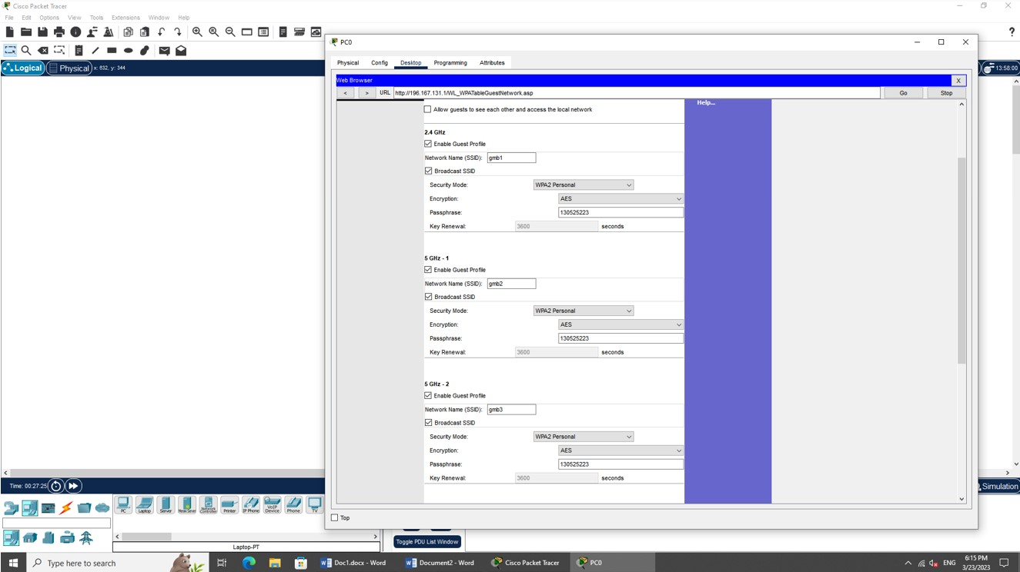

- On each laptop, connect to the 2.4 GHz band using the SSID and password you configured for that band.
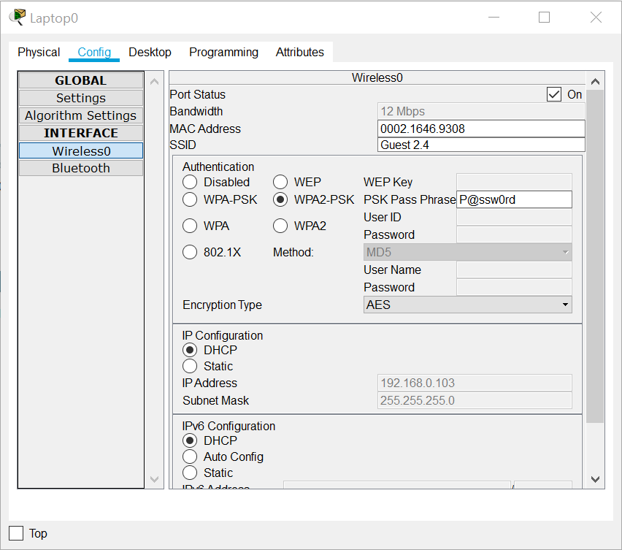
Using the correct SSID and password will allow you to connect to the router.
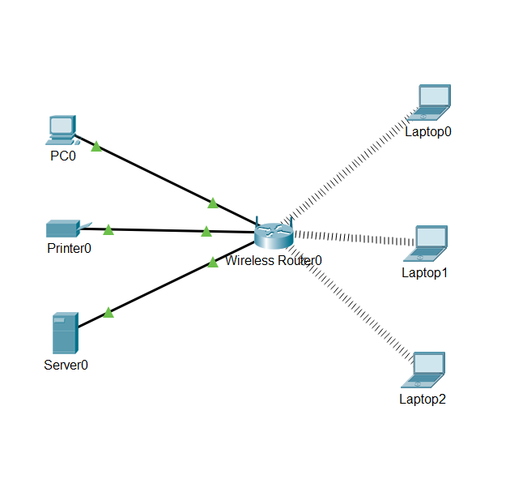
Wireless MAC Filter
While gaming with your friends, they all team up against you causing you to lose. You decide to restrict all their access to the internet by filtering out their device from the network.
- Use the PC to login into the router.
- Under the “Status” tab and “Local Network” subtab, click on “DHCP Client Table”.
- Record the MAC address for the last 3 IP addresses.
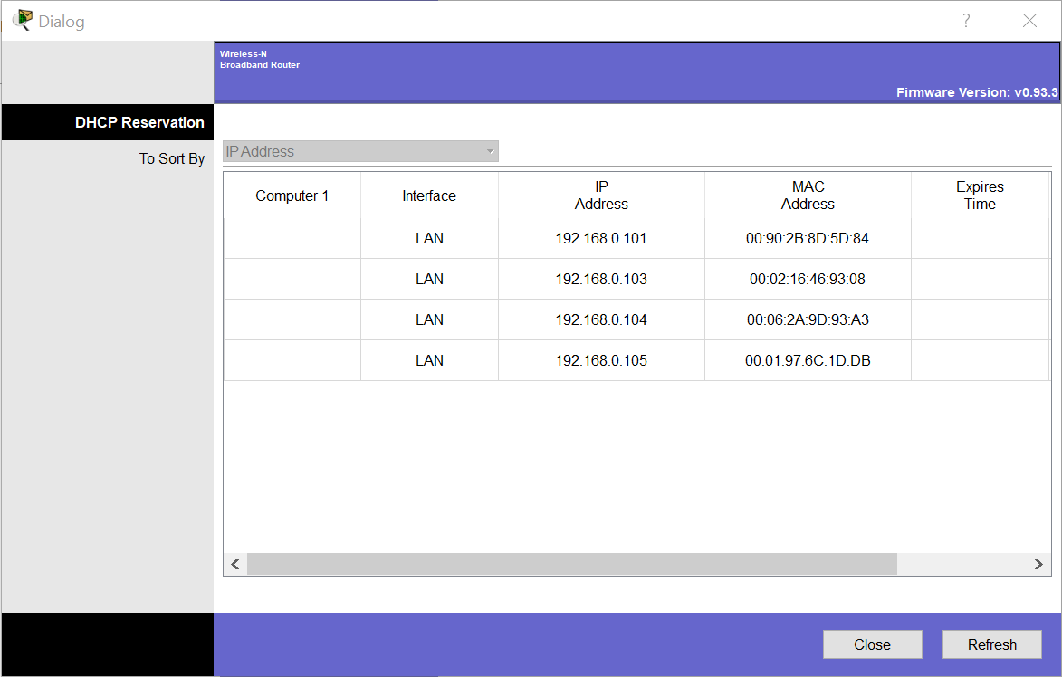

- The MAC Address for your laptops may appear different from the screenshot.
- Navigate back to the “Wireless” tab and “Wireless MAC Filter”.
- Enable the “Wireless Port” to 2.4G.
- Enter the MAC addresses of the 3 laptops.

Make sure the setting “Prevent PCs listed below from accessing the wireless network” is selected to ensure the laptops are being restricted.
After saving the settings, you should notice the laptops are no longer connected to the network.
Can the friends reconnect to the 2.4G wireless network? Explain. [1 mark]

Click or tap here to enter text.

