Task 1: Superstore

Question one: Map the amount of high-priority shipments within 2010 on a timeline.

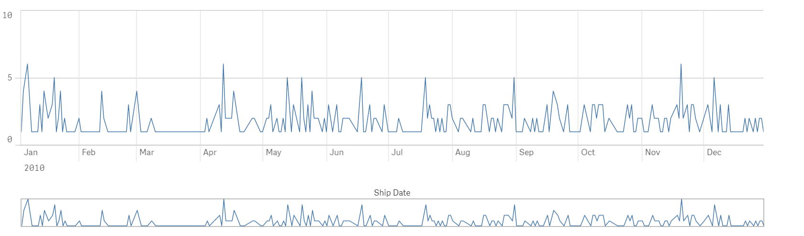

Question two: Graph out the minimum and maximum shipping costs per container type.

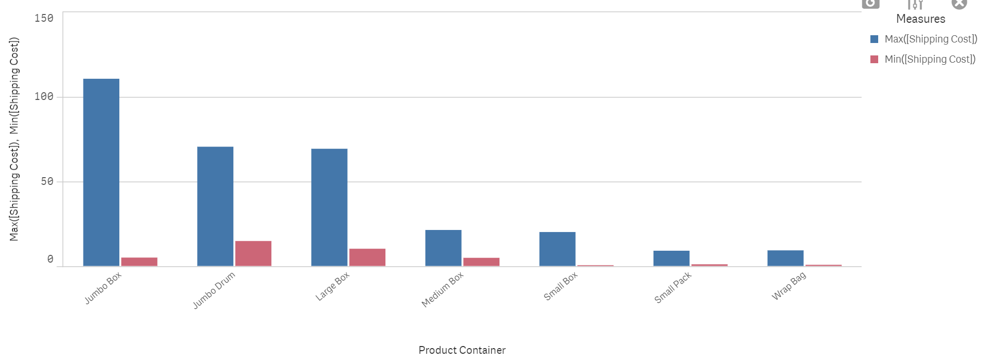

Question three: Graph out the minimum and maximum shipping costs per container type.

