1. Bike Stations distributed in LA

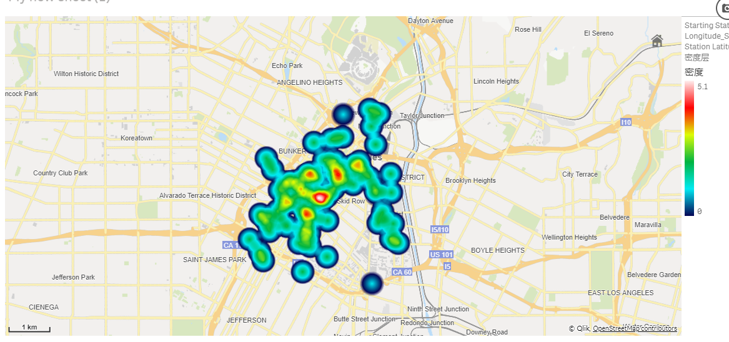

Conclusion:

**basically, the city center has more stations**

1. Using frequency by station id

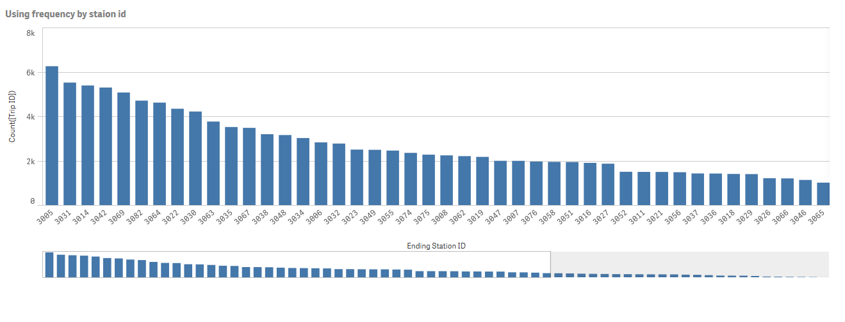

Conclusion:

**3005 has the most use and should have some additional care. (or maybe top 10, they are quite similar)**

1. Using frequency by date

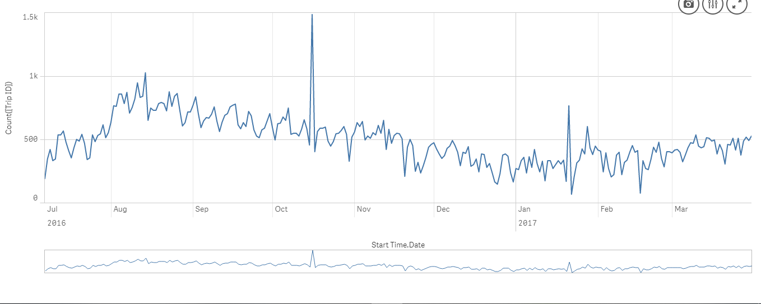

Conclusion:

**Basically, the use of share bike from 2016/8 is decreasing and is increasing from 2017/02**

1. Using frequency by hours

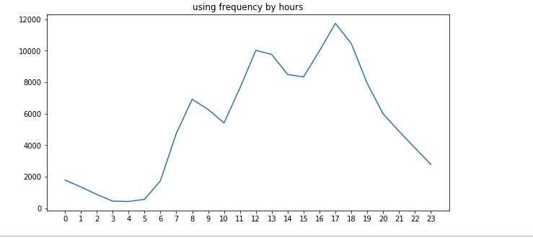

Conclusion:

**5pm has the most often use.**

1. Using frequency by passholder type

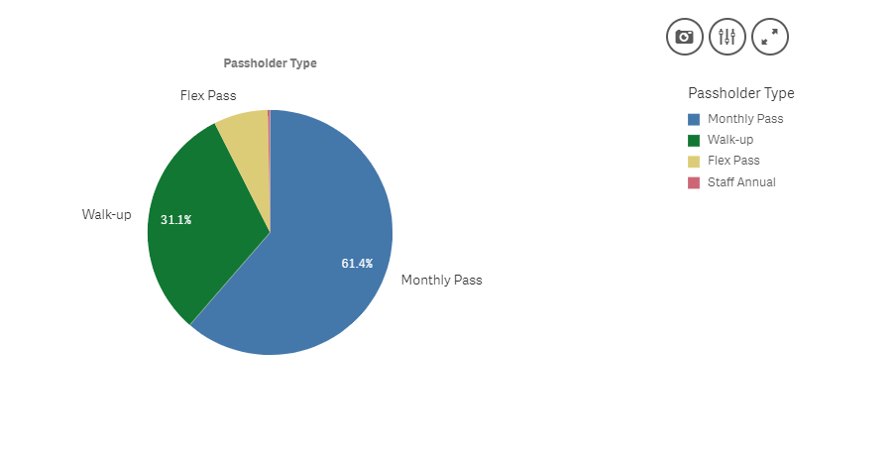

Conclusion:

**Obviously, people who have ‘Monthly Pass’ use share bikes often.**