BSPD THEORY OF OPERATION
Friday, February 21, 2025
9:58 PM

Functions of the board:
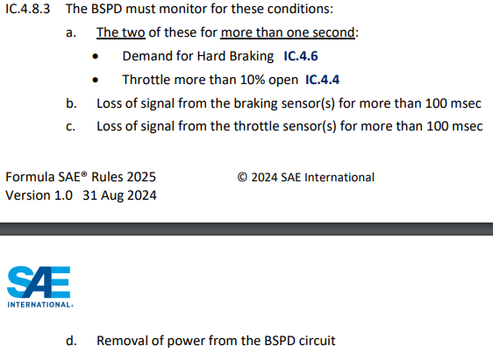

INPUT STAGE:
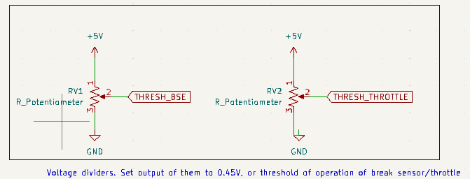
These potentiometers will be set to the lowest operating point of the BSE or Throttle sensors. For simplicity, 0.45V is shown as the threshold for operation

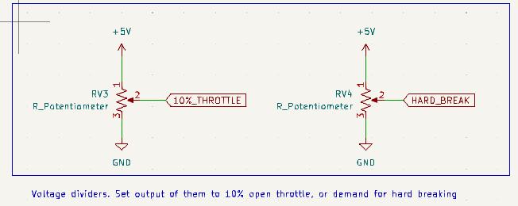
These potentiometers will be set to the voltage of both 10% throttle, or the voltage present on the BSE during a "hard break" (unknown at the moment).

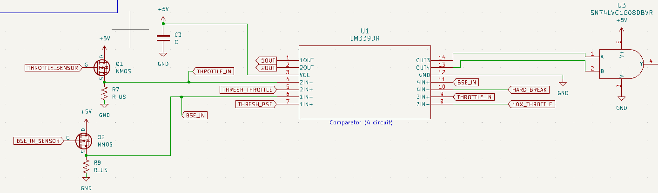
For condition A , "demand for hard breaking and throttle 10% open" :
- 3IN+ (throttle sensor input), 3IN- (10% throttle). If "THROTTLE_IN" is higher than the 10% open throttle voltage, pull output "OUT3" high to 5V.
- 4IN+ (BSE input), 4IN- (Hard breaking threshold). If "BSE_IN" is greater than the "hard breaking" voltage, pull output "OUT4" high to 5V.
- Condition says to monitor the TWO of these, so they are fed into an AND gate.

For conditions B&C, "Loss of signal … for 100msec" :
- 1IN+ (threshold for BSE ON), 1IN - (BSE_IN). If BSE_IN falls below the operating voltage 1IN+, then output high fault signal of 5V from pin 1OUT
- 2IN+ (threshold for Throttle sensor ON), 2IN- (THROTTLE_IN). IF THROTTLE_IN falls below the operating voltage 2IN+, then output high fault signal of 5V from pin 2OUT
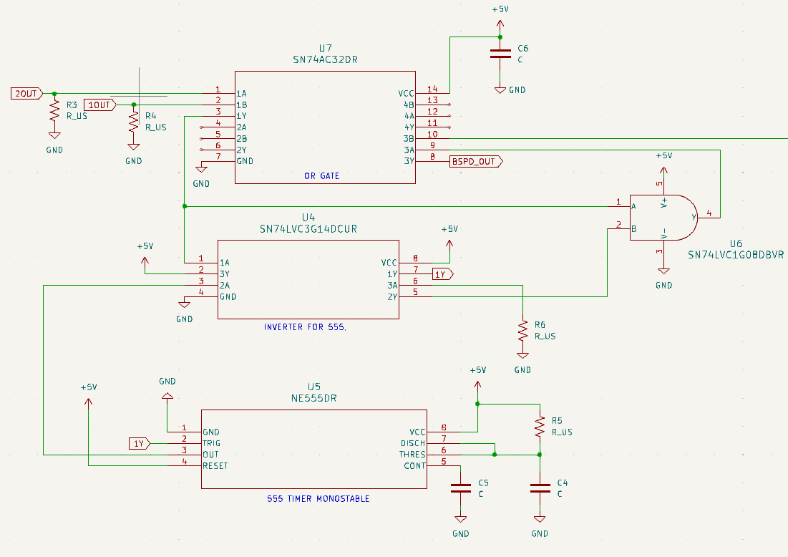
OR the two "Loss of Signal" outputs into the 1A, 1B pins of the OR gate. Send output (1Y) to an inverter for the 555 timer. Send output of the inverter to the 555 timer which is configured in monostable mode (to provide a pulse 100 msec later). Feed the OUT pin of the 555 into the inverter again to re-invert the logic. Finally, AND the output of the second inversion 2Y and the current state of the "Loss of Signal" (1Y of the OR gate). If the "loss of signal" is present and was observed 100msec ago, the output of the U6 AND gate should be high 5V.

Feed the two AND gate outputs into the OR gate. The output of this will be the BSPD_OUT signal.

