Department of Computing

**Arithmetic Operators**

CS-110: Fundamentals of Computer Programming

Mr. Jaudat Mamoon

**Learning Objectives**

After completing this section you will be able to:

1. Do some basic printing in C.
2. Do variable declarations and initializations.
3. Get input from keyboard
4. Do some basic math in C

# Lab Tasks

1. Write a program that prints a box, an oval, an arrow and a diamond as follows:

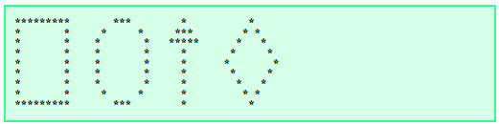

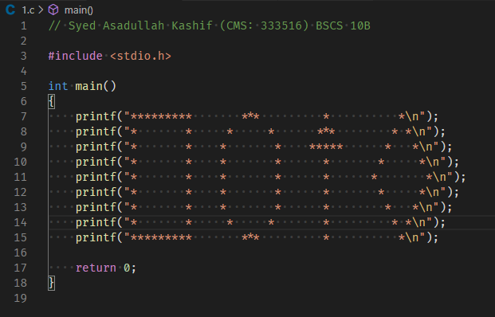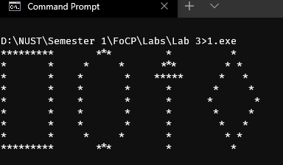

1. Write a program that inputs three different integers from the keyboard, and then prints the sum, the average, the product. The screen dialogue should appear as follows:

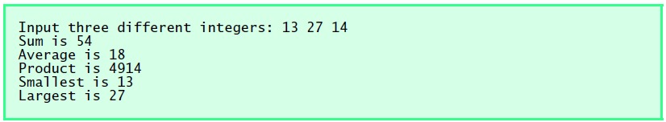

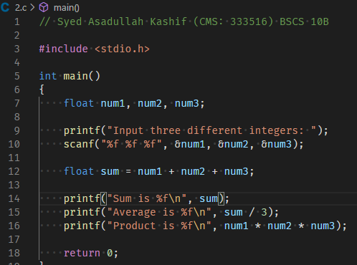d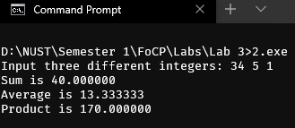

1. Write a program that reads in the radius of a circle and prints the circle’s diameter, circumference and area. Use the constant value 3.14159 for π. Perform each of these calculations inside the *printf ( )* statement(s) and use the conversion specifier %f for floating point data.

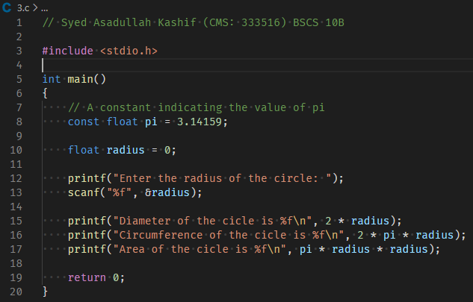 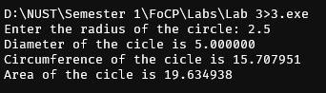

1. Here’s a peek ahead. So far, you learned about integers and the type int. C can also represent uppercase letters, lowercase letters and a considerable variety of special symbols. C uses small integers internally to represent each different character. The set of characters a computer uses and the corresponding integer representations for those characters is called that computer’s character set. You can print the integer equivalent of uppercase A for example, by executing the statement

printf( "%d", 'A' );

Write a C program that prints the integer equivalents of some uppercase letters, lowercase letters, digits and special symbols. As a minimum, determine the integer equivalents of the following: A B C a b c 0 1 2 $ * + / and the blank character.



f