4th Build= Meat of the project

1)Contain scheduling system for customers to choose lawn services and delivery landscaping supplies.

2)Checkout functionality to acquire payment and collect data from customer(if they allow)

3)Confirmation (delivery day, give a rough idea of delivery time since customers don’t need to be home . Maybe create a comment box for delivery instructions like location to where the landscaping supplies could be left on the property.

2nd Build=Pages will contain items for purchase such as Services (mowing, trimming, etc…) and Landscaping supplies which will contain items for purchase such as plants, mulch, etc… Built in HTML with functionality to checkout , possibly a database for customer data collection.

3rd Build= Pages will contain information and links. Contact page could be redundant but in HTML course user friendly was key. So to have two different pages could be helpful.

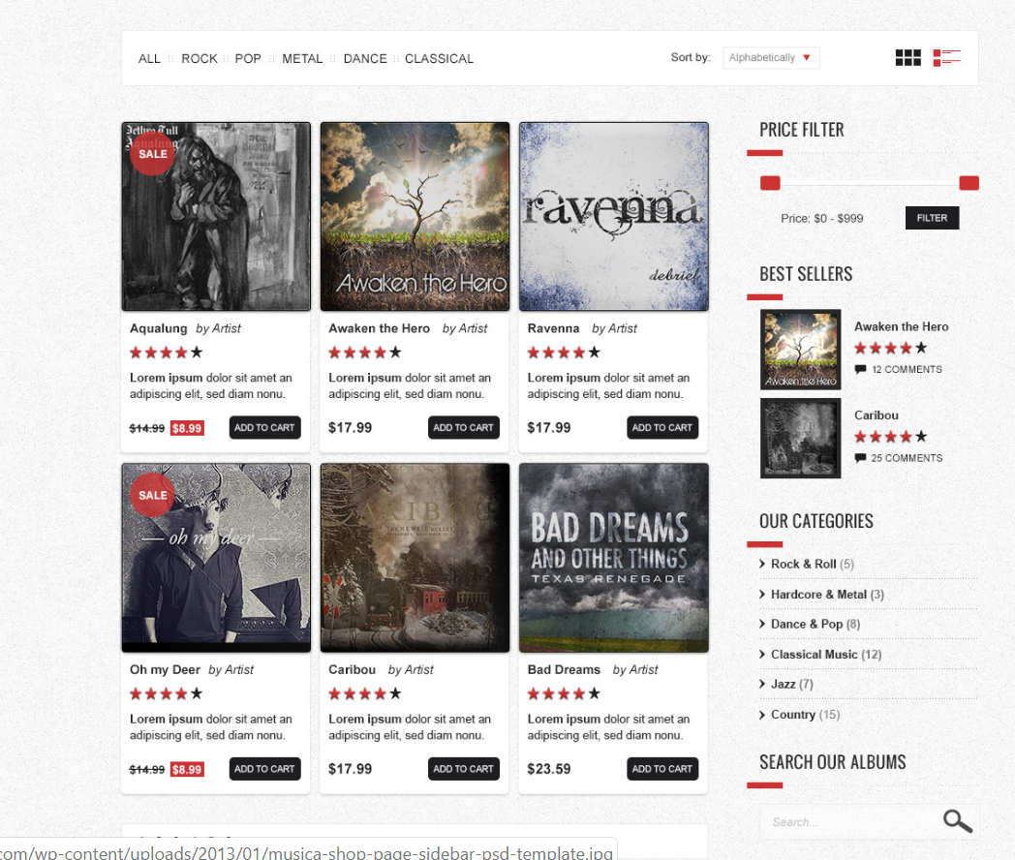

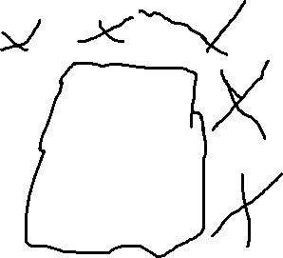

Example: I liked the add to cart feature, the description, the picture, price, and how the items were contained in identical shapes. but we need to add price structure (I don’t know if you want to add it to the container) for example in services:

1. Small Lot size- 25-100 X 25-100 = $25.00 (anything less would still be priced at the level)
2. Medium lot size- 101- 200 X 101-300= $50.00
3. Large lot size- 201-400 X 301-500= $75.00

Tree trimming(number of trees on the property and size)

1. 1-5 trees 0-10 foot tall=$125.00(only done every few years)
2. 5-10 trees 10-20foot tall=$250.00
3. 10-20 trees 20-40 foot tall=$500.00

Shrubs trimming( could be under every year)

1. 1-5 shrubs =$15.00
2. 5-10 shrubs=$30.00
3. 10-20 shrubs=$40.00

Duplicate this same style to Landscaping page but instead offer products for delivery.