

[REPLACE THE KITTEN WITH AN IMAGE REPRESENTING YOUR GAME] no

*Green Thumb*

by

**Team Boyd**

Table of Contents

**Version History** **3**

**Game Overview** **4**

**Win/Lose Conditions** **4**

**Game Controls** **4**

**Game Mechanics** **4**

Coffee Cups 4

**HUD Layout** **4**

**Level Layouts** **5**

**Asset List** **5**

Programming 5

Art 5

Audio 5

Level Design 5

# Version History

|  |  |
| --- | --- |
| **Version** | **Change log** |
| V1.0 | * Initial Draft |
| V2.0 | * Alpha Build, hud layout, ipm char |
| V3.0 | * Beta Build, Plants, Enemies, Turrets, Shop |
|  |  |

# Game Overview

***Green Thumb*** is a garden simulation game, in which you learn to grow better crops while defending your garden from bugs, stray animals, and neighbors. In this fast-paced chaotic game, follow the various upgrade paths to get better defense systems, better crops and fertilizers, and bigger space in your backyard. If you lose all your money and cannot afford seeds for the next day, the game is over and you lose.

# Win/Lose Conditions

Survival – Waves will get more and more difficult as time goes on.

Lose – Player runs out of money and cannot buy anymore seeds.

# Game Controls

WASD – Basic Movement

E – Interact: Plant seeds, water plants, harvest plants, place tower

Click – Within the Shop scene will buy new items

# Game Mechanic

## Plant Care

* **Watering Can**
  + Watering Can will be an item which the Player will use to tend their crop and make sure it will grow fast.
  + The Watering Can will have its own sound and animation when interacting with the plants

## Plants

* Plants will start of as seeds and will grow during the daytime with different visual signals attached to the plant to show and track plant growth
* Plants will need to be tended by the Player to keep growing and produce a successful crop
* Plants will be the main target for enemies as they will try to destroy the Players plants

## Shop

* The Shop will be where the Player will be able to interact with and purchase and sell items
* The Player will be able to buy seeds, upgrade items, and buy turrets
  + These items will be used to either help plant growth or help the player fight against the enemy

## Structures

* **Turrets**
  + Turrets will be able to be purchased in the shop and will be the Players best defense against enemies
  + Turrets will automatically target the enemy and depending on the turret will have different types

# HUD Layout and Level Layouts

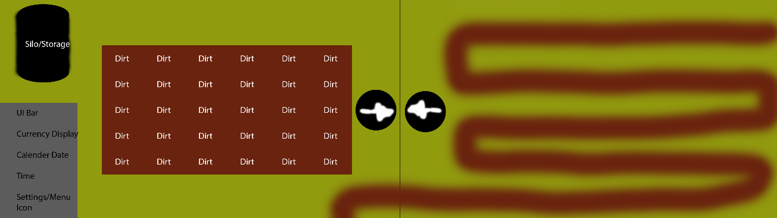

# IPM Chart

|  |  |  |  |  |  |  |
| --- | --- | --- | --- | --- | --- | --- |
| Mechanics | Level |  |  |  |  |  |
|  | 1 Day | 1 Night | 2 | 2 Night | 3 | 4 |
| Moving | P |  | M |  |  |  |
| Plant | P |  | M |  |  |  |
| Water | P |  | M |  |  |  |
| Harvest | P |  | M |  |  |  |
| Silo |  |  | P |  | M |  |
| Turret |  |  |  |  | P | M |
| Shop |  | P |  | M |  |  |
| Melee |  |  |  |  | P | M |
| Enemies |  |  |  |  | P | M |

# Asset List

## Programming

* Shop System: Buy and Sell
* Plant Interaction
  + Plant
  + Harvest
  + Water
* Plant Growth Progress Tracker
* Enemy Controller
* Player Controller
* Turret Controller
* Item Mechanics
  + Watering Can
  + Turret Placer

## Art

* Plant
* Items
* Farm
* Enemies
* Player
* Structures

## Audio

* Shop Interactions
* Player Actions
* Turret Actions
* Enemy Actions

## Level Design

* Tile Placement for Plants
* Farm Rows
* Silo
* House and Fence

|  |  |  |  |
| --- | --- | --- | --- |
| **Game** | **Night** | Day | Progression |
| *Location* | UI Layouts: Shop, Settings, Menu | Farmland: tiled out dirt, house background | Night: more items will become available in the shop  Day: Dirt tiles will be buyable to give more space to farm |
| *Gameplay* | Point and click | Switch Items, Plant, harvest, water and build turrets to fight against enemies | Different turrets plants and enemies introduced |
| *Objective* | Buy supplies and upgrade for the next day | Harvest plants and fight against emus | Will remain the same |
| *Upgrades* | Buy upgrades | Upgrade values on Turrets and Plants | Better upgrade values |
| *Enemies* | No interaction | Attack the plants or turrets in game | New Enemies Introduced, different targets for each enemy |
| *Plants* | Buy Seeds | plant, harvest, water, sell | new plants with different interactions |
| *Turrets* | Buy turrets | Plant and Pickup Turrets | new turrets with different interactions |