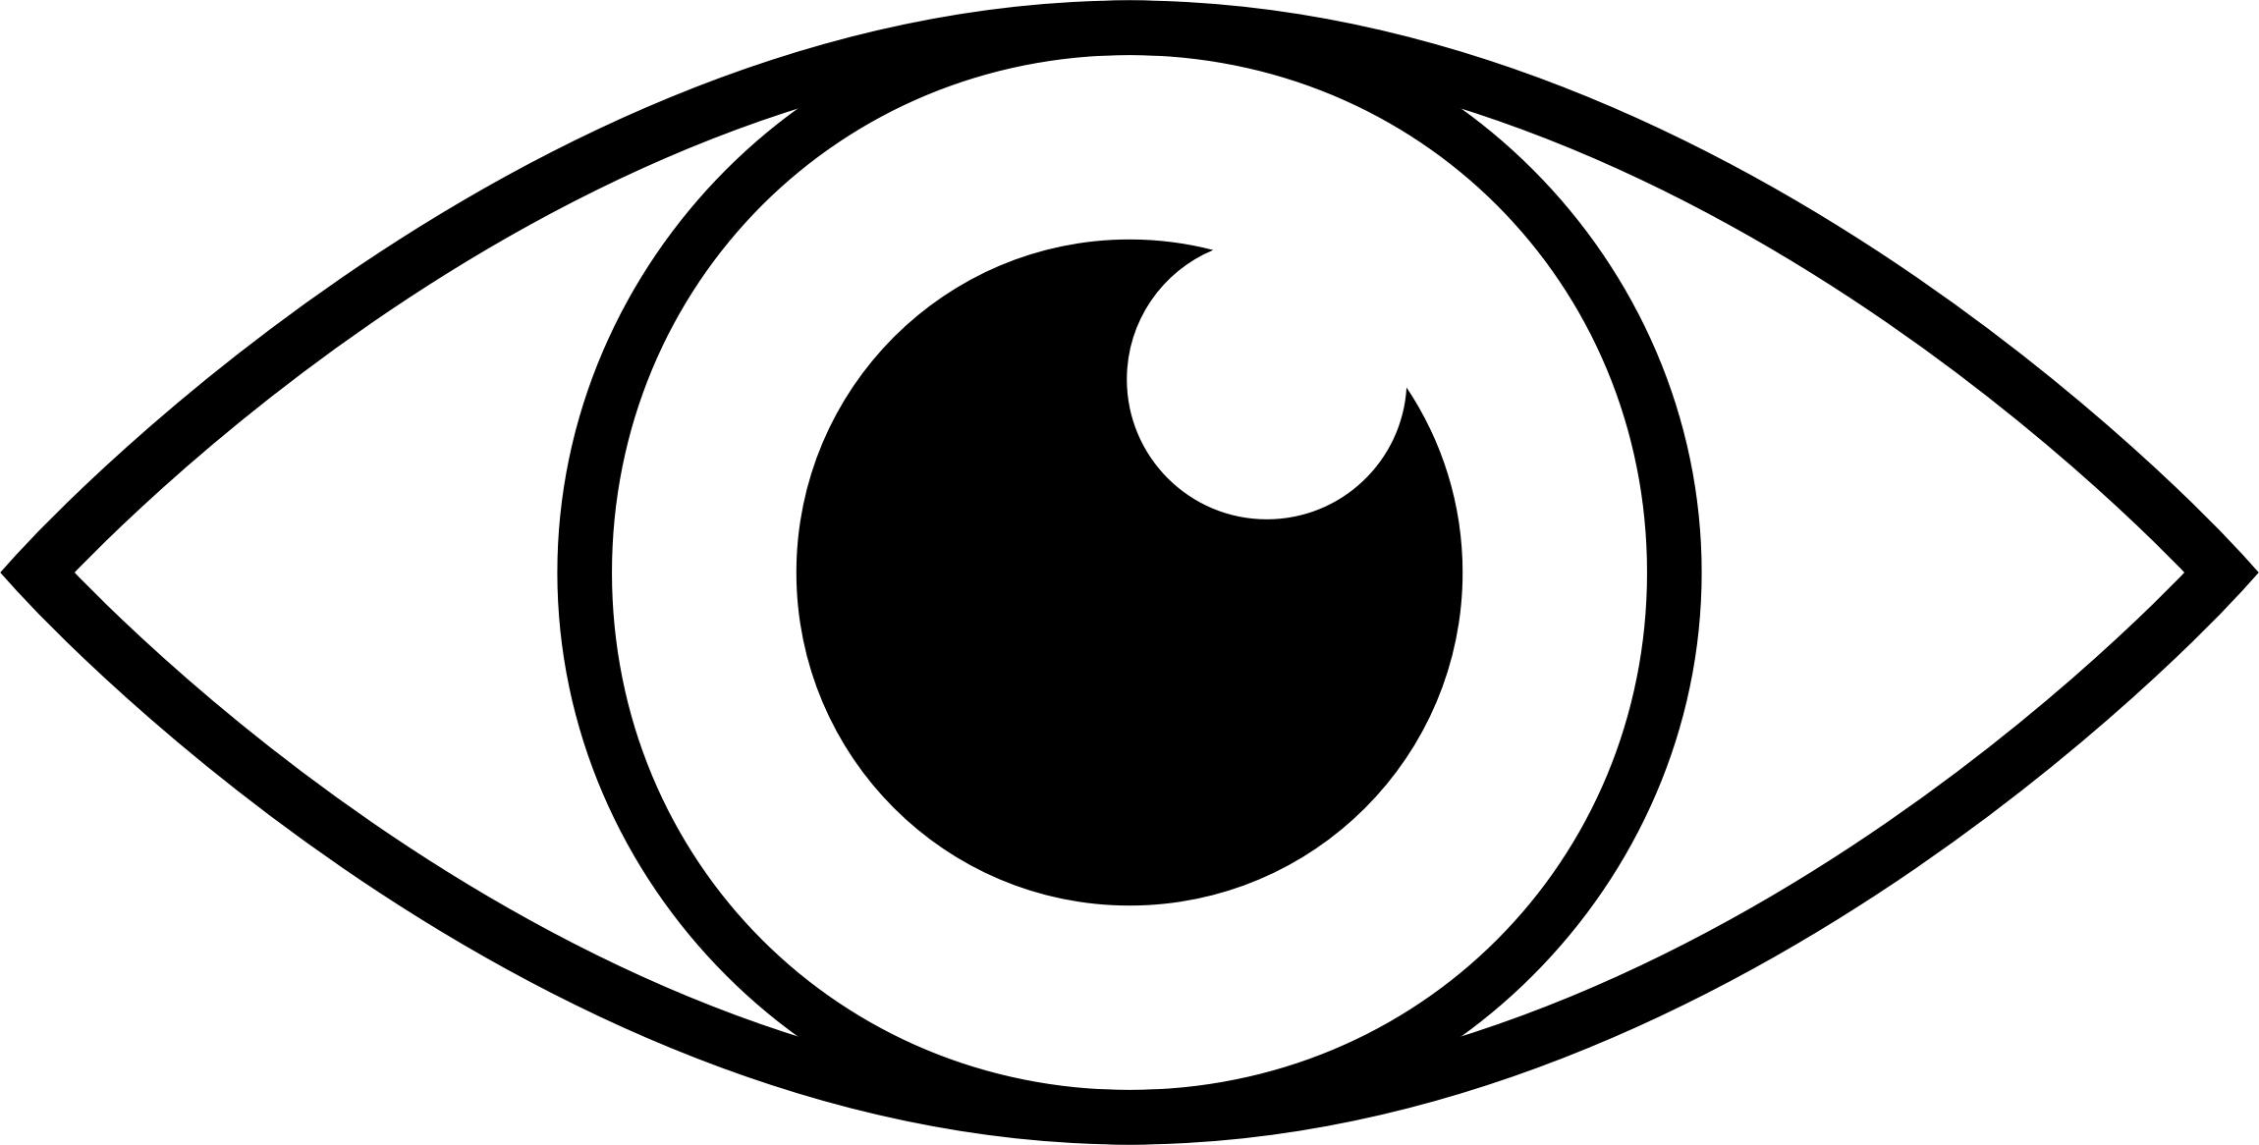
WE ARE

WATCHING

OVER YOU

TO ENSURE YOUR SAFETY

