Museum Husky Lidar Run — Process Report
Oct 20, 2026 · @huihang

Summary
We took three usable Husky recordings (named room01, room04, room05), which took about 13 minutes of driving, covered 180 m of path and produced 4.4 GiB of raw lidar data. From them we built one merged point cloud, a Nav2 map and two 3D models covering about 660 m² of the museum interior.
- Passes: the hall was driven once (7 min 13 s); the inner rooms were driven twice, as room04 and room05 (3 min 43 s + 2 min 00 s), so those two recordings overlap.
- Accuracy: rooms align to 7 cm RMS, hall to rooms 9 cm RMS, floors within 2 cm.
- Turnaround: about 20 minutes of compute for the full pipeline on a 2-core machine.

Field capture
Each area was recorded in a single continuous rosbag (MCAP, ROS 2 Jazzy). Times are local (EDT) on Mon 19 Oct 2026; the robot clock was NTP-synced.
Recording | Area | Time (EDT) | Duration | Path length | Avg speed | Lidar scans | Bag size
room01 | Hall | 09:58–10:05 | 7 min 13 s | 79 m | 0.18 m/s | 4,148 | 2.5 GiB
room04 | Inner rooms, pass 1 | 10:33–10:37 | 3 min 43 s | 63 m | 0.28 m/s | 2,052 | 1.2 GiB
room05 | Inner rooms, pass 2 | 10:40–10:42 | 2 min 00 s | 38 m | 0.32 m/s | 1,170 | 0.7 GiB
Total |  |  | 12 min 56 s | 180 m |  | 7,370 | 4.4 GiB
The robot was moving for 63% of the hall recording and about 90% of the room recordings; top speed was about 0.9 m/s. Two other recordings are not included: room02 was started by accident, and room03 was lost when the robot ran out of battery mid-recording, before the bag was saved. Path lengths and speeds come from the lidar odometry, not the wheel encoders.

Data size
The three bags total 4.4 GiB in 6 MCAP files, almost all of it lidar point clouds. That is about 5.8 MiB/s, or roughly 21 GiB per hour of driving. The recorder dropped only 0.16–0.69% of messages, with no effect on the maps.

How the outputs were made
Processing took about 22 minutes of compute in total. Each step below lists what was done and what came out of it.
1. One map per recording. We ran lidar odometry (KISS-ICP) on each bag to get the robot path and a point cloud per recording. Wheel odometry was not usable for this: its heading drifted about 38° between room04 and room05.
2. Join the recordings. room05 was aligned onto room04 by matching their wall layouts. The hall was aligned to the rooms through the open glass double door, checking that no wall lands where the other recording saw open space.
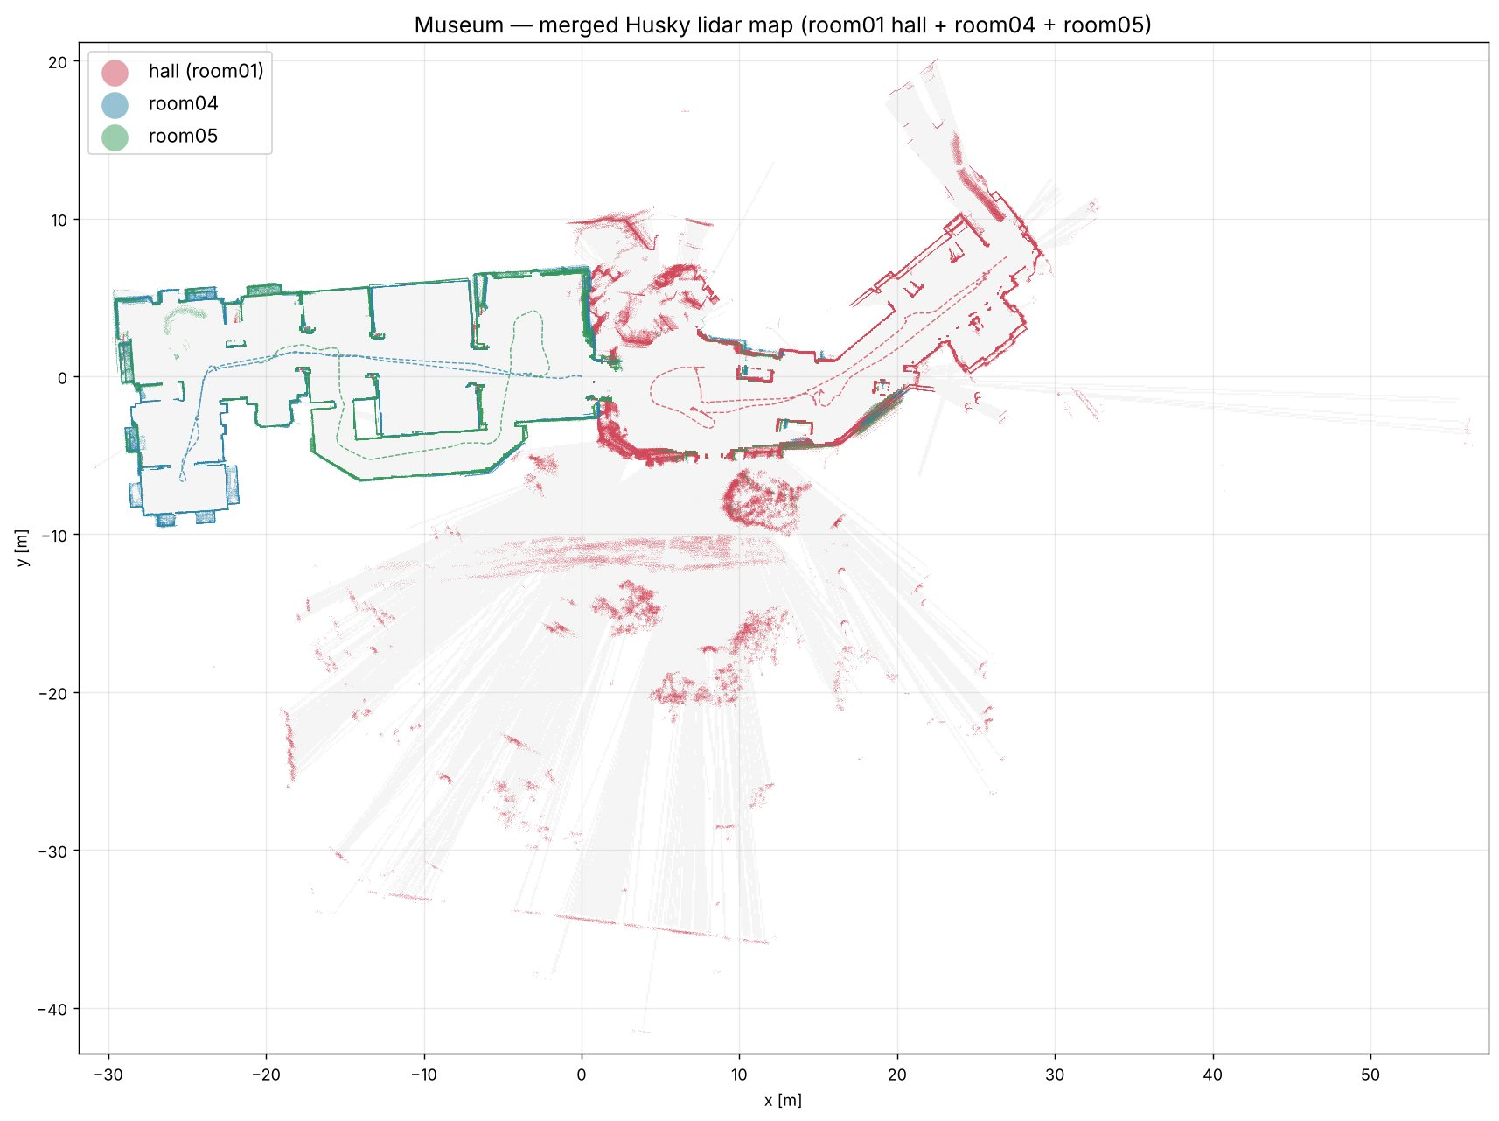
Figure 1. Merged floor plan: hall (room01, red), room04 (blue), room05 (green); dashed lines are the robot paths.
3. Merged point cloud. The joined clouds form one point cloud in a shared frame with the floor at z = 0. People walking next to the robot were removed. Points the lidar saw outside the building through glass doors and windows were also removed.
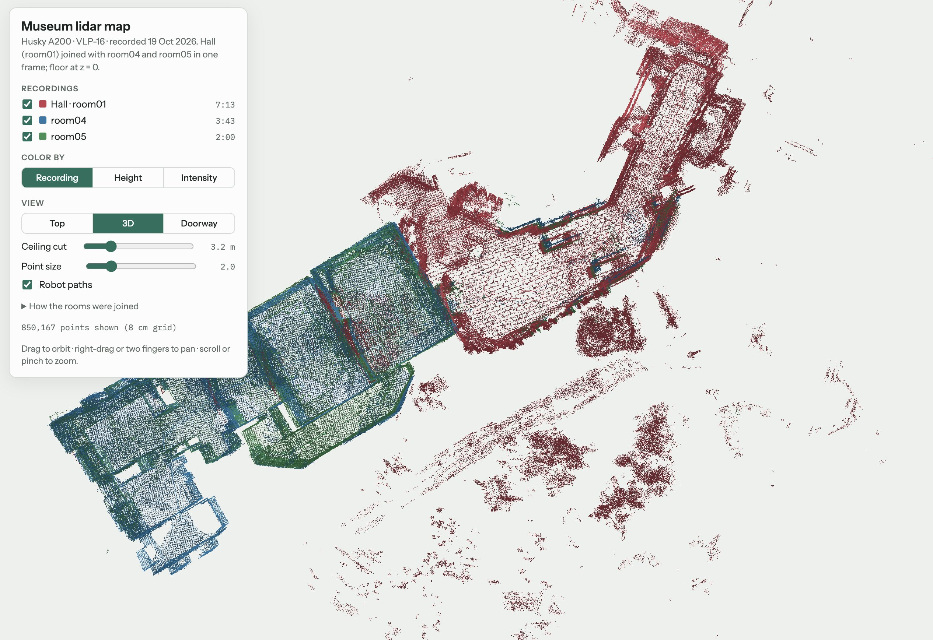
Figure 2. Merged point cloud, 3D view (ceiling cut at 3.2 m).
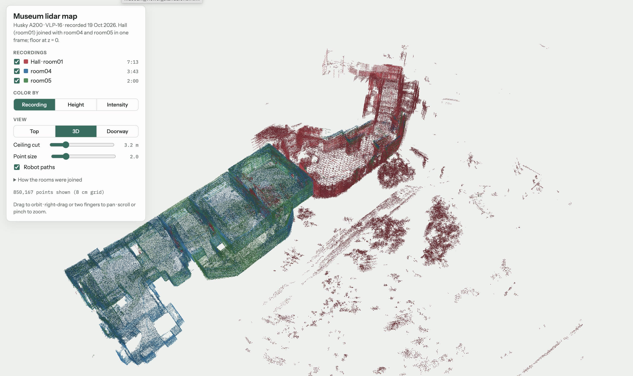
Figure 3. Same cloud from another angle; the scattered points in the lower right are outside the building, seen through glass.
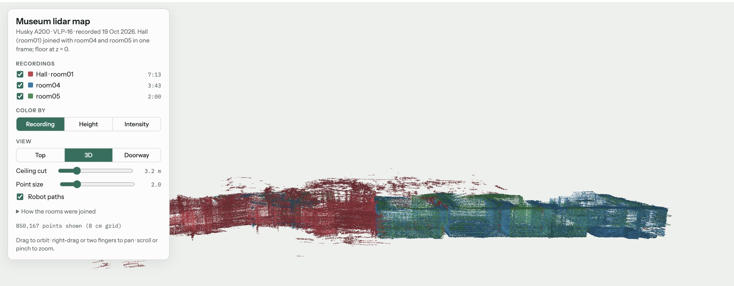
Figure 4. Side view: the floors of all three recordings line up (within 2 cm).
4. 3D model. From the cleaned cloud we built two models. The architectural model has walls extruded to the measured ceiling height (2.6–3.4 m), a flat floor, and exhibits as blocks. The scan mesh is a surface reconstructed directly from the points. The hall ↔ room04 glass double door is modelled from measurements (opening 2.25 × 2.13 m, two 1.12 m leaves) and can be opened or closed in the viewer.
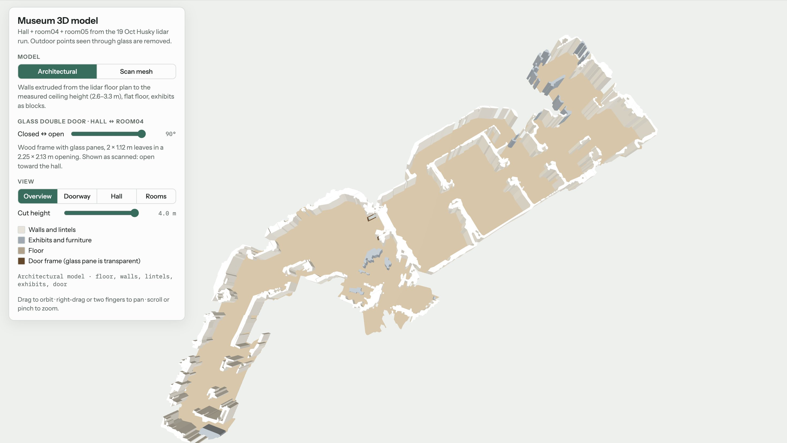
Figure 5. Architectural 3D model (floor, walls, lintels, exhibits, door).

Results
The three recordings join into one map with 7–9 cm alignment error, covering about 660 m² of interior (556 m² of floor).
Check | Result
room04 ↔ room05 alignment | 73% of wall points within 15 cm, 7 cm RMS
Hall ↔ rooms alignment | 9 cm RMS, joined through the open glass double door
Floor height across recordings | agree within 2 cm
Wall noise, single recording | 3.2 cm RMS
Ceiling height | 2.6–3.4 m
Hall ↔ room04 door (measured) | opening 2.25 × 2.13 m, two 1.12 m leaves, wall 0.9 m deep

Links
Point cloud viewer: https://museum-point-cloud.netlify.app
3D model viewer: https://museum-3d-model.netlify.app
Files in the repository: merged point cloud (PLY), per-recording clouds and poses, Nav2 map, 3D models (GLB and STL), and offline HTML viewers. Raw bags (4.4 GiB) are kept on OneDrive.

