SAGE (Spreadsheet Adventure Game Engine)

How it Works
SAGE is a system that lets you design or play an adventure game based only on a series of spreadsheets and assets (e.g. images and fonts). For the player, the only difference is how the game is packaged: you'll need SAGE and you'll need to put the game data in a particular place within your SAGE folder (more on that in a moment). For the developer, it means all your development is done outside of the engine. There aren't a lot of fiddly bits. There's no importing and re-importing of images, there's no creating objects in an engine and connecting events to them and endless configuration settings. It's just you and your art and Excel – or Open Office – or whatever.

How to Play
Whatever folder the engine is in, you will need a Games folder sitting in that directory. Inside of the Games folder, each folder not beginning with a “_” or a “.” symbol will be considered to be a game, and will be displayed on the game select menu. If there is only one game in the Games directory, then that game will be autoselected upon starting the engine and the game select menu will not be displayed.
The first time you save while within a game, a corresponding folder within a new Saves directory (again, in the same folder as the engine) will be created. It needs to stay there to be detected.
Some games may change the shortcut keys, but by default they are:
- F5 to create a quick save (quick save overwrites any previous quick save)
- F9 to load your quick save
- Tab or the letter I to toggle the inventory
- Q and E to switch characters in multi-character games

For developers – but players may need to use these if the combos are accidentally pressed:
- Ctrl-Backspace to toggle Debug Mode
- Period to toggle the current player's dialogue/portrait menu

Overview
You're going to want to start with the spreadsheet, game-data.ods. You are free to add columns and any formulas, macros, or formatting that you find useful for your workflow. The main thing the engine will be interested in is the export of each tab: you'll need to save them as CSVs (“comma-separated values”) with double-quotes around each field and commas between. The header row will also need to contain all expected values, and a “DEFAULT” row (more detail in “The Nitty Gritty”) needs to exist.
In the included game-data.ods, I've also included a macro which will export all of the tabs. You'll need to close & reopen the file after to get the spreadsheet version back (as opposed to the CSV). Or if you're doing it manually, it will look something like this:
Most of the tabs are pretty straightforward. The one pictured above is the Characters tab, with 6 columns dedicated to fonts and another 6 to their starting screen/position. Almost every tab has a DEFAULT line (in black above). This allows you to set your own defaults for everything. If you want to use the same font for every character, then you will only need to fill in the DEFAULT line and you can leave everything else blank. Again, more detail on all of this later.
By far the most complicated piece of this will be the Scripts tab. For that reason it's not the best place to start, but I want to give you a taste of what's ahead.
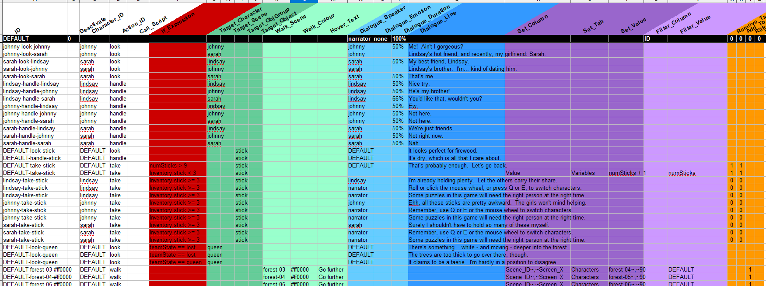
The white columns indicate that a character is taking an action. This, together with the green columns (the action's target) and the red (any conditions on the action) will indicate when the script fires. Your “script” may be one line or multiple; the engine will look at every line matching the triggers and run them in order. So example you might want something to happen when Lindsay looks at Johnny. When you fill in the appropriate columns, you're defining a script with ID “lindsay-look-johnny”. Now you fill in the blue columns to trigger dialogue or the purple to alter any property. For example, to change the positioning or current scene of a character (whose starting values we saw above). The orange columns are specific things that can happen afterwards, such as adding an object to inventory, waiting some time, or reloading the scene.
Another piece that is a bit complicated is “walkmaps”. For every scene you will have an image for the background, optionally one for the foreground, and most likely also a walkmap. All of these should be the same size as each other. Here is my forest scene side-by-side with its walkmap:

The purpose of this is to tell the engine where the player can go – and whether going there should trigger any scripts. Players will not be able to move on to areas painted in black. All other colours are allowed, although white is highly recommended as the “do nothing” colour. Other colours are arbitrarily decided by you, however I recommend having a pattern you can remember easily (mine goes by hex colour value: ff0000, or red, to move left, and 0000ff, or blue, to move right). Because I also have scripts defined for red and blue on the scripts tab, the player will change scenes when they step there.

The Nitty Gritty

Information on All Sheets
If you're ready to start building a game, begin here! Take a look at the Objects tab for your example, but concepts used throughout the process are detailed in this section.
Almost every tab will begin in the same way: Row #1 is a list of properties beginning with “ID”, and Row #2 is a list of default values beginning with “DEFAULT”.
Don't alter the text in the first row at all, ever. These column names must remain as they are in order for the engine to find them. (However it is fine to add/alter formatting, change the ordering of columns, and add additional columns. Just don't change the names of the ones that are already there.)
Aside from the cell with the word “DEFAULT”, the second row is yours to play with. This is a very important row (which is why I made it so distinct). Any cell left blank in other rows will use the value in this row, if there is one. Using this liberally can save you a lot of time – and trouble. For example, I've defined many properties with multiple columns that might be more naturally considered one piece of information, because of the power of the default row. Consider the image associated with each object. Inside your game directory, your folder structure is yours to choose – but you will most likely want to put all of your Object images in one place. Odds are also good that you'll be sticking mostly with one type of image – png, jpeg, whatever. So fill in the path and the extension once each, and only the Filename needs to be entered multiple times. For the occasional oddball, you can fill in on the row itself, but most of them can be blank. This dramatically decreases the chances of making a typo on just one image, and also reduces the effort required if you later decide to move your fonts into a new folder.
Note that “Path” and “Extension” could also include a “prefix” or a “suffix”, respectively, to the filename. e.g. maybe you want to put the inventory image for each object in the same folder as the object images, but those will all start with “inv_” - you can include that in the “Path” column because in the end, all three columns just get used together.
You should also take care with the ID Column. You are free to use whatever combination you like of uppercase and lowercase letters, numbers, and even some symbols here. However they must be unique within any given tab. You should also keep them unique across tabs if you can, as I cannot guarantee that you would not encounter any errors from having, e.g. a character “penny” and also an object “penny”. Choose your IDs well, particularly for your characters, so that you will remember them when you need to reference them in other sheets. Characters show up again in Inventory, Emotions (for character portraits), and Animations. Characters and many others also appear in Scripts.
Also, be aware that every property on every page is just the starting value. You can set up scripts to alter the value of any property as the game goes on.

Objects

Group & Unique Advanced
You can ignore these columns most of the time. They will only be used if you want to define a collection of objects that appear distinct in the scene, but group together once in the inventory. For example in Lake of Reflection the player needs to collect multiple sticks. In that case I define Group as “stick” for each and give a unique number, then make the ID be Group+Unique. SAGE looks at ID and at Group only. If making use of this functionality, you will also need to fill in a corresponding record in the ObjGroups tab.

Scene_ID
This is where you define the starting scene for each object. It needs to correspond to an ID in the scenes tab.

Visible
Set this as 1 for visible, 0 for hidden.

Actionable
In most cases this column will be 1 to indicate that the player can interact with the object. For those situations where an object should not stand out from the scene in any way, set this property to 0. An example of use is a scene that contains a secret passageway. At the start of the game you might cover it up with a wall object with Actionable=0. Once the passageway is discovered, you might hide the wall. Or you might change it to Actionable=1 and set up a click event to toggle it between an “open” and a “closed” image.

Image _Path, _Filename, & _Extension
Taken together, these three columns point to the image that will be used for this object. The “root” folder (where Path is blank) is your game folder, and you should always use what's called a “relative path” which leaves off everything prior to and including your game's directory. For example, if your game is in “C:/Documents/SAGE/MyGame” and your image is in a folder called “images” inside of that, then Image_Path would be “images/”. (Don't leave off the closing bracket, nor the period in front of the extension - the Path, Filename, and extension are simply combined to form the final result: you'll want the system looking at “images/obj.png” and not “imagesobjpng”.

Screen_X, Screen_Y, Base_X, & Base_Y
These values together indicate where the object is drawn on the screen. Note that they are given in percentages in order to reduce reliance on specific image sizes. If you later change your scenes from 3:4 ratio to 16:9, your objects will still show up roughly where you expect them to.
So Base_X and Base_Y are the point within the object which will be anchored to Screen_X and Screen_Y, a point within the scene. If Base_X and Base_Y are both set to 50%, then Screen_X and Screen_Y indicate where the center of the object sits. Alternately, you might prefer to set Base_X and Base_Y to be a position indicating the top or bottom of the object, the place where the object meets the floor or ceiling. Thus the position within the screen is more meaningful. (You will need to consider the Base coordinates for Characters anyway, in order for the walkmaps to work as you expect).
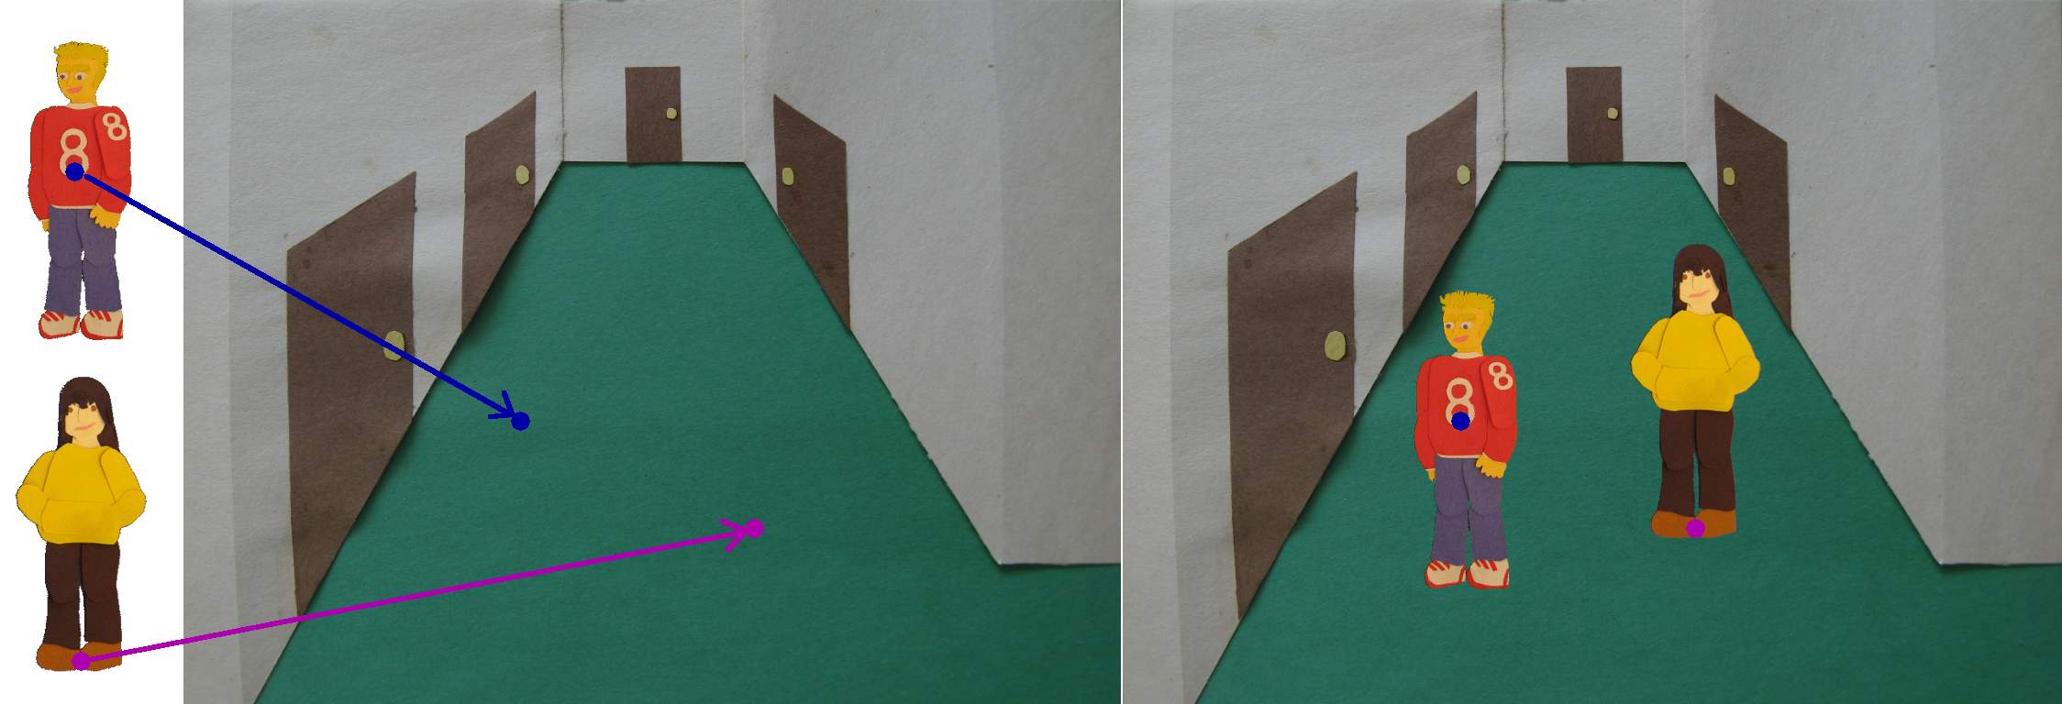
Note that Base_X and Base_Y are the percentage of the object image, while Screen_X and Screen_Y are the percentage of the screen (or scene image).

Zoom
The size at which to draw the object onto the scene. At 100%, it's exactly the dimensions of the object file.

Rotation
Rotation of the object on the scene, in degrees. 0 (aka 0°) is the same as in your image file; 90 is a quarter-turn anti-clockwise, 180 is upside-down, and so on.

Flip_H & Flip_V
These can cause your object to be a mirror image of your file, either horizontally (Flip_H) or vertically (Flip_V) or both. 1 to flip, 0 to leave alone along that axis.

