GREEN DIGITALS ERP
User Guide — Screens, Buttons & Options
Version 1.0 (Web)
Generated: 2026-07-24 · Updated: 2026-10-20 (covers changes up to v24)
About This Guide
This guide walks through every module of the Green Digitals ERP application. For each screen you will find a screenshot of the interface followed by a plain-English list of every button, dropdown, and input field found on that screen, along with what it does.

What's New (v21 – v23)
This guide was first written on 2026-07-24. The changes below came afterwards; each points to the chapter that explains it, in a section called "Updates since the original guide". Screenshots of new screens use sample data.
Set these up first
- Company Details — Printed invoices and quotations now take the company address, phone, GST number and bank details from the Company / Bank Details tab, and print those lines blank until you fill them in. (They used to carry another company's details.) See chapters 12–14 and 19.
- Accounts — Green Digital no longer has any built-in bank accounts. Add up to three in Company / Bank Details › Bank Accounts; they then appear in every payment and account dropdown, the Ledger, the Dashboard and the Summary. Cash and Pending are always available. See chapters 3, 5, 15 and 19.
New and improved
- Daily Expense — Account filter, Category / Sub filter, Duplicate button, Quick Add chips, and an Excel Template / Import / Export. The Salary & Wages list no longer contains staff names. (Chapter 5)
- Customers — Check Duplicates finds and merges customers entered twice; the Customer Details form is one row; names are compared ignoring capital letters. (Chapter 11)
- Reports — The Sales Report reads its own date fields; Invoice and Quotation reports include every record; restricted users see only their own records. (Chapter 17)
- Database Backup — A one-click backup of this application's database and a guarded restore. (Chapter 19)
- Admin protection — Backup, Restore, creating or deleting users and changing roles now require an admin login on the server itself, and admins see a banner if the server is older than the page. (Chapters 18 and 21)
- Sales Tracker — Fixed: a sale whose serial number was stored as text could not be opened for editing. (Chapter 3)
Invoicing (v23)
- Invoice numbers GD01 / GDN01 — New invoices are numbered GD01, GD02… (GST) and GDN01, GDN02… (without bill), restarting each financial year. Earlier R01 / RN01 numbers stay as they are. (Chapter 13)
- Cancel instead of delete — Admins cancel an invoice (reason required): its number is kept, it is marked CANCELLED and left out of totals and reports. Delete is only for the newest invoice of its series that was never printed or shared. A Check numbering button finds missing numbers. (Chapter 13)
- Green Digital's own logo — Invoices and quotations printed Rio Print Media's logo; they now print Green Digital's. (Chapter 13)

1. Login Page
The Login page is the first screen anyone sees when opening the app. It shows the company logo and branding on the left, with a username and password sign-in form on the right.
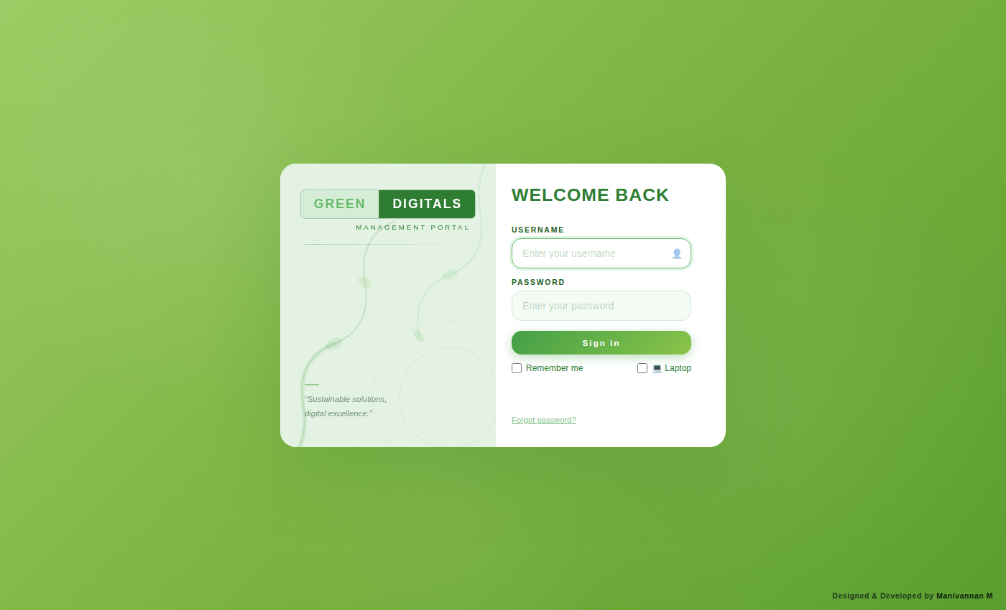
Buttons & Actions
- Sign In — Verifies the entered username and password, then opens the Dashboard on success.
- Forgot password? — Opens the password recovery flow for users who can't remember their login.

2. Dashboard
The Dashboard is the landing screen after login. It gives a quick, at-a-glance summary of the business — pending payments, active jobs, and key numbers pulled from every other module — plus quick links to jump straight into related screens.
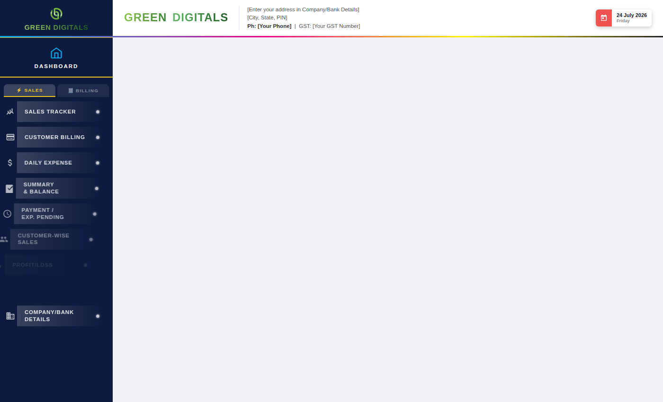
Buttons & Actions
- REFRESH — Reloads the latest data from the server.
- View All Pending → — Opens the full Payment / Expense Pending list.
- View All Jobs → — Opens the full Job Tracker list.

3. Sales Tracker
Sales Tracker is where day-to-day sales entries are recorded — product, size, quantity, rate, GST, billing type, and payment/advance details. Entries here flow into the Ledger, Invoice, and Customer records.
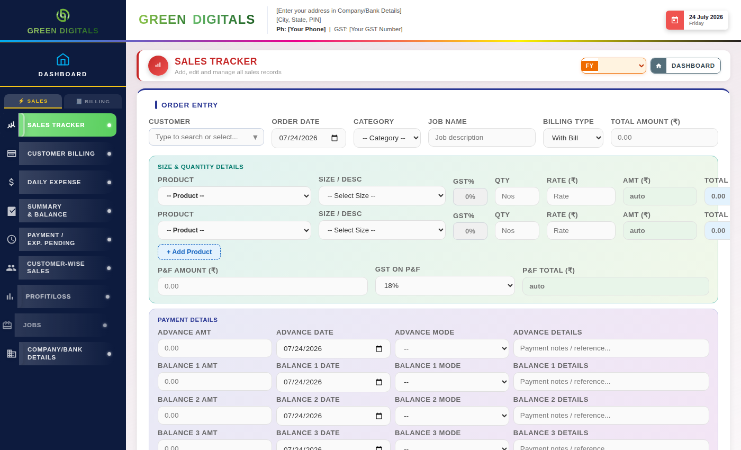
Buttons & Actions
- ✕ Cancel Edit — Exits edit mode without saving changes and returns the form to blank.
- + Add Product — Adds another product/size row to the same sales entry.
- Add Entry — Saves the entry currently filled in on the form into the list/table below.
- Delete Entry — Deletes the selected sales entry.
- GO TO LEDGER — Jumps to the Ledger screen, filtered to the relevant account.
- GO TO INVOICE — Jumps to the Invoice screen to raise an invoice for this sale.
- GO TO CUSTOMER — Jumps to the Customers screen for this customer's record.
- Go — Runs the search/report for the date range, customer, or filters selected above.
- Reset — Clears the filter fields back to their defaults.
- Refresh — Reloads the latest data from the server.
Dropdown Fields
- Category — Choose the product category for this sale. (Options: -- Category --, Sunpac, Promotional)
- Product — Choose the specific product within the selected category.
- Billing Type — Choose whether this sale is billed With Bill (GST) or Without Bill.
- Size — Choose the size/dimension variant of the product. (Options include 16x6, 18x6, 12x18, 12x12, 16x16, 24x18, 24x12, 24x24, 36x12, 36x24, 48x4 Inches, Others)
- GST % — Choose the GST rate applied to this sale. (Options: 0%, 5%, 18%)
Updates since the original guide (v21)
- Advance / Balance 1–3 Mode dropdowns — Now list the accounts you set up in Company / Bank Details › Bank Accounts, plus Cash. Until you add accounts only Cash is offered.
- Opening an older sale — A sale saved earlier under an account name that is no longer in the list keeps that value when you open it, so editing and saving it never loses the payment.
- Edit — Fixed a problem where a sale whose serial number was stored as text could not be opened for editing.
- Product list refresh — The product list is reloaded every time you open the Sales screen, and the rows already on screen are updated, so a product you have just added in the Products tab appears straight away. If the list could not be loaded the dropdown says so and clicking it tries again; if no products exist yet it says to add them in the Products tab.

4. Customer Billing
Customer Billing shows outstanding and settled bills per customer, letting you record payments received and track balances owed.
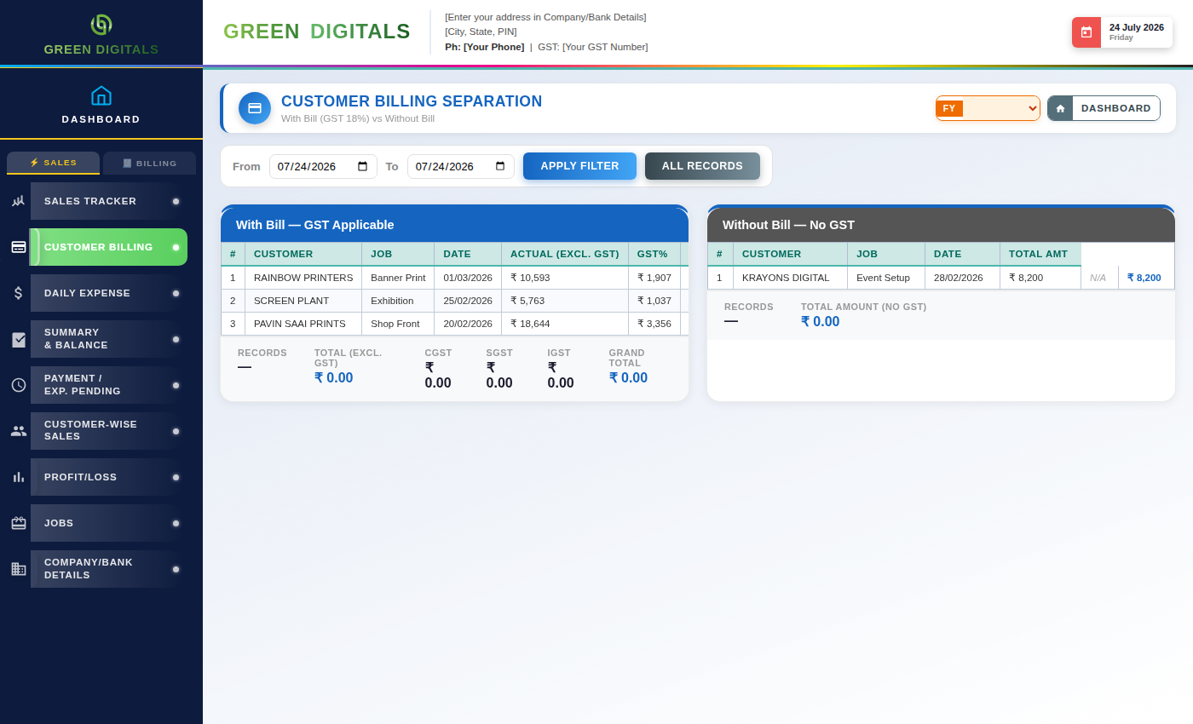
Buttons & Actions
- Refresh — Reloads the latest billing data from the server.
Dropdown Fields
- Customer — Select which customer's billing record to view.

5. Daily Expense
Daily Expense records day-to-day business spending — category, sub-category, amount, and payment mode — so it flows into the Ledger and Profit/Loss reports.
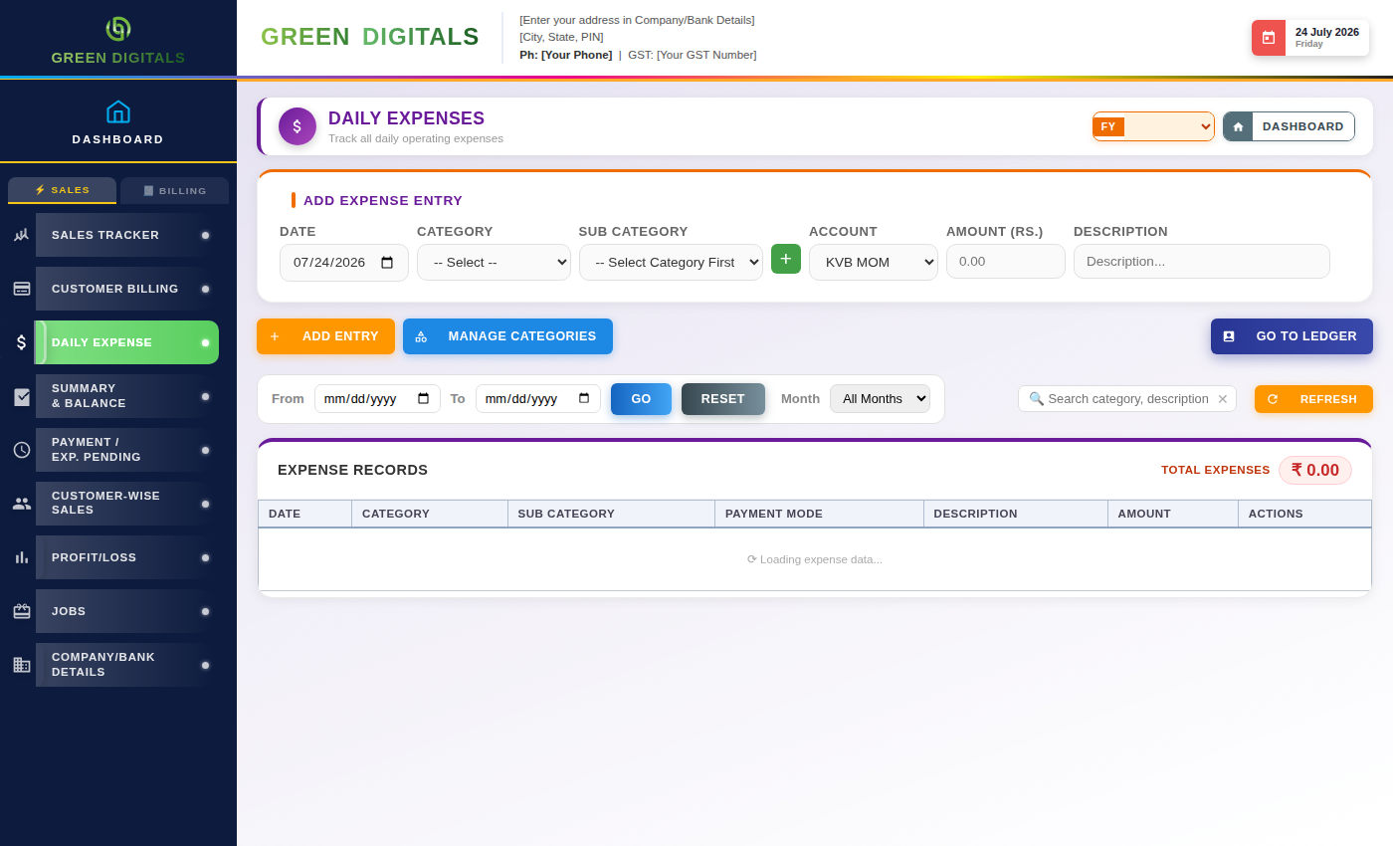
Buttons & Actions
- ✕ Cancel Edit — Exits edit mode without saving changes.
- Add Entry — Saves the expense entry into the list below.
- Delete Entry — Deletes the selected expense entry.
- + Add Category — Adds a new expense category to the dropdown list.
- Go — Runs the search/report for the selected filters.
- Reset — Clears the filter fields back to their defaults.
- Refresh — Reloads the latest data from the server.
Dropdown Fields
- Category — Choose the expense category (e.g. Rent, Utilities, Salaries).
- Sub-Category — Choose a more specific sub-category within the selected category.
- Payment Mode — Choose how the expense was paid (Cash, Bank, UPI, etc.).
Updates since the original guide (v21)
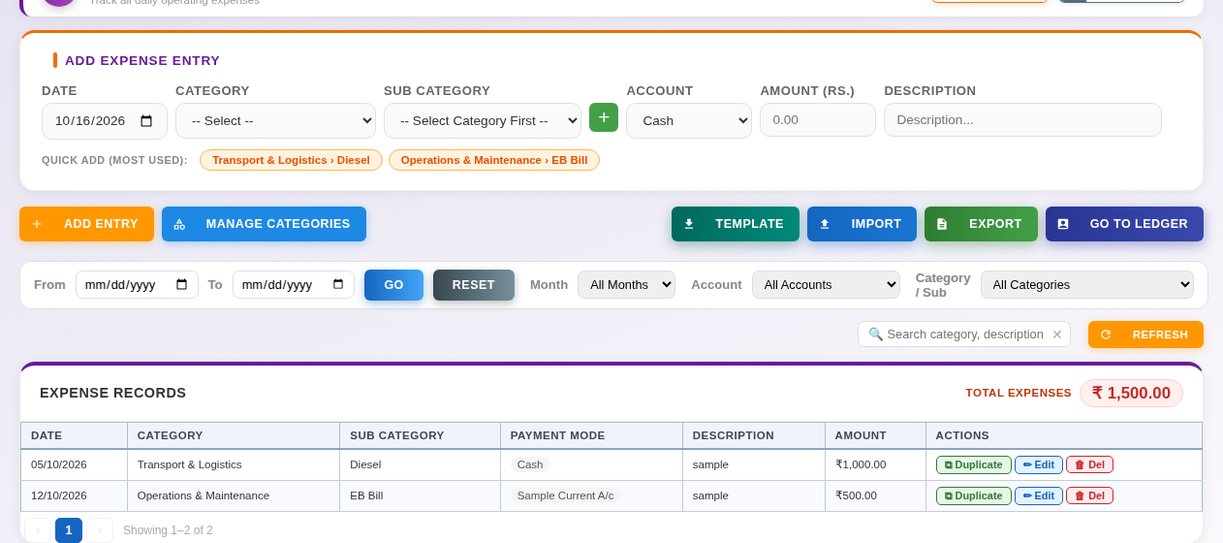
Daily Expense with the new tools (sample data).
- Account (entry form and filter) — Lists your accounts, Cash and Pending. The Account filter beside Month narrows the records to one account; Reset clears it.
- Category / Sub filter — A dropdown listing every Category and Sub Category in use; it can be combined with the other filters and is cleared by Reset.
- ⧉ Duplicate (on every expense row) — Copies that row's Category, Sub Category, Account, Amount and Description into the Add Expense Entry form with today's date and puts the cursor in Amount. Check the date and amount, then Add Entry; the original is never changed.
- Quick Add chips — Up to eight buttons showing your most-used Category / Sub Category pairs. Clicking one fills only Category and Sub Category.
- TEMPLATE / IMPORT / EXPORT — TEMPLATE downloads an Excel file with a Date dropdown (the current month, DD-MM-YYYY), Category, Sub Category (which follows the chosen Category) and Account dropdowns, plus Amount and Description. IMPORT adds the rows of a filled template and reports any it skipped; new categories are registered immediately. EXPORT downloads the records currently shown.
- Salary & Wages — The sub-category list now contains only Other. Add your own staff as sub-categories with Manage Categories.
- Manage Categories — Deleting a category or sub-category now works. A category that expenses still use cannot be deleted.

6. Summary & Balance
Summary & Balance gives a consolidated view of income, expenses, and running balances across accounts for a selected date range.
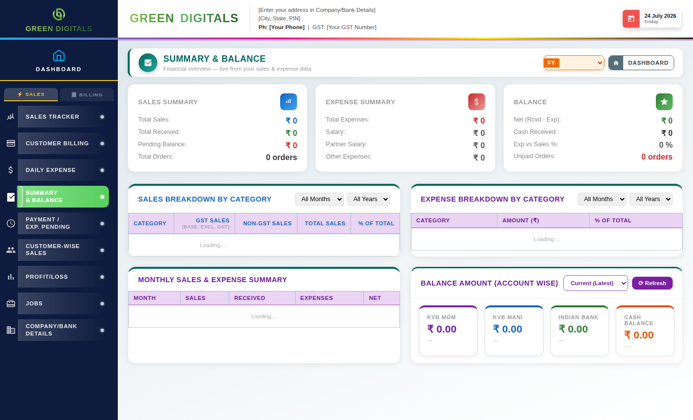
Buttons & Actions
- Refresh — Reloads the latest summary data from the server.
Dropdown Fields
- Date Range / Period — Choose the period this summary should cover.
- Account — Filter the summary to a specific account.
Updates since the original guide (v21)
- Account balance cards — Show one card for each account you set up in Company / Bank Details, plus Cash. Cards for accounts that are not set up are hidden.

7. Payment / Expense Pending
This screen lists all payments and expenses still marked pending — money owed to you, or bills you still need to pay — so nothing gets missed.
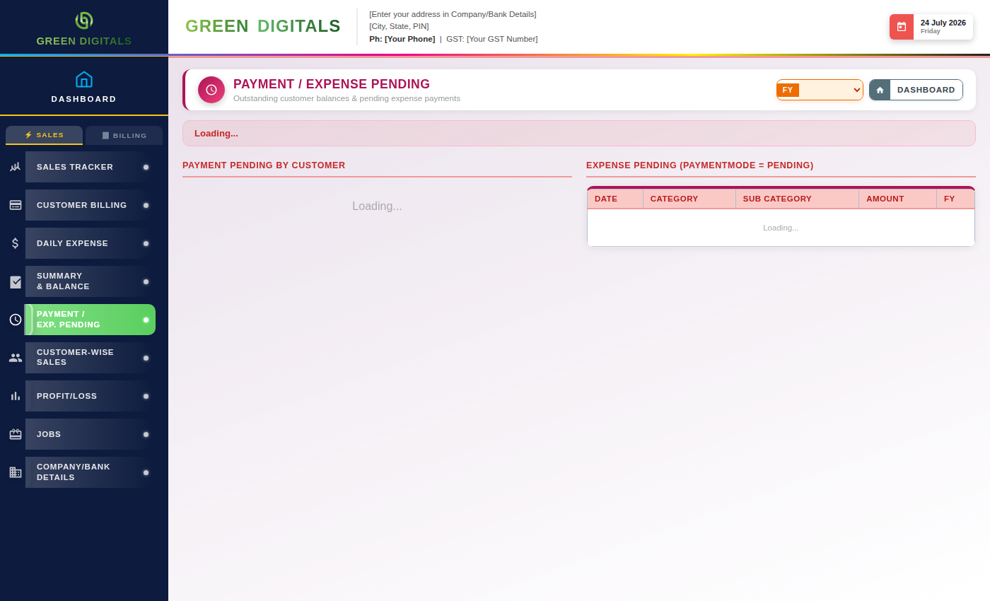
Dropdown Fields
- Filter / Status — Filter the pending list by status or type.

8. Customer-Wise Sales
Customer-Wise Sales breaks down orders, billing type, and balance owed for each customer individually, useful for spotting your top accounts or overdue balances.
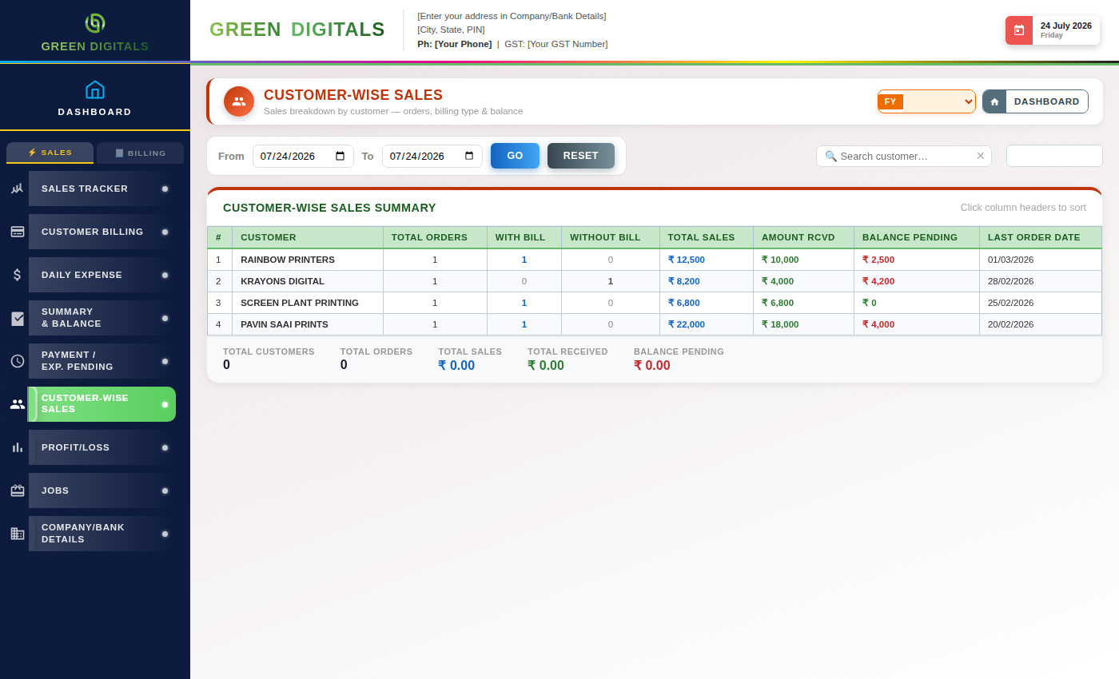
Buttons & Actions
- Go — Runs the report for the selected customer and date range.
- Refresh — Reloads the latest data from the server.
Dropdown Fields
- Customer — Select which customer's sales breakdown to view.

9. Profit / Loss
The Profit / Loss statement compares total income against total expenses for a selected period, giving a clear net profit or loss figure.
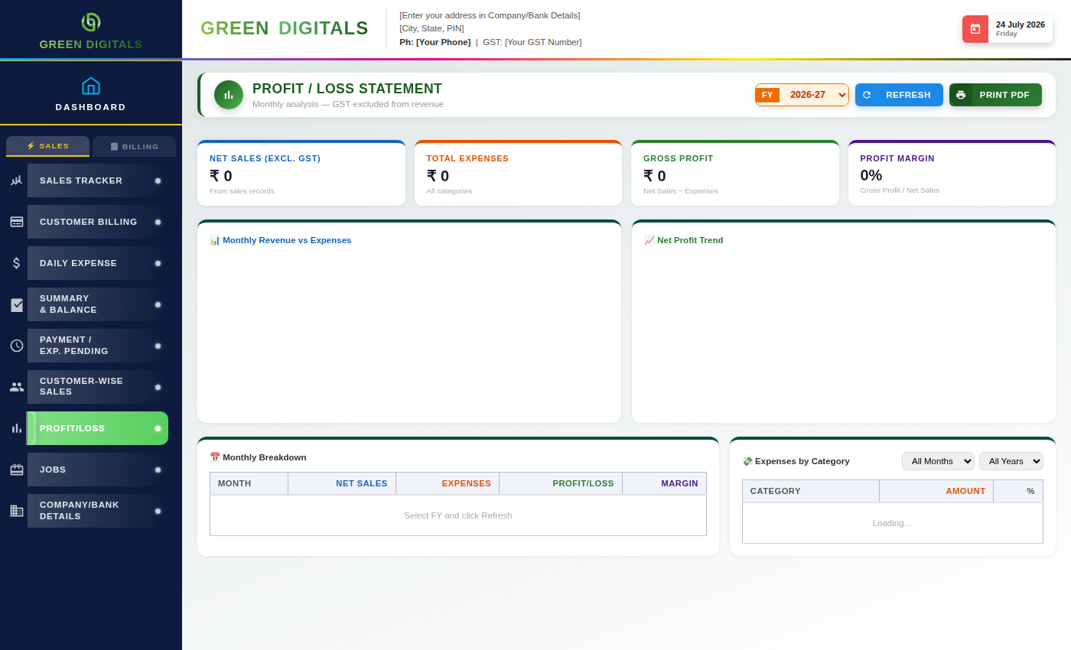
Buttons & Actions
- Go — Runs the profit/loss calculation for the selected period.
- Refresh — Reloads the latest data from the server.
Dropdown Fields
- Period / Financial Year — Choose which period this statement should cover.

10. Jobs
Jobs tracks work orders through their stages from start to completion, keeping a record of status, assigned staff, and due dates.
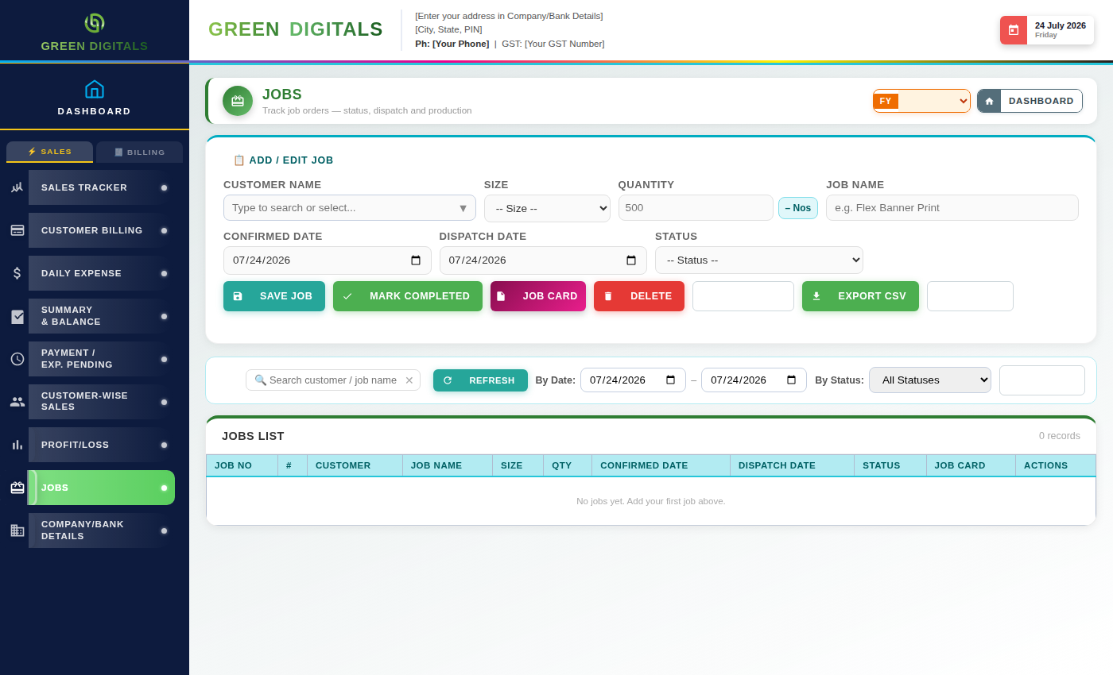
Buttons & Actions
- ✕ Cancel Edit — Exits edit mode without saving changes.
- Add Entry — Saves the job entry into the list below.
- Delete Entry — Deletes the selected job.
- Go — Runs the search/filter for jobs matching the criteria above.
- Reset — Clears the filter fields back to their defaults.
- Refresh — Reloads the latest data from the server.
Dropdown Fields
- Status — Filter or set the job's current status (e.g. Pending, In Progress, Completed).
- Customer — Link this job to a specific customer.

11. Customers
Customers holds the master list of customer records — contact details, address, and GST number — referenced throughout Sales, Invoice, and Billing.
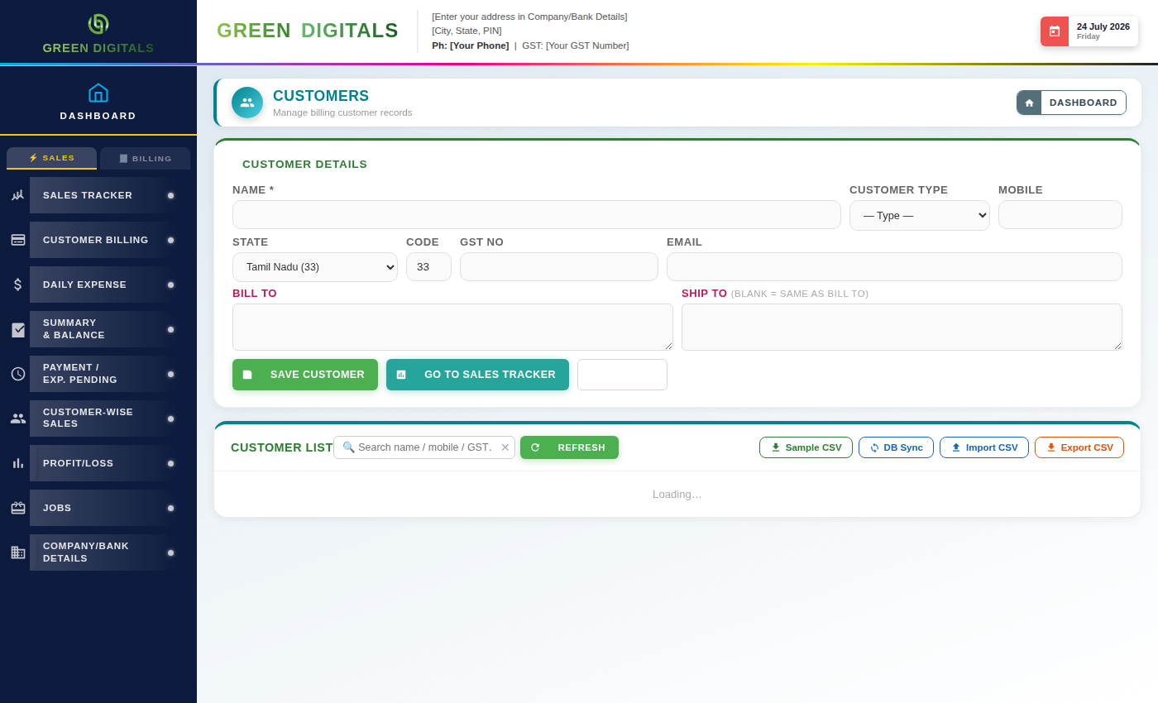
Buttons & Actions
- ✕ Cancel Edit — Exits edit mode without saving changes.
- Add Entry — Saves the new or edited customer record.
- Delete Entry — Deletes the selected customer record.
- Go — Runs the search for customers matching the filter.
- Reset — Clears the filter fields back to their defaults.
- Refresh — Reloads the latest data from the server.
Dropdown Fields
- State — Select the customer's state, used for GST calculations.
Updates since the original guide (v21)
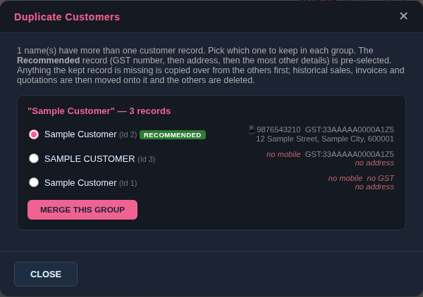
Check Duplicates (sample data). The recommended record is pre-selected; each row shows what it has and what it is missing.
- Check Duplicates — On the button row beside DB Sync. Lists customers who share a name once capital letters and spaces are ignored. In each group choose the record to keep then click Merge This Group. Each record shows its mobile, GST number and billing address. The record with a GST number, then a billing address, then the most other details filled in is pre-selected and marked Recommended; choose a different one if you prefer.
- What merging does — Any detail the kept record is missing (GST number, billing and shipping address, mobile, email, state, customer type) is first copied over from the records being removed, so nothing is lost; where both have a value, the kept record's is used. Sales, invoices and quotations then move to the kept customer; old invoices and quotations are never blanked (a detail is written to them only when it has a value). The other records are deleted. This cannot be undone, so take a database backup first.
- Customer Details form — Name, Customer Type, Mobile, State, Code, GST No and Email are now on one row.
- Saving a customer — Names are compared ignoring capital letters, so 'john' and 'John' cannot be added twice. Renaming a customer to a name that already exists is refused.

12. Invoice
Invoice is where GST or non-GST bills are generated for customers, pulling in product, quantity, rate, and tax details ready to print or share.
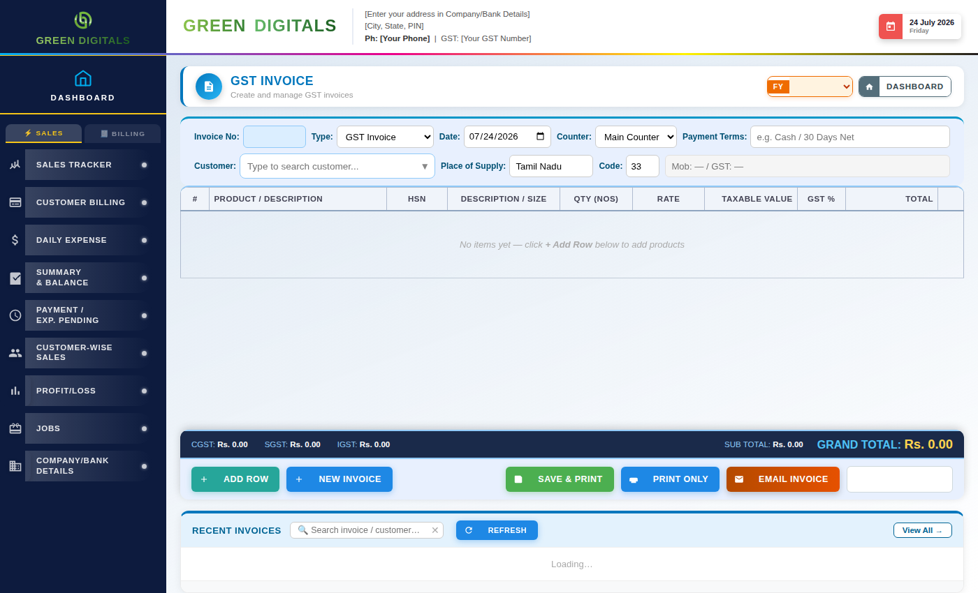
Buttons & Actions
- ✕ Cancel Edit — Exits edit mode without saving changes.
- + Add Product — Adds another product line to the invoice.
- Generate Invoice — Creates the final invoice from the entered details.
- Print — Opens the print dialog for the current invoice.
- Reset — Clears the invoice form back to blank.
- Refresh — Reloads the latest data from the server.
Dropdown Fields
- Customer — Select which customer this invoice is for.
- Billing Type — Choose With Bill (GST) or Without Bill.
Updates since the original guide (v21): company details on printed documents
- Header — The heading prints GREEN DIGITALS (or the Account Name saved under Current Account), then the address, phone, email and GST number saved in Company / Bank Details. Anything not saved prints blank.
- GST invoice and quotation footer — The Bank Details box prints the Current Account saved in Company / Bank Details (bank, account number, IFSC, branch).
- Without Bill invoice footer — Prints the Savings Account saved in Company / Bank Details, with its UPI ID and a QR code. When no UPI ID is saved the QR code is left out.
- Fill these in once — Before issuing invoices, complete Company / Bank Details (chapter 19). Earlier versions printed another company's address, GST number and bank account.

13. Invoice Manager
Invoice Manager lists every invoice raised, letting you search, reprint, or edit past invoices without starting from scratch.
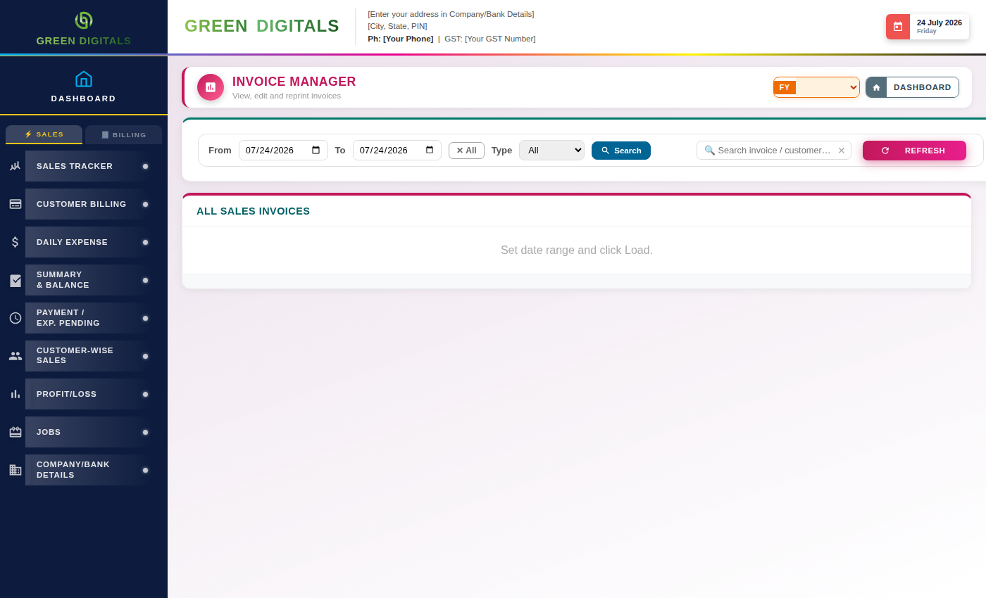
Buttons & Actions
- Search — Finds invoices matching the entered invoice number or customer.
- Refresh — Reloads the latest data from the server.
Dropdown Fields
- Date Range — Filter invoices to a specific date range.
Updates since the original guide (v23): cancelling invoices
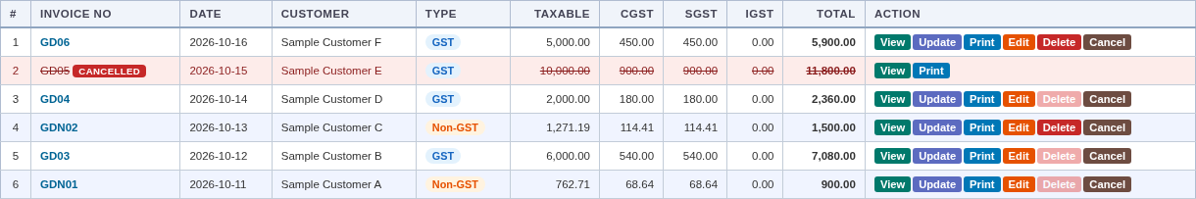
Invoice Manager with a cancelled invoice (sample data).
- Cancel (new button on every invoice) — Admins only. Asks for a reason, then marks the invoice CANCELLED. It keeps its number and stays in the list, struck through with a red CANCELLED badge (hover it to see the reason, who and when). It is left out of totals and reports, can no longer be edited or updated, and the sale it was made for can be invoiced again with a new number. This cannot be undone.
- Delete (stricter) — Only the most recent invoice of its series (GST or Non-GST), and only if it was never printed or shared. Once an invoice has been printed or made into a PDF it can only be cancelled. A cancelled invoice cannot be deleted.
- Numbers are not reused after a cancellation — Cancelling GD05 means the next invoice is GD06. (A never-issued invoice that is deleted does give its number back, because it never left the building.)
- Invoice numbers — GD01, GD02… for GST invoices and GDN01, GDN02… for without-bill invoices, restarting each financial year. Earlier R01 / RN01 numbers are still recognised and keep their own series.
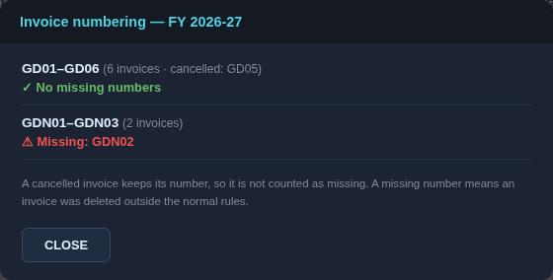
Check numbering (sample data).
- Check numbering — Beside Search. For each series in the selected financial year it shows how many invoices there are, which were cancelled, and any number that is missing (a cancelled number is not missing). A missing number means an invoice was deleted outside the normal rules.
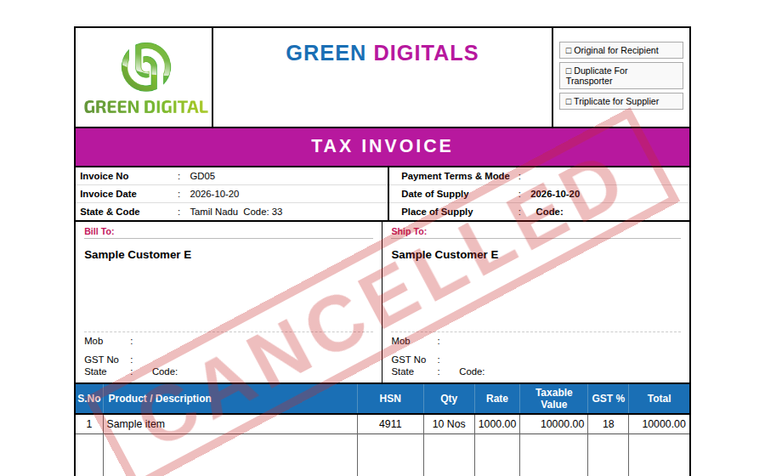
A cancelled invoice still opens and prints, with CANCELLED across it (sample data).
- CANCELLED watermark — A cancelled invoice can still be viewed, printed and downloaded; it carries a large red CANCELLED so it cannot be mistaken for a live one.
- Saving — If another user has just used the same invoice number, the save is refused with a message giving the next free number. Refresh the number and save again.
- Lists and reports — The Invoice Manager and the invoice register show cancelled invoices; the Dashboard totals, the Invoice Report and the sales report leave them out.
- Logo — Invoices and quotations now print Green Digital's own logo. Earlier versions printed Rio Print Media's logo.
- GST returns — Ask your accountant how cancelled invoices should be shown in your GST return.

14. Quotation
Quotation lets you prepare price quotes for customers before a sale is confirmed, using the same product and pricing details as Invoice.
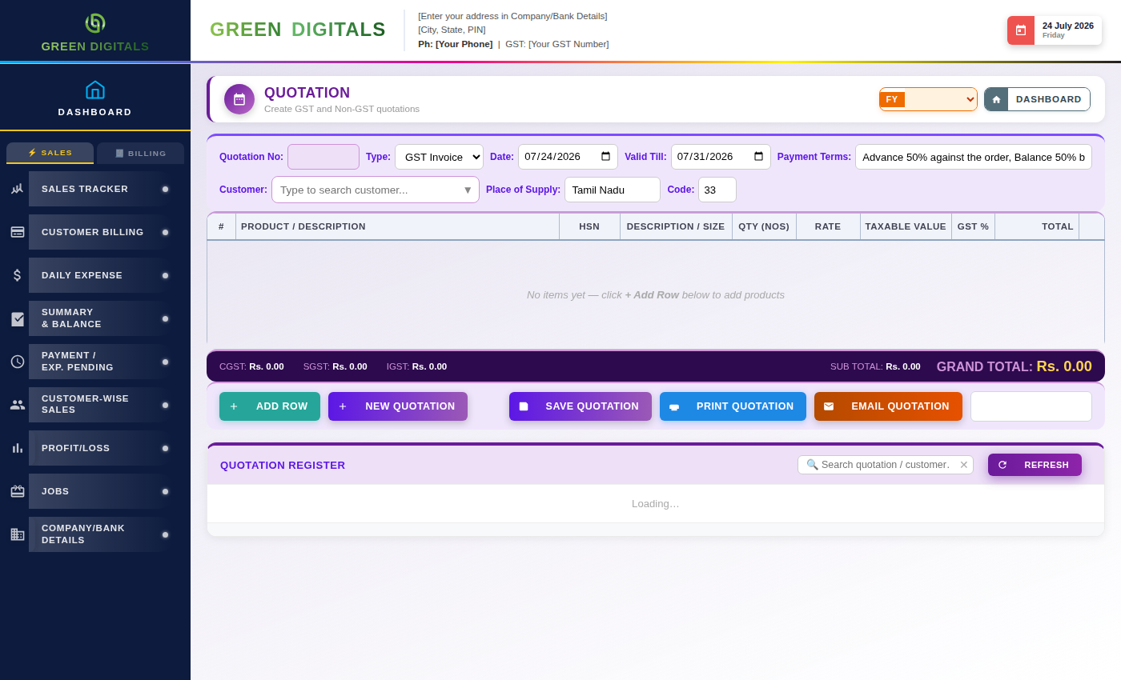
Buttons & Actions
- ✕ Cancel Edit — Exits edit mode without saving changes.
- + Add Product — Adds another product line to the quotation.
- Generate Quotation — Creates the final quotation document.
- Print — Opens the print dialog for the current quotation.
- Reset — Clears the quotation form back to blank.
- Refresh — Reloads the latest data from the server.
Dropdown Fields
- Customer — Select which customer this quotation is for.

15. Account Ledger
The Ledger shows a running, chronological record of debits and credits for a selected account, similar to a bank passbook.
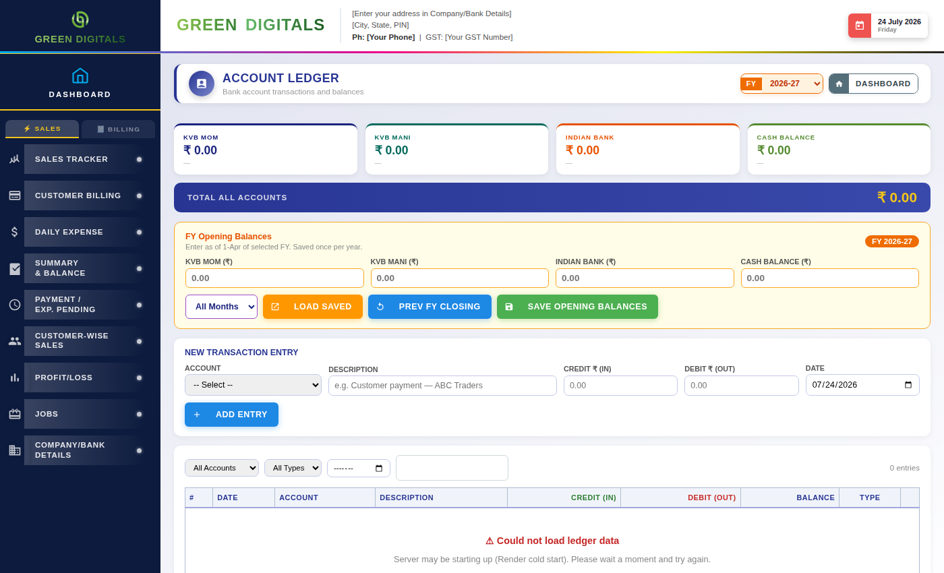
Buttons & Actions
- Go — Runs the ledger report for the selected account and date range.
- Reset — Clears the filter fields back to their defaults.
- Print — Opens the print dialog for the current ledger view.
- Refresh — Reloads the latest data from the server.
Dropdown Fields
- Account — Select which account's ledger to view.
- Date Range — Choose the period this ledger view should cover.
Updates since the original guide (v21)
- Accounts — The Ledger shows one balance card and one Opening Balance box for each account you set up, plus Cash. The Account dropdowns (new entry and filter) list the same names.
- Accounts that are not set up — Their cards and boxes are hidden. If you used KVB MOM, KVB Mani or Indian Bank in an earlier version, type the same names in Bank Accounts and those entries and balances appear again.
- Renaming an account — Does not change entries already saved under the old name.

16. Products
Products holds the master list of items sold — name, category, default size options, and pricing — referenced throughout Sales, Invoice, and Quotation.
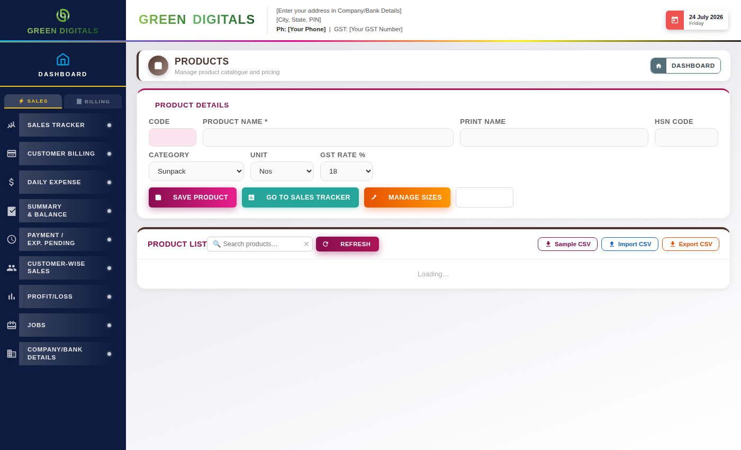
Buttons & Actions
- ✕ Cancel Edit — Exits edit mode without saving changes.
- Add Entry — Saves the new or edited product record.
- Delete Entry — Deletes the selected product.
- + Add Category — Adds a new product category.
- Go — Runs the search for products matching the filter.
- Reset — Clears the filter fields back to their defaults.
- Refresh — Reloads the latest data from the server.
Dropdown Fields
- Category — Choose which category this product belongs to.

17. Reports
Reports gives access to every business report in one place — Sales, Expense, Invoice, Quotation, Customer-Wise, Jobs, Bank Ledger, and Expense Breakdown — each with its own filters and export.
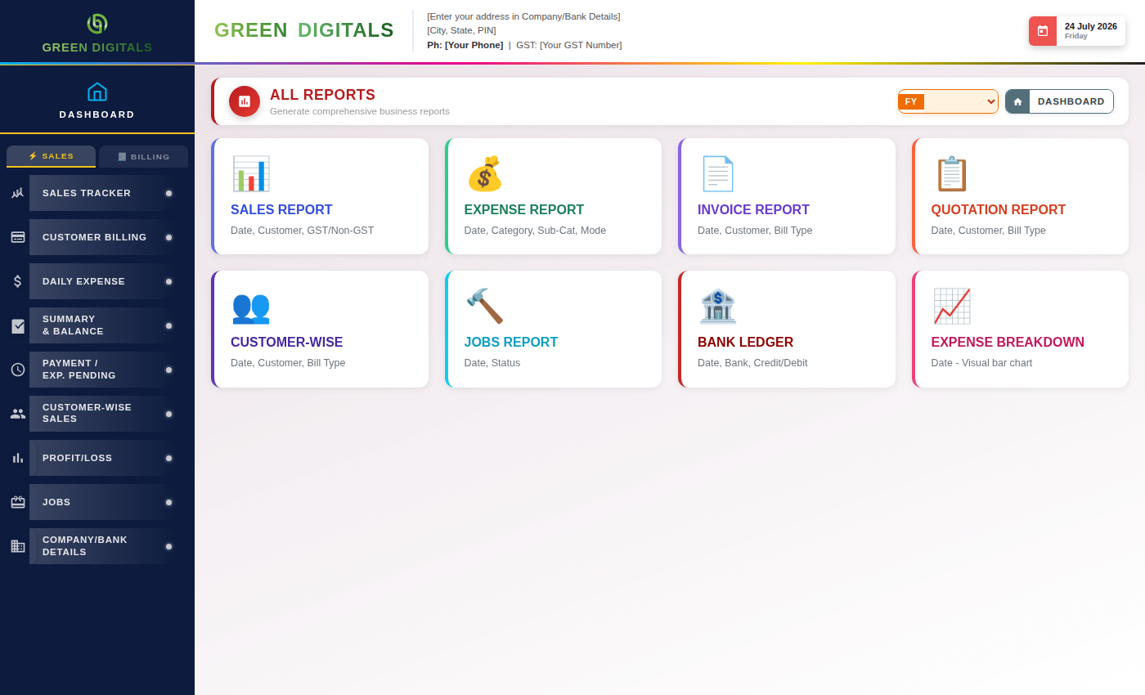
Buttons & Actions
- Go — Runs the selected report for the chosen filters.
- Export — Downloads the current report as an Excel or PDF file.
- Refresh — Reloads the latest data from the server.
Dropdown Fields
- Report Type — Choose which report to generate (Sales, Expense, Invoice, Quotation, Customer-Wise, Jobs, Bank Ledger, Expense Breakdown).
- Date Range — Choose the period the report should cover.
Updates since the original guide (v21)
- Sales Report dates — The Sales Report now reads its own From / To fields (they default to the current month). Before, it could read the Sales Tracker's date filter instead and report "Please select a date range" even with dates filled in.
- Invoice and Quotation reports — Now include every record in the date range; a very large range could previously be cut off after 500 records, understating the totals.
- Restricted users — Users set to see only their own records now also see only their own records in the Sales, Invoice, Quotation and Customer-wise reports.
- Bank / payment-mode filters — List your accounts and Cash.

18. User Management
User Management is where staff accounts and their access permissions are created and configured — deciding which screens each role can see, and whether they can view only or also edit.
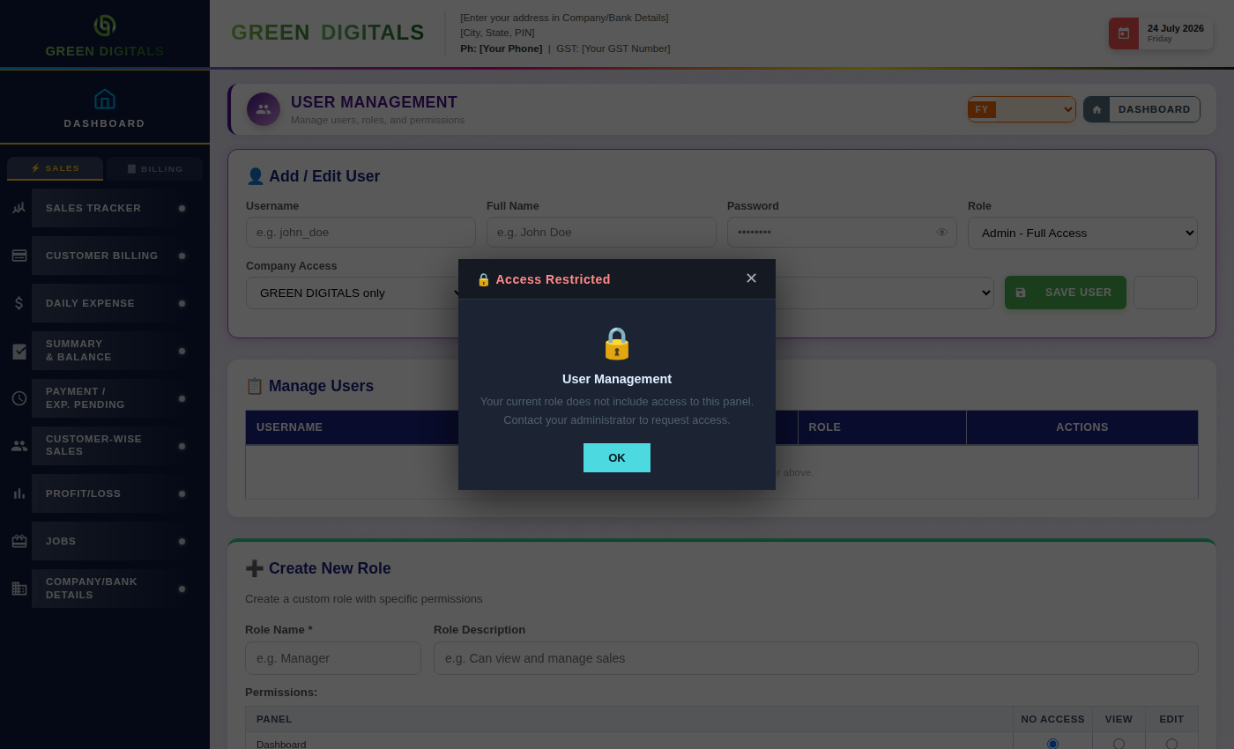
Buttons & Actions
- Create Role — Saves a new custom role with the permissions selected above.
- Clear — Resets the new-role form back to blank.
- Save Role Configuration — Saves changes made to an existing role's permissions.
- Create User — Adds a new staff account with the selected role.
Dropdown Fields
- Role — Select which role to assign to a user, or configure permissions for.
Updates since the original guide (v21)
- Server-side protection — Creating or deleting users and creating or deleting roles now require an admin login on the server itself. Before, anyone who could reach the server could do these directly.
- Changing your own password — Any logged-in user can still change their own password; other changes to their own account are ignored.
- If an action is refused — A message explains why ("session expired, please log out and log in again" or "admin access is required"). See chapter 21.

19. Company / Bank Details
Company/Bank Details holds core business information used across invoices, reports, and login branding — admin contacts, bank accounts, factory address, and a general phone book of contacts. Each section opens as its own card.
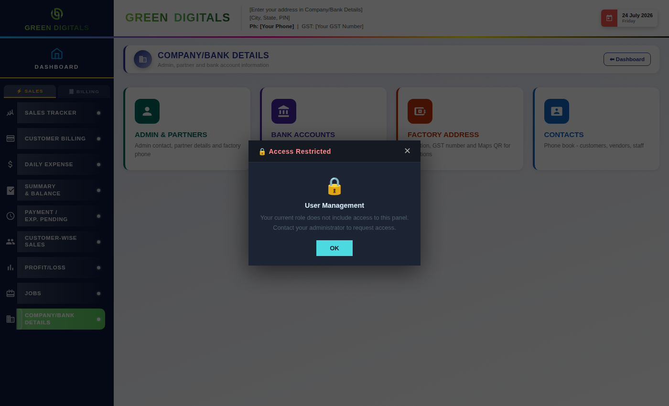
Buttons & Actions
- Admin & Partners — Opens the section for admin contact and partner details.
- Bank Accounts — Opens the section for current account, savings, and UPI details.
- Factory Address — Opens the section for the registered address and GST number.
- Contacts — Opens the general phone book of customers, vendors, and staff contacts.
- Save — Saves changes made within the open section.
- ← Back — Returns to the Company/Bank Details overview from within a section.
Updates since the original guide (v21)
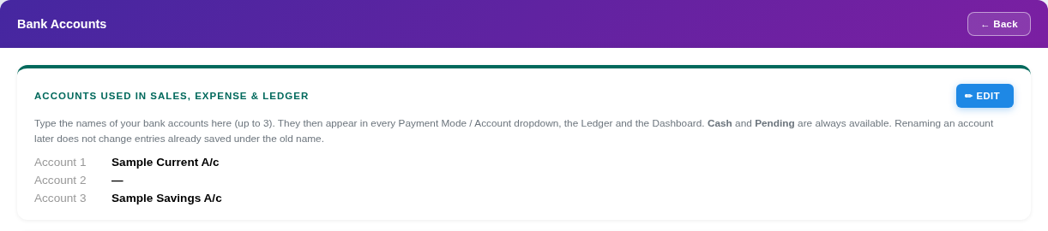
Bank Accounts › Accounts card (sample data).
- Accounts used in Sales, Expense & Ledger — At the top of Bank Accounts. Click Edit and type up to three account names (for example your current and savings accounts). Cash and Pending are always available. They appear in every payment-mode and account dropdown, the Ledger, the Dashboard and the Summary.
- Blank until you fill it in — Details you have not saved show a dash. Earlier versions showed another company's phone numbers and bank account numbers in empty fields.
- Current Account and Savings Account — These feed the bank details printed on invoices and quotations (chapters 12–14). The Maps QR on Factory Address is built from the saved address.
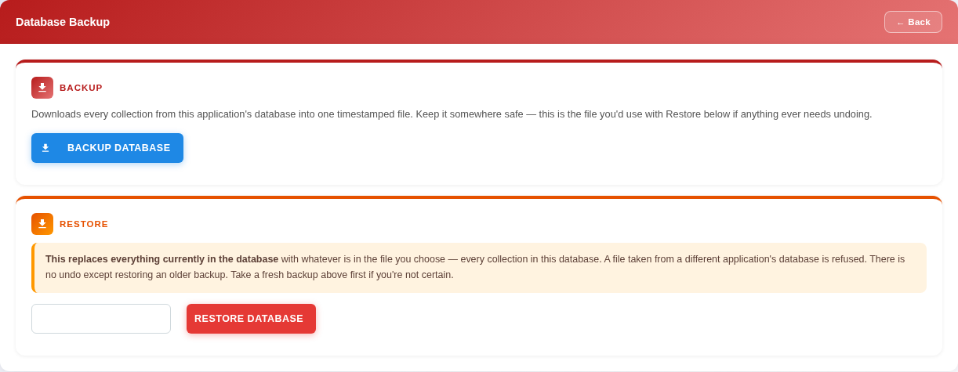
Database Backup (admin only).
- DATABASE BACKUP card (admin only) — Backup Database downloads one timestamped JSON file (green_digital_db_backup_<date-time>.json) with every collection of this application's database, and shows how many were saved.
- Choose Backup File and Restore Database — Pick a backup file; a confirmation shows when it was taken, then Restore Database replaces everything currently in the database with the file. It cannot be undone and the page reloads, so take a fresh backup first. A file taken from a different application's database is refused.

20. Purchase & Stock
Purchase & Stock tracks raw material and inventory purchases, supplier details, and current stock levels.
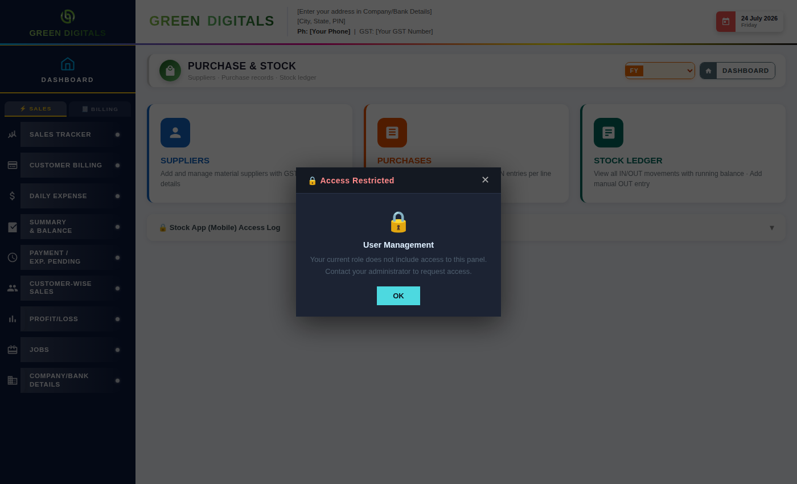
Buttons & Actions
- ✕ Cancel Edit — Exits edit mode without saving changes.
- Add Entry — Saves the purchase/stock entry into the list below.
- Delete Entry — Deletes the selected entry.
- Go — Runs the search/filter for the criteria above.
- Reset — Clears the filter fields back to their defaults.
- Refresh — Reloads the latest data from the server.
Dropdown Fields
- Supplier — Select the supplier this purchase is from.

21. Administration, Security & Deployment
This chapter was added in v21. It explains who can do what, how login sessions work, how to deploy an update safely, and what to set up the first time.
First-time setup checklist
- 1. Company / Bank Details — Fill in Admin Details (phone, email), Factory Address (address, city, pin, phone, GST number), Current Account (bank, account number, IFSC, branch) and, for Without Bill invoices, Savings Account with its UPI ID.
- 2. Bank Accounts › Accounts — Type the names of your bank accounts (up to three).
- 3. Database name — On Render, set the MONGO_DB environment variable to Green Digital's own database name. If it is not set the server logs a warning that it is using the name RioPrintMedia, which could be shared with Rio.
- 4. First backup — Take a database backup (Company / Bank Details › Database Backup) once everything is set up.
Who can do what (enforced by the server)
- Admin only — Database Backup and Restore; creating or deleting users; creating or deleting roles.
- Any logged-in user — Change their own password. Nothing else about user accounts.
- Everything else — Sales, expenses, customers, invoices and reports follow each user's role and scope inside the app. The server does not yet require a login for these routes.
Login sessions
- Session token — When you log in the server gives your browser a token and the page sends it with every request. Each user has one token, so logging in on another device replaces it.
- "Session expired" message — Appears on an admin action when your token is no longer valid. Log out and log in again.
Emergency switch
- RIO_ENFORCE_ADMIN — An environment variable on Render. Set it to 0 and restart to switch the server-side admin check off if it ever locks the owner out. Set it back to 1 (or remove it) to protect the admin actions again.
Server update banner
- Orange bar at the bottom (admins only) — Means the server is older than this page. Upload the latest Green_Digital_api file to Render. The ✕ hides it for the session.
Deploying an update
- Deploy both files together — Each release contains the server file (Green_Digital_api_vNN.py) and the page (Green_Digital_ERP_vNN.html). Upload both. A new server with an old page blocks Backup / Restore; an old server with a new page shows the update banner.
- Release notes — Every version is recorded in Green_Digital_Changelog.xlsx, which ships with each release.

