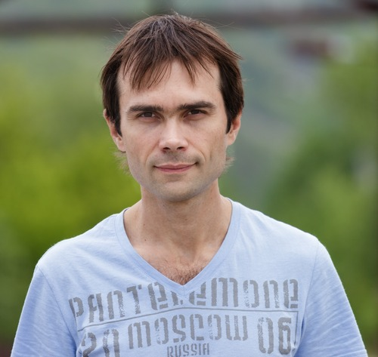 |  |  | Negoda Alexander  Male, 38 years, born on 20 March 1977  +7 (903) 335-86-38  alexander.negoda@gmail.com — preferred method of communication  Skype: g.r.e.e.n.d.o.g  www: http://github.com/greendog  Reside in: Samara  Citizenship: Russia
Desired position
Programmer / Developer  IT, Internet, Telecom  • Software Development  • CTO, CIO, IT Director  • Startups  Employment: full time, project work  Work schedule: full time, flexible schedule, remote working, rotation based work  travel time to work: any |  |  |  | salary expectation  $7000
Work experience
October 2013 — till now |  | Intelligent systems  http://i-sys.ru  Lead developer  Rails, DevOps
January 2013 — till now |  | ShopOnRails  http://github.com/shoponrails  Author, developer  Rails, CoffeeScript, Jquery, Compass, Bootstrap, Liquid, ActiveAdmin, Opscode Chef, Docker
March 2012 — September 2013 |  | ClickAvia  http://clickavia.ru  DevOps Engineer  Rails, Ruby, Chef, AmazonWS, Bash, Nginx, Puma, Sidekiq, Memcached, Linux, Vagrant, Opscode Chef Server, Nginx Cluster, Foreman, Errbit, Docker, Jenkins
October 2005 — March 2012 |  | iPelican  http://ipelican.com/  Senior Developer  Marketplace to find and select food service supplies and professional equipment  Development using Ruby On Rails, MySQL, Spree, JQuery, Git, Capistrano, Nginx, Linux
October 2003 — January 2005 |  | R-Telecom Holding  http://www.ertelecom.ru  Head Support Service  Management a group of technical support.
August 2002 — September 2003 |  | Computer Club GreenDog  Director, System Administrator  Opened Computer Club "from scratch". I hire staff, buy equipment, collect and customize it. Conducted financial accounting.
Education
Incomplete higher
2000 |  |  | Samara State Aerospace University  Flight vehicles department
Key skills
Languages |  |  | Russian — native  English (only writing)— I read professional literature
Skills |  |  | Strong: Ruby RubyOnRails Backbone Opscode Chef CoffeeScript FreeBSD JavaScript Linux MySQL PostgreSQL Redis Elasticsearch Rspec AngularJS ReactJS Bootstrap Memcached Haproxy Apache Dovecot Sendmail Postfix Squid Iptables Git DevOps Bash Intellij IDEA Nginx IOT Docker Jenkins Capistrano AWS DigitalOcean AdobeFlex Vagrant Arduino STM32  Middle: Grails Groovy Java C/C++ GWT MongoDB Node.JS Perl Corosync+Pacemaker
Additional information
About me |  |  | IDE: Jetbrains IDEA, Eclipse,  OS: Linux  Hobbies and other skills:  Robotics, Quadrocopters, Photography, Science, Astronomy & Space Science, Fishing, Building, Sport  I am interested philosophy, politics, economics, technology.  Hard worker. Extrovert. Choleric. I do not have any bad habits. Married.

