Nov 2, 2018

Dear Dr. Goff,

I am enthusiastic to collaborate with you and the other co-PIs in the Seed Network Application. I lead a research group which specializes on Bayesian non-negative matrix factorization for high throughput genomics analysis. As you are aware, we have been collaborating as part of the Collaborative Computational Tools for the Human Cell Atlas in the extension of these methods for single cell data and transfer learning approaches to relate latent space representations in a query dataset to a target. These efforts have also led to standardized language and formats for latent space representations and automated analysis pipelines for latent space representations through collaborations with other PIs in this team and the broader network. I am excited to extend this work for efficient, biologically-driven low dimensional representations of Human Cell Atlas data in the proposed project.

Sincerely,

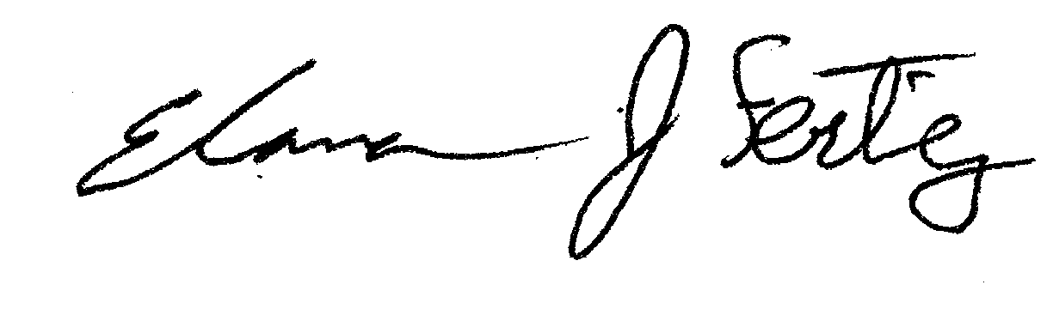

Elana J Fertig, Ph.D.

Associate Professor of Oncology and Applied Mathematics and Statistics

Assistant Director of the Research Program in Quantitative Sciences