TankerTrack — System Architecture
Ethanol fleet transportation management system for Green Energy. Two clients over one API and one database:
• Manager website — dispatch scheduling, live fleet tracking, trip reports,
and workshop / cost tracking. Desktop-first.
• Driver mobile app — a downloadable app the driver uses in-cab: open a trip
by ID, log departure/stops/expenses/arrival. Offline-tolerant.
Both talk to the same role-aware API. Nothing the driver does is trusted blindly — authorisation rules live server-side and in the database.
Status legend used throughout: ✅ built & verified · 🟡 written, not yet run (no Node/blocked binaries on the current machine) · ⬜ planned / not started. See apps/api/README.md for what has actually been exercised.

1. Requirements

Functional
Area | Capability | Client
Dispatch | Schedule a trip: vehicle, driver, route, max stops, load, deadline, advance, invoice, expected return | Manager web
Dispatch | Issue a Trip ID the driver enters in the app | Manager web
In-cab | Open trip by ID, confirm departure (weight + opening odometer) | Driver app
In-cab | Log stops (location, type, time); server flags unauthorized | Driver app
In-cab | Add trip expenses (Food/Parking/Unloading/RTO + extras) with receipts | Driver app
In-cab | End trip (arrival weight, closing odometer, diesel litres) | Driver app
Reporting | Auto trip report: duration, delivered qty, stops, inactivity gaps | Manager web
Settlement | Standardised trip sheet: expenses total, advance, balance, mileage | Manager web
Costs | Log maintenance with mandatory bill; spend rollups; service-due | Manager web
Costs | Fuel log + odometer readings; tank-to-tank mileage per vehicle | Manager web
Fleet | Live map of last-known truck positions | Manager web

Non-functional
• Scale (near-term): 15 trucks, ~2 depots, tens of trips/day, a handful of
concurrent manager users. This is a *small-fleet* system — the design target is correctness and auditability, not high throughput.
• Scale (GPS phase): if trackers ping every 10–30 s, 15 trucks ≈ 30–90
pings/min sustained. Still modest, but it is the highest-volume path and the only one that needs partitioning thought.
• Availability: manager web can tolerate short downtime; the driver app
cannot depend on connectivity — highway stretches drop signal, so in-cab actions must queue locally and sync later.
• Auditability: hazmat goods carriage — trip sheets and GPS history need an
immutable trail (who logged what, when, where) and a retention policy.
• Security: driver PII, GPS history, and bill evidence encrypted at rest;
TLS in transit; least-privilege data access per role.

Constraints
• Solo/small team, phased build. Favour one boring stack over many.
• Existing brief already picks: React (web), React Native/Expo (mobile),
NestJS + PostgreSQL + PostGIS, Redis, S3-compatible storage, JWT auth.
• Current dev machine has PostgreSQL 18 but no Node, no Docker, no
PostGIS, and an app-control policy that intermittently blocks unsigned binaries. So TypeScript can be written but not compiled here, and even SQL verification is not always available. This shapes *what can be proven* now, not the target design.

2. High-Level Design
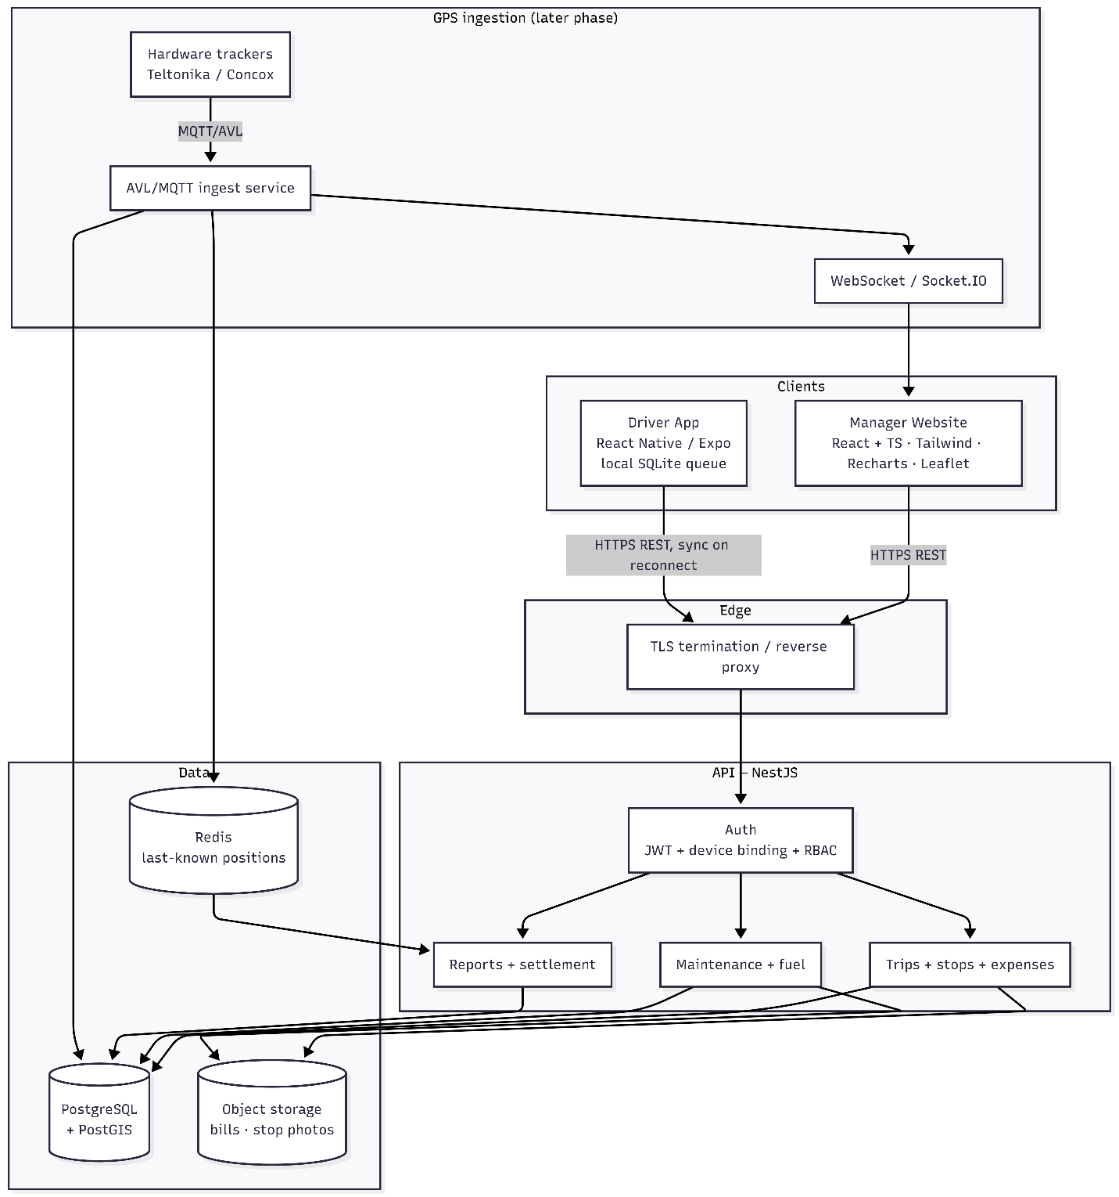

Component responsibilities
Component | Responsibility | Status
Manager website | Dispatch, reports, workshop/costs, live map. React + TS + Tailwind, Recharts, Leaflet/Mapbox. | 🟡 prototype tms-app.html is now manager-only and persists via store.js (vanilla; React port pending)
Driver app | In-cab trip flow, offline queue, camera for bills, GPS. React Native / Expo. | 🟡 standalone driver.html prototype (mobile-shaped, own client, shares store.js); Expo port pending
Shared store | Stand-in for the API/DB: one persistent store both clients read/write, cross-tab live via storage events. The seam where real fetch() slots in. | ✅ store.js (localStorage)
API | Single role-aware backend serving both clients. NestJS. | 🟡 written, not run
PostgreSQL | System of record. All domain rules as constraints/triggers. | ✅ 001–004 verified · 🟡 005 written
Object storage | Bill scans + stop photos, encrypted, served by presigned URL. | 🟡 StorageService written
Redis | Cache last-known truck position for the live map. | ⬜
GPS ingestion | Trackers → PostGIS → WebSocket. Replaces rule-based stop flags with geofence deviation. | ⬜ (schema stubbed in migration 003)

Why one API for two clients
The manager and driver are not two systems — they are two views with different permissions over the same trips. Splitting the backend would force the same trip-state and settlement logic to exist twice and risk them drifting. Instead, one API enforces role scope:
• Driver sees only their own active trip; can depart, log stops, add
expenses, arrive. Has no route to change the advance, invoice, or any scheduling field.
• Dispatcher sees their depot's fleet; schedules trips; reads reports and
costs.
• Fleet manager / admin see the whole fleet; fleet-wide export and config.

3. Deep Dives

3.1 Data model
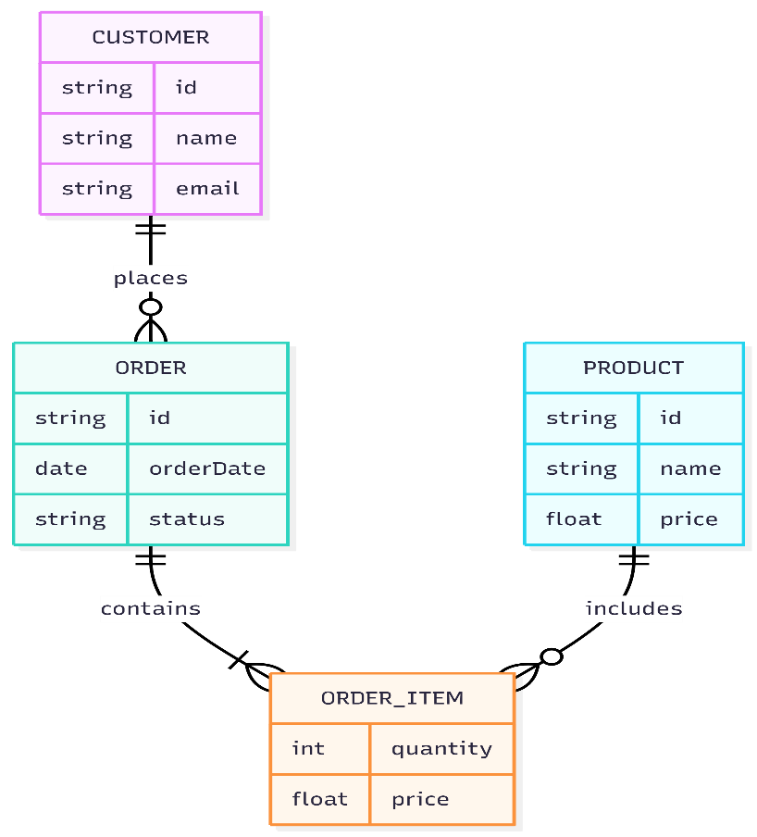
Key tables (see apps/api/db/migrations):
• trips — the whole lifecycle: scheduled → active → completed/cancelled.
Manager-set columns (advance, invoice, phone, expected return) and driver-set columns (odometers, diesel) live here; distance is a generated column.
• trip_stops / trip_expenses / audit_log — append-only (triggers
block UPDATE/DELETE). Corrections are new rows, never edits. This is the hazmat audit requirement made structural.
• maintenance_records — bill_id is NOT NULL, so "no bill, no record" is
a database invariant, not a UI nicety.
• fuel_log + fuel_mileage_spans (view) — tank-to-tank mileage; odometer
monotonicity enforced across both fuel and trip readings.
• trip_settlement (view) — expenses total, balance owed/recoverable,
distance, mileage, computed in SQL.
Money is stored as bigint minor units (paise); GST in basis points; never floating point. Totals are generated columns so they cannot drift.

3.2 API surface (per role)
Method | Route | Role
POST | /auth/login · /auth/refresh | public
DELETE | /auth/sessions/:id | fleet manager, admin
POST | /trips | dispatcher+
GET | /trips · /trips/:ref (report) | any (scoped)
POST | /trips/:ref/depart · /stops · /expenses · /arrive | driver
POST/GET | /maintenance · /maintenance/bills · /summary | dispatcher+

REST over JSON. No GraphQL — the surface is small and the clients' needs are predictable, so REST keeps the driver app's offline replay trivial (a queue of POSTs to replay in order).

3.3 Auth & device binding
• Short-lived access token, long-lived hashed refresh token bound to one
device fingerprint.
• Session liveness checked on every request, so revoking a lost handset
takes effect immediately, not when the access token expires.
• Credential entry (password) happens only on the device — never brokered by
the server.

3.4 Offline-first driver app
The single most important client-side decision. Highways drop signal, so the app must be usable with no connectivity and reconcile later.
• Every in-cab action is written to a local outbox first and shown as
"pending sync". A background worker replays the queue in order when signal returns.
• Because the server is the authority (it assigns stop sequence and decides
authorisation), the client never computes final state — it just replays intent and re-reads the result. This avoids merge conflicts.
• Idempotency: each queued action carries a client-generated key so a
replay after a flaky connection can't double-log a stop or expense.
• Bill/stop photos queue as local files and upload on reconnect, then the
record references the returned object key.

3.5 Object storage for evidence
Bills and stop photos never live in Postgres and are never streamed through the API process. They go to S3-compatible storage (MinIO locally, cloud in prod), content-addressed by checksum, encrypted at rest, and served to clients by short-lived presigned URLs. A crafted filename can't traverse or overwrite anything because the storage key is derived from the hash, not the name.

3.6 GPS ingestion (later phase)
Hardware trackers → lightweight AVL/MQTT ingest service → PostGIS (gps_pings, geofences) → publishes last-known position to Redis and a WebSocket feed for the live map. This is what eventually replaces the prototype's rule-based "unauthorized stop" flag with real geofence-deviation detection, evaluated server-side so a compromised device can't suppress an alert. Schema is stubbed in migration 003 (needs PostGIS); the ingest service is not built.

4. Scale & Reliability
• Load: trivial for the transactional paths (15 trucks). The only path that
grows is gps_pings — at ~90 pings/min it is ~4M rows/month. Partition gps_pings by month before it gets large; everything else is fine on a single managed Postgres instance for years.
• Scaling shape: vertical first. The API is stateless (JWT + DB), so if the
manager user count ever grew it scales horizontally behind the load balancer with no session affinity. Redis and Postgres are the only stateful pieces.
• Reliability: managed Postgres with automated backups + PITR (retention set
to the hazmat regulatory minimum). Object storage versioned. The driver app's offline queue *is* the reliability story for in-cab data — a dropped request is never lost, just deferred.
• Monitoring: health checks on API↔DB (already: the API refuses to start if
the DB is unreachable or unmigrated), request/error metrics, and alerts on ingest lag once GPS is live.

5. Trade-offs & Decisions
Decision | Chosen | Alternative | Why
Backend count | One API, two clients | Separate manager/driver backends | Trip + settlement logic exists once; RBAC gives the split.
Rule enforcement | In the database (constraints/triggers) | In the service layer only | A compromised device or a second writer can't bypass the DB. Matches the brief's "server-side, not client-side" mandate.
API style | REST/JSON | GraphQL | Small, predictable surface; makes the driver app's offline replay a simple ordered queue.
Driver client | Native app (Expo) | Mobile web | Camera, GPS, and offline SQLite need native; must work one-handed in-cab.
Corrections | Append-only + reversing entries | Editable rows | Hazmat audit trail must be immutable.
Money | bigint paise + generated totals | float / computed in JS | No rounding drift; totals can't disagree with their parts.
Diesel on trip sheet | Litres only, feeds mileage | Cash expense | Matches the real sheet; diesel is fuel-card settled, not from the advance.

What I'd revisit as it grows: partition gps_pings and add a time-series rollup for the live map; introduce Redis read-through caching for the dashboard only if query latency becomes visible; consider per-depot data isolation if the fleet expands beyond a couple of depots.

6. Build Phases
Phase | Scope | Depends on
1 — Backbone ✅🟡 | Postgres schema (001–005), NestJS API with auth/RBAC, trips, maintenance, fuel, settlement. | Node installed to run/verify the API.
2 — Two clients 🟡 | ✅ Prototype split done: tms-app.html (manager-only) + driver.html (standalone mobile app) share one persistent store (store.js), so a trip scheduled on the website is opened and completed in the app and flows back. ⬜ Remaining: port to React (web) + Expo (mobile) and repoint store.js at the real API. | Phase 1 running.
3 — Offline + evidence ⬜ | Driver app local SQLite outbox + sync worker + idempotency keys; camera → object storage for bills and stop photos. | Phase 2.
4 — Live GPS ⬜ | Tracker vendor + AVL/MQTT ingest service; PostGIS geofences replacing rule-based stop flags; Redis + WebSocket live map. | PostGIS; hardware decision.

Immediate next steps
1. Install Node 20+ on the build machine so the API can be compiled, run,
and its TypeScript verified (currently written-not-run).
2. **Split tms-app.html** into a manager-only website and a standalone driver
app so the two-client boundary is real, then wire each to the API.
3. Stand up Postgres + MinIO (Docker compose) so the API has a database and
object store to talk to end-to-end.

7. Open Decisions (carried from the brief)
• Real geofencing logic to replace the rule-based unauthorized-stop flag.
• Inactivity threshold: currently per-trip (default 45 min) — tune by route
length/type.
• GPS tracker vendor and integration protocol.
• Full depot list, 15-vehicle roster, driver roster for seed data.
• Whether offline queuing ships in the driver app from day one (recommended:
yes — it is Phase 3 here, but the data model already supports it).

