INSTRUCTION MANUAL FOR ICSS

This is the login screen

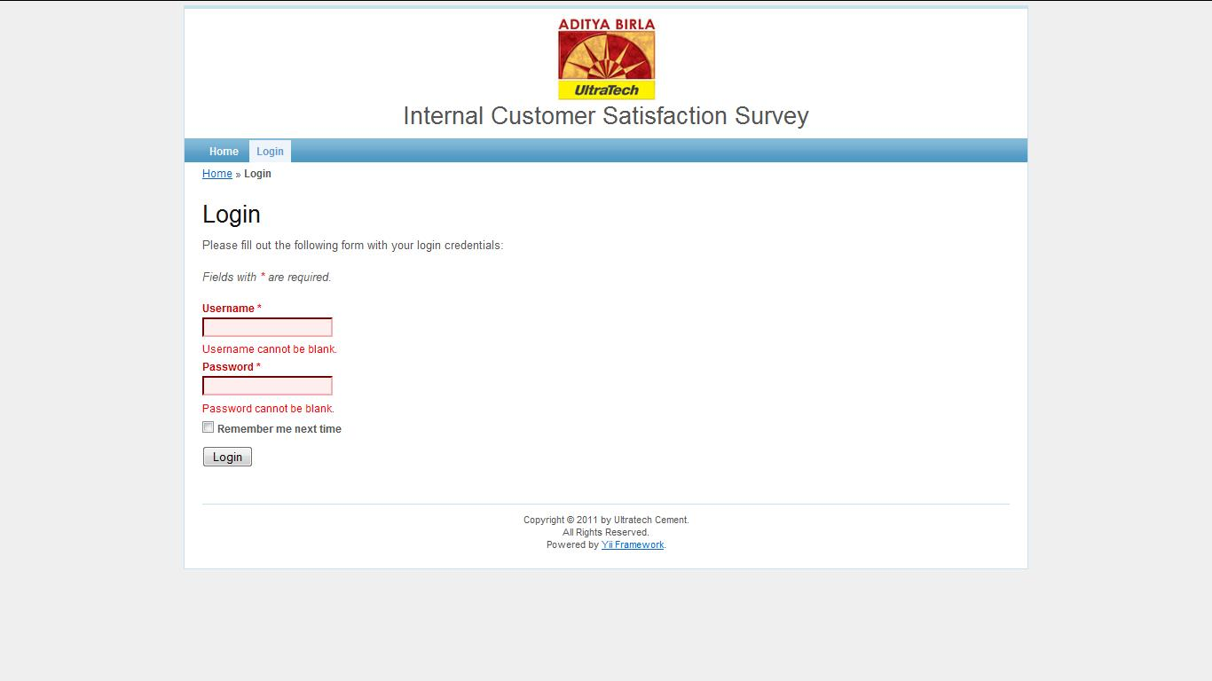

POWERS OF USER

If a normal user logs in, he can only take a survey or change his password.

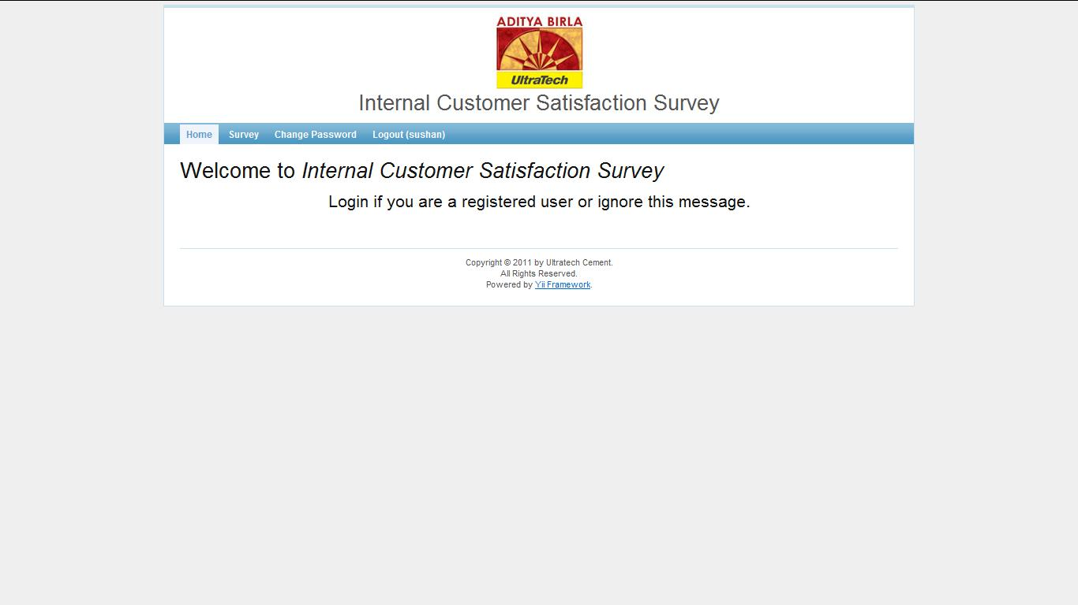

The change password screen is shown here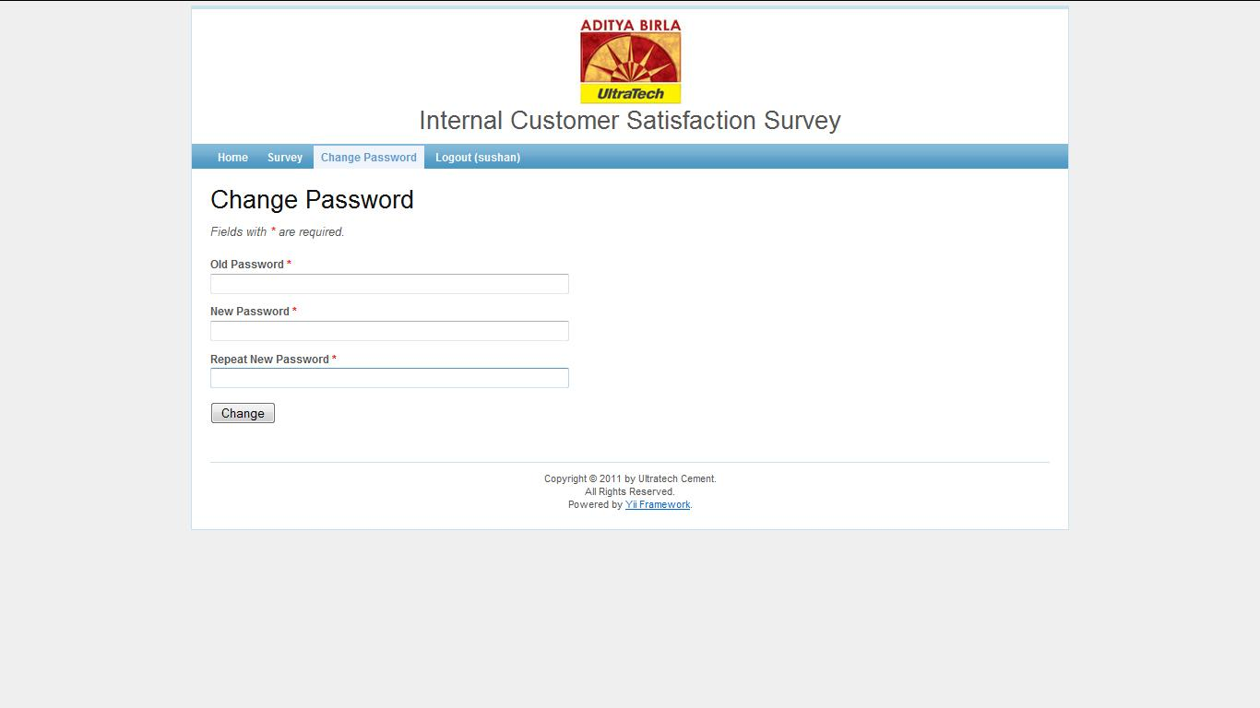

This requires the old password and asks for confirmation on change.

The user can also take surveys by choosing an appropriate survey from the list under the survey tab.

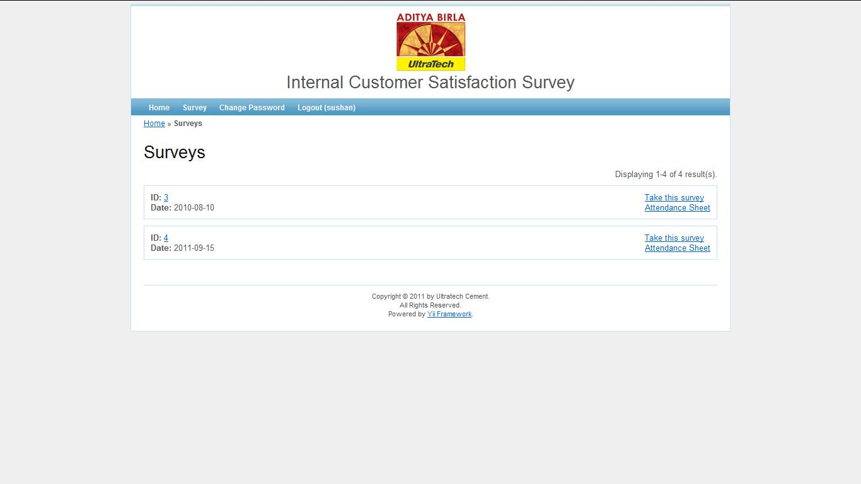

After choosing an appropriate survey, he can view the survey screen.

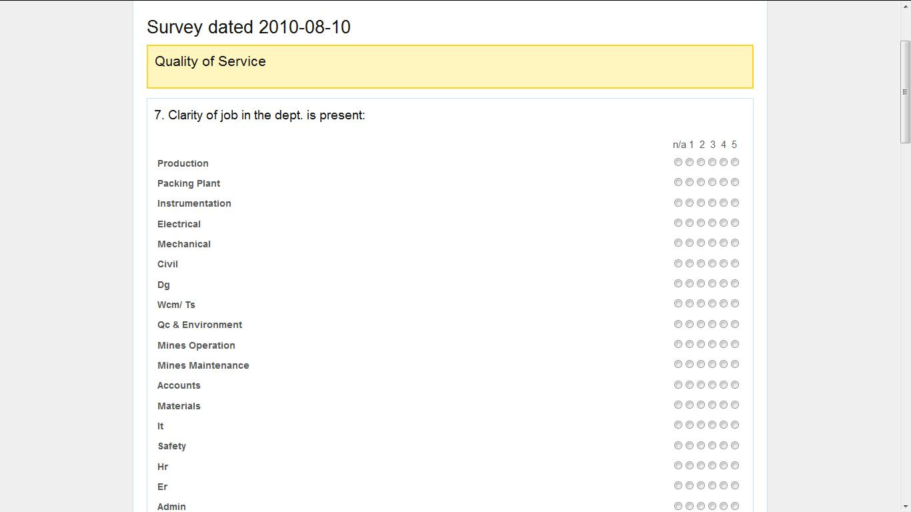

Each page of the survey has one question group only. Each page can also be saved individually. This makes the very long survey into smaller parts. The user can also fill up the survey in parts. This part also makes use of sticky answers, whereby if the user misses out on some question and presses submit, an error message is shown but the answers he had entered are saved. Also, if the user fills part of the survey, the software saves the state and the session and when he logs in next, he can start from where he left.

Additionally, the user can see the attendance list for his department only.

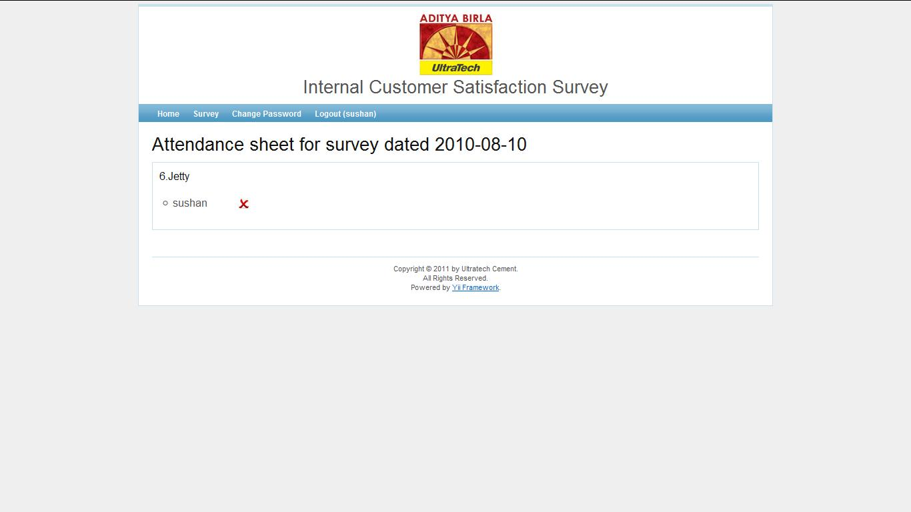

POWERS OF ADMIN

The admin has many more powers. His home screen looks like this.

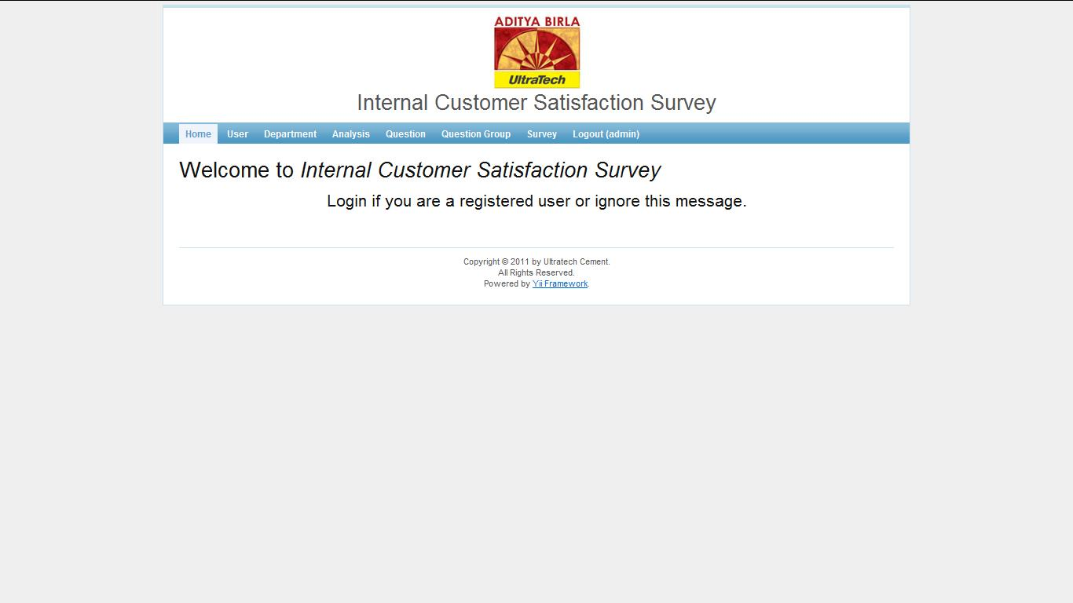

He can view and edit the lists for various entities in the application. They are listed below.

Departments-The admin has the power to add and remove any department. The changes are reflected in any subsequent survey as the list for each question will be modified accordingly. This the screen by which the user can list and modify the departments.

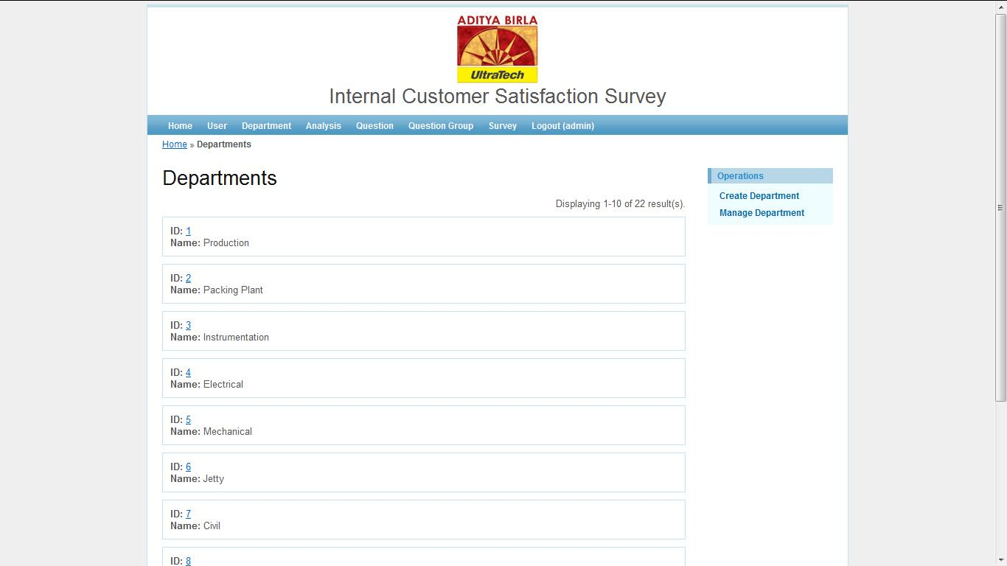

User- The user can create and update a user as well as delete an existing user. Deleting a user deletes all his reponses.

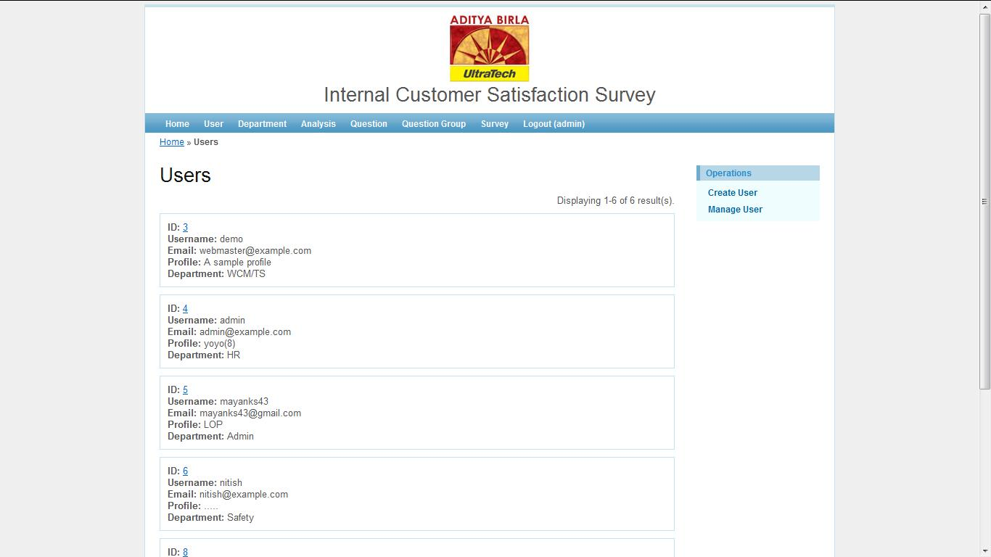

Question Groups-The admin can create a new question group for the survey which shows up as an independent page. He can also delete a question group. This causes all it’s associated questions to be deleted as well.

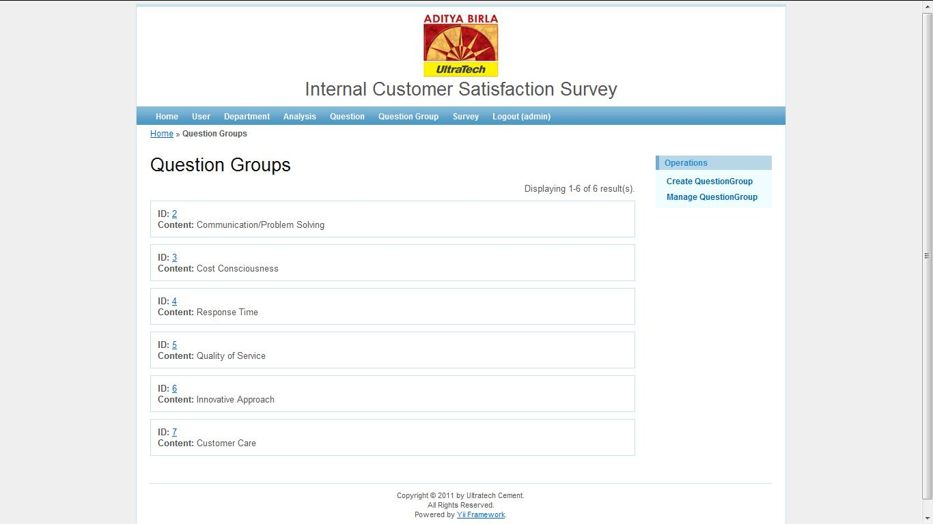

Questions- The user can add and subtract specific questions from the survey. The questions can be put into one of the pre-existing question groups.

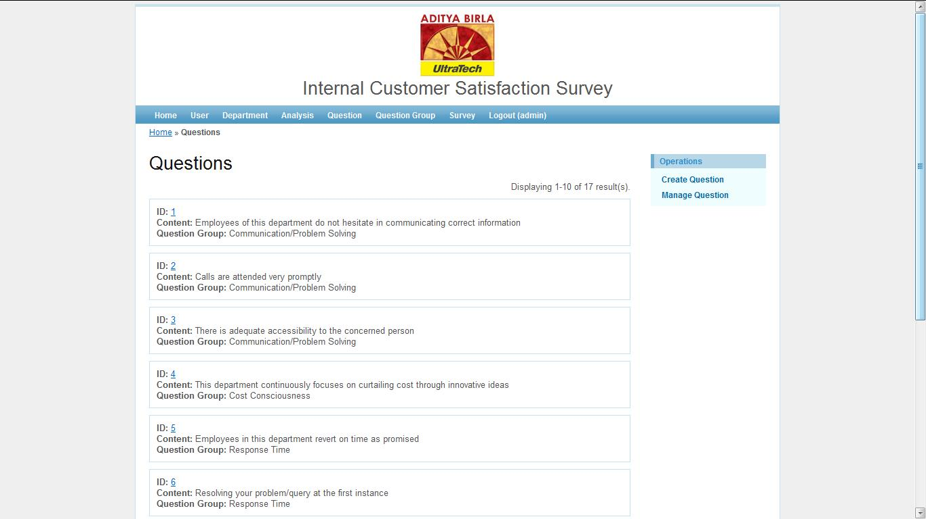

Survey-Under the survey tab, the user has the option of activating and deactivating surveys. A normal user can only take an active survey. The admin can also create a new survey. He can also view the overall attendance sheet for a given survey.

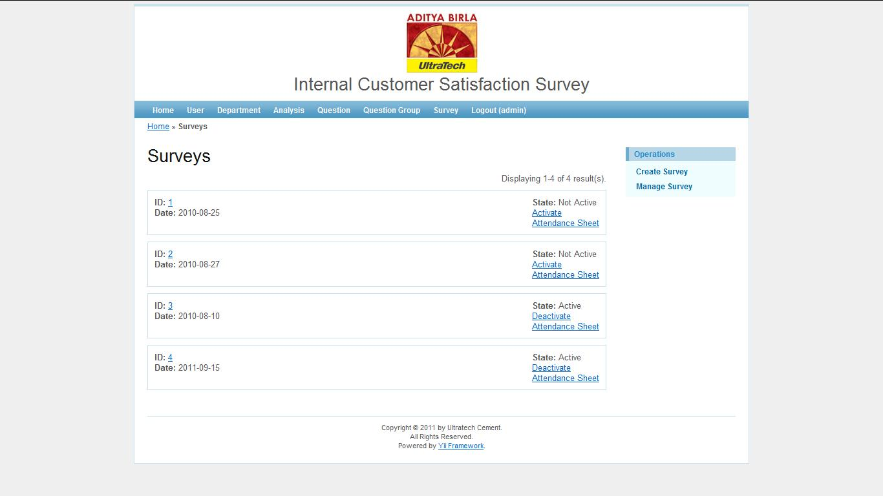

Analysis- The analysis tab helps the admin rate each department’s performance with respect to a given question group or overall.

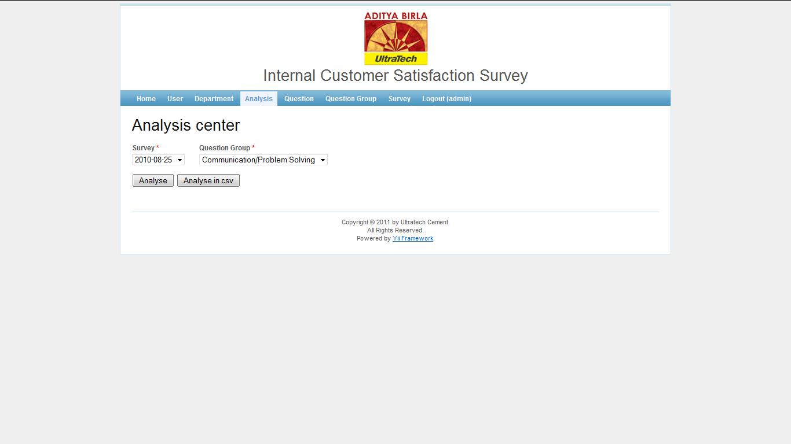

He can perform analysis in four ways.

One question group- one survey

One question group- all surveys

All question groups- one survey

All question groups- all surveys

The software automatically arranges the departments in descending order of average score. This can be used to rank them in a particular criterion or overall.

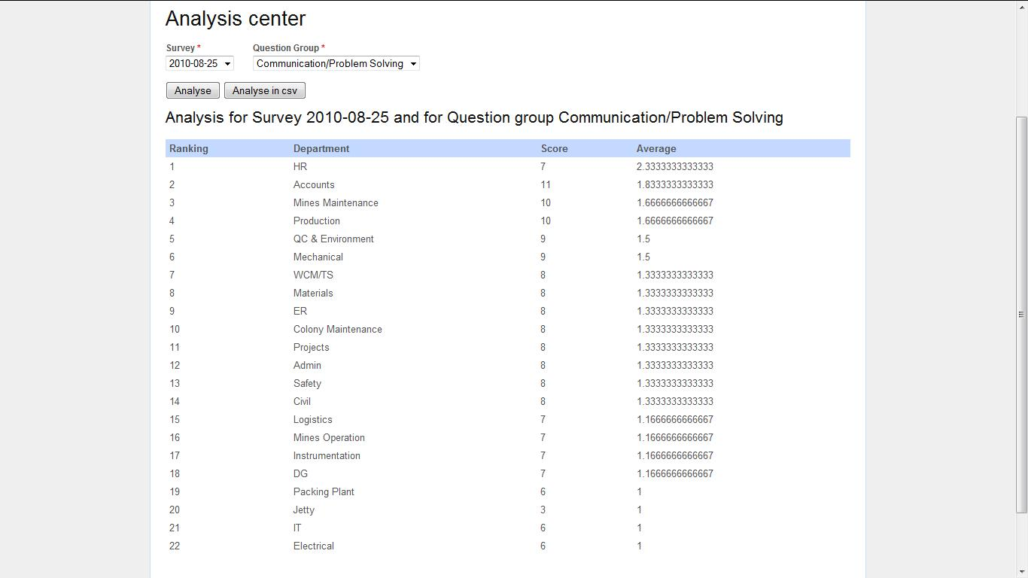

The sorted list can then be viewed in .csv format for further analysis. This format can be opened using Excel and the results can then be saved.

