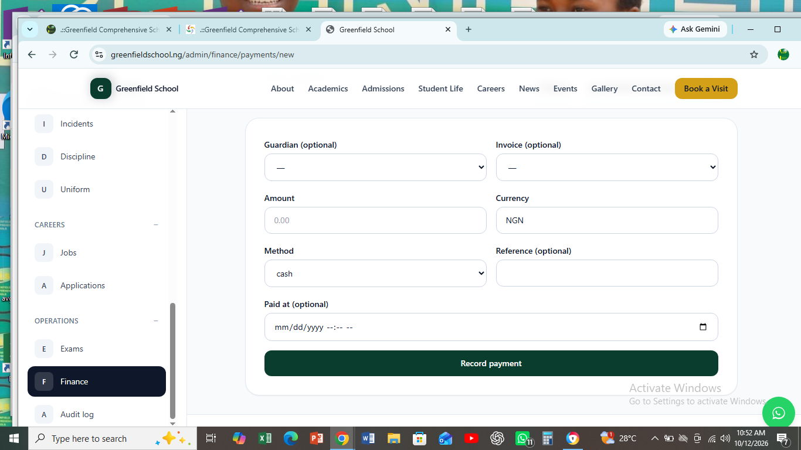
PLEASE SIR, HERE CAN WE HAVE THE CLASS AND THE CHILD’S NAME TOO. THIS WILL HELP US GET THE TOTAL AMOUNT GENERATED FOR A CLASS SO AND CAN TRACK DEBTOR FROM HERE TOO. THANKS

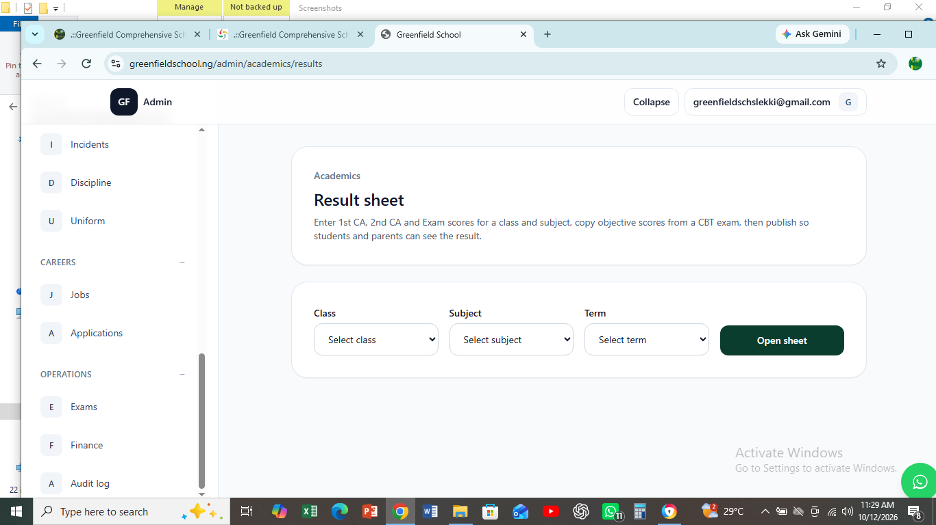
WHEN I SELECT TERM IT WON’T DISPLACE SO I DON'T UNDERSTAND. SORRY THIS HAS BEEN RESOLVE SIR

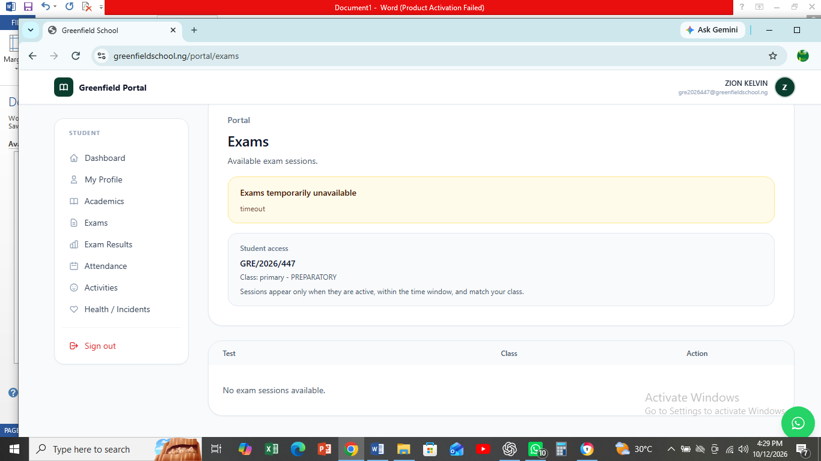
I DON’T UNDERSTAND THIS PART BECAUSE WHEN THE DATE FOR EXAM START TODAY, A CHILD IN THAT CLASS IS SUPPOSED TO SEE THE PAPER BUT IT IS NOT THE CASE, SO I DON'T UNDERSTAND WHY SIR. I AM SURE, STARTING TIME AND END TIME SHOULD NOT BE PART OF IT AND WHAT SHOULD BE OTANINABE IS STARTING DATE AND END DATE ALSO THE DURATION SHOULD BE INCLUDED WHERE STAFF CREATE NUMBERS OF QUESTIONS. THANKS,

Also we need a section where we can see class and check children in the class and can also edit their if wrongly registered

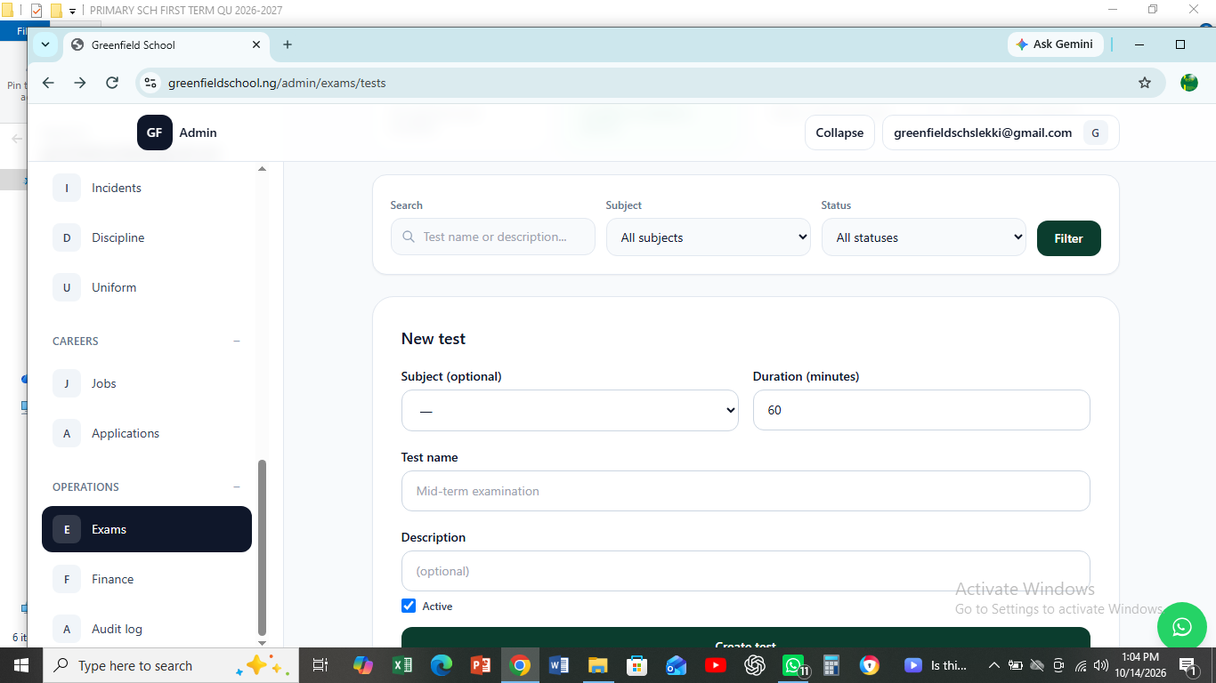
WE NO NUMBERS OF QUESTIONS HERE. EG 30, 20, 50, 60

