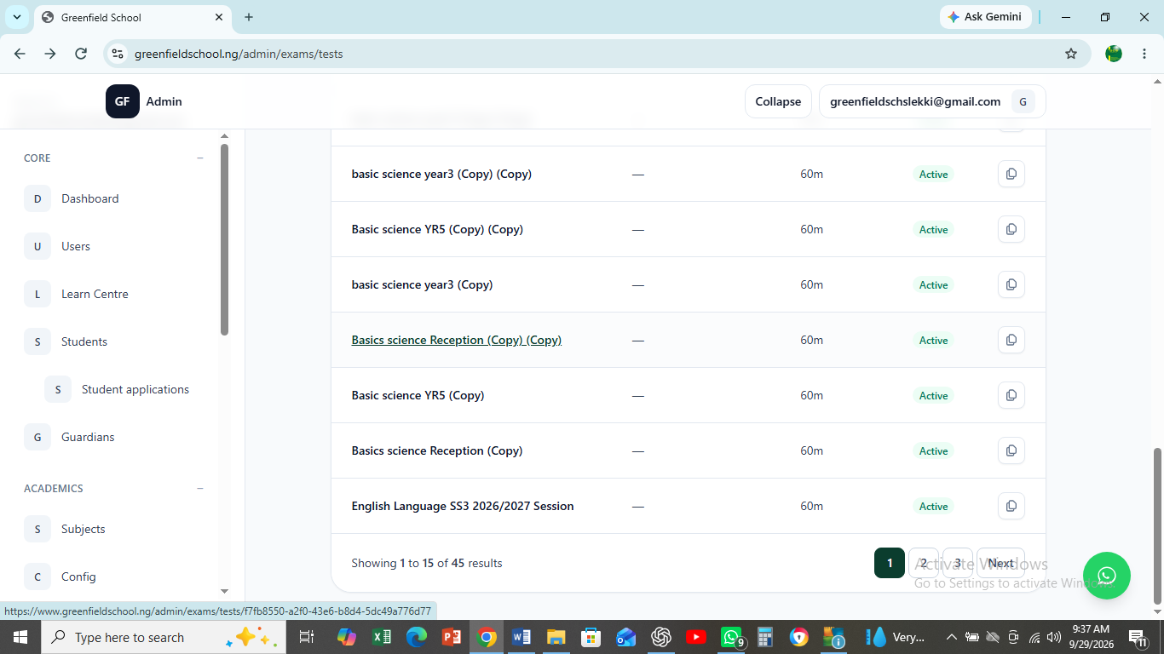
HOW DO I DELETE THIS?

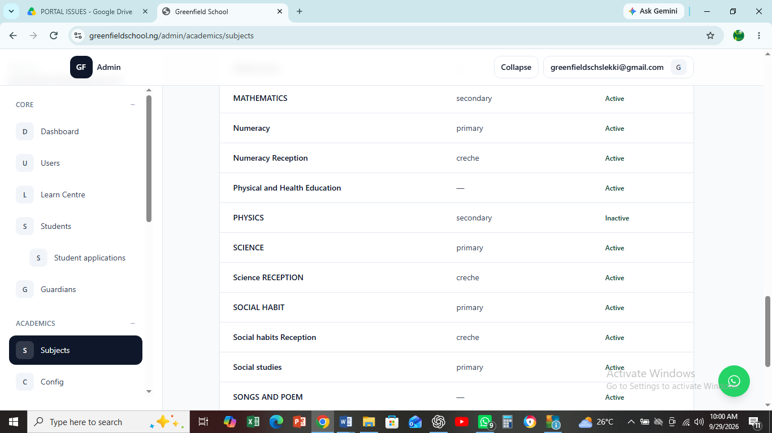
HOW DO I REMOVE THIS SUBJECTS CARRYING CLASSES. I WANT TO LEAVE THE SUBJECTS WITHOUT CLASS SO THAT THE CLASS WITH WILL BE ATTACHED FROM THE EXAM END.

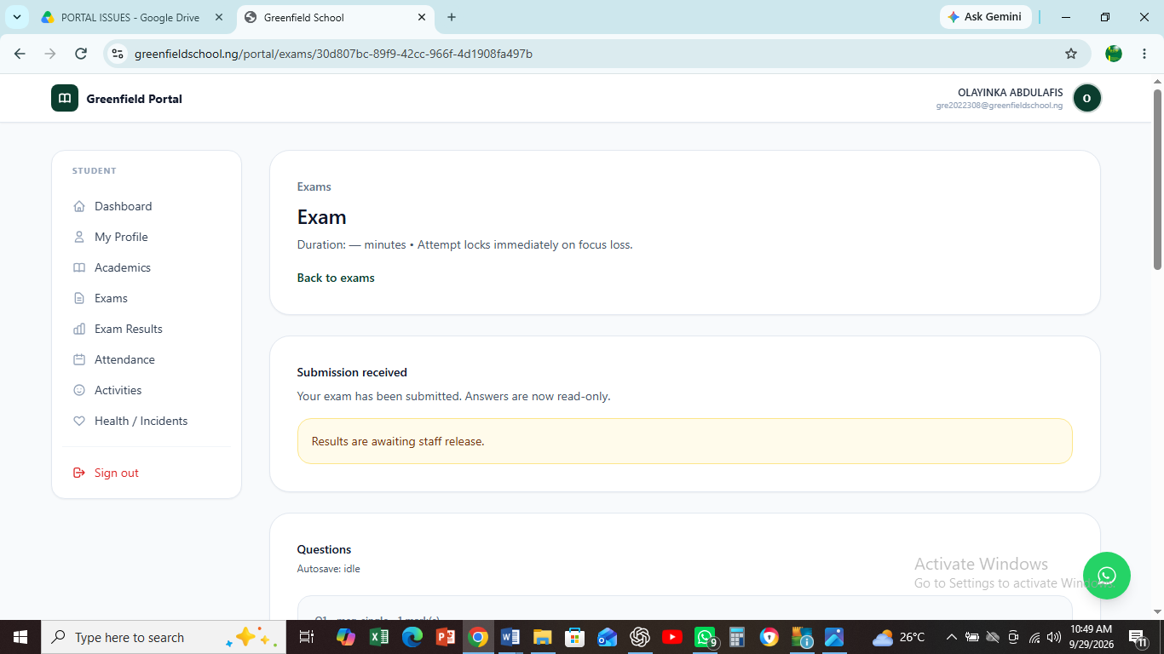
HOW DO I SEE THIS RESULT OR PUBLISH THE RESULT? HERE, THE RESULT WAS SUPPOSE TO SHOW ON THE CHILD DASHBOARD AND THE TEACHER COPY AND ADD THE OBJECTIVES SCORES. ALSO THE RESULT END SHOULD SHOW WHERE WE CAN INPUT FIRST CA, 2ND CA AND EXAM BEFORE IT IS PUBLISH FOR PUPILS OR STUDENTS TO SEE.

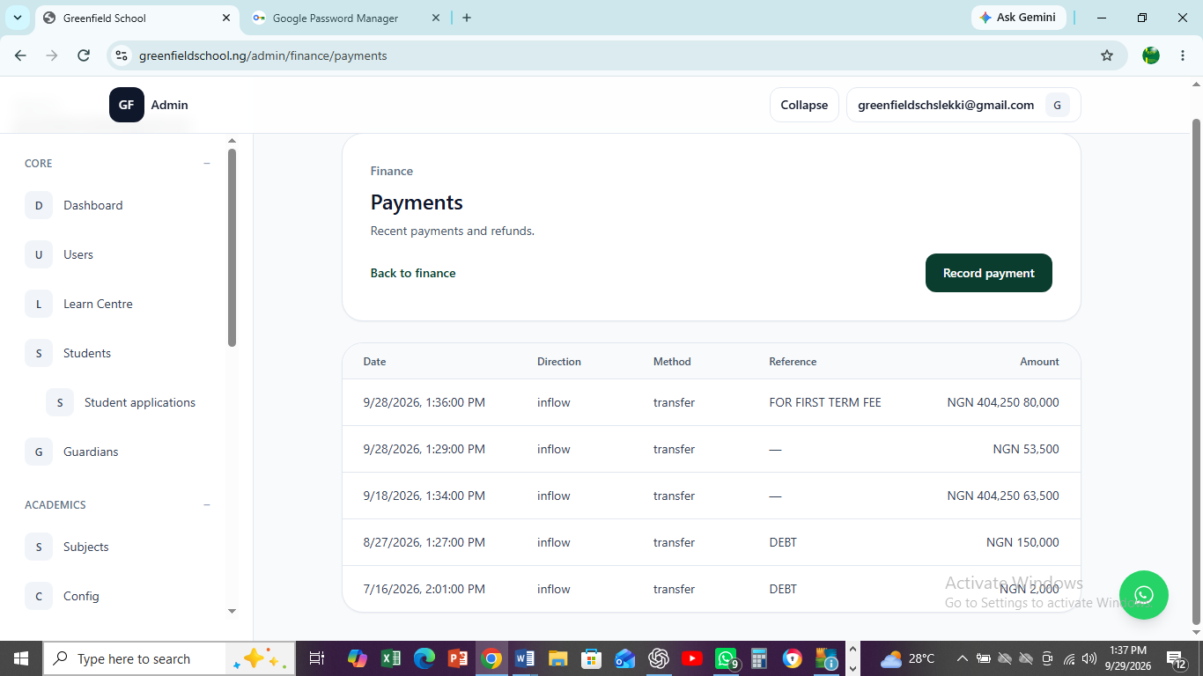
HOW DO I EDIT THIS PAYMENT THAT WAS WRONGLY ENTERED?

