Hodgkin-Huxley model simulation

# Methodology

## Basic model

Implementing this was fairly straightforward, as it just involved translating the equation to code. We start off with current values given, and our job is to find out the corresponding the voltages. The main equation relates these quantities (and the time-varying conductances) using a first order differential equation. Hence, the easiest way to go about this task is by calculating voltages and conductances step-wise, using the results of the previous step and the slopes to figure out the current values.

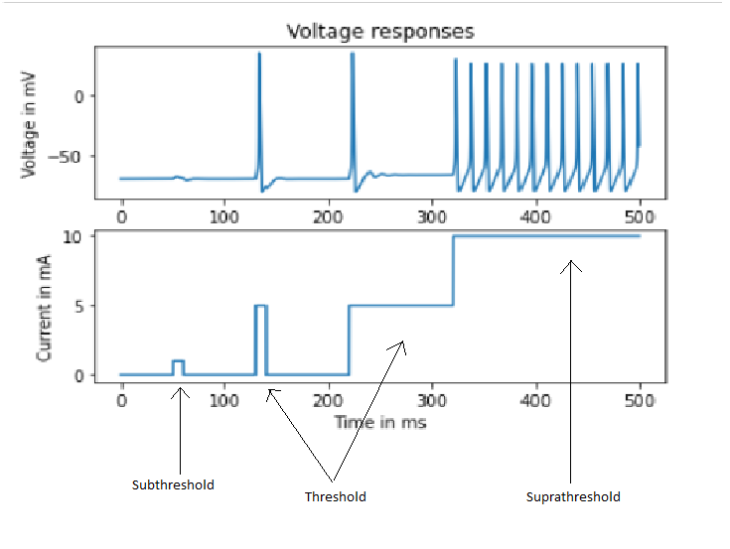

## Estimating the rheobase

This was for the most part, manual. I did not figure out a way to reliably identify when a spike occurs. (However, given that spikes occur, I can count them, which is what I used for plotting the f-I curve). The value came out to be 2.237 mA.

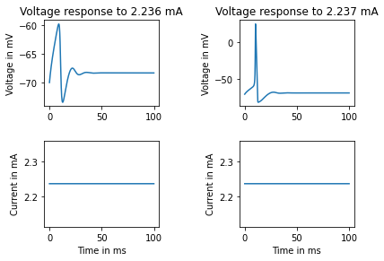

## Plotting f-I curve

I iteratively called the simulation function for a range of constant current values. For each array of voltages returned, I calculated the number of peaks (Which is the number of values for which its left and right is less than itself. Except for when the current is less than the rheobase, for which the number of peaks is zero. This is still not completely accurate, but it was the best I could do).

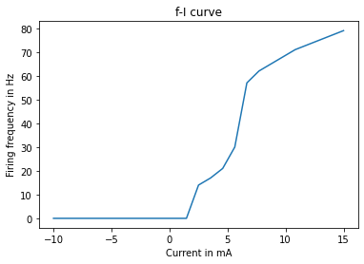

# Code

Please find the code at <https://github.com/greenfish8090/Hodgkin-Huxley-neuron-simulation/blob/master/HH%20simulation.ipynb>