

FieldPress

User Manual

Last updated: July 2016

Creative Commons License  
This work by [UBC Open Geography](https://creativecommons.org/choose/open.geog.ubc.ca) is licensed under a [Creative Commons Attribution-ShareAlike 4.0 International License](http://creativecommons.org/licenses/by-sa/4.0/).

Recommended Citation:

Green, A.G., L. Brown, D. Turner, Y. Shen, E. Liu, A. Fung, and M. Katz. 2016. FieldPress User Manual. UBC Open Geography: Vancouver, British Columbia. http://open.geog.ubc.ca

The FieldPress plugin and this user manual have been made possible by the generous support of:

 

For further information, please contact us at: [http://open.geog.ubc.ca](http://open.geog.ubc.ca/)  

Contents

Introduction 4

Development 4

License 5

Installation 6

FieldPress Admin Options 9

Field Trip 9

Creating a Field Trip 9

Create a Field Trip Stop 12

Managing Field Trips 15

Field Trip Categories 17

Optional: Adding Maps 21

User Management 22

Instructors 22

Students 26

General User Management 28

Assessment 29

Reports 31

Notifications 32

Discussion Boards 34

Settings 36

Additional Support 37

# Introduction

FieldPress is a powerful and versatile plugin for WordPress that allows you to turn a WordPress website into a platform for creating and managing field trips. FieldPress turns WordPress into a learning management system. It enables users to set up field trips, create field stops with dynamic content, integrate learning assessments, create discussion boards, track student progress, and assign grades. While FieldPress is designed and optimized for use in educational environments, it can equally be used for creating a wide range of activities such as historical or cultural sightseeing tours and scavenger hunts. This manual contains “Quick Start” instructions on how to install FieldPress and get your first field trip up and running as well as more detailed instructions that go over the full functionality of the plugin.

Please note, it is assumed that users of FieldPress have prior knowledge and experience with the WordPress content management system. If you have not used WordPress before, we recommend that you complete a WordPress tutorial prior to installing FieldPress. WordPress tutorials can be found online, for example:

* Word Press Lessons ([https://codex.WordPress.org/WordPress_Lessons](https://codex.wordpress.org/WordPress_Lessons))
* First Steps with WordPress ([https://codex.WordPress.org/First_Steps_With_WordPress](https://codex.wordpress.org/First_Steps_With_WordPress))

## Development

The FieldPress project emerged as part of a pedagogical innovation initiative on the part of the Department of Geography at the University of British Columbia.  In addition to the plugin, FieldPress includes a compatible FieldPress theme and a number of related plugins which add desired functionality. FieldPress code was primarily developed by Yuqing Shen. FieldPress is based on but significantly adapts the open source code for the CoursePress plugin (<http://coursepress.org/>) developed by wpmudev. For additional information about FieldPress, technology assisted field trips, and a wide range of other open educational resources developed by the Department of Geography at UBC please visit us at [open.geog.ubc.ca](http://open.geog.ubc.ca/).

## License

FieldPress is licensed under GNU General Public License, version 2:

<http://www.gnu.org/licenses/gpl-2.0.html>

FieldPress code is available on GitHub:

<https://github.com/greengeographer/FieldPressPlugin>

# Installation

In order to use FieldPress, you first need to install WordPress on a server. FieldPress is compatible with WordPress version 4.5.1. The following section will show you how to install FieldPress on the WordPress platform.

1. In your WordPress admin sidebar, select **Plugins** > **Add New**.

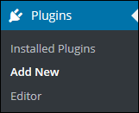

1. Search for “FieldPress”.



1. Click on **Install**.
2. Once successfully installed, go to **Installed** **Plugins**.

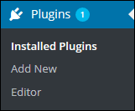

1. **Activate** the FieldPress.



1. Once activated, you will be directed to “Welcome to FieldPress” page. On the bottom of the page, select **Setup Permalinks**.



1. FieldPress requires that “pretty permalinks” to be enabled. Under **Common Settings**, select your permalink preference. We recommend the **Post name**.

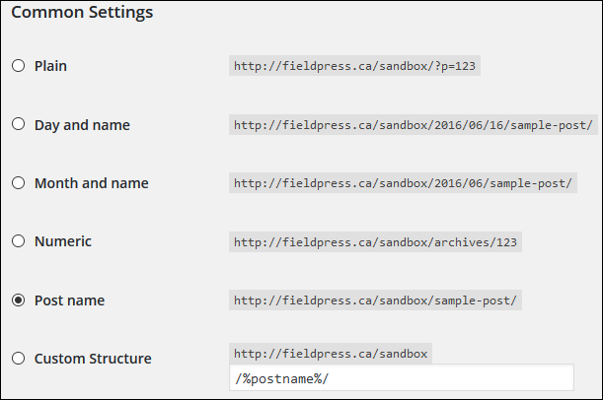

1. Save settings by clicking on **Save Changes** on the bottom of the page.
2. The FieldPress plugin automatically downloaded a FieldPress theme when you installed the plugin. It is important that you enable the FieldPress theme as part of the installation.
3. Go to **Appearance** > **Themes** and **Activate** the FieldPress theme. You should now see the FieldPress theme on the main FieldPress website. The FieldPress homepage is set to the default posting page.

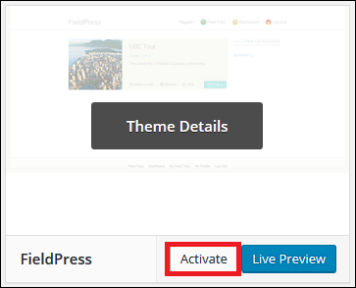

1. To change what your front page displays, select **Settings** > **Reading** from your dashboard view. Change the “Front page”.

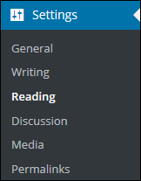

On the front page of your website, you will see that there are two new dynamic pages in the menu for your website (Field Trips and Dashboard). The Field Trips shows you all the available field trips on the website. The Dashboard shows you the field trips in which you are enrolled and your profile.



# FieldPress Admin Options

Once you have installed the FieldPress onto WordPress, FieldPress should appear in you WordPress admin sidebar located on the left side of the page. Click on **FieldPress** in the admin side bar and all the options that are built into the FieldPress plugin will appear (these options also appear when you hover your mouse over “FieldPress”).

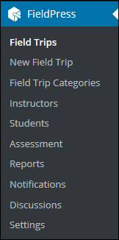

# Field Trip

The following section will walk you through how to create a field trip, how to create stops for field trips, and how to manage your fieldtrips.

## Creating a Field Trip

1. To create a new field trip, select **FieldPress** > **Field Trips** in the admin sidebar. Then click on **Add New.** FieldPress will walk you through a six step process to set up your field trip (You can also select **FieldPress** > **New** **Field Trip** in the admin sidebar).

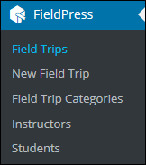



1. As you navigate through the steps, use the **Previous** and **Next** buttons to move forwards and backwards. If you go back and change a setting in one of the steps, click **Update** to save your changes. Below is a brief description of each step.

* Step 1 (Field Trip Overview): This step will set up the basic information about your field trip. Basic information includes your field trip title, a brief description, the cover image (listing image), field trip categories, and a field trip. Once you have entered all the information, scroll to the bottom of the page and save.
* Step 2 (Field Trip Description): This step will create the detailed description of your field trip and allow you to manage which stops are visible or hidden to students.
* Step 3 (Instructors): This step will allow you to assign different instructors (including TAs) to your field trip. You can assign an existing user as an instructor, or invite a new user with the Invite New Instructor function. The creator of the field trip is automatically assigned as an instructor.
* Step 4 (Field trip Date and Time): This step will allow you to put constraints on the day that students can enroll, and set the date and time that the field trip will be made available.
* Step 5 (Groups & Discussion): This step will allow you to manage the number of students in each group on your field trip and enable discussion forums and student workbooks.
* Step 6 (Enrollment & Field Trip Cost): This step will allow you to limit who can register for the field trip.

1. After you have completed all six steps, click **Done** to finish creating the field trip. This will direct you to the Stop creation panel to start making stops for your field trip.

## Create a Field Trip Stop

1. If you are not already on the edit stops page, go to **FieldPress > Field Trips**. Run your mouse over your field trip and select **Stops.**

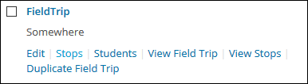

Alternatively, you can select **Edit** and select **Stops**.

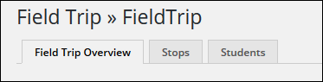

1. Fill in the information for your stops. Adding assessments for stops will be described in more detail in the assessment section.

* **Stop Title**: Give your individual stop a name. We recommend using a format that includes the stop number, to help students navigate between stops (e.g. Stop 1 - Location Description).
* **Stop Availability**: Use this to set a date for when the stop becomes available to students. You can saveand previeweach stop as you are developing it.
* **Stop Pages**: Clicking on the “+” symbol will allow you to have multiple pages for this stop. This will create a “Next” button on the lower left of the first page on the front end of your stop site, and numbers in the lower right to help navigate between pages.
* **Page Label**: This gives a short description to label your stop in the “Field Trip Overview and Individual Stop” pages.

1. Under “Build Page” at the bottom of the “Stop Settings”, you can add elements to the stop such as an assessment. Select “Single Choice” to create multiple choice questions and “Answer Field” for long answers. More details will be given on the assessment options in the Assessment and Reports section.

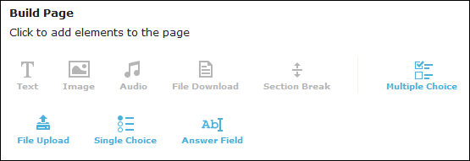

Example: **“**Image” allows you to add images to the stop. You can add content either using a URL or by browsing for an image using your Media Library. Once an image is selected, you can choose to use an existing media caption or create your own custom caption using the radio buttons and the space provided.

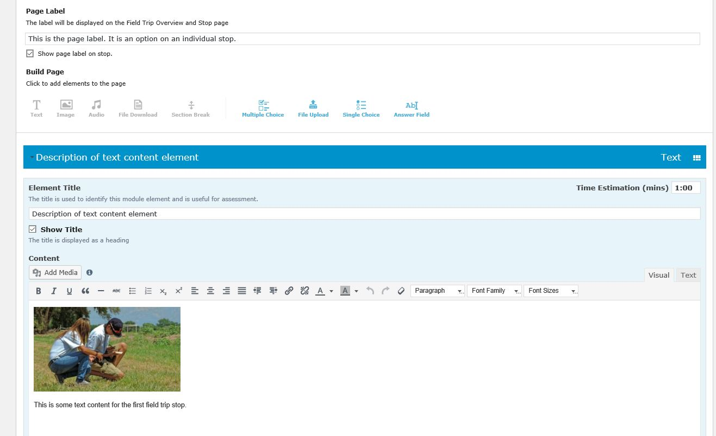

On the main field trip page, this is what students will see:

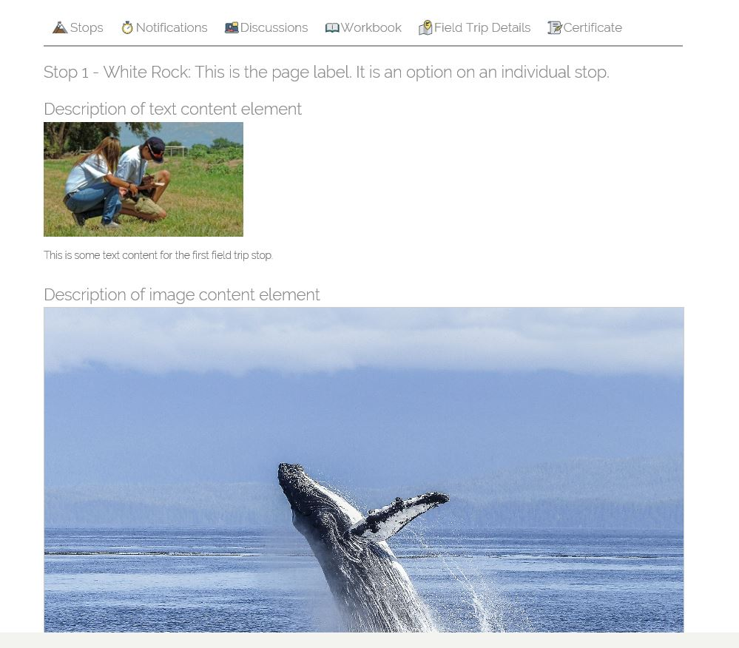

1. You can continue making the next stop by clicking the **Add New Stop** button in the upper left corner of the stop editing panel. Each stop created will appear as a separate tab on the upper left.

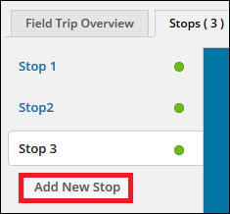

1. Use the **Save** button to save your stop. Publish your stop by moving the slider in the upper right corner from “Draft” to “Live”.



1. Once you have completed all your stops, you are ready to publish your field trip us the **Publish** button on the top right. This will make the field trip live and accessible (only by those you allowed in the Field Trip Overview). You can change this setting at any time to make your field trip inaccessible by clicking on the slider again.



## Managing Field Trips

The following section will walk you through how to manage existing field trips.

1. Go to **FieldPress** > **Field Trips**. This page displays all the field trips you have created. You can easily publish or unpublish a field trip or delete a field trip 
2. You can also publish, unpublish, and delete multiple field trips. Select the field trips by using the checkbox. Then go to the “Bulk actions” dropdown box and select the action.

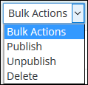

1. For more field trip management options, move your mouse cursor over the fieldtrip you would like to edit.

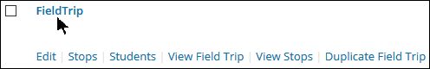

* **Edit** will allow you to edit the field trip setup.
* **Stops** will allow to edit the field trip stops.
* **View Field Trip** and **View Stops** will bring you how the field trip and stop will appear on the FieldPress website (as seen by students).
* You can also **Duplicate Field Trip** to quickly copy information from an existing fieldtrip into a new fieldtrip.

# Field Trip Categories

Field trip categories are designed to help you organize your field trips. You can choose to organize your field trips by course, content type, location or any other subject or theme. To create a category for a field trip, you must first create the category under **FieldPress** > **Field Trip Categories** and then assign the category to your fieldtrip through “Step 1” in **FieldPress > Field Trip**

1. To create categories for your field trips, click on **FieldPress > Field Trip Categories** in the admin sidebar. This page will allow you to add new field trip categories or edit existing categories.

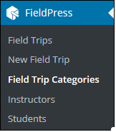

1. Fill in the fields under the “Add New Field Trip Category.

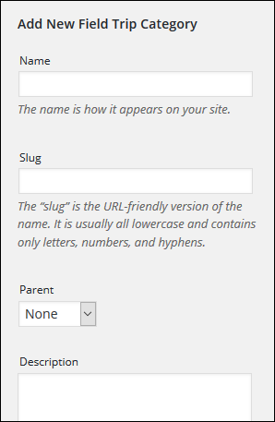

* You can name new categories and nest them within other categories using the “Parent”drop-down field.

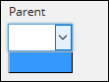

1. Click on the **Add new Field Trip Category** once you finish filling out the fields for the new category. This will automatically update the list of existing field trip categories.



1. To edit or delete existing categories, you can move your mouse over the category and then select **Edit** or **Delete**. You can also click on **View** to see how the category will appear on the FieldPress website. If you are edit the category, make sure you select **Update**.

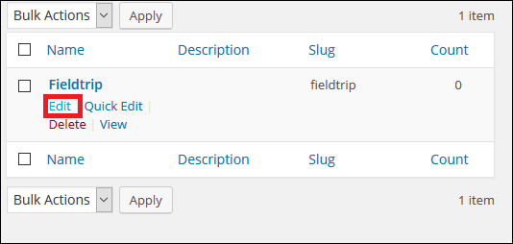

1. To assign a category to a field trip, select **FieldPress > Field trips** in the admin side bar. Then select your field trip and open the “Step 1 - Field Trip Overview”. You can choose the category for your field trip under the “Field Trip Category”.

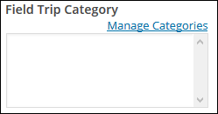

# Optional: Adding Maps

Maps are critical parts of most field trips as they provide orientation and enhance the content for stops on field trips. FieldPress does not come with a built in mapping function for inserting maps, yet there are many ways of inserting maps into your field trip. Below we provide links to a few simple tutorials for making online maps. You should consider add maps to both your field trip overview and to individual stops in your field trip.

You can simply create a Google Map and embed it using the instructions in these tutorials: [https://en.support.WordPress.com/google-maps/](https://en.support.wordpress.com/google-maps/)

<http://www.google.com/earth/outreach/tutorials/mapseng_lite.html>

[http://www.wpbeginner.com/wp-tutorials/how-to-add-google-maps-in-WordPress/](http://www.wpbeginner.com/wp-tutorials/how-to-add-google-maps-in-wordpress/)

You can add a map via a WordPress plugin. For example, Leaflet Maps Marker allows you to build complex maps within your WordPress website and enter maps via shortcode: [https://en-ca.WordPress.org/plugins/leaflet-maps-marker/](https://en-ca.wordpress.org/plugins/leaflet-maps-marker/)

# User Management

The two types of users using FieldPress will be instructors and students. This is the equivalent of WordPress administrators and subscribers, respectively. Under the FieldPress sidebar, you can select to manage **Instructors** or **Students.**

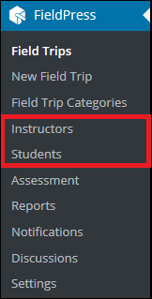

## Instructors

To assign an instructor to a field trip, you must first create the user under **FieldPress** > **Instructors** and then assign the instructor to the field trip under **FieldPress** > **Field Trips** step 3.

* 1. Go to **FieldPress -**>**Instructor** in the sidebar.

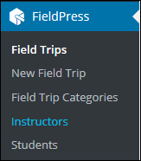

* 1. To add a new user, click on the **Add New** button. This will bring you to the “Add New User” page.

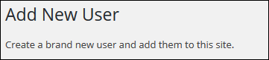

* 1. Fill out all the required information. Next to the “Role”, select **Admin** to have full control of the website.

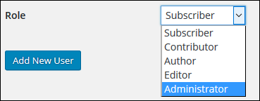

Subscriber

Contributor

Author

Editor

Administrator

* 1. Click on **Add New User** on the bottom of the page. Password setup instructions will be send to your email. Make sure to check your spam if instructions are not found in the inbox.
  2. You can also invite instructors under “Step 3-Instructors” in **FieldPress** > **Field Trips**.

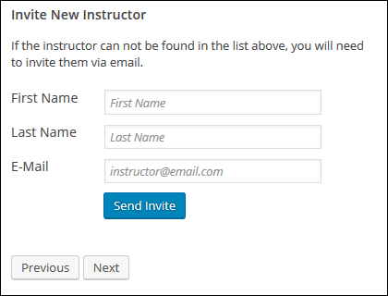

* 1. To assign an instructor to the fieldtrip, go to **FieldPress** > **Field Trips** and select **Step 3-Instructors**.



* 1. You can assign one or more existing users to be an instructor for a field trip.

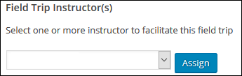

* 1. Select **Assign** once you have selected the Instructor.
  2. To unassign an instructors from field trips. Move your mouse over the instructor under the assigned instructors and click on the x button.

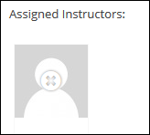

* 1. You can also remove instructors completely or unassign instructors from all field trips by going to **FieldPress** > **Instructors**. Select the instructors using the checkbox, then select the action from the “Bulk Actions” dropdown box and click **Apply**.

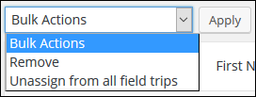

## Students

Students can add themselves for a fieldtrip when they sign up for a FieldPress account. You can also invite students through the **FieldPress > Students** admin sidebar. The following section will walk you through how to invite students and add them to fieldtrips.

* + 1. Go to the **FieldPress** -> **Students**. Under this setting, you can view and edit the profile of existing students.
  + **Workbook** : Shows the field trips submitted, responses, grades, and comments made by students
  + **Profile**  **:** Shows the profile of the student and the field trips taken.
  + **Remove**  **:** Removes the student from **all** field trips.

* + 1. To add a new student to FieldPress, click on **Add New.**

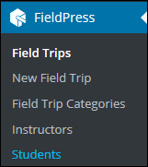

* + 1. Select **Subscriber** under “Role”



* + 1. Make sure the “Send User Notification” has a check mark in the checkbox. This will ensure that instructions and password for setting up will be send to the student.



* + 1. Once you have added the student to FieldPress, you can add them to specific field trips by going to **FieldPress** > **Fieldtrip**.
    2. Select the fieldtrip and then click on the **Students** tab.



* + 1. Select the student you want to add to the field trip in the dropdown and then select **Add Student.**

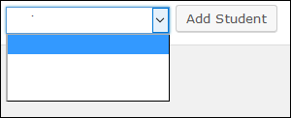

## General User Management

1. Go to **Users** under the admin sidebar. This page will display a list of all the FieldPress users and their roles.
2. To edit a specific user, move your mouse cursor over their name to **Edit** or **Delete** the user. Please note that deleting or editing the user from this page will make changes to all field trips.

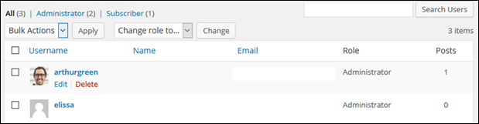

1. You can delete multiple users by selecting users using the checkbox  and then selecting “delete” under the “Bulk Action” dropdown. Select **Apply** to delete.

1. You can also change roles for multiple users by selecting users using the checkbox  and then selecting the role under the “Change role to...” drop down. Select **Change**.

# Assessment

In this section you can view and mark each student’s submissions in different formats including multiple choice, short answers, file upload, etc.

1. If you haven’t created an assessment while setting up the fieldtrip stop (in the above section, you can do so by going to **FieldPress > Field trips**.
2. Select the fieldtrip that you want to add an assessment to and then click **Stops**. This will bring you to the “Stop Settings”.
3. At the bottom of the “Stop Settings”, you will have several assessment options under “Build Page”.

* Multiple Choice: Students pick more than one correct answer.



* File Upload: Students will need to upload a file as their answer.



* Single Choice: Students can only pick one answer as the correct answer.



* Answer Field: Students will need to write down their answer.



1. You can limit attempts for questions, choose whether an answer will be graded, and if an answer is mandatory to continue the field trip.

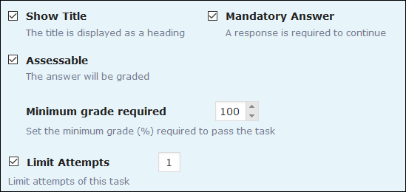

1. For a summary of student responses and grades, go to FieldPress > Assessment.

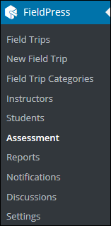

# Reports

1. Go to **FieldPress > Reports** to generate a detailed PDF report for a student’s total grade from each field trip, and how they performed on each question. You will also see when they completed the question, or if they have not submitted it yet.

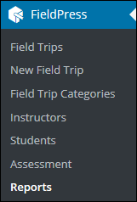

1. Click on the PDF symbol  under “Report” to download the PDF and view the performance of each student.

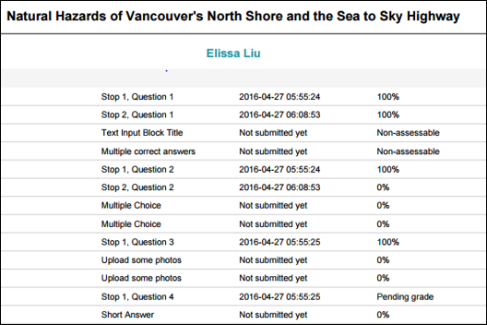

# Notifications

You can create notifications to for all of your students or students registered in a specific field trip.

1. To create notifications, go to **FieldPress > Notifications** in the admin sidebar.

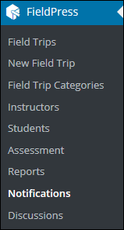

2. Select **Add New** to create a notification for your students. You have the option of sending notifications to students from a specific field trip or students from all field trips.

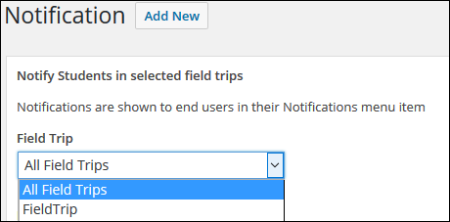

3. Enter the notification title and content, then select **Create**.



When students go to the official field trip pages, students will now see your notifications under the “Notifications” tab in the each of the field trip pages.

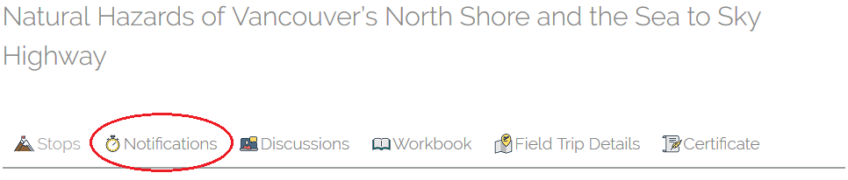

# Discussion Boards

On FieldPress, both students and instructors can create and participate in discussions for field trips.

1. On the admin page, you can select **FieldPress >Discussions** on the admin sidear.

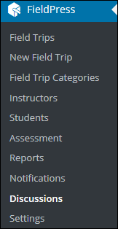

1. To create a new discussion, select **Add New** and then you can fill in the Discussion Title and Content.
2. Select the fieldtrip for the discussions in the dropdown box. Then click **Create**.

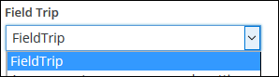

1. Once the discussion is created, you will be redirected to the main “Discussions” page which list all the discussions you have created. You can delete any discussions by selecting the x button.

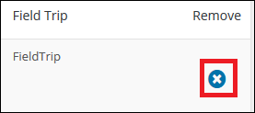

When students log into a field trip, they are able to click on Discussions and view what you or other students have posted. They can also ask their own questions by clicking on the yellow **Ask a Question** button.

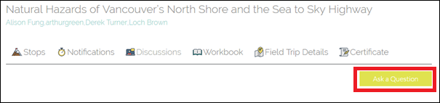

# Settings

The settings on FieldPress are easy to access and edit. You can access the settings from the FieldPress submenu in the administrative dashboard view.

1. Select **FieldPress** > **Settings**.

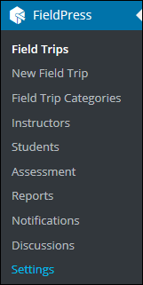

Explore each of the settings options:

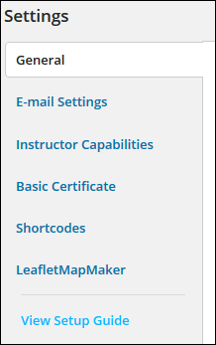

* + **General**: Modify the URL for each page, known as slugs.
  + **E-Mail Settings:** Modify when subscribers will receive emails, the text of the email, and other information you want to include.
  + **Instructor Capabilities:** Control accessibility of instructors.
  + **Basic Certificate:** The default option is for subscribers to receive a certificate when they complete the fieldtrip, but you can uncheck the box under “Enable Basic Certificate” if you do not want a certificate.

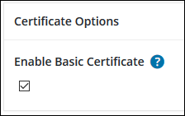

Options under “Certificate Layout” allows you to personalize the certificate.

* + **Shortcodes:** You can include dynamic content in posts and pages on your site by typing or coping and pasting these contents into your post or page.
  + **Leaflet Maps Maker plugins:** You canembed Google Maps and other maps into the field trips. This plugin is installed and active in FieldPress. If you wish to deactivate it, click on the Plugin option on the left sidebar, scroll down to Leaflet Maps Maker, and click on Deactivate.

# Additional Support

This user manual provides an in-depth overview of the FieldPress plugin. We invite you to contact us if you need additional help in setting up your own installation. While the plugin is free, additional support may require payment for services.

You can find out more here:

<http://open.geog.ubc.ca/resources/fieldpress/>

You can collaborate with us and contribute back to the project here:

<https://github.com/greengeographer/FieldPressPlugin>