day4加入失败计数和故障分级

把状态“结构化输出”
现在已经有这些能力：
- 有 SensorFrame
- 有 status / valid
- 有 g_health（failCnt / consecFail / consecOff）
- 串口能打印一行人类可读日志
👉 但现在有一个很典型的“伪工程问题”：
❗现在的输出是“给人看的”，不是“给系统用的”
举个很真实的 ECU 场景：
后面要做：
- diag task（诊断读取）
- log task（日志模块）
- comm task（通信上报）
这些模块不会去解析字符串：
[SENSOR] status=OK valid=true failCnt=3 ...
它们需要的是：
👉 结构化数据（structured data）
否则就会出现一个很糟糕的情况：
- 每个模块都要自己解析字符串 ❌
- 解析逻辑重复 ❌
- 容易出错 ❌
- 完全不像 ECU ✅（反例）

如果不做结构化，而是靠字符串：
- 诊断模块可能解析错 → 返回错误状态
- 日志模块可能丢字段 → 无法追踪问题
- 攻击者甚至可以构造“伪日志字符串”（后面会讲）
定义一个“对外输出结构体”

改代码
加结构体（原地加，不动旧代码）
👉 放在 SensorFrame 下面
C++
struct SensorReport {
SensorStatus status;
bool valid;
int16_t ax;
int16_t ay;
int16_t az;
int16_t gx;
int16_t gy;
int16_t gz;
int16_t tempRaw;
uint32_t totalReadFail;
uint32_t consecutiveFail;
uint32_t consecutiveOffline;
};
加健康结构体
C++
struct SensorHealth {
uint32_t totalReadFail;
uint32_t consecutiveFail;
uint32_t consecutiveOffline;
};
SensorHealth g_health = {0, 0, 0};
加 build 函数
C++
SensorReport buildSensorReport(const SensorFrame& frame) {
SensorReport r;
r.status = frame.status;
r.valid = frame.valid;
r.ax = frame.ax;
r.ay = frame.ay;
r.az = frame.az;
r.gx = frame.gx;
r.gy = frame.gy;
r.gz = frame.gz;
r.tempRaw = frame.tempRaw;
// 当前先接入（虽然还没更新）
r.totalReadFail = g_health.totalReadFail;
r.consecutiveFail = g_health.consecutiveFail;
r.consecutiveOffline = g_health.consecutiveOffline;
return r;
}
新增 printReport
Go
void printReport(const SensorReport& r) {
Serial.print("[SENSOR] status=");
Serial.print(statusToString(r.status));
Serial.print(" valid=");
Serial.print(r.valid ? "true" : "false");
Serial.print(" failCnt=");
Serial.print(r.totalReadFail);
Serial.print(" consecFail=");
Serial.print(r.consecutiveFail);
Serial.print(" consecOff=");
Serial.print(r.consecutiveOffline);
if (!r.valid) {
Serial.println();
return;
}
Serial.print(" | ax=");
Serial.print(r.ax);
Serial.print(" ay=");
Serial.print(r.ay);
Serial.print(" az=");
Serial.print(r.az);
Serial.print(" | tempRaw=");
Serial.print(r.tempRaw);
Serial.print(" | gx=");
Serial.print(r.gx);
Serial.print(" gy=");
Serial.print(r.gy);
Serial.print(" gz=");
Serial.println(r.gz);
}
改 loop
C++
SensorFrame frame = sensorReadFrame();
SensorReport report = buildSensorReport(frame);
printReport(report);

把失败计数“接到真实逻辑里”
现在：
- 已经有 g_health ✔
- 已经有 SensorReport ✔
- 串口能打印 ✔
但问题是：
❗这些计数 还没有被更新
现在的系统是：
有计数变量，但永远是 0
👉 这在 ECU 里是“假数据”，没有任何意义

如果 ECU：
- 读失败，但不累计
- 离线，但不统计
那么系统就会：
- 永远认为“只是偶发问题”
- 无法进入故障状态
- 无法触发降级
👉 等价于：
❌ 故障检测系统是“假的”

改代码
sensorReadFrame()
找到这里：
C++
if (!sensorIsOnline()) {
return frame;
}

改成：
C++
if (!sensorIsOnline()) {
g_health.consecutiveOffline++;
g_health.consecutiveFail++;
g_health.totalReadFail++;
return frame;
}

找到这一段：
C++
if (!readInt16(0x3B, frame.ax)) return frame;

改成：
C++
if (!readInt16(0x3B, frame.ax)) {
g_health.consecutiveFail++;
g_health.totalReadFail++;
return frame;
}

下面这几行 全部一样改：
C++
if (!readInt16(0x3D, frame.ay)) { ... }
if (!readInt16(0x3F, frame.az)) { ... }
if (!readInt16(0x41, frame.tempRaw)) { ... }
if (!readInt16(0x43, frame.gx)) { ... }
if (!readInt16(0x45, frame.gy)) { ... }
if (!readInt16(0x47, frame.gz)) { ... }

找到：
C++
if (sensorFrameLooksAbnormal(frame)) {
frame.status = SENSOR_DATA_ABNORMAL;
frame.valid = false;
return frame;
}

改成：
C++
if (sensorFrameLooksAbnormal(frame)) {
g_health.consecutiveFail++;
g_health.totalReadFail++;
frame.status = SENSOR_DATA_ABNORMAL;
frame.valid = false;
return frame;
}

找到最后：
C++
frame.status = SENSOR_OK;
frame.valid = true;
return frame;

👉 改成：
C++
frame.status = SENSOR_OK;
frame.valid = true;
// 成功 → 清零连续计数
g_health.consecutiveFail = 0;
g_health.consecutiveOffline = 0;
return frame;

C++
✅ 正常情况
[SENSOR] status=OK valid=true failCnt=0 consecFail=0 consecOff=0
✅ 偶发抖动（你轻碰线）
failCnt=3 consecFail=1
👉 说明系统能区分“偶发”
✅ 故意制造离线（拔 SDA 或 SCL）
status=OFFLINE
failCnt=10
consecFail=5
consecOff=5
👉 说明系统进入“持续故障”

故障等级
现在已经能得到：
consecFail = 3
consecOff = 5
但问题是：
❗系统还不知道“这算不算严重问题”

真实 ECU 不会直接用计数，而是会做：
计数 → 故障等级

举个例子
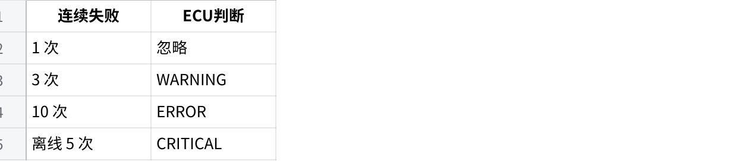
点击图片可查看完整电子表格
也就是说：
❗计数只是“原始信号”，
ECU真正用的是“等级”

改代码
定义故障等级枚举
C++
enum FaultLevel {
FAULT_NONE = 0,
FAULT_WARNING,
FAULT_ERROR,
FAULT_CRITICAL
};
在 SensorReport 里加字段
找到：
C++
struct SensorReport {
加一行：
C++
FaultLevel faultLevel;
写“故障判断函数”
放在 buildSensorReport() 上面
JavaScript
FaultLevel evaluateFault(const SensorHealth& h) {
if (h.consecutiveOffline >= 5) {
return FAULT_CRITICAL;
}
if (h.consecutiveFail >= 10) {
return FAULT_ERROR;
}
if (h.consecutiveFail >= 3) {
return FAULT_WARNING;
}
return FAULT_NONE;
}
在 buildReport 里接入、
找到：
C++
return r;
在 return 前加：
C++
r.faultLevel = evaluateFault(g_health);
第 5 步：打印出来
C++
const char* faultToString(FaultLevel f) {
switch (f) {
case FAULT_NONE: return "NONE";
case FAULT_WARNING: return "WARNING";
case FAULT_ERROR: return "ERROR";
case FAULT_CRITICAL: return "CRITICAL";
default: return "UNKNOWN";
}
}
然后在 printReport() 里加：
C++
Serial.print(" fault=");
Serial.print(faultToString(r.faultLevel));
完整代码
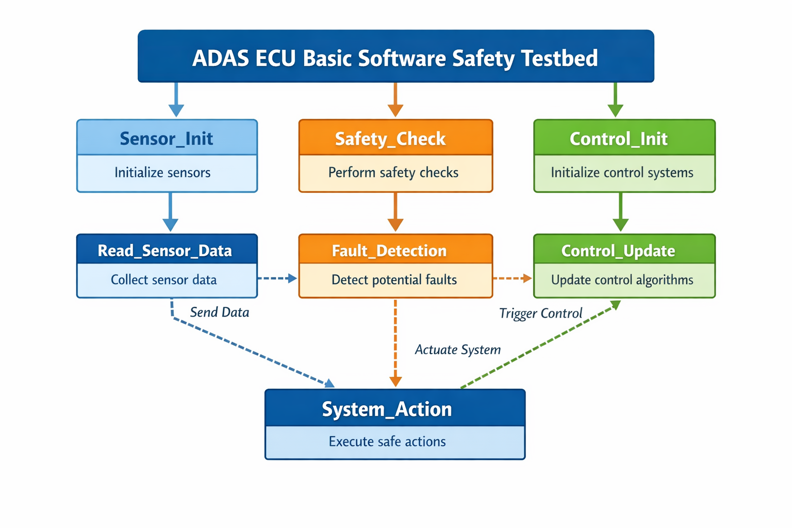
C++
#include <Wire.h>
#define MPU_ADDR 0x68
#define REG_PWR_MGMT_1 0x6B
#define REG_WHO_AM_I 0x75
#define WHOAMI_MPU6050 0x68
#define WHOAMI_MPU6500 0x70
enum SensorStatus {
SENSOR_OK = 0,
SENSOR_OFFLINE,
SENSOR_READ_FAIL,
SENSOR_DATA_ABNORMAL
};
enum FaultLevel {
FAULT_NONE = 0,
FAULT_WARNING,
FAULT_ERROR,
FAULT_CRITICAL
};
struct SensorFrame {
int16_t ax, ay, az;
int16_t tempRaw;
int16_t gx, gy, gz;
SensorStatus status;
bool valid;
};
struct SensorHealth {
uint32_t totalReadFail;
uint32_t consecutiveFail;
uint32_t consecutiveOffline;
};
SensorHealth g_health = {0, 0, 0};
struct SensorReport {
SensorStatus status;
bool valid;
int16_t ax, ay, az;
int16_t gx, gy, gz;
int16_t tempRaw;
uint32_t totalReadFail;
uint32_t consecutiveFail;
uint32_t consecutiveOffline;
FaultLevel faultLevel;
};
// ================= I2C =================
void writeRegister(uint8_t reg, uint8_t value) {
Wire.beginTransmission(MPU_ADDR);
Wire.write(reg);
Wire.write(value);
Wire.endTransmission();
}
bool readRegister(uint8_t reg, uint8_t &value) {
Wire.beginTransmission(MPU_ADDR);
Wire.write(reg);
if (Wire.endTransmission(false) != 0) return false;
if (Wire.requestFrom((uint8_t)MPU_ADDR, (uint8_t)1) != 1) return false;
value = Wire.read();
return true;
}
bool readInt16(uint8_t reg, int16_t &value) {
Wire.beginTransmission(MPU_ADDR);
Wire.write(reg);
if (Wire.endTransmission(false) != 0) return false;
if (Wire.requestFrom((uint8_t)MPU_ADDR, (uint8_t)2) != 2) return false;
uint8_t h = Wire.read();
uint8_t l = Wire.read();
value = (int16_t)((h << 8) | l);
return true;
}
// ================= 判断 =================
bool sensorIsOnline() {
uint8_t who = 0;
if (!readRegister(REG_WHO_AM_I, who)) return false;
return (who == WHOAMI_MPU6050 || who == WHOAMI_MPU6500);
}
bool sensorFrameLooksAbnormal(const SensorFrame &f) {
if (f.ax==0 && f.ay==0 && f.az==0 &&
f.tempRaw==0 && f.gx==0 && f.gy==0 && f.gz==0)
return true;
if (abs(f.ax) > 32000 || abs(f.ay) > 32000 || abs(f.az) > 32000) return true;
if (abs(f.tempRaw) > 32000) return true;
if (abs(f.gx) > 32000 || abs(f.gy) > 32000 || abs(f.gz) > 32000) return true;
return false;
}
// ================= 读取核心 =================
SensorFrame sensorReadFrame() {
SensorFrame f = {0};
f.status = SENSOR_OFFLINE;
f.valid = false;
// OFFLINE
if (!sensorIsOnline()) {
g_health.consecutiveOffline++;
g_health.consecutiveFail++;
g_health.totalReadFail++;
return f;
}
f.status = SENSOR_READ_FAIL;
// READ_FAIL
if (!readInt16(0x3B, f.ax)) goto fail;
if (!readInt16(0x3D, f.ay)) goto fail;
if (!readInt16(0x3F, f.az)) goto fail;
if (!readInt16(0x41, f.tempRaw)) goto fail;
if (!readInt16(0x43, f.gx)) goto fail;
if (!readInt16(0x45, f.gy)) goto fail;
if (!readInt16(0x47, f.gz)) goto fail;
// DATA_ABNORMAL
if (sensorFrameLooksAbnormal(f)) {
g_health.consecutiveFail++;
g_health.totalReadFail++;
f.status = SENSOR_DATA_ABNORMAL;
return f;
}
// SUCCESS
f.status = SENSOR_OK;
f.valid = true;
g_health.consecutiveFail = 0;
g_health.consecutiveOffline = 0;
return f;
fail:
g_health.consecutiveFail++;
g_health.totalReadFail++;
return f;
}
// ================= 故障等级 =================
FaultLevel evaluateFault(const SensorHealth& h) {
if (h.consecutiveOffline >= 5) return FAULT_CRITICAL;
if (h.consecutiveFail >= 10) return FAULT_ERROR;
if (h.consecutiveFail >= 3) return FAULT_WARNING;
return FAULT_NONE;
}
// ================= 构建报告 =================
SensorReport buildSensorReport(const SensorFrame& f) {
SensorReport r;
r.status = f.status;
r.valid = f.valid;
r.ax=f.ax; r.ay=f.ay; r.az=f.az;
r.gx=f.gx; r.gy=f.gy; r.gz=f.gz;
r.tempRaw=f.tempRaw;
r.totalReadFail = g_health.totalReadFail;
r.consecutiveFail = g_health.consecutiveFail;
r.consecutiveOffline = g_health.consecutiveOffline;
r.faultLevel = evaluateFault(g_health);
return r;
}
// ================= 打印 =================
const char* statusToString(SensorStatus s) {
switch(s){
case SENSOR_OK: return "OK";
case SENSOR_OFFLINE: return "OFFLINE";
case SENSOR_READ_FAIL: return "READ_FAIL";
case SENSOR_DATA_ABNORMAL: return "DATA_ABNORMAL";
default: return "UNKNOWN";
}
}
const char* faultToString(FaultLevel f) {
switch(f){
case FAULT_NONE: return "NONE";
case FAULT_WARNING: return "WARNING";
case FAULT_ERROR: return "ERROR";
case FAULT_CRITICAL: return "CRITICAL";
default: return "UNKNOWN";
}
}
void printReport(const SensorReport& r) {
Serial.print("[SENSOR] status=");
Serial.print(statusToString(r.status));
Serial.print(" valid=");
Serial.print(r.valid);
Serial.print(" fault=");
Serial.print(faultToString(r.faultLevel));
Serial.print(" failCnt=");
Serial.print(r.totalReadFail);
Serial.print(" consecFail=");
Serial.print(r.consecutiveFail);
Serial.print(" consecOff=");
Serial.print(r.consecutiveOffline);
if (!r.valid) {
Serial.println();
return;
}
Serial.print(" | ax="); Serial.print(r.ax);
Serial.print(" ay="); Serial.print(r.ay);
Serial.print(" az="); Serial.print(r.az);
Serial.print(" | gx="); Serial.print(r.gx);
Serial.print(" gy="); Serial.print(r.gy);
Serial.print(" gz="); Serial.print(r.gz);
Serial.print(" | temp="); Serial.println(r.tempRaw);
}
// ================= main =================
void setup() {
Serial.begin(115200);
Wire.begin(21,22);
Serial.println("=== SENSOR TEST ===");
uint8_t who;
if (!readRegister(REG_WHO_AM_I, who)) {
Serial.println("WHO_AM_I fail");
while(1);
}
Serial.print("WHO_AM_I=0x");
Serial.println(who, HEX);
writeRegister(REG_PWR_MGMT_1, 0x00);
}
void loop() {
SensorFrame f = sensorReadFrame();
SensorReport r = buildSensorReport(f);
printReport(r);
delay(500);
}

ECU分层
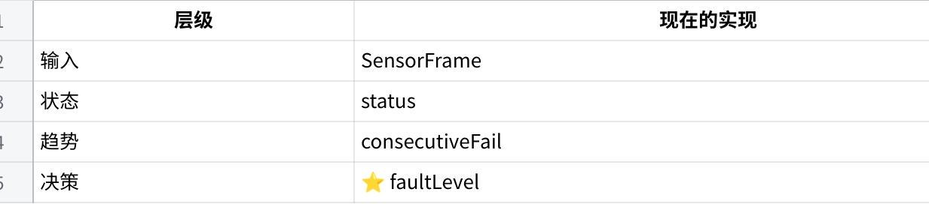
点击图片可查看完整电子表格

