傳捷門控系統

# Sub document Type

Software, application portion.

# Release Note

|  |  |  |
| --- | --- | --- |
| **Application information** | | |
| Release date | Version | Supported platform |
| 2014/11/15 | alpha.141115 | Android 4.3+ with BLE capable Bluetooth moduel |
| 2014/11/01 | 20141101.alpha.001 | Android 4.3+ with BLE capable Bluetooth moduel |

|  |  |  |
| --- | --- | --- |
| **New features** | | |
| WP ID | Date | description |
| A.11 | 2014/11/15 | Orientation is always in portrait mode. |
| A.10 | 2014/11/15 | after “home” button pressing, this application should exist in Android recent app list and keep its current status. |
| A.9 | 2014/11/15 | Show quit confirmation dialog after “back(🡨)” button pressing. If user presses “yes”, this application still exists in Android recent app list. |
| A.8 | 2014/11/15 | Show connection status and signal strength on the peripheral in listview |
| A.7 | 2014/11/15 | Execute first scan as application launched |
| A.1 | 2014/11/9 | User can press button with text: “掃瞄” to get all BLE peripherals around user device and show them on listview. |
| A.2 | 2014/11/9 | User can select 1 peripheral from listview and can start to do control: up, stop and down |
| A.3 | 2014/11/9 | User can press button with text: ▲ to send “Up” string to remote BLE-capable door for rolling up. |
| A.4 | 2014/11/9 | User can press button with text: ◼ to send “Stop” string to remote BLE-capable door for stop rolling. |
| A.5 | 2014/11/9 | User can press button with text: ▼ to send “Down” string to remote BLE-capable door for rolling down. |
| A.6 | 2014/11/9 | User own device can get data from the selected peripheral by notification registration. |

|  |  |  |
| --- | --- | --- |
| **Bug fix** | | |
| Issue ID | Date | description |
|  |  |  |

# System Introduction

## System design

This application will send control related commands to our hardware control modules to control rolling door’s actions, like: up, down and stop, Below is UUID table of Service and characteristics.

|  |  |  |  |
| --- | --- | --- | --- |
| Type | Sub-Type | Name | UUID |
| Service |  | DoorService | 713d0000-503e-4c75-ba94-3148f18d941e |
| characteristic | Write | 713d0003-503e-4c75-ba94-3148f18d941e |
| characteristic | Notification | 713d0002-503e-4c75-ba94-3148f18d941e |

## Installtion

You can install this software by below ways:

1. Install SecurityLocker.apk through USB.
2. *Install this software from Google Play (not support yet).*

# User Interface Introduciton

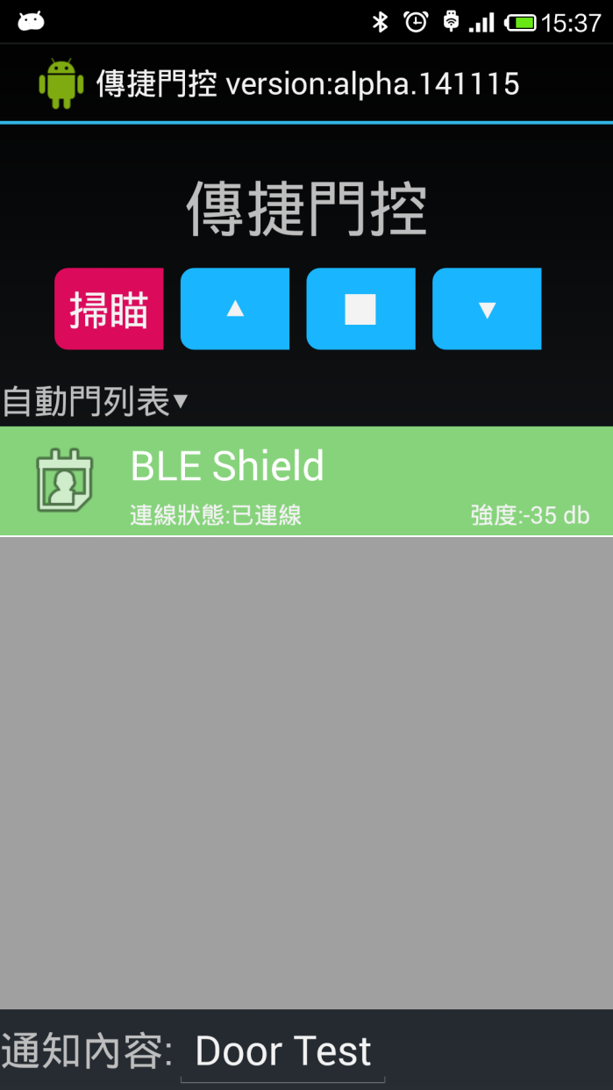

**Connection status**

**Signal Strength**

**Version number**

**It will show the message of peripheral (will be removed in formal release)**

**1: button for scanning**

**2: button for rolling up**

**3: button for rolling stop**

**4: button for rolling down**

**Peripheral list**

**3**

**2**

**4**

**1**

# Test

### Under Arduio with RedBearLab’s BLE board

1. Load “Simple chat” into your Arduino board. ( you can download from <http://redbearlab.com/bleshield/> )
2. Open serial monitor window (Ctrl+Shift+M) from Arduino IDE, you can utilize this window to help you debug the issue of data transferring.

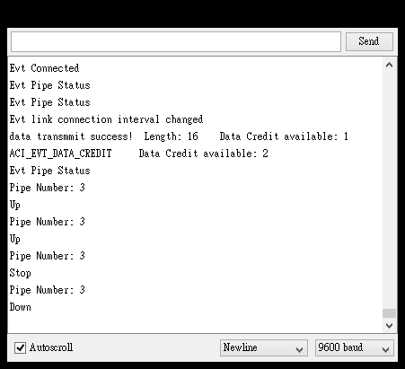

1. Install this application into your Android device.
2. Select 1 peripheral and start to send/receive commands/data after scanning.