



PROJECT REPORT ON
Greenie Culture (Smart Eco-Plant Management System)

AS A PARTIAL REQUIREMENT FOR THE DEGREE OF
BACHELOR OF COMPUTER APPLICATION (B.C.A.)

SUBMITTED BY: GUIDED BY:
738 – 5913 – Aesha Modi Prof. Harsh Purohit
766 – 5997 – Nikita Tank
765 – 5991 – Hetvi Siddhpuriya
711 – 5937 – Isha Parmar

ACKNOWLEDGEMENT

I am sincerely grateful to everyone who supported and guided me in the successful completion of my project, “Greenie Culture: Smart Eco-Plant Management System.”
- Faculty & Institution

I would like to express my heartfelt gratitude to my college, principal, and faculty members for providing valuable guidance, encouragement, and academic support throughout the development of this project. Their suggestions and insights played an important role in improving the quality of my work.

- Project Guide

I extend my special thanks to my project guide for their continuous support, expert advice, and constructive feedback. Their mentorship helped me understand the concepts of website development and guided me in building the Greenie Culture platform successfully.

- Family & Friends

I am deeply thankful to my parents, family members, and friends for their constant motivation, patience, and encouragement. Their support helped me stay focused and confident during the completion of this project.

- Technical Learning & Resources

I also acknowledge the various online resources, learning platforms, and tools that helped me understand modern web development technologies such as front-end design, database integration, and AI chatbot implementation used in this project.

- Team & Support
Finally, I would like to thank everyone who directly or indirectly contributed to the completion of this project. Their cooperation and support made this journey a valuable learning experience.
This project represents not only academic learning but also practical experience in developing a plant-selling website that promotes greenery and sustainable living.
With sincere appreciation,
Sutex Bank College of Computer Applications & Science, Amroli.
Chapter | Page No.
1. Introduction | 1
1.1 Collage Profile | 2
1.2 Project Description | 3
1.3 Project Profile | 5
2. Environment Description | 6
2.1 Hardware and Software Requirements | 7
2.2 Technologies Used | 8
3. System Analysis and Planning | 9
3.1 Existing System and its Drawbacks | 10
3.2 Feasibility Study | 12
3.3 Requirement Gathering and Analysis | 14
4. Proposed System | 15
4.1 Scope | 16
4.2 Project modules | 17
4.3 Expected Advantages | 18
5. Detail Planning | 19
5.1 Data Flow Diagram  5.2 Process Specification | 20  39
5.3 System Flow Diagram | 26
5.3 Entity-Relationship Diagram | 27
6. System Design | 28
6.1 Database Design | 29
6.2 Directory Structure | 37
6.3 System Layouts | 49
7. Software Testing [Test Cases] | 81
7.1 Software Testing | 82
 | 83
8. Limitations and Future Scope of Enhancements | 85
7.1 Limitations | 86
7.2 Future Scope | 87
9. References | 88
9.1 Reference Websites | 89
INDEX

1. Introduction

- College Profile
- Project description
- Project Profile

College Profile

Prof. V. B. Shah Institute of Management, R. V. Patel College of Commerce (English Medium), V. L. Shah College of Commerce (Gujarati Medium) & Sutex Bank College of Computer Applications & Science are Self - Financed colleges affiliated to the Veer Narmad South Gujarat University, Surat. Prof. V. B. Shah Institute was started in the year 1998 with a view to churn out management professionals. A progressive academic record has been maintained in this regard. The R. V. Patel College of Commerce which was started in the year 2001 offers the B.Com. degree programme in English Medium whereas the V. L. Shah college of Commerce started in the year 2006 offers the B.Com. degree programme in Gujarati Medium. Sutex Bank College of Computer Applications & Science started in the year 2000 offers the B.C.A. degree programme, with the onset of the 21st century, there has been tremendous advancement in science and technology.

The entire academic year is replete with academic, extra & co-curricular activities, sporting events, guest lectures, Industrial Visit, Educational tour, seminars and workshops. A significant goodwill has been created by the institute among its stakeholders.

The institute is proud to have a qualified, competent and an industrious staff. They assist the students in unleashing their talents and exhibiting their skills. The perspective institutional plan is collectively chalked out by the I/c Principal, members of the managing trust (Jivan Jyot Trust, Amroli), the faculty members as well as the administrative staff. Industrial visits and practical tasks help the students a great deal in supplementing their learning. Students are also given ample of scope to sharpen their entrepreneurial skills. The institute takes pride in stating that it focuses on the optimal use of resources available and takes all the measures for quality enhancement and quality sustenance.
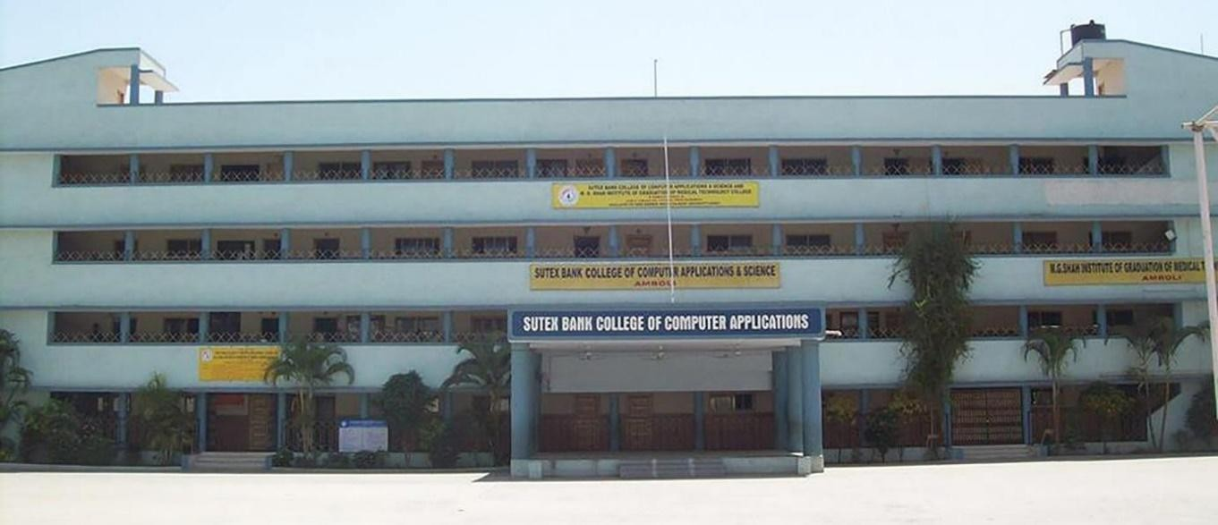

Project Description

Greenie Culture is an innovative online nursery management and plant e-commerce system that provides an end-to-end digital solution for managing botanical operations and plant care. The system is designed to automate order full fillment, simplify inventory management, improve customer experience through AI assistance, and provide real-time monitoring of regional sales activities. The platform integrates customer ordering, AI-powered plant expertise, and administrative management into a single unified system, ensuring efficient communication and seamless operation between all stakeholders.

Core Features:

1. Efficient Online Order & Regional Management:
Order Management in Greenie Culture enables customers to browse the botanical menu, place orders, and track their order status efficiently. The system facilitates accurate processing while minimizing delays and errors common in traditional nursery operations.
- Easy Catalog Browsing and Regional Personalization – Customers can explore the nursery menu through categorized sections such as Indoor Plants, Outdoor Plants, Flowering Plants, and Seeds. The system automatically highlights plants that are popular and suitable for the user's specific state, ensuring they choose items that will thrive in their local climate.
- Real-Time Order Lifecycle Tracking – After placing an order, customers can monitor its progress through various stages: Pending, Confirmed, Processing, Shipped, and Delivered. This provides complete transparency throughout the order fulfillment process.

2. Advanced Digital Payment & Secure Verification:
Greenie Culture simplifies the payment process by integrating secure online systems that allow customers to complete transactions digitally without relying on manual billing methods.
- Multiple Integrated Payment Options – Customers can choose from several payment methods, including Cash on Delivery (COD), UPI Payments, Card Payments, and Razorpay Online Integration for secure and flexible transactions.
- Automated Invoicing and Secure PIN Verification – The system automatically generates professional order invoices for all purchases. To ensure security, every shipment is assigned a unique Delivery PIN that the customer must provide to the delivery partner during the final handover.

3. Intelligent AI Plant Assistant & Support:
Greenie Culture provides a 24/7 AI-powered Plant Expert that offers professional gardening advice and support to all users.

- Multilingual Botanical Assistance – The AI assistant supports multiple languages, including Hindi, Gujarati, and Hinglish. It can understand natural language questions and provide advice on plant care, sunlight requirements, and health issues in the user's preferred language.
- Plant Diagnosis and Care Reminders – Users can describe their plant problems to the AI for a professional diagnosis and specific product recommendations. Additionally, the system allows users to set automated reminders for watering and fertilizing to ensure long-term plant health.

4. Centralized Management & Regional Analytics:
Greenie Culture allows administrators to efficiently manage the nursery’s inventory and promotional activities through a centralized digital dashboard.
- Dynamic Product and Inventory Management – Administrators can easily add, edit, or remove products, including descriptions, pricing, plant categories, images, and current stock levels.
- State-Wise Sales and Performance Analytics – The system provides administrators with real-time data on state-wise sales, top-performing products, and regional market trends to help optimize inventory and business decisions.

5. Role-Based Access for System Security:
Greenie Culture ensures system security and an organized workflow by implementing Role-Based Access Control (RBAC) for different types of users within the platform.
- Admin: Provides full control over the system, including menu management, order monitoring, user management, and detailed regional analytics.
- Customer: Allows users to browse the regional menu, place orders, manage their shopping cart, track order history, and use AI features.
- Delivery: Responsible for processing orders, updating shipping statuses, and verifying the secure Delivery PIN during the final handover process.

Project Profile

Title | Details
Project Title | Greenie Culture (Smart Eco-Plant Management System)
Developed by | Aesha Modi  Nikita Tank  Hetvi Siddhpuriya  Isha Parmar
Front-End | Angular, TypeScript, RxJS, HTML5, CSS3
Back-End | Node.js, Express.js
Ai Integration | Google Gemini 1.5 Flash (Generative AI)
Authentication | JWT (JSON Web Token) & Google OAuth2
Database | MongoDB Atlas (Cloud Database)
Supported Platforms | Web (Fully Responsive)
Development Duration | 3 Months
Project Guide | Prof. Harsh Purohit
Submitted to | Sutex Bank College of Computer Applications & Science

2.Environment Description

- Hardware and Software Requirements
- Technologies Used

  - Hardware and Software Requirements

- SOFTWARE REQUIREMENT

Operating System | Windows 11
Technology | MEAN STACK
Software | Visual Studio Code
Front End | Angular 21
Back End | Node.js, Express.js
Browser | Google Chrome
Database | MondgoDB

- HARDWARE REQUIREMENT

Microprocessor | Intel Core i3 OR ABOVE
Memory | MINIMUM 8 GB RAM

Technologies Used

Technology Stack:

- Front End:
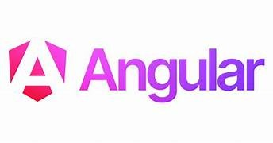

- Brief History of Angular :

- AngularJS (2010) — Created by Misko Hevery at Google. First released as an open-source JavaScript framework to simplify dynamic web app development using two-way data binding and MVC architecture.
- Directives & Templates — Introduced ng-model, ng-repeat, ng-if etc., allowing HTML to be extended with custom behavior directly in the template.
- Two-Way Data Binding — Automatically synced the model and view, reducing the need for manual DOM manipulation (a major selling point over jQuery).
- Angular 2 (2016) — Complete rewrite from scratch by Google. Moved from JavaScript to TypeScript, introduced component-based architecture, and dropped the "JS" from the name (now just "Angular").
- Component-Based Architecture — UI broken into reusable, self-contained components (similar to React), making large-scale apps easier to manage.
- Angular CLI — Command-line interface introduced to scaffold, build, test, and deploy Angular apps with a single command.
- RxJS & Observables — Angular adopted RxJS for reactive programming, enabling powerful async operations and event handling via Observables.
- Angular Modules (NgModules) — Provided a way to organize application code into cohesive blocks of functionality.
- Ivy Renderer (Angular 9, 2020) — New default rendering engine that improved build times, bundle sizes, and debugging experience significantly.
- Angular Universal — Brought Server-Side Rendering (SSR) to Angular apps, improving SEO and initial page load performance.
- Standalone Components (Angular 14, 2022) — Eliminated the mandatory use of NgModules, making Angular simpler and more beginner-friendly.
- Signals (Angular 17, 2023) — Introduced a new reactive state management primitive (Signals) for more fine-grained and efficient change detection, reducing reliance on Zone.js.
- Angular remains one of the most widely used full-featured frameworks, backed by Google, and is preferred for large-scale enterprise applications due to its opinionated structure, built-in tools, and TypeScript-first approach.

- Back End:
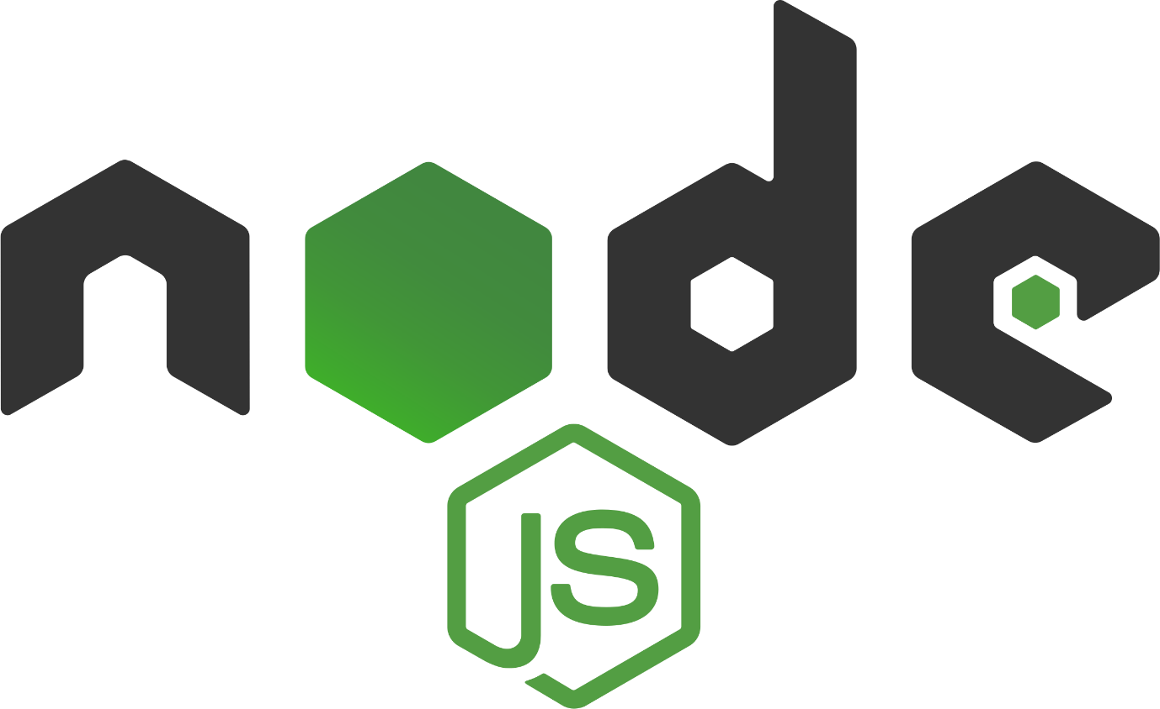

  - Brief History of Node.js:
  - Node.js was created by Ryan Dahl to improve the efficiency of server-side applications by using JavaScript outside the browser.
  - It was first released as an open-source project, enabling asynchronous, event- driven programming for building scalable network applications.
  - Node.js is built on the V8 JavaScript engine, which compiles JavaScript into highly efficient machine code.
  - The introduction of non-blocking I/O operations allowed Node.js to handle multiple connections simultaneously, making it ideal for real-time applications.
  - npm (Node Package Manager) was introduced, providing a vast ecosystem of reusable packages and modules.
  - Express.js, a popular web framework for Node.js, simplified backend development with minimal setup.
  - WebSockets and real-time capabilities made Node.js a go-to choice for chat applications, gaming servers, and live-streaming platforms.
  - Microservices architecture became widely adopted, with Node.js enabling lightweight and modular backend systems.
  - Serverless computing further expanded Node.js usage by allowing developers to run functions without managing backend infrastructure.



- Brief History of Express.js:

  - Express.js was created by TJ Holowaychuk as a minimal and flexible web framework for Node.js.
  - It was designed to simplify server-side development by providing a lightweight and unopinionated structure.
  - Built on top of Node.js' HTTP module, Express introduced a more streamlined way to handle routes, middleware, and requests/responses.
  - The concept of middleware allowed developers to extend functionality easily, making Express highly customizable.
  - With its simple and minimalistic API, Express became the most popular Node.js framework for building RESTful APIs and web applications.
  - Express Generator was introduced, providing a command-line tool for quickly scaffolding applications.
  - The framework gained widespread adoption due to its compatibility with databases
  - like MongoDB, PostgreSQL, and MySQL.
  - Express became the foundation for MEAN, MERN, and MEVN stacks, enabling full-stack JavaScript development.
  - It played a key role in the rise of microservices architecture, providing a lightweight and scalable backend solution.

- Database :



- Brief History of MongoDB:

  - MongoDB was developed by Dwight Merriman, Eliot Horowitz, and Kevin Ryan as part of their company 10gen to address scalability and performance issues in traditional relational databases.
  - It was designed as a NoSQL database, using a document-oriented model instead of tables and rows.
  - MongoDB stores data in BSON (Binary JSON) format, making it more flexible and scalable compared to relational databases.
  - Unlike SQL databases, it features schemaless data storage, allowing dynamic and flexible document structures.
  - Sharding and replication were introduced to ensure high availability and scalability for large-scale applications.
  - MongoDB Atlas, a fully managed cloud database service, was launched to simplify deployment and management.
  - The Aggregation Framework provided powerful data processing capabilities similar to SQL queries.
  - Indexing and performance optimization features were improved to handle large datasets efficiently.
  - MongoDB became a core part of modern tech stacks like MEAN, MERN, and MEVN, making full-stack JavaScript development seamless.

3.System Analysis and Planning

- Existing System and its Drawbacks
- Feasibility Study
- Requirement Gathering and Analysis

Existing System and Its Drawbacks

In many traditional plant nurseries and gardening businesses, order management and customer engagement still rely heavily on manual processes such as physical cataloging, verbal advice on plant care, and fragmented communication through basic messaging apps. These outdated approaches lead to significant inefficiencies, such as inaccurate inventory tracking, delays in delivery coordination, and a lack of personalized plant care support for customers. Such limitations hinder both gardening enthusiasts and business owners, particularly during peak planting seasons.
- The absence of a dedicated digital platform for managing large-scale plant inventories, seasonal categorization, and customer plant-care data creates several operational bottlenecks. Below is a detailed analysis of the key drawbacks of the current manual management systems and the necessity for an automated, specialized solution like Greenie Culture.

- Manual Order Processing Leads to Inefficiencies :

One of the primary challenges in traditional plant nurseries and gardening businesses is the reliance on manual order-taking methods, such as phone calls, physical nursery visits with handwritten slips, or manual stock checks across vast greenhouse areas.

- Problems Caused by Manual Order Processing :

- Time-Consuming Stock Verification – Manually checking plant availability across different sections of a nursery and recording orders by hand is slow, especially during peak gardening seasons.
- Prone to Inventory & Variety Errors – Relying on manual notes often leads to misidentifying specific plant varieties (e.g., similar-looking succulents) or overselling plants that are no longer in optimal condition for sale.
- Difficulty Handling Seasonal High Volume – During peak demand periods like spring or festivals, managing multiple plant orders manually for various categories (Indoor, Outdoor, Bestsellers) becomes chaotic and increases operational errors.
- Lack of Real-time Shipment Tracking – Plants are fragile and require careful transit. Traditional methods offer no visibility for the customer into the real-time status or handling of their delicate plant shipments, leading to anxiety about plant health upon arrival.
- Ineffective Sales & Performance Analysis – Maintaining paper records of daily sales and stock levels makes it nearly impossible to track historical data, analyze seasonal trends, or identify which plant categories are the most profitable over time.

- Lack of a Centralized System for Menu and Order Management :

Traditional nurseries often operate without a unified digital system to synchronize plant stock, seasonal pricing, and customer data. Managing product updates (like new arrivals of indoor plants) and order processing manually leads to significant operational bottlenecks.

- Problems Caused by the Lack of a Centralized System:

- Delayed Product & Inventory Updates – When a specific plant variety (e.g., a popular Bestseller) sells out or prices fluctuate seasonally, staff must manually update tags or inform customers one by one, causing confusion and lost sales.
- Fragmented Sales and Shipment Handling – Orders coming from different sources (walk-ins, phone calls, or social media) are handled separately, leading to disjointed inventory levels and uncoordinated dispatching of fragile plant shipments.
- Restricted Real-time Data Access – Administrators cannot instantly view the current status of high-demand plant categories, monitor recent sales, or analyze customer feedback across the entire nursery ecosystem.
- Absence of Digital Order & Customer Records – Without a centralized database (like MongoDB), it is nearly impossible to maintain a detailed history of plant purchases, track customer gardening preferences, or provide tailored plant-care guidance.
- Disorganized Team Coordination – Without a unified system (like the Admin and Delivery Panels), coordination between the nursery inventory team, the delivery staff, and management remains slow, leading to mismanaged shipments and late deliveries.

- Real-time Tracking of Plant Orders and Payment Reconciliation:

Traditional plant nurseries and gardening services often lack a digital mechanism for tracking the journey of live, fragile plants once they leave the nursery, as well as a way to instantly reconcile various payment methods (COD, Online) with specific customer orders.

- Problems Caused by the Lack of Real-time Tracking and Payment Systems:

- Uncertainty Over Perishable Plant Shipments – For plants that require immediate unboxing and watering upon arrival, customers are left in the dark about the exact delivery status, potentially leading to plant stress or damage if not received on time.
- Manual and Error-prone Payment Reconciliation – Reconciling cash-on-delivery (COD) payments with online gardening orders manually leads to frequent accounting discrepancies, missing records, and billing errors.
- Inaccurate Delivery Status for Management – Nursery administrators cannot easily view which plants are currently out for delivery, which orders are pending, or which shipments have successfully reached the customer.
- Delayed Delivery Confirmations – Without an automated system (like the Delivery Panel in Greenie Culture), the process of confirming order completion and payment receipt is slow, leading to outdated sales and stock data.
- Lack of Proactive Communication – In the event of a logistical delay, there is no automated way to notify the customer about the updated delivery time for their sensitive plant orders, resulting in a poor customer experience.

Feasibility Study

A feasibility study is conducted to determine whether the Greenie Culture e-commerce platform is practical, cost-effective, and sustainable for real-world nursery and plant retail operations. This study evaluates the technical, economic, and operational aspects of the system to ensure that the application can be successfully developed, deployed, and used by gardening enthusiasts and nursery administrators.

    - Technical Feasibility:

- Can the system be built with the available technology?

Greenie Culture is built using a scalable and modern full-stack architecture:

- Frontend: Angular (for a robust, structured, and high-performance single-page application UI).
- Backend: Node.js & Express.js (ensuring a fast and scalable server-side environment for handling orders and plant data).
- Database: MongoDB with Mongoose (a flexible NoSQL database ideal for storing complex plant categories, care instructions, and user orders).
- AI Integration: Google Gemini AI (integrated via @google/generative-ai to provide smart gardening assistance and personalized plant recommendations).
- Authentication: JWT (JSON Web Token) with Bcryptjs (for secure user sessions and encrypted password protection).
- Communication: Nodemailer (for automated order confirmations and plant-care reminders).

- Why is this technology stack suitable?

- High Scalability – The MEAN stack (MongoDB, Express, Angular, Node) efficiently handles growing inventories of plants and high volumes of seasonal orders.
- Cross-Platform Compatibility – The responsive Angular frontend ensures a seamless experience across desktops, tablets, and mobile devices.
- Real-Time Logistics Tracking – The dedicated Delivery Panel allows for instant status updates on fragile plant shipments.
- Secure Data Architecture – Role-based access control (Admin, Delivery, Customer) ensures that sensitive business data and customer information remain protected.
Example: A nursery receiving hundreds of diverse plant orders during the spring season can efficiently process inventory updates and shipments using Greenie Culture without system lag thanks to its asynchronous Node.js backend.

    - Economic Feasibility:

- Is this system cost-effective to develop and maintain?

Greenie Culture is developed using open-source frameworks and modern development practices which significantly reduce the overall operational expenses.

- Open-Source Technologies: Angular, Node.js, and MongoDB are free to use, eliminating expensive proprietary licensing costs.
- Efficient Cloud Deployment: The system is designed to be hosted on cost-effective cloud platforms (such as Render, Vercel, or AWS), utilizing "pay-as-you-go" models.
- Automated Order & Care Management: Digital tracking reduces the need for manual stock checking and paper-based care instructions, saving on labor and printing costs.
- Reduced Administrative Overhead: Automated reporting and centralized inventory management minimize the staff workload required for daily nursery operations.

Example: A nursery that currently spends money on printed catalogs, manual stock registers, and phone-based order coordination can significantly cut costs by migrating to Greenie Culture’s digital storefront.

    - Operational Feasibility:

- Will users be able to adopt and use the system efficiently?

For any software to succeed in a retail environment, it must be intuitive. Greenie Culture is designed with clear navigation and specialized dashboards for different user roles.
- Responsive Web Application – Customers can browse "Bestsellers" or "Indoor Plants" and place orders easily from their smartphones while in their gardens.
- Intuitive User Interface – Focused design with clear categories (FAQs, Reviews, Offers) makes plant discovery easy even for less tech-savvy users.
- Role-Based Dashboards – Admins manage stock, Delivery staff track shipments, and Customers track their plants—each seeing only what they need.
- Streamlined Logistics Workflow – Delivery personnel can quickly update shipment statuses (Pending → Shipped → Delivered) through a simplified mobile-friendly interface.
- Minimal Training Required – Nursery employees can be onboarded quickly due to the straightforward design and automated features of the management panels.
Example: A delivery staff member can log into the Delivery Panel, view their assigned plant shipments for the day, and mark them as "Delivered" with a single click, ensuring the main inventory system is updated instantly.

Requirement Gathering and Analysis

Developing a robust plant e-commerce and nursery management system like Greenie Culture requires a deep understanding of gardening enthusiasts' expectations, specialized nursery operational workflows, and modern web technologies. The requirements for this project were identified through research on existing plant retail platforms, observation of traditional nursery operations, and analysis of common challenges faced by nursery owners, delivery teams, and plant parents.
The system is designed to improve efficiency in plant inventory management, simplify the administration of diverse plant categories, and provide a seamless digital platform for discovering and purchasing live plants with expert care guidance.

The following key requirements were identified during the analysis phase:

- Automated Plant Order Processing and Tracking – Streamlining the journey from plant selection to doorstep delivery.
- Specialized Delivery Management – A dedicated panel for tracking fragile plant shipments and managing delivery schedules.
- Dynamic Inventory Management System – E asily managing plant categories like Bestsellers, Indoor Plants, and Rare Species with real-time stock updates.
- Integrated Gardening Assistance (AI-Powered) – Utilizing Google Gemini AI to provide instant answers to plant-care queries and gardening advice.
- Secure Payment Integration – Providing safe and diverse transactions for high-value plant collections and gardening kits.
- Real-Time Logistics Status Updates – Keeping customers informed about the moisture-sensitive transit phase of their plants.
- Scalable and High-Performance Architecture – Ensuring the MEAN stack handles seasonal surges in plant demand efficiently.
- Role-Based Security and Access Control – Defined interfaces for Administrators (Stock/Orders), Delivery Staff (Logistics), and Customers (Profile/Orders).
- Detailed Plant Information and Social Proof – Integrated FAQ systems and Customer Reviews to help users make informed gardening choices.
- Cross-Platform Accessibility – Ensuring a responsive design that works perfectly on smartphones, tablets, and desktops for garden-side browsing.

4.Proposed System

- Scope
- Project modules
- Expected Advantages

4.1 Scope

4.2 Project Modules

Greenie Culture –Smart Eco Plant Management System has four modules:
- Admin
- User
- AI
- Delivery

  - Module wise Objective / Functionalities / Constraints

- Admin:

- User :

- Delivery :

- AI:

4.3 Expected Advantages

We can expect following advantages from Greenie Culture – Smart Eco-Plant Management System:

- Data Flow Diagram
- Process Specification
- System Flow Diagram
- Enity-Relationship Diagram
5. Detail Planning

5. Detail Planning

- Data Flow Diagram
- Process Specification
- System Flow Diagram
- Entity-Relationship Diagram

  - Data Flow Diagram

Introduction:
  - Data Flow Diagram (DFD) represents of how data moves through an application, showing how information is input, processed, stored, and output across different part of the app, helping developers understand the data flow of the system.

Different Levels of DFDs:
    - Context Diagram (Level 0): Shows the entire system as a single process with its external entities and major data flows.
    - Level 1 Diagram: Breaks down the system into its major sub- systems and their interactions.
    - Level 2 Diagrams: Further decompose each subsystem into increasingly detailed processes and data flows.

Components of a DFD:
1.External Entities 2.Processes
3.Data Stores
4.Data Flows

External Entities:
  - Symbol: Rectangle
  - Function: Represents external sources or destinations of data, like customers, suppliers, or other systems.

Processes:
  - Symbol: Circle, Oval, or Rectangle
  - Function: Represents the actions or operations that transform data, described by a verb phrase.

Data Stores:
  - Symbol: Double horizontal line
  - Function: Represents where data is stored within the system, like a database or file.

Data Flows:
  - Symbol: Arrow
  - Function: Shows the direction of data movement between processes, data stores, and external entities.

