**Introduction**

The COVID-19 pandemic, otherwise known as the coronavirus pandemic, is a result of the spread of severe acute respiratory syndrome coronavirus 2 (SARS-CoV-2) thought to have been contracted from bats originating in Wuhan, China. The first case in the United States was diagnosed in Snohomish County, WA on January 20, 2020. Since then, the number of cases in the US has grown to 1.89 Million with 21,349 in Washington alone. In an effort to slow the spread of the virus, states have issued stay-at-home orders to strongly encourage social distancing. Washington state issued a stay-at-home order from March 23, 2020 to May 31, 2020. The impact the coronavirus has had on the economy has been partially due to the temporary shutdown of businesses. Therefore, reopening as soon as possible without allowing the virus to explode in new cases is an important question to address.

The purpose of this project is to minimize the number of statemandated shelterinplace order (SIPO) days in Washington such that the number of infected persons requiring hospitalization is below the hospital capacity and the number of deaths is limited to a defined number. Several variations of the optimization problem will be analyzed: standard case with no SIPO, stay at home order following real life scenario of Washington, and optimizing the duration of SIPO given a minimum start date of March 23. These scenarios will be compared to one another for further analysis of the effectiveness of the SIPO.

**System Characterization**

In order to formulate this optimization problem, mathematical models for the spread of infectious diseases and current statistics for the coronavirus needed to be considered. I chose to use the Susceptible-Infective-Removed (SIR) Model as my primary mathematical expression for the rate of spread of the disease. The model is represented by 3 equations:

**S: $S_{t+1}-S_{t}=-rS_{t}I_{t}$**

**I: $I_{t+1}-I_{t}=rS_{t}I_{t}-aI_{t}$**

**R: $R_{t+1}-R_{t}=aI_{t}$**

Where $a$ is the recovery rate parameter, determined by the infectious period of the disease. For coronavirus, the infectious period is a combination of the incubation and symptomatic time periods, thus ranging from 12-28 days. Considering the upper range to give us more cushion in our model gives us $a=\frac{1}{t_infectious}=\frac{1}{24}$. Studies show that the basic reproductive number of coronavirus is somewhere between 3 and 4. I picked 3.5 as the median, then I calculated the standard value of r in the SIR model using the following equation:

$R_{Φ}=3.5= τcd$

Where tau is the transmitability, c is the average rate of contact between susceptibles and infectives, and d is the duration of infectiousness. Since r = $τc$ and $a=1/d$, then $R_{Φ}$ can also be written as $R_{Φ}=\frac{r}{a}=q$. Solving for r, I found r to be 0.1458333. Now, if the SIPO improved social distancing so that the average rate of contact between infectives and susceptibles is reduced by 80%, then the new $R_{Φ}=q$ value is 0.7 and thus r = 0.0291667. Another important consideration in the problem design was a stopping point. Since a vaccine was predicted to be available within a year, I decided that keeping the objective function bound by the constraints was only necessary for 365 days. Thus, the maximum number of stay at home order days is limited from the start date until day 365. In addition to these considerations, Table 1 in Appendix A outlines the other statistical information important to characterizing this optimization problem.

Using this information to formulate our optimization problem, we have a simple objective function, ${∆t}_{SH}$, written in terms of 2 variables, the SIPO start date $,{ t}_{0SH}$ and the stop date, ${ t}_{fSH}$, and whose minimum is limited by 4 constraints. The optimization problem is written in standard form below:

MIN $f\left(t\right)=t_{fSH}-{ t}_{0SH}$

W.R.T. $t={\{ t}_{0SH}, t_{fSH} \}$

S.T. $g_{1}= 0.0175 × max(I)≤1500$

$g_{2}=t_{0SH}-t_{fSH}≤0$

$g_{3}={- t}_{0SH} ≤62, - t_{fSH}≤62$

$g_{4}=\max\left(I\right)× 0.20 × 0.3333≤5070$

It is important to note that $g_{1}$ and $g_{4}$, while they don’t directly involve $t_{0SH}$ or $t_{fSH}$, are reliant on them through the term $max(I)$, since the maximum number of infectives is depending on the *r* value in the update formula of the SIR model. And this *r* value is dependent on time as illustrated in the following piecewise function:

$$r=\left\{\begin{aligned}0.14583 for t≤t_{0SH} \\ 0.0291667 for t_{0SH}≤t≤t_{fSH} \\ 0.07 for t_{fSH}≤t\end{aligned}\right.$$

For the control scenario with no SIPO, ${∆t}_{SH}$ = 0, I examined how far the function overstepped the constraints. When modeling Washington’s current situation, I plotted a graph hardcoded with the SIPO start and stop dates. I will be using this one as a comparison to the optimized problem.

**Optimization Algorithm Selection**

The optimization problem has a simple continuous objective function with only 2 variables, and several linear and nonlinear constraints, of which some are dependent on non-design variables. This reliance on non-design variables drew me towards using Matlab’s built in tool box. I decided to use Matlab’s Sequential Quadratic Programming built in function *fmincon* since I needed an algorithm that could handle both linear and non-linear constraints, incorporate the use of non-design variables, and be able to approximate gradients since I was unable to calculate one by hand for the non-linear constraints.

**Design Space Exploration**

The problem I designed is heavily dependent on the accuracy of the SIR graph. Thus, to evaluate the validity of my model, I graphed the SIR curves without SIPO implementation and the SIR curves based on Washington States actual actions and proceeded to compare them to the statistics provided by the Washington State Department of Health’s website.

The plot of the SIR curves without any social distancing measures is shown in *Figure 1*. Based on this graph, we see that the peak of the virus progression would occur around middle of July and predicts that about 35% of the population in Washington will become infected with coronavirus at the peak. By March 23 (day 62), we can see from *Figure 2* that the fraction of population infected is about 0.00005. The number of reported cases in Washington State on March 23 was 369, which correlates to roughly 0.000048. Since 0.00005 $≈$ 0.000048, and the peak of the virus roughly correlates to the projected peak of the virus without social distancing measures. Furthermore, upon plotting the actual actions of Washington state, it’s apparent that the general trend of the number of infections closely follows the statistics from Washington State Department of Health as shown in *Figure 3*, *Figure 4*, and *Figure 5*. Thus, I concluded that my model was valid.

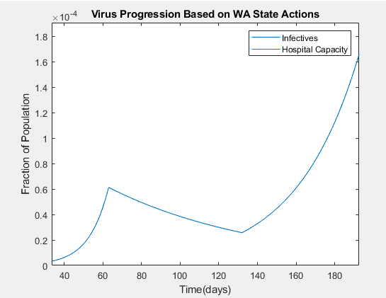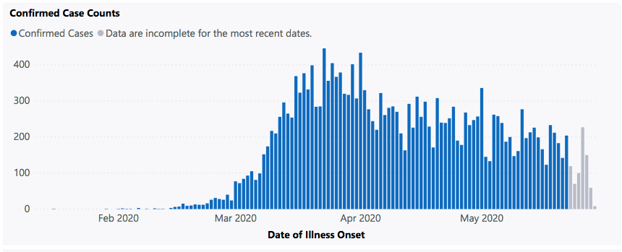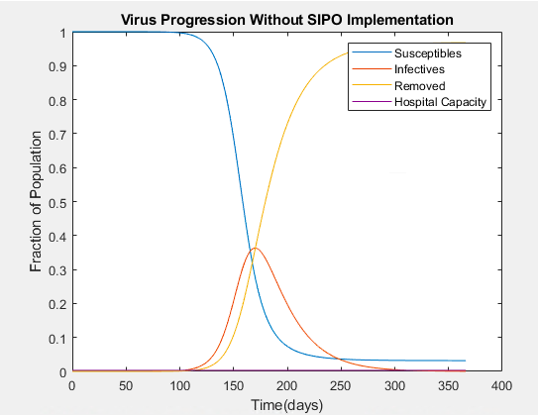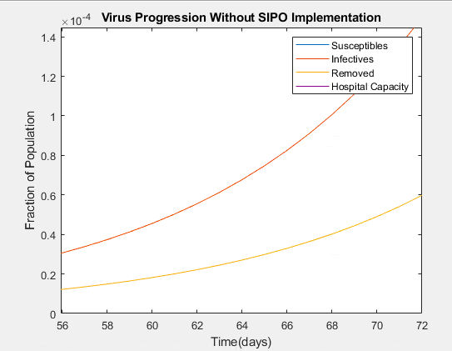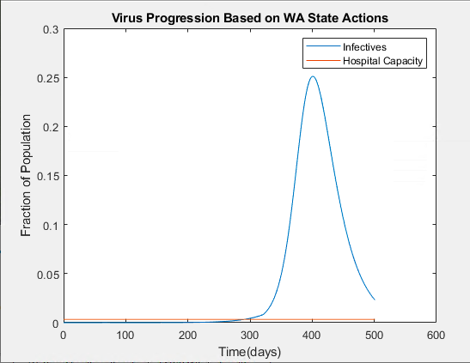

Figure 4. Close up image of Figure 3, noting shape of curve resembles that in Figure 5.

Figure 5. Statistical plot of I curve collected from Washington State Department of Health.

Figure 1. Plot of SIR curves without any social distancing measures implemented

Figure 2. Close up image of Figure 1 centered on day 62, to compare the fraction of population infected with the actual number documented by Washington State on March 23, 2020

Figure 3. Plot of I curve with social distancing practices as promoted by Washington State.

**Optimization Results and Validation**

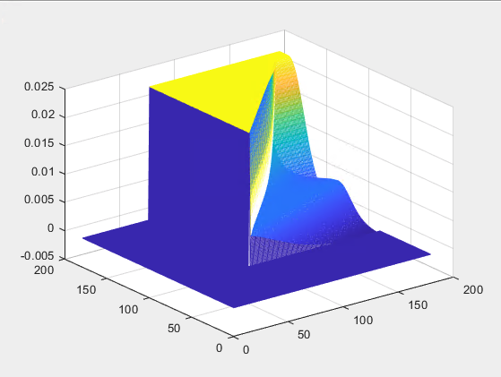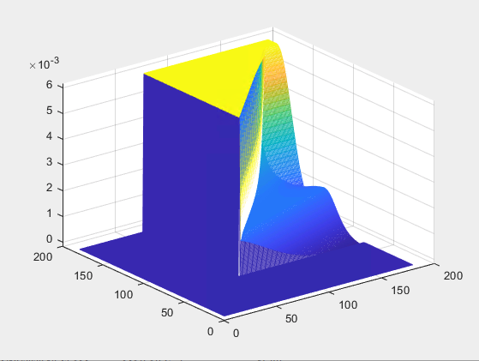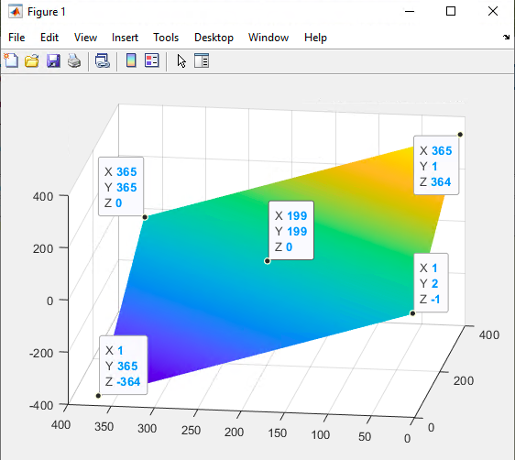Despite numerous efforts in refining the model, *fmincon* was unable to optimize this problem. *Figure 6* is a 3D plot of the objective function. Examining this image, it’s clear that the function is continuous, and that the theoretical solution should lie somewhere in the upper half of the plane (the green-yellow region). We can also deduce that there is almost an infinite number of solutions since the minimized point will be a line. However, I expected that the constraints would limit it so that there would only be one optimal solution. To further investigate the reason the algorithm was having with the model, I also graphed 3D plots of the constraint, shown in *Figure 7* and *Figure 8*. Strangely, the region of the constraints I was concerned with is the yellow triangle on each of the graphs. Since it was flat, it meant that the value of the constraint was the same for each combination of $t_{0SH}$ and $t_{fSH}$ in that region. With an unchanging and infeasible constraint value and a line of solutions for the objective function, no wonder the algorithm was having a difficult time optimizing the problem. However, I did not expect the constraint to stay constant. Rather, it should be varying with change in peak of the infectives curve. To verify that the peak of the infective curve was changing, I plotted the I curve given many different $t_{0SH}$ and $t_{fSH}$ combinations. I discovered that the peak of the infective curve did not change as long as the curve was within the 365-day limit. However, Once I started to push the curve past the 365-day limit, then the maximum of the I curve would be the point where the curve crosses the 365-day mark instead of the peak of the curve. In this manner, I was able to manually find a plausible solution to this optimization problem. By visually looking at the graph at varying combinations of $t_{0SH}$ and $t_{fSH}$ until the hospital capacity constraint became active at day 365. The result is shown in *Figure 9*. Here, the start

Figure 8. 3D plot of desired death maximum constraint

Figure 7. 3D plot of the hospital capacity constraint.

Figure 6. 3D plot of the objective function against the start date (X) and end date(Y) of the stay at home order.

date was day 62 and the end date was day 141, correlating to March 23 through June 10 for a total of 79 days. The question arises with this finding, whether “flattening the curve” is a myth? In this model, the curve is never flattened—the peak is just postponed. This partially explains why the 3D plot of the constraints is flat in my area of interest. However, I am still perplexed at why at some point that flat area doesn’t change as I push the curve past the 365-day upper-bound.

Due to the nature of the objective function and constraints, when using *fmincon* to solve the problem, the result is:

*x =*

*66.8367 148.1354*

*fval =*

*81.2987*

*output =*

*iterations: 3*

*funcCount: 11*

This is the best possible solution I was able to find. I discovered that the algorithm was very sensitive to starting values. If I had a starting value of x = {62, 201}, I get the results stated above and the graph shown in *Figure 10*. We can see in the figure that constraints are violated, and therefore it is an infeasible solution. Now, if I have a starting value of x = {62, 140}, I get an fval of 43.6667, but the constraints are even more violated than the last solution. Tweaking the set *r* values changes the character of the curve. If, for instance, even after the stay-at-home order ends, the $R_{Φ}$ value remains below 1, the curve will plateau and we will have a feasible solution no matter the duration of the stay-at-home order.

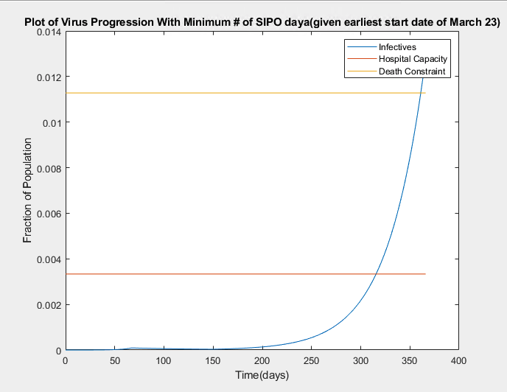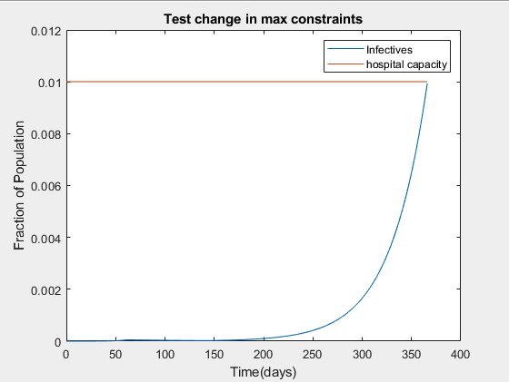

Figure 10. Results from fmincon algorithm. An infeasible solution since it crosses both the hospital capacity and death constraint lines.

Figure 9. Results of investigation for changing maximum of Infective curve - pseudo optimum found with start date at day 62 and end date at day 141.

In conclusion, we see that a feasible solution should be possible, as illustrated in *Figure 9*. But I have seemed to reach the limits of Matlab’s *fmincon* function with this optimization problem. For future work, I would research the use of other optimizer algorithms, consider scaling the constraints, and refining the $R_{Φ}$ values to resemble a more realistic problem and thus have a better chance of attaining a feasible solution that is less sensitive to a variety of initial guesses.

**References**

<https://www.doh.wa.gov/Emergencies/NovelCoronavirusOutbreak2020COVID19/DataDashboard>

[**https://www.usnews.com/news/best-states/washington/articles/2019-06-28/washington-states-population-tops-75-million**](https://www.usnews.com/news/best-states/washington/articles/2019-06-28/washington-states-population-tops-75-million)

**Appendix A**

|  |  |  |
| --- | --- | --- |
| **Characteristic** | **Value** | **Reference** |
| Population of Washington | 7.6 Million | [*USA News*](https://www.usnews.com/news/best-states/washington/articles/2019-06-28/washington-states-population-tops-75-million) |
| Initial infective number (I0) | 1 | *To Be Added in Final Report* |
| Initial susceptible number (S0) | 7,599,999 | *To Be Added in Final Report* |
| Initial removed (R0) | 0 | *To Be Added in Final Report* |
| t0 | January 20, 2020 | *To Be Added in Final Report* |
| Confirmed cases in Washington | 21,349 | [*Washington State Department of Health*](https://www.doh.wa.gov/Emergencies/NovelCoronavirusOutbreak2020COVID19/DataDashboard) |
| Deaths in Washington | 1118 | [*Washington State Department of Health*](https://www.doh.wa.gov/Emergencies/NovelCoronavirusOutbreak2020COVID19/DataDashboard) |
| Percent Death Rate in relation to confirmed cases in Washington | 5.2% | [*Washington State Department of Health*](https://www.doh.wa.gov/Emergencies/NovelCoronavirusOutbreak2020COVID19/DataDashboard) |
| Hospital Capacity in Washington | 13,000 | [*USA News*](https://www.usnews.com/news/best-states/washington/articles/2020-03-18/washington-state-scrambles-to-secure-hospital-beds-supplies) |
| Hospital percent occupancy on a regular basis | 61% | *To Be Added in Final Report* |
| Number of bed available before COVID-19 pandemic | 5070 | *Determined from above information* |
| COVID-19 cases requiring hospitalization | 20% | [*STAT*](https://www.statnews.com/2020/03/10/simple-math-alarming-answers-covid-19/) |
| Washington declared stay-at-home order start | March 23, 2020 | *To Be Added in Final Report* |
| Washington declared stay-at-home order end | May 31, 2020 | *To Be Added in Final Report* |
| Number of days SIPO after first case | 62 days | *Determined from information above* |
| Vaccine Release Date | 1 year from first case |  |
| Estimated number of infectives |  |  |

Table 1.Statistical information used in developing the mathematical equations used to characterize the optimization problem.