14512926

Abstract
In this portfolio file, we will take a real-world problem and then solve it out using problem solving strategies. We will use python programming to solve the problem and also learn about the basis of python programming language.
PROBLEM SOLVING AND PROGRAMMING
MOBILE SELECTION AND PURCHASE

Contents
TABLE OF FIGURES 3
MOBILE SELECTION: A REAL-WORLD PROBLEM 4
OVERVIEW 4
ANALYSIS 4
PHONE SELECTION 4
DEVICE SPECIFICATION 4
PAYMENT 4
ALGORITHM DESIGN 5
PSEUDO CODE 5
FLOW CHART 6
KEY POINTS 7
IMPORTING LIBARARY 7
OBJECTS: CLASSES 7
FUNCTIONS 7
LOOPS 7
WHILE LOOP 7
FOR LOOP 7
CONDITIONAL STATEMENTS 8
IF-ELSE STATEMENTS 8
EXPLAINATION OF PROGRAM (SDS) 8
DESIGNING 8
IMPLEMENTATION 9
TESTING 14
SUPPORTED LINKS 17
CONCLUSION 18
REFERENCES 19
APPENDIX 20

TABLE OF FIGURES
Figure 1 Flow chart algorithm 01 4
Figure 2 Flow chart algorithm 02 5
Figure 3 Basic functions of the code 8
Figure 4 Python code for payment options 9
Figure 5 Restart code option 10
Figure 6 Creating user interface 11

TASK 01

MOBILE SELECTION: A REAL-WORLD PROBLEM

OVERVIEW
In today’s world, mobile is one of the most import part of our life. Selecting a mobile phone can be very hard as we need to be very careful towards it. While selecting for a particular mobile, we check out its features and make sure that it matches the valid criteria of our needed specification.

ANALYSIS
To solve out this problem, we will create a python program which would let users set their specified mobile using the options provided to them via the code. Here in our code we will create a class which would consist of various functions related to our problem. Here are the options of the mobile we would work on in this python project.

PHONE SELECTION
Under this option, user will get a chance to select one of the two options. Each option would be a whole set of programs containing the information about the phone.

DEVICE SPECIFICATION
Under this option, user can check the device specifications and also get to know that if the device they selected is the only device they want to get. Or they can go back to check any other phone they can do so to get the best one on their choice.

PAYMENT
Here the user is retrieved to the payment if he wishes to do so. He is given two options here. One is car payment which would ask them to enter the card details and then complete the payment. Or the other option is on instalments where he can take it on instalments as per the duration he wishes to from the options given. Then he is asked for card details and then the information is collected and payment is done.

TASK 02

ALGORITHM DESIGN

PSEUDO CODE
- Create a class named Mobile
- In the Mobile class, create a constructor that takes a name parameter and assigns it to the name attribute
- Create a method named gaming that returns a dictionary with two options for gaming devices
- Create a method named photography that returns a dictionary with two options for photography devices
- Create a method named dailyuse that returns a dictionary with two options for daily use devices
- Create a method named get_details that takes a device_name parameter and returns a dictionary with the specifications and price for the device
- Create a method named card_payment that takes a price parameter and handles the card payment process
- Create a method named installment_payment that takes a price parameter and handles the installment payment process
- Create a method named restart_option that prompts the user to restart the device selection process
- Create a method named user_interface that displays the device categories and handles the user's selection
- Create an instance of the Mobile class and call the user_interface method to start the device selection process.

FLOW CHART

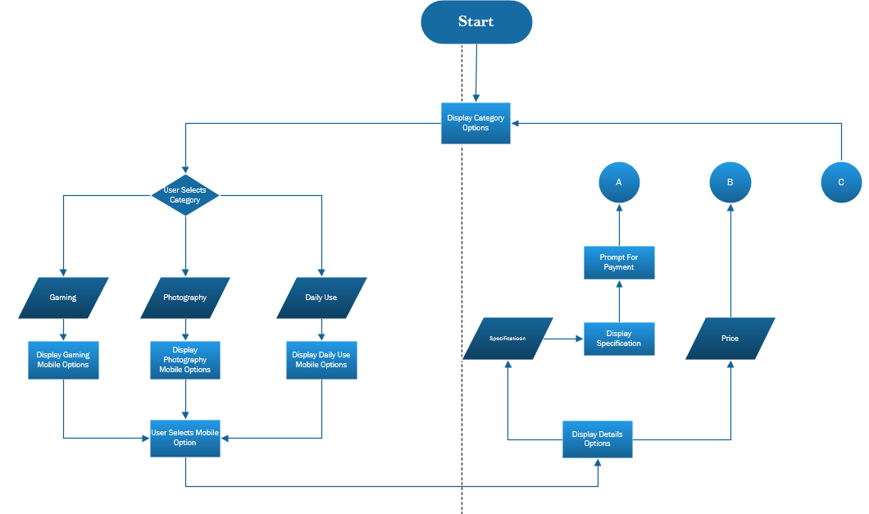
Figure 1 Flow chart algorithm 01
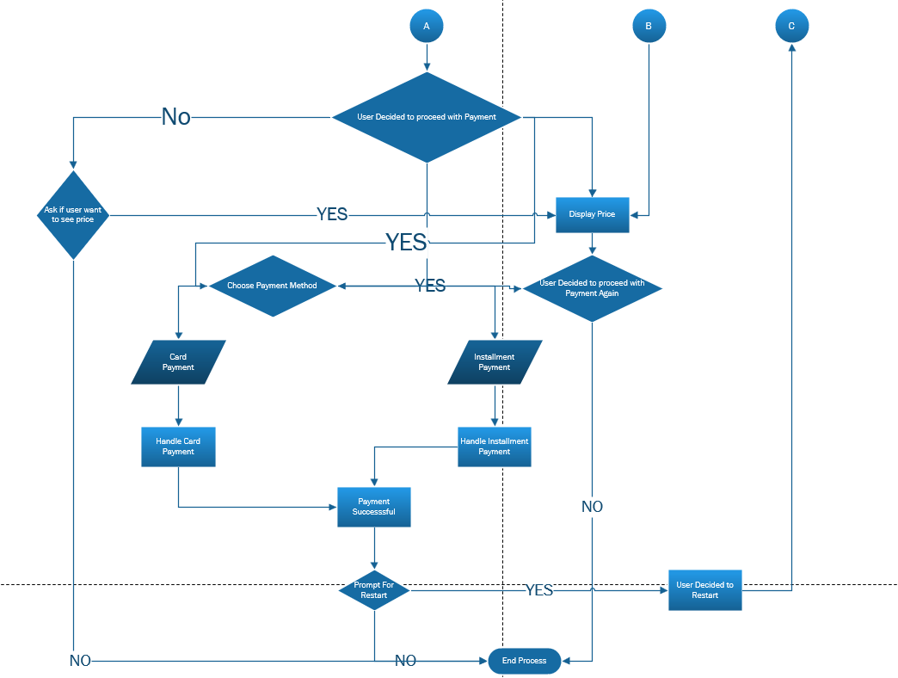
Figure 2 Flow chart algorithm 02

TASK 03

KEY POINTS

IMPORTING LIBARARY
Re: Python regular expressions are supported through the re module. This code uses it to validate strings that are entered, including PINs, card numbers, CVVs, and expiration dates.

OBJECTS: CLASSES
In Python, a class serves as a blueprint for constructing objects, containing methods that manipulate data and data attributes. By combining related functionalities into one group, it enables the creation of modular and reusable code. The Mobile class is defined with several methods that provide information about mobile devices and handle payment processing.

FUNCTIONS
A function in Python is a block of reusable code that performs a specific task when called, allowing for modular and organized programming. Here we used many functions to define various parts of the code and make it simpler to code and perform. We used photography, dailyuse and gaming to define phone options, get details to store the device specifications and other functions to perform relative tasks.

LOOPS
Loops are used in a program to iterate over some sort of code. A loop can run for infinite number of times. We can exit a loop by setting a condition in it. When the given condition satisfies, the loop is exited and further code is processed to run.

WHILE LOOP
A while loop in Python is a control flow statement that allows code to be executed repeatedly based on a given Boolean condition. When the condition sets out to be true, the loop is exited. In our program, we used various while lops to make our function running smoothly and make sure that user do not find any problem in using the interface. For instance, we used while loop in card payment function while taking the input of card number or other card details to make sure that if the user writes invalid input, the code reruns from the same point to make it convenient to put in the values.

FOR LOOP
A for loop is used to iterate over a sequence such as over a list, tuple or a dictionary. In our program, we used for loop in order to make the user to select the option he wants, for instance selecting a number while choosing a phone of his choice.

CONDITIONAL STATEMENTS

IF-ELSE STATEMENTS
IF ELSE statements are used as when we need to state multiple code and to make sure that it only runs if the condition given is satisfied. Our program consists of various if else statement. As for example in payment category, if the user selects card payment, it will ask for the card details. Otherwise if he selects the instalment option, he will be shown the instalment durations from which he can select a particular time period under which it again gives him the choice to fill out the card details. This is also an example of the nested if else statement which implies condition under a given condition.

TASK 04

EXPLAINATION OF PROGRAM (SDS)
Following the steps of a software development cycle, we created a program for our problem. The process included various aspects such as designing, implementation and testing.

DESIGNING
In the design phase, we designed a solution to our problem in a simple way. we defined the structure and functionality of the Mobile class using various functions. This included outlining the key methods required to meet the specifications:
- Category Methods: we used three functions which hold the value for the phones available under a particular option. The functions are: gaming(), photography(), dailyuse()
- Details Method: we create a function which holds the details of all phones named get_details(device_name)
- Payment Methods: the user gets two options for the payment. The function named card_payment(price), installment_payment(price) hold these codes.
- Interface: the user interface is provided which helps the user to interact with the problem easily. The functions used here are restart_option(), user_interface()

IMPLEMENTATION
In this part, we created the code in the python IDE. We took all the references from the designing phase document and put that all into the programming language.
First we will define the basic functions which contain the data relared to mobiles
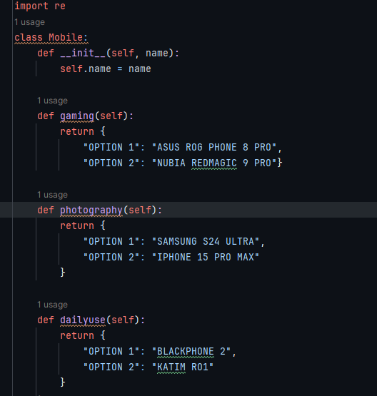

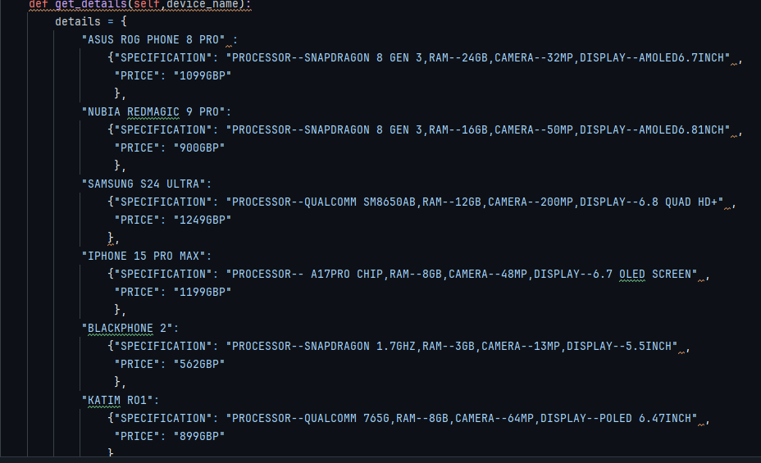
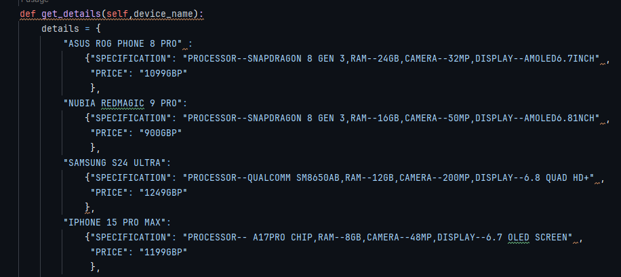
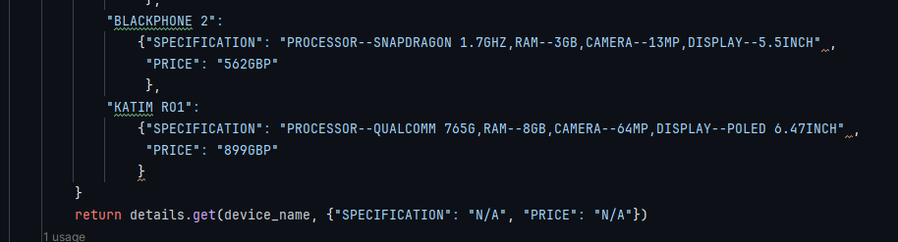
Figure 3 Basic functions of the code

Define the payment options one by one. For the card payment and the instalment selection.
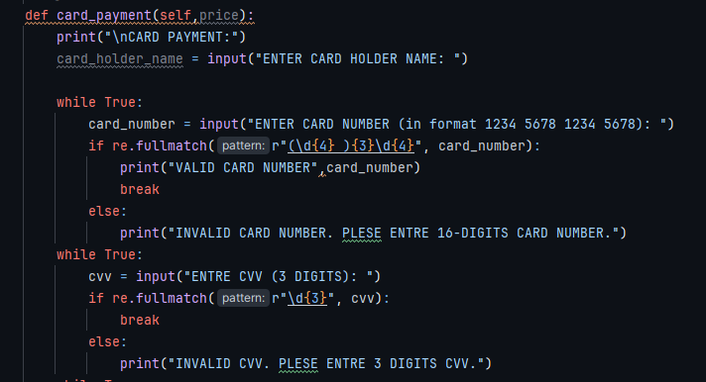
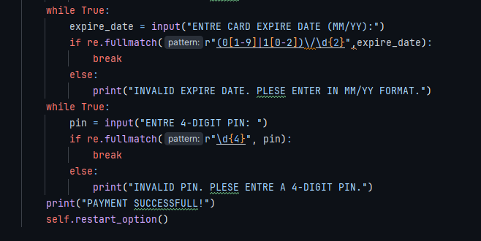
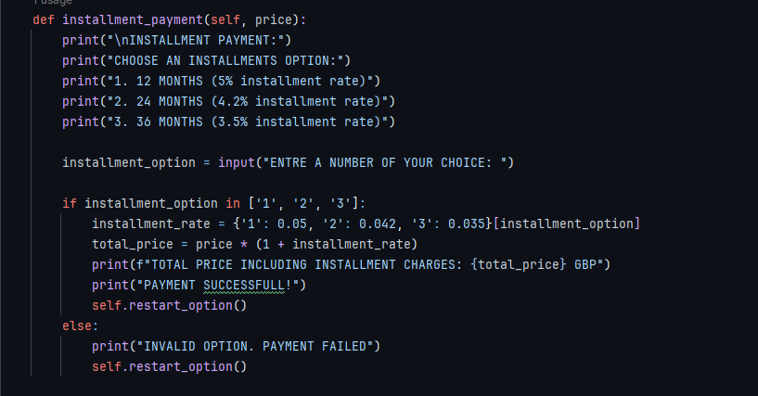
Figure 4 Python code for payment options
After completing the payment or denying the purchase, the user is given option to select other device he would like to know about.
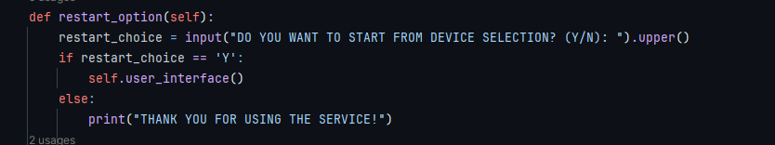
Figure 5 Restart code option
Now at the end, we will define the user interface and call the function here one by one as required in the specific field.
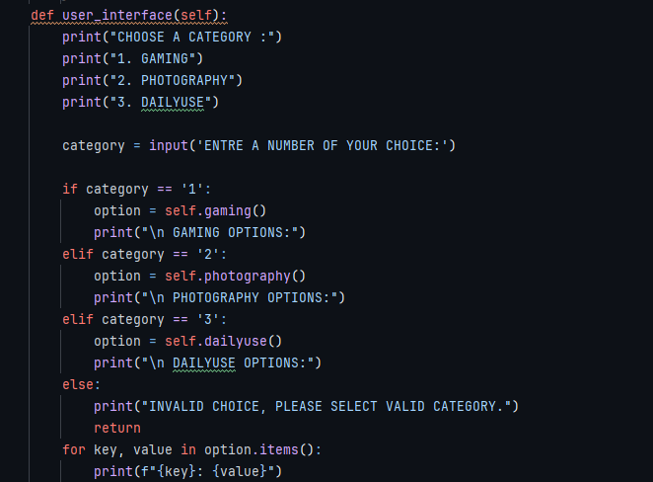
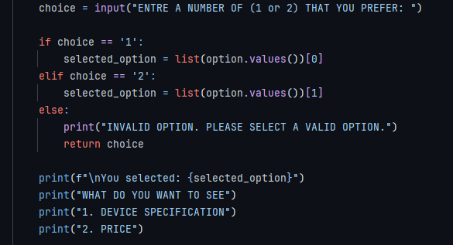
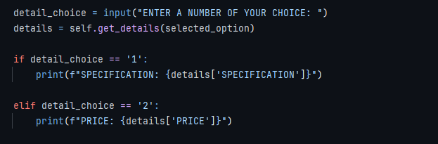
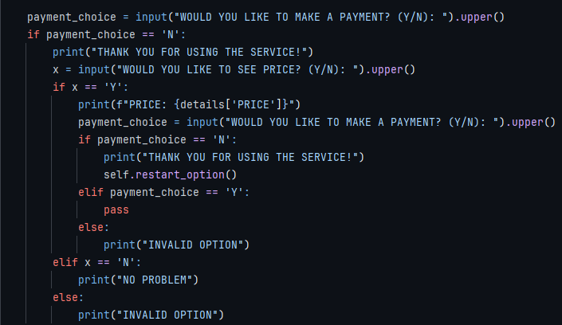
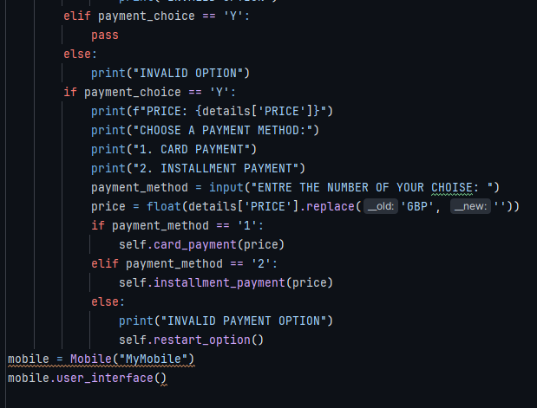
Figure 6 Creating user interface

TESTING
Testing involves checking it the function goes well as required and if anything more is not required to amend the code.
Now we we run and test our python code
First we will select a category. Then the available options are shown and the selected option is displayed.
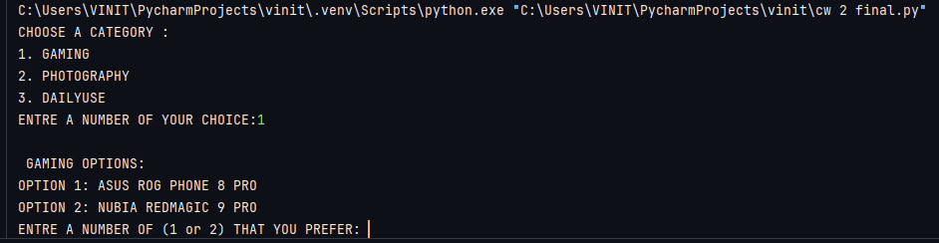
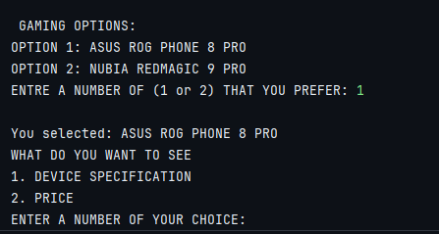
Then it asks if the user wants to see the price or the device specification.
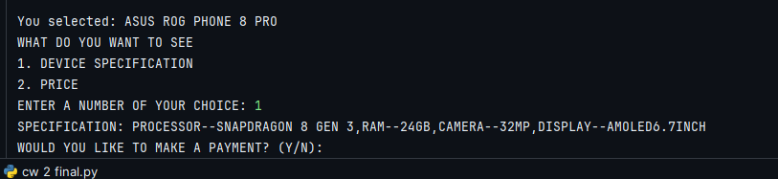

OPTION 01
If user selects device specification:
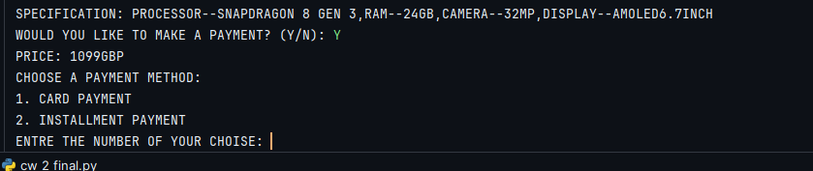
Then the payment options are displayed. If he selects card payment:
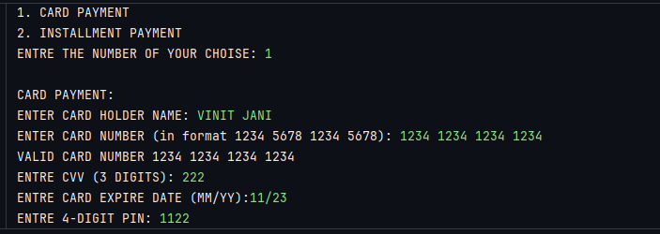
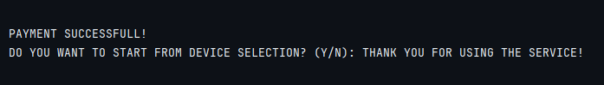
OPTION 2
If user selects price option under device specifications:
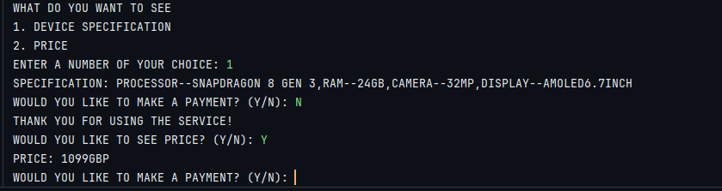

It asks if the user wants to make payment now.
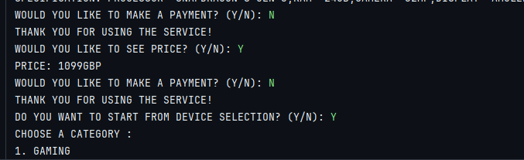
OPTION 3
If user want to use the instalment option
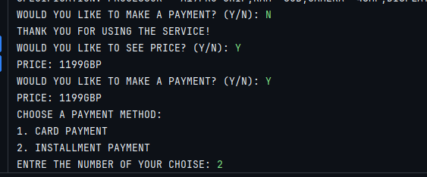
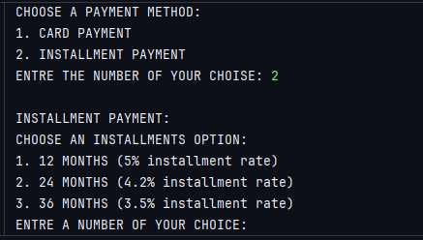
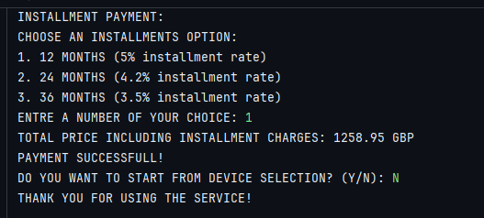

SUPPORTED LINKS
PORTFOLIO: https://sites.google.com/view/vinitjani14/home

CONCLUSION
Absolutely, this is a well-structured breakdown of the mobile selection program. Here are some key takeaways:
Overall functionality:
- The program addresses a real-world problem: selecting a mobile phone based on user needs.
- It offers a user-friendly interface to guide users through phone categories, specifications, and payment options.
Program design:
- The mobile class acts as a blueprint for creating phone objects with functionalities like getting details, handling payments, and restarting the selection process.
- Different functions manage phone categories (gaming, photography, daily use), device details, payment processing (card and instalments), and user interface interactions.
Code implementation:
- The program utilizes various python constructs like loops (while, for), conditional statements (if-else), and functions for modularity.
- Libraries like re (for regular expressions) might be used for data validation (e.g., card details)

Testing:
- The explanation covers testing scenarios like selecting a category, viewing device details/price, and choosing payment methods (card, instalments).
Improvements:
- Consider incorporating error handling to gracefully manage invalid user inputs.
- The program could be extended to include functionalities like comparing phone features or offering personalized recommendations based on user preferences.
Overall, this breakdown demonstrates a well-designed and implemented program that tackles the mobile selection problem effectively.

REFERENCES
- Cheng, C., & Jackson, M. (2016). Python. Candlewick Press.
- Python Class. (n.d.). Www.w3schools.com. Retrieved June 1, 2024, from https://www.w3schools.com/python/gloss_python_class.asp
- Python Projects for Beginners with Free Certificate. (n.d.). Great Learning. Retrieved June 1, 2024, from https://www.mygreatlearning.com/academy/learn-for-free/courses/python-projects-for-beginners
- Python Projects for Beginners with Free Certificate. (n.d.). Great Learning. Retrieved June 1, 2024, from https://www.mygreatlearning.com/academy/learn-for-free/courses/python-projects-for-beginners
- Tech With Tim (2020). Python Beginner Project Tutorial #1 - Your First Python Project. [online] YouTube. Available at: https://youtu.be/7R-CfL21zIY?feature=shared Accessed 1 Jun. 2024]

‌

APPENDIX
The python code for our problem is:
import re
class Mobile:
def __init__(self, name):
self.name = name
def gaming(self):
return {
"OPTION 1": "ASUS ROG PHONE 8 PRO",
"OPTION 2": "NUBIA REDMAGIC 9 PRO"}
def photography(self):
return {
"OPTION 1": "SAMSUNG S24 ULTRA",
"OPTION 2": "IPHONE 15 PRO MAX"
}
def dailyuse(self):
return {
"OPTION 1": "BLACKPHONE 2",
"OPTION 2": "KATIM RO1"
}
def get_details(self,device_name):
details = {
"ASUS ROG PHONE 8 PRO" :
{"SPECIFICATION": "PROCESSOR--SNAPDRAGON 8 GEN 3,RAM--24GB,CAMERA--32MP,DISPLAY--AMOLED6.7INCH" ,
"PRICE": "1099GBP"
},
"NUBIA REDMAGIC 9 PRO":
{"SPECIFICATION": "PROCESSOR--SNAPDRAGON 8 GEN 3,RAM--16GB,CAMERA--50MP,DISPLAY--AMOLED6.81NCH" ,
"PRICE": "900GBP"
},
"SAMSUNG S24 ULTRA":
{"SPECIFICATION": "PROCESSOR--QUALCOMM SM8650AB,RAM--12GB,CAMERA--200MP,DISPLAY--6.8 QUAD HD+" ,
"PRICE": "1249GBP"
},
"IPHONE 15 PRO MAX":
{"SPECIFICATION": "PROCESSOR-- A17PRO CHIP,RAM--8GB,CAMERA--48MP,DISPLAY--6.7 OLED SCREEN" ,
"PRICE": "1199GBP"
},
"BLACKPHONE 2":
{"SPECIFICATION": "PROCESSOR--SNAPDRAGON 1.7GHZ,RAM--3GB,CAMERA--13MP,DISPLAY--5.5INCH" ,
"PRICE": "562GBP"
},
"KATIM RO1":
{"SPECIFICATION": "PROCESSOR--QUALCOMM 765G,RAM--8GB,CAMERA--64MP,DISPLAY--POLED 6.47INCH" ,
"PRICE": "899GBP"
}
}
return details.get(device_name, {"SPECIFICATION": "N/A", "PRICE": "N/A"})
def card_payment(self,price):
print("\nCARD PAYMENT:")
card_holder_name = input("ENTER CARD HOLDER NAME: ")
while True:
card_number = input("ENTER CARD NUMBER (in format 1234 5678 1234 5678): ")
if re.fullmatch(r"(\d{4} ){3}\d{4}", card_number):
print("VALID CARD NUMBER",card_number)
break
else:
print("INVALID CARD NUMBER. PLESE ENTRE 16-DIGITS CARD NUMBER.")
while True:
cvv = input("ENTRE CVV (3 DIGITS): ")
if re.fullmatch(r"\d{3}", cvv):
break
else:
print("INVALID CVV. PLESE ENTRE 3 DIGITS CVV.")
while True:
expire_date = input("ENTRE CARD EXPIRE DATE (MM/YY):")
if re.fullmatch(r"(0[1-9]|1[0-2])\/\d{2}",expire_date):
break
else:
print("INVALID EXPIRE DATE. PLESE ENTER IN MM/YY FORMAT.")
while True:
pin = input("ENTRE 4-DIGIT PIN: ")
if re.fullmatch(r"\d{4}", pin):
break
else:
print("INVALID PIN. PLESE ENTRE A 4-DIGIT PIN.")
print("PAYMENT SUCCESSFULL!")
self.restart_option()
def installment_payment(self, price):
print("\nINSTALLMENT PAYMENT:")
print("CHOOSE AN INSTALLMENTS OPTION:")
print("1. 12 MONTHS (5% installment rate)")
print("2. 24 MONTHS (4.2% installment rate)")
print("3. 36 MONTHS (3.5% installment rate)")
installment_option = input("ENTRE A NUMBER OF YOUR CHOICE: ")
if installment_option in ['1', '2', '3']:
installment_rate = {'1': 0.05, '2': 0.042, '3': 0.035}[installment_option]
total_price = price * (1 + installment_rate)
print(f"TOTAL PRICE INCLUDING INSTALLMENT CHARGES: {total_price} GBP")
print("PAYMENT SUCCESSFULL!")
self.restart_option()
else:
print("INVALID OPTION. PAYMENT FAILED")
self.restart_option()
def restart_option(self):
restart_choice = input("DO YOU WANT TO START FROM DEVICE SELECTION? (Y/N): ").upper()
if restart_choice == 'Y':
self.user_interface()
else:
print("THANK YOU FOR USING THE SERVICE!")
def user_interface(self):
print("CHOOSE A CATEGORY :")
print("1. GAMING")
print("2. PHOTOGRAPHY")
print("3. DAILYUSE")
category = input('ENTRE A NUMBER OF YOUR CHOICE:')
if category == '1':
option = self.gaming()
print("\n GAMING OPTIONS:")
elif category == '2':
option = self.photography()
print("\n PHOTOGRAPHY OPTIONS:")
elif category == '3':
option = self.dailyuse()
print("\n DAILYUSE OPTIONS:")
else:
print("INVALID CHOICE, PLEASE SELECT VALID CATEGORY.")
return
for key, value in option.items():
print(f"{key}: {value}")
choice = input("ENTRE A NUMBER OF (1 or 2) THAT YOU PREFER: ")
if choice == '1':
selected_option = list(option.values())[0]
elif choice == '2':
selected_option = list(option.values())[1]
else:
print("INVALID OPTION. PLEASE SELECT A VALID OPTION.")
return
print(f"\nYou selected: {selected_option}")
print("WHAT DO YOU WANT TO SEE")
print("1. DEVICE SPECIFICATION")
print("2. PRICE")
detail_choice = input("ENTER A NUMBER OF YOUR CHOICE: ")
details = self.get_details(selected_option)
if detail_choice == '1':
print(f"SPECIFICATION: {details['SPECIFICATION']}")
elif detail_choice == '2':
print(f"PRICE: {details['PRICE']}")
payment_choice = input("WOULD YOU LIKE TO MAKE A PAYMENT? (Y/N): ").upper()
if payment_choice == 'N':
print("THANK YOU FOR USING THE SERVICE!")
x = input("WOULD YOU LIKE TO SEE PRICE? (Y/N): ").upper()
if x == 'Y':
print(f"PRICE: {details['PRICE']}")
payment_choice = input("WOULD YOU LIKE TO MAKE A PAYMENT? (Y/N): ").upper()
if payment_choice == 'N':
print("THANK YOU FOR USING THE SERVICE!")
self.restart_option()
elif payment_choice == 'Y':
pass
else:
print("INVALID OPTION")
elif x == 'N':
print("NO PROBLEM")
else:
print("INVALID OPTION")
elif payment_choice == 'Y':
pass
else:
print("INVALID OPTION")
if payment_choice == 'Y':
print(f"PRICE: {details['PRICE']}")
print("CHOOSE A PAYMENT METHOD:")
print("1. CARD PAYMENT")
print("2. INSTALLMENT PAYMENT")
payment_method = input("ENTRE THE NUMBER OF YOUR CHOISE: ")
price = float(details['PRICE'].replace('GBP', ''))
if payment_method == '1':
self.card_payment(price)
elif payment_method == '2':
self.installment_payment(price)
else:
print("INVALID PAYMENT OPTION")
self.restart_option()
mobile = Mobile("MyMobile")
mobile.user_interface()

