**PBIO 504**​**Homework SCREENING TESTS Name: Michael Chambers**

1. A study of drug users compared two different populations: Population One consisted of injection drug users (N=55), and Population Two consisted of people who used inhaled (smoked) drugs (N=80). A type of self-completed questionnaire was designed to screen health behaviors and indicate those subjects who should be evaluated for HIV. In Population One, there were 20 people whose questionnaires indicated high risk of HIV infection, and 12 of these actually had the disease, compared to 1 actual case among those who screened negative by the questionnaire. In Population Two there were 8 HIV infected patients among the 35 who screened positive, and 2 cases among those who screened negative. Calculate the positive and negative predictive values of the questionnaire in each of the study populations, and then answer the questions on the worksheet.

|  |  |  |  |  |
| --- | --- | --- | --- | --- |
| Population 1 | Dx: HIV | NonDx: No HIV | Total: | PPV/NPV |
| * Test | 12 | 8 | 20 | PPV: 12/20=60% |
| * Test | 1 | 34 | 35 | NPV: 34/35=97% |
| Total: | 13 | 42 | 55 |  |
| Sp/Se | Sensitivity: 12/13=92.3% | Specificity: 34/42=81% |  |  |

|  |  |  |  |  |
| --- | --- | --- | --- | --- |
| Population 2 | Dx: HIV | NonDx: No HIV | Total: | PPV/NPV |
| * Test | 8 | 27 | 35 | PPV: 8/35=22% |
| * Test | 2 | 43 | 45 | NPV: 43/45=95.6% |
| Total: | 10 | 60 | 80 |  |
| Sp/Se | Sensitivity:  8/10=80% | Specificity:  43/60=72% |  |  |

a) **What factor accounts for the difference in PPV in the two different populations? Explain.**

Prevalence accounts for the difference in PPV. The prevalence of population 1 is 23.6% (13/55), where as the prevalence in population 2 is 12.5% (10/80). PPV increases with prevalence, and the prevalence is higher in population 1. In this case it appears that the prevalence of HIV among injection drug users is higher than the prevalence of HIV in non-injection drug users.

b) **What is the NPV in the first population?** 97%

c) **What is the NPV in the second population?** 95.6%

2. Consider the following data.

|  |  |  |  |  |
| --- | --- | --- | --- | --- |
| X-ray | Tuberculosis | No Tuberculosis | Total | PPV/NPV |
| Positive | 22 | 51 | 73 | PPV:  22/72=30.1% |
| Negative | 8 | 1739 | 1747 | NPV: 1739/1747=99.5% |
| Total | 30 | 1790 | 1820 |  |
| Se/Sp | Sensitivity:  22/30=73.3% | Specificity:  1739/1790=97% |  |  |

**Calculate and interpret the Se, Sp, PPV, and NPV for this test.**

Se: 73.3%

Sp: 97%

PPV: 30.1%

NPV: 99.5%

3. A screening test for a certain disease is being evaluated. In order to determine the effectiveness of the new test, it was administered to 900 people randomly selected from the population at risk for that disease; 150 of the individuals diagnosed with the disease tested positive. A negative test result occurred for 60 people who had the disease. A total of 50 persons not diseased tested positive for it.

|  |  |  |  |  |
| --- | --- | --- | --- | --- |
|  | Dx | NonDx | Total: | PPV/NPV |
| * Test | 150 | 50 | 200 | PPV: 150/200=75% |
| * Test | 60 | 640 | 700 | NPV: 640/700=91.4% |
| Total: | 210 | 690 | 900 |  |
| Se/Sp | Sensitivity:  150/210=71.4% | Specificity:  640/690=93% |  |  |

a) **Comment on the validity of this new screening test.**

Validity of a test is defined as the ability of a test to distinguish between those who have a disease and those who do not, and this depends on the inherent quality of the test. Although this test is fairly sensitive in that 71% of those with the disease will be identified, and this test is very specific, in that only 7% of those who do not have the disease will be mis-identified as having the disease.

b) **How is the PPV influenced by the sample selected?**

The PPV can be affected by the prevalence of disease being reflected in the sample. If possible, it is critical that the prevalence of the disease is accurately reflected in the sample as opposed to randomly generating a large sample.

4. An occupational health epidemiologist is measuring the effect of stress on the workers in a manufacturing plant. Two different tests previously developed to measure stress in industrial workers are selected: stress test alpha and stress test delta. The sensitivity and specificity of each test are shown below. Which test generates the greatest proportion of false positives?

**​Stress Test Alpha​ Stress Test Delta**

​Sensitivity = 60% ​Sensitivity = 75%

​Specificity = 95% ​Specificity = 90%

False + = 5% False + = **10%**

Stress test delta generates the greatest proportion of false positives. The false positive percent is the difference between the specificity percent and 100% (delta stress test: 100-90=10%).

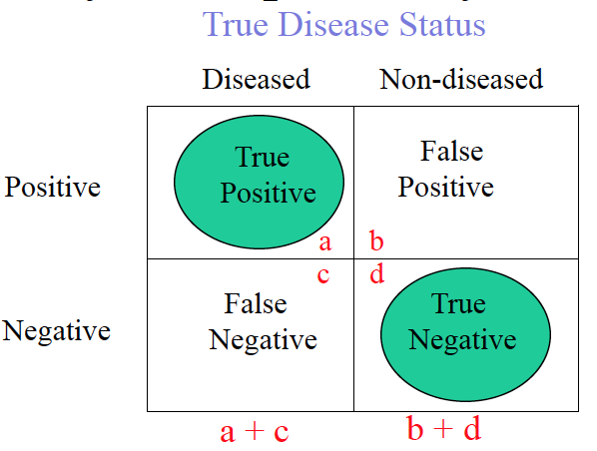

5. A new type of blood test has been developed to screen people for HPV, a virus than can cause cervical cancer in women and oral cancer in both sexes. A total of 100 people tested positive for the virus, and of these subjects there were 73 who actually had HPV according to the standard microbiology examination. Of those who tested negative for the virus (N=624), there were 618 who were truly negative by the standard examination. Determine the sensitivity and specificity of the new blood test. Would you recommend that it be brought into medical practice?

|  |  |  |  |  |
| --- | --- | --- | --- | --- |
|  | Dx: HPV | NonDx: No HPV | Total | PPV/NPV |
| * Test | 73 | 27 | 100 | PPV:  73/100=73% |
| * Test | 6 | 618 | 624 | NPV:  618/624=99% |
| Total | 79 | 645 |  |  |
| Se/Sp | Sensitivity:  73/79=92% | Specificity:  618/645=95.8% |  |  |

**What is the sensitivity of the new blood test?** 92%

**What is its specificity?** 95.8%

**What do you recommend regarding using this test to test for HPV?**

I think this would be a good test to expand to the population because even though the test is moderately sensitive (92% of those with HPV would test positive), only 4.2% of those who do not have the disease would test positive, which seems to be a fairly low percent given the benefit of being able to identify patients who have HPV and are at risk of cervical and oral cancer and could be considered for medical practice (tests with a higher specificity are valuble when screening populations). Of note, both the sensitivity and specificity of this HPV test are similar to currently existing HPV screens.