PBIO 504 Homework

Non-Parametric Statistics

Name: Michael Chambers

A pilot study evaluated daily dietary intake of a wide range of nutrients among professional female athletes. The main nutrients of interest were total fat (grams) and calcium (mg). The athletes were grouped by age, such that the two groups of interest were 18-29 year olds vs. 30-39 year olds.
Your assignment is to perform descriptive analysis of the data, in addition to using both parametric and non-parametric tests to evaluate the same age group differences. By comparing the two classes of test you will see how different their results can be in the same data set. You should:
- examine the raw distributions of the nutrients for evidence of normality (compare mean and median, look at graphs);
- perform T-tests for age group differences in fat and calcium;
- perform the Wilcoxon rank sum test for age group differences in calcium;
- perform the test for the linear relationship of fat and calcium using Spearman correlation; and
- answer the questions on the worksheet.

Data
The variables are age group (1=18-29 years old, 2=30-39 years old), fat, and calcium. The data are shown below in repeating units of these 3 variables. Note that some data points are missing (denoted by ‘.’) and these observations will have to be excluded from the calculations for the Spearman correlation.

Data: total fat (g), calcium (mg)
Group: professional female athleats

2 10.5 4 2 12.6 6 2 15 6 2 17 8 2 18 10.6 2 20 10
2 20.5 11 2 22 14 2 23 16 2 24 19 2 25 22.3 2 28 26
2 29 30.7 2 35 35 2 39 40 2 44 45 2 48 50 2 52 55
2 55 60.1 2 64 65 2 70 80.9
1 5 10.4 1 9 15.8 1 10 15 1 11 20 1 12 22 1 14 25
1 14.1 40.9 1 16.9 45.5 1 17.5 50.2 1 18.7 55.1 1 19 57 1 21 60
1 22.3 65.5 1 28.5 70 1 32 75 1 33 80.8 1 40 80 1 44 .
1 12.5 30 1 13 32 1 16 38 1 47 . 1 56 . 1 62 .

NON-PARAMETRIC STATISTICS WORKSHEET

Name: Michael Chambers Date: 191127

1. Is the variable FAT an appropriate candidate for non-parametric statistics? Yes

Why or why not? The variable FAT is not normally distributed, but appears to take on more of a Poisson distribution. Non-normally distributed variables are appropriate candidates for non-parametric statistics.

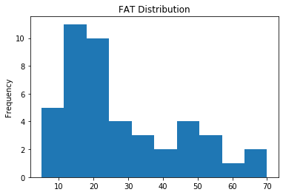

2. What about CALCIUM? Yes

CALCIUM is an even better candidate for non-parametric statistics because it takes on a uniform distribution (not a normal distribution).

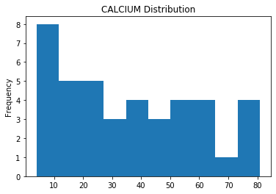

3. Report and interpret the Spearman correlation coefficient for FAT and CALCIUM. R_{s}=.6342 P=8.5e-6

Based upon the Spearman correlation coefficient we can assert that there is a strong positive correlation between fat and calcium consumption, and based upon the p-value we can reject the null hypothesis that ρ = 0.

4. Is there a significant T-test result for FAT by age group? No T = -1.64, P = 0.11

5. Interpret (in plain English) the T-test result for CALCIUM. Yes T = 2.14, P = .039 (drop rows with missing data)

Based upon results of the individual T-test I would reject the null hypothesis, based upon the p-value there appears to be a statistically significant difference in the mean calcium intake between the age groups of female athletes.

6. Combining both groups, for FAT: mean: 27.69 median: 22
Combining both groups, for CALCIUM: mean: 36.65 median: 32

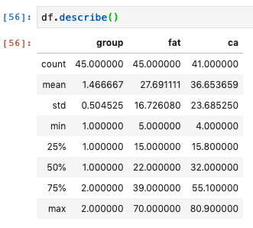
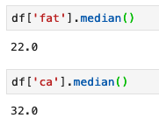

7. What is the result of the Wilcoxon rank-sum test for CALCIUM? (use Stata or by hand)
W_{s}= 503, Z = 2.165, P = 0.0304
(removed rows containing missing data)
Your interpretation:

We can reject the null hypothesis that the median value between the two groups are equal and can conclude that the two distributions of dietary calcium intake are different between the two age groups of female athletes.

8. How are the T-test and non-parametric test results different for this data set?

Both the T-test and Wilcoxon rank-sum tests reject the null hypothesis and have similar test-statistic values, but the null hypothesis are slightly different. The two-sample T-test null hypothesis assumes equal means, whereas the Wilcoxon test assumes equal medians. In both tests we are looking for shifts between the two groups in one direction or the other, but for the T-test the shift is in the mean and for the Wilcoxon it’s in the median.

9. What does the term "non-parametric" mean?

Non-parametric means that there are no parameters. In the context of statistical tests, non-parametric tests (parameter-free or distribution free tests) do not require an estimate of certain population parameters, nor do they require as many assumptions about the input data (namely, is the data normally distributed). Because the data is rank transformed, non-parametric tests are able to accommodate outliers as well.

