PBIO 504

Name: Michael Chambers

**Meta-Analysis Homework**

In this assignment you will find two tables of data regarding associations of stomach cancer risk with green or black tea consumption. For several decades, epidemiologists have been studying whether drinking tea protects against a wide range of different cancers. By this time there are enough published results for a meaningful meta-analysis. Some of the results were from case-control studies of stomach cancer, and others were prospective studies of cancer incidence among tea drinkers and non-drinkers (or those who rarely drink tea). From each study, the tables below record the relative risk (odds ratios were assumed to be good estimators of RR) with their 95% CI, contrasting the highest and lowest levels of tea consumption reported in that population: for example, three or more cups per day versus none.

Use the data in these tables, including the summary RR that we calculated for you, to draw a forest plot according to the instructions below.

You can draw a Forest Plot by hand on graph paper, or use Excel.

Follow the instructions below carefully, and answer all the questions.

Questions about green tea

1. Attach your forest plot of all green tea studies (see Table 1, below).

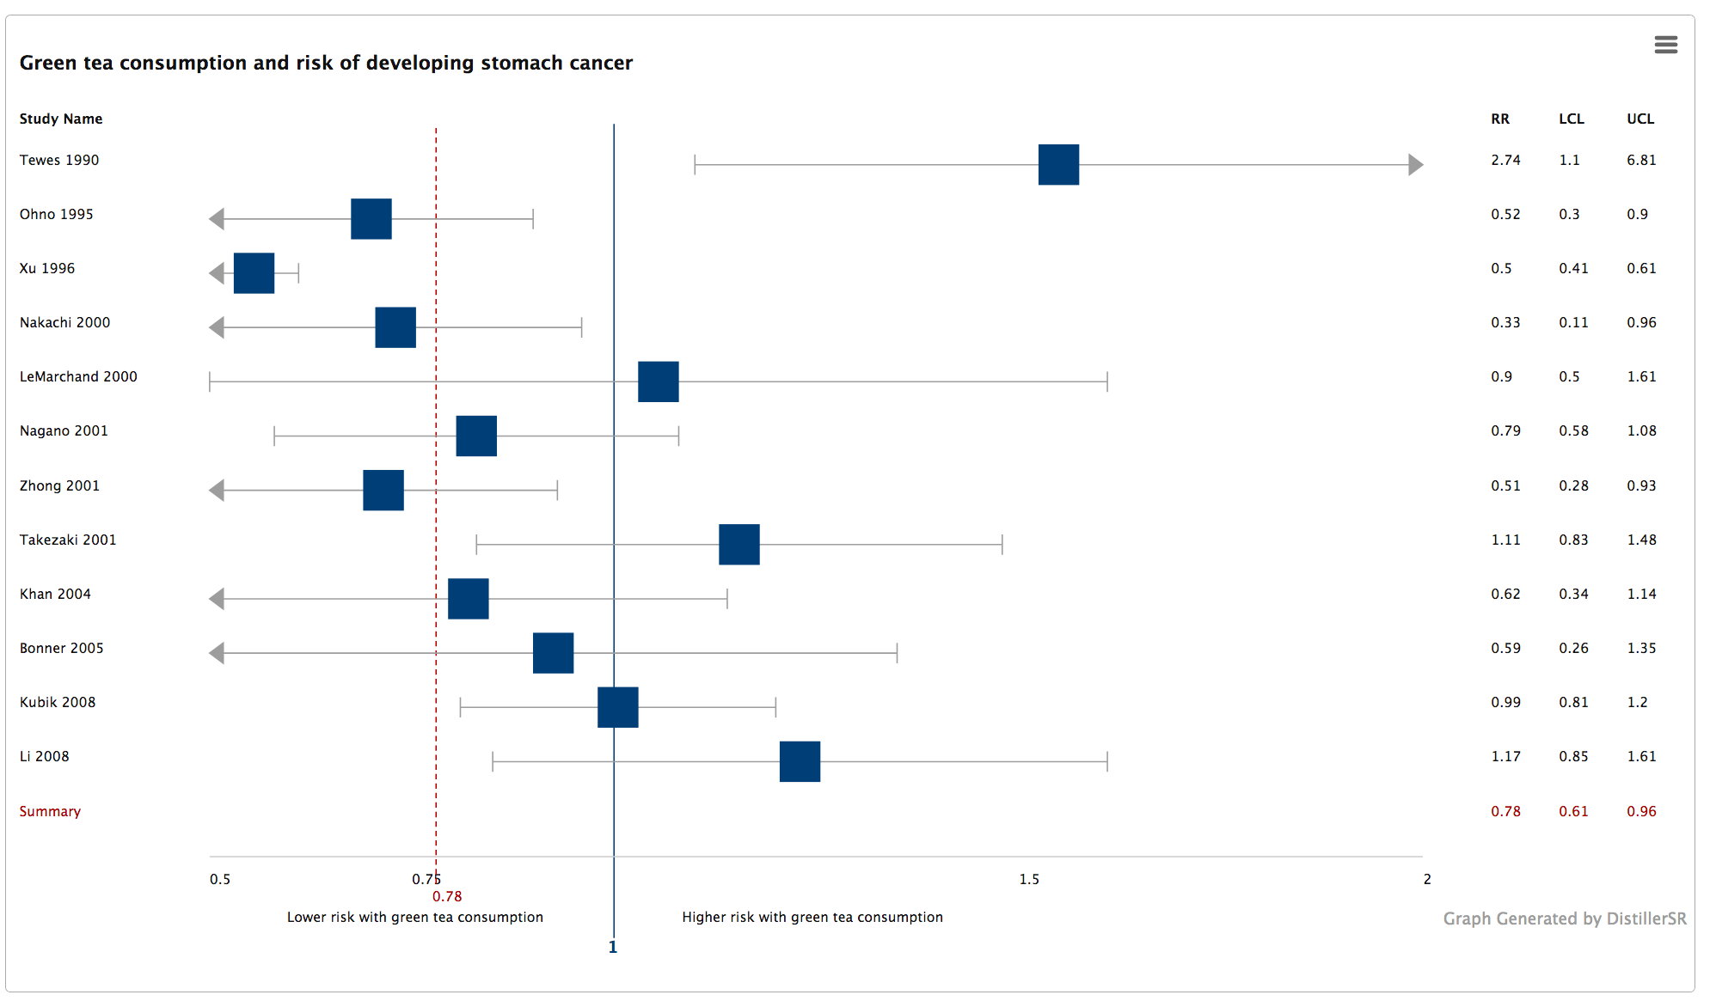

2. Describe your overall impressions of the plot: what does it reveal?

Most of the RRs for the included studies are below 1, with 3 of the 12 studies having CIs that do not include 1. And just one of the 12 studies has an RR of ~1, most of the studies are below (a majority) or above. This plot reveals that green tea consumption reduces the risk of developing stomach cancer. With an overall risk ratio of .78 and a 95% CI of .61-.96, these data may be deemed significant in that the summary CI does not include 1.

3. Interpret the summary statistic (what does it mean?).

The summary statistic risk ratio of .78 with a 95% confidence interval that excludes 1 (.61-.96) suggests that consumption of green tea reduces the risk of stomach cancer. However, looking at the individual studies there does appear to be a trend over time in that green tea consumption increases the risk of stomach cancer.

4. Compare and contrast the results from the prospective group of studies with the case-control studies (with or without a forest plot). Would you derive a different conclusion from either type of study alone, compared to the plot in Question 1? You might have to speculate about those summary RRs, not provided by study type.

Looking just at the case-control studies there appears to be a broader RR range for stomach cancer and green tea consumption, with most of the study CI ranges including 1. Based on the case control studies alone there appears to be no conclusive data regarding green tea consumption and the risk of developing stomach cancer.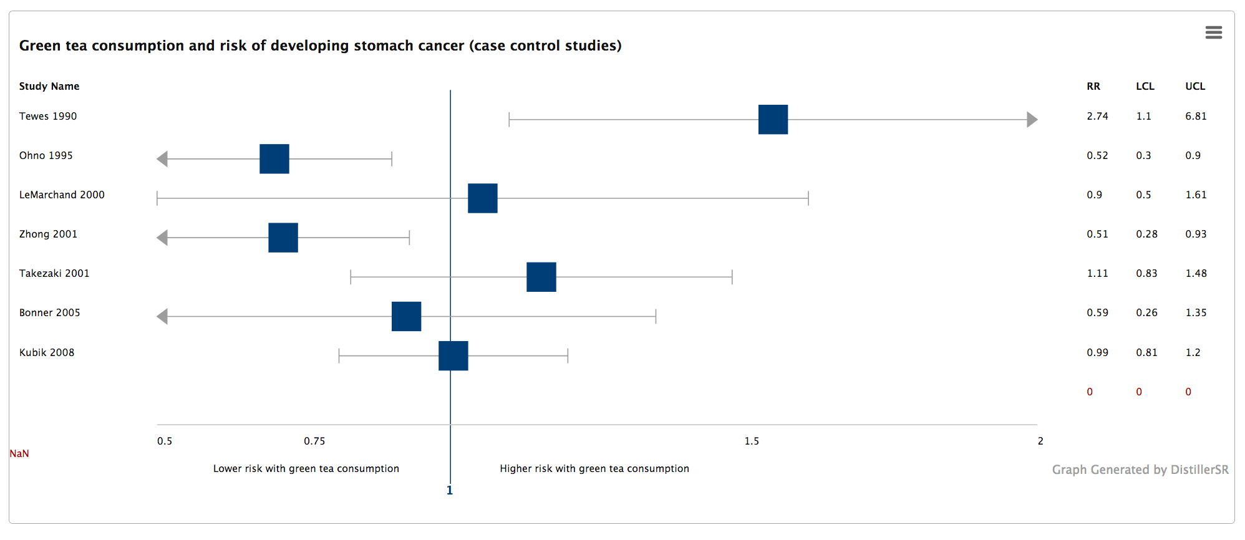

When looking just at the prospective cohort studies there appears to be a more narrow RR range between the studies, most of which are below 1, although only two of the 5 studies have CIs that do not include 1. These data do somewhat suggest that green tea consumption reduces the risk of stomach cancer.

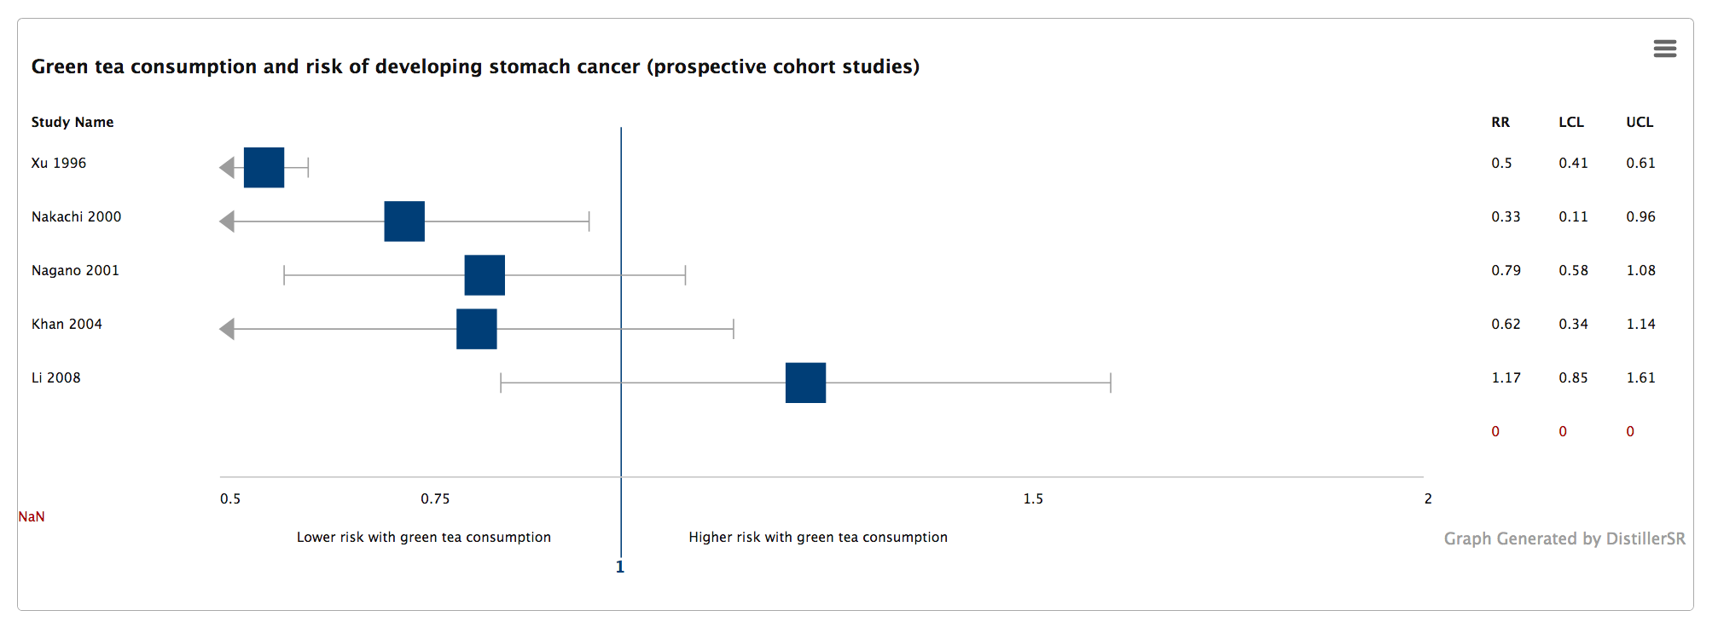

5. Similarly, compare and contrast the group of studies from Asia with those from other countries.

Interestingly, a majority of the Asian studies find that consumption of green tea reduces the risk of developing stomach cancer, as opposed to studies conducted in other countries that do not find any conclusive evidence that green tea consumption is associated with stomach cancer.

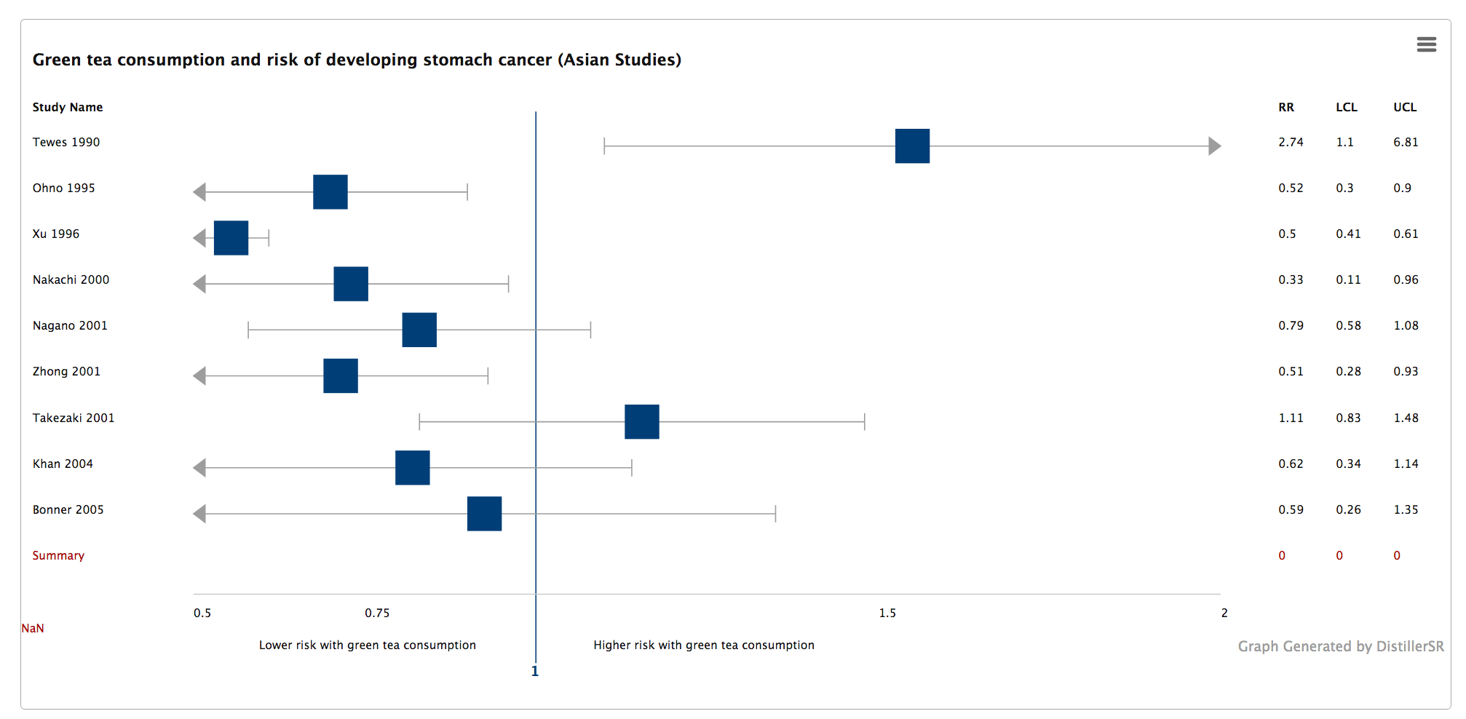

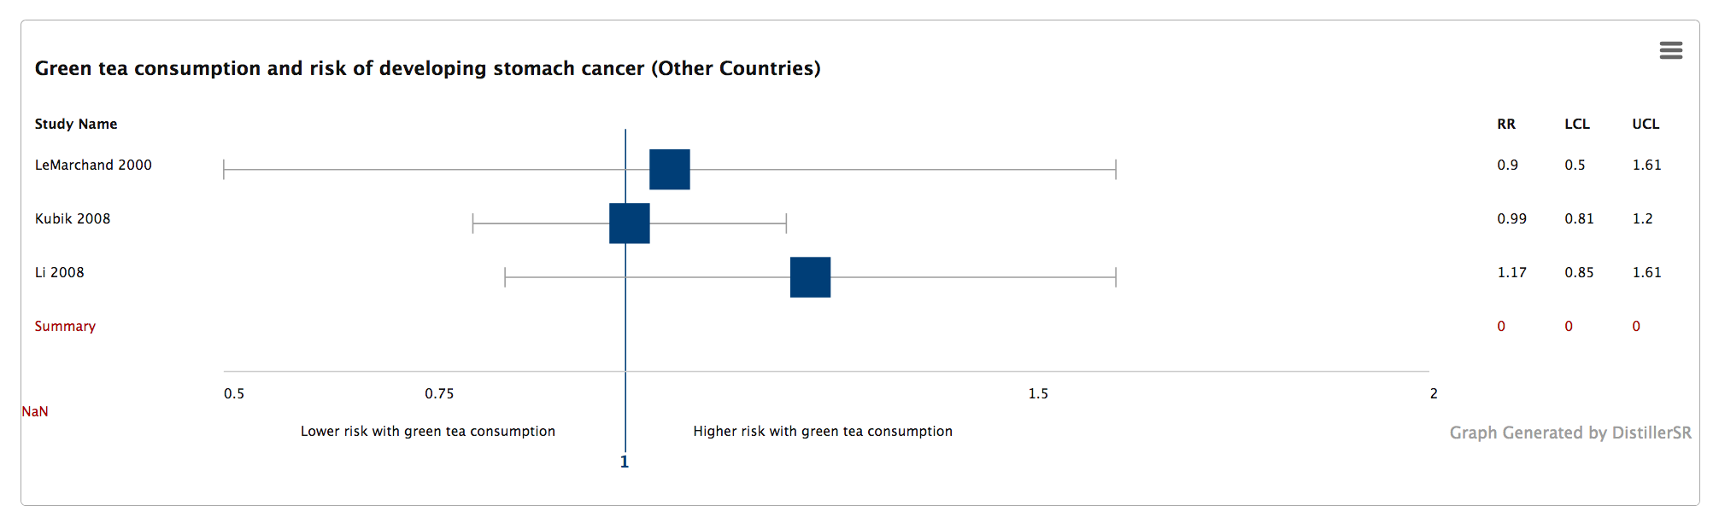

Questions about black tea

6. Attach your forest plot of all black tea studies (see Table 2, below).

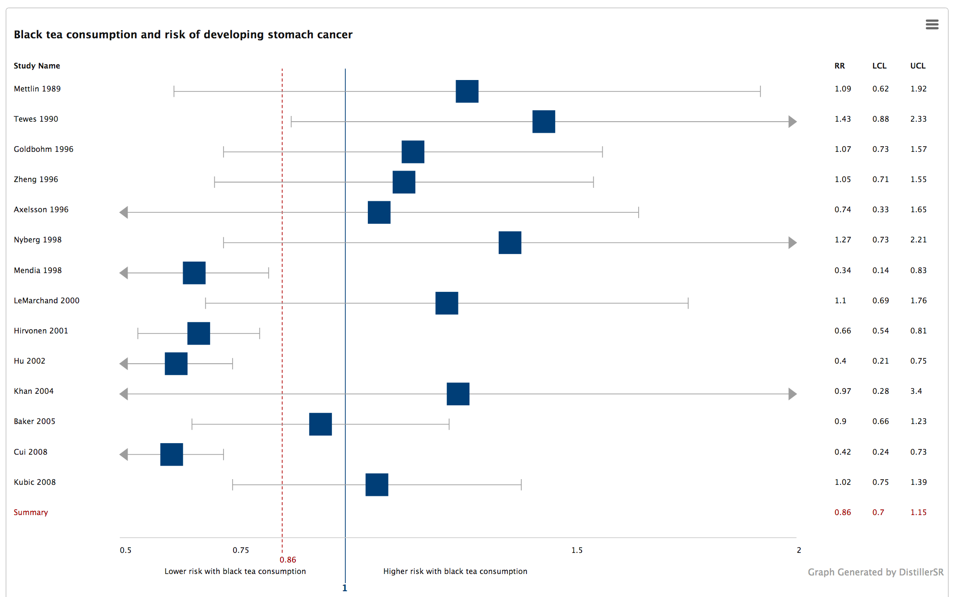

7. Describe your overall impressions of the plot: what does it reveal?

Most of the studies appear to suggest that black tea consumption is associated with stomach cancer, but these studies also have wide 95% confidence intervals. Interestingly, 4 of the 14 studies have RRs well below 1 and their CIs do not include 1

8. Interpret the summary statistic (what does it mean?).

With a summary statistic RR of .86 and a confidence interval of .7-1.15 we cannot reject the null hypothesis. That is to say that there appears to be no association between black tea consumption and stomach cancer, meaning that black tea consumption does not appear to affect the risk of developing stomach cancer.

Overall conclusions

9. The information presented in the tables did not take into account the weight of each study. If you knew it, how might that information have changed your impressions of the patterns you saw in the graphs?

The weights could drastically affect the overall impressions because there were a few studies in each meta-analysis that had CI’s that did not include 1 (specifically for the black tea meta-analysis). Should those studies be given more weight then that could strongly affect the conclusions made in the black tea meta-analysis. There was one study in the green tea meta-analysis that had an RR above 1 and a CI that did not include 1, and if the weight for that study was pretty high then that would nullify the conclusions made.

10. Meta analysis can be a useful tool to summarize the medical literature on a specific association. Besides the information you have seen in these tables and graphs, what else would you want to know before recommending that everyone drink tea to prevent cancer?

I would like to know how large the study cohorts were, the ages and genders of the participants, how each study was funded, and more details about the outcome measure or criteria (how much tea consumed, how regularly, etc).

Table 1. Risk estimates from studies of green tea consumption (comparing highest level to none/lowest) and stomach cancer risk

|  |  |  |  |
| --- | --- | --- | --- |
| Country | Study type | Author, year | RR (95% CI) |
| China | Case-control | Tewes 1990 | 2.74 (1.10 - 6.81) |
| Japan | Case-control | Ohno 1995 | 0.52 (0.30-0.90) |
| China | Prospective cohort | Xu 1996 | 0.50 (0.41- 0.61) |
| Japan | Prospective cohort | Nakachi 2000 | 0.33 (0.11 - 0.96) |
| USA | Case-control | LeMarchand 2000 | 0.90 (0.50-1.61) |
| Japan | Prospective cohort | Nagano 2001 | 0.79 (0.58 - 1.08) |
| China | Case-control | Zhong 2001 | 0.51 (0.28 – 0.93) |
| Japan | Case-control | Takezaki 2001 | 1.11 (0.83 – 1.48) |
| Japan | Prospective cohort | Khan 2004 | 0.62 (0.34 – 1.14) |
| China | Case-control | Bonner 2005 | 0.59 (0.26 – 1.35) |
| Czech | Case-control | Kubik 2008 | 0.99 (0.81 – 1.20) |
| Canada | Prospective cohort | Li 2008 | 1.17 (0.85 – 1.61) |
|  |  | summary | 0.78 (0.61 - 0.96) |

Table 2. Risk estimates from studies of black tea consumption (comparing highest level to none/lowest) and stomach cancer risk

|  |  |  |  |
| --- | --- | --- | --- |
| Country | Study type | Author, year | RR (95% CI) |
| USA | Case-control | Mettlin 1989 | 1.09 (0.62 – 1.92) |
| China | Case-control | Tewes 1990 | 1.43 (0.88 – 2.33) |
| Netherlands | Prospective cohort | Goldbohm 1996 | 1.07 (0.73- 1.57) |
| USA | Prospective cohort | Zheng 1996 | 1.05 (0.71 – 1.55) |
| Sweden | Case-control | Axelsson 1996 | 0.74 (0.33 - 1.65) |
| Sweden | Case-control | Nyberg 1998 | 1.27 (0.73 – 2.21) |
| Uruguay | Case-control | Mendia 1998 | 0.34 (0.14 – 0.83) |
| USA | Case-control | LeMarchand 2000 | 1.10 (0.69 - 1.76) |
| Finland | Prospective cohort | Hirvonen 2001 | 0.66 (0.54 – 0.81) |
| Canada | Case-control | Hu 2002 | 0.40 (0.21 – 0.75) |
| Japan | Prospective cohort | Khan 2004 | 0.97 (0.28 – 3.40) |
| USA | Case-control | Baker 2005 | 0.90 (0.66 – 1.23) |
| USA | Case-control | Cui 2008 | 0.42 (0.24 - 0.73) |
| Czech | Case-control | Kubic 2008 | 1.02 (0.75 – 1.39) |
|  |  | summary | 0.86 (0.70 – 1.15) |