Git Notes

Use git bash to enter commands

.gitconfig – global

git settings in – in c:\users\jms2
This stores global parameters of git

cat .gitconfig – prints .gitconfig on screen
change - git config --global <parameter to change>

Each project has a repository on the local computer – it keeps a .git directory that keeps track of all the changes made to the project

Creating a repository - Repository keeps snapshots of the changes that were made
Go to the folder in which you want to stage the repository using dos cd commands

git init – will create all the files git needs for that project

Changes to working directory

git checkout - restores from repository
It's a good practice when we're not trying to checkout (restore) a branch to put dash--dash, followed by file we are trying to restore git checkout -- <file > - that says stay on the current branch. That bare double dash is just there to indicate that we're not checking out a new branch, we're just talking about a file in the current branch.

Changes to staging directory

git reset HEAD <file >..." to unstage - the HEAD pointer points to the last commit of the tip (tail) of the current branch, which is master. That's our current branch. Tells Git to go look at that last commit and reset yourself to be the same as what that has.

How things are stored in the Repository

Let's say that we wanted to do change something about the commit that's represented with snapshot B, the one right in the middle. So 38e73d6134... so on is the SHA (Secure Hash Algorithm ) that it came up with when we first made that commit. So if we make a change to this, even if we just change the commit message, it's going to change that SHA to be something different, and if that SHA becomes something different, well, now the parent of snapshot C will need to be changed as well, because it needs to point to something different. And if we change the parent of snapshot C, well then when we run it through the algorithm it's going to come up with a different SHA as well.
So all the way down the chain every single Git object will have to be changed just because we've made a change earlier down the line. Well, it's completely broken the integrity of the data that's in Git. So Git doesn't want us to do that. However, it is possible for us just to change the last commit, because nothing depends on it yet. So the most recent commit the commit that HEAD points to we do have the ability to edit. Once we've tacked another on to the end of that we can't edit in anymore, but the one at the end is still editable, and we can do that using the amend option.
If we make a commit and then realize we really wanted another change to be in that most current commit (backup) we can amend the most recent commit.
git commit --amend -m “message about the commit” - you can put the same message form the previous commit
If after the amend you want to change the commit message, just do another commit –amend -m and put another message.
Each one of these times that we do this that we make those edits, the SHA changes.
Even if we just change the message, the dates that we've made the commit, everything changes, and so the SHA changes as well. That's why we only have the ability to amend the most recent commit, the one that HEAD points to.
Basically, you can change the last commit as many time as you want to by using –amend

Retrieving Old Versions
If we need to make changes to older commits, the best advice is to make new commits, commits that undo what was done in those older commits. Not only does it maintain the data integrity of Git, but then the log file also accurately reflects the changes that were made over time, and it shows that a 1.1 change was made and then several commits later another commit was made.

Run git log and find the commit in which you made the change and then use the SHA from the previous commit. Copy part of the S-H-A at the top (the first 10 or so characters) and copy those and use those for a reference. Then say git checkout and use that reference to the commit that is wanted:
At this point you can restore the entire commit by just entering git checkout and the SHA of the commit you want to restore
git checkout 406a246caba456e2b45
Note: checking out '406a246caba456e2b45'.

You are in 'detached HEAD' state. You can look around, make experimental
changes and commit them, and you can discard any commits you make in this
state without impacting any branches by performing another checkout.

If you want to create a new branch to retain commits you create, you may
do so (now or later) by using -b with the checkout command again. Example:

git checkout -b <new-branch-name>

HEAD is now at 406a246... First Commit

This restores all the files in the commit to the state they were in prior to the commit – sort of making this a new starting point. If that's what you want to do, make any changes you want, do a commit add and commit -m and note that you are creating a new starting point. Of course, the previous commits will still be in the log. Another way to do this is to create a branch – see the docs further down for that process.

If you want to restore a specific file from a previous commit , enter the command git checkout followed by a dash, dash, and the file name
git checkout c0229510faf7b68c4 -- filename you want to restore
Look at git status, and you'll see that it moved it into the staging and the original document is changed back to its original (pre-commit ) state.
If you run a commit now, the old version will be committed and will become the current version (at the tail of the current branch). It's a good habit when you're reverting a particular commit to actually refer to the SHA for that original commit. So, it would be a good idea to take part of the SHA and copy it and then say this commit reverts commit, and give that SHA, so it's a reference.
To undo the restore and go back to the pre-restore state:
Do git reset HEAD file you just restored. That will put it back in the working directory, and then do git checkout -- file you just restored, and that now removes it from our working directory so that now our working directory is clean.

The Revert command.
The Revert command will do is it will take all of the changes that were there, and it will flip them around. It will do the exact opposite of those changes. So, anything that was added will be deleted, anything that was deleted will be added back in again, and anything that was modified will be changed back to its previous state. It's going to be a complete mirror image of this commit.
git revert, S-H-A portion
You can pass in the -n option with revert, and then it won't actually do the commit, it will just stage it and then wait for you to actually do the commit yourself. It will give you the chance to write your own message (using the text editor you placed in .gitconfig) for it and also make any other modifications you might need to make.

Git Reset
Allows us to specify where the HEAD pointer (where to write the next backup) should point to. Rewind back to our previous commit, and that's where we're going to start recording from now on, and we're going to just overwrite whatever came after that. Git reset always moves the HEAD pointer. That's one thing that it does in every case. But there are three different options thatto look at that we can use to control some of the other behaviors that it has, and those options are going to be soft, mixed, and hard.
Soft is going to move the HEAD pointer to the specified commit, and it's not going to change the staging index, or the working directory at the same time. It's just going to move the pointer. It's the safest of all these options. The staging index and our working directory are going to contain the files in their later revised state. The repository is going to be set back to an earlier version.
Mixed reset. This is in between soft and hard which is why it's called mixed, and it is the default. What it does is it moves the HEAD pointer to the specified commit, and it also changes the staging index to match the repository. It does not change your working directory though. So, at this point, the staging index and the repository will be set in one place, our working directory, though, has all those changes that we've made since the last commit. All the things that were in later versions of the repository are still in our working directory- on our hard drive. We haven't lost any work. It's just waiting for us to stage it and then commit it.
A hard reset will not only move the pointer of the repository, but it will make your staging index and your working directory match that as well. So that means any changes that came after that commit are completely obliterated. They don't exist in the repository, the staging index, or the working directory, they're completely gone. So use this one with caution. It really is for when things have gone completely wrong, and you really just want to reset everything back to a specific point in time, and you don't mind losing whatever came after it.
Note – always make a text copy of the log prior to any reset – once you do a rewind(reset) you won't be able to see that portions of the log after the commit to which you rewound
To find current head SHA:
$ cat .git/HEAD
ref: refs/heads/master

$ cat .git/refs/heads/master
daf34035baa3131289ceea29c5ecd2d7148b3571 – most recent commit

Soft reset example
git reset –soft (SHA to which you want to reset)
$ git reset --soft e3836d5909e8ed55992d
$ cat .git/refs/heads/master
e3836d5909e8ed55992d7f7ea419c6a90bb56e8c – new reset point

$ git status
On branch master
Changes to be committed:
(use "git reset HEAD <file>..." to unstage)

modified: resources.html

Untracked files:
(use "git add <file>..." to include in what will be committed)

Log prior to rewind

git reset with the soft option is the safest and least destructive, because it didn't actually remove anything at all. All it did was moved the HEAD pointer that other commit was still there, and all of our work was still maintained in the staging index and in our working directory. We didn't lose anything.
Mixed reset
works exactly the same as the soft reset with one additional thing, which is that it makes the staging index look the same as what's in the repository.
$ git reset --mixed e3836d5909e8ed55992
Unstaged changes after reset:
M resources.html

$ git status
On branch master
Changes not staged for commit:
(use "git add <file>..." to update what will be committed)
(use "git checkout -- <file>..." to discard changes in working directory)
modified: resources.html
Untracked files:
(use "git add <file>..." to include in what will be committed)
Log prior to rewind

no changes added to commit (use "git add" and/or "git commit -a")
git --mixed did the exact same thing as git --soft did, the only difference here is how our staging index looks.
The changes that we had subsequently made are not gone, they're just only in our working directory. They're not in two places, they're just in one place.
Hard reset
makes our staging index and our working directory exactly match the repo. It throws out everything that happened after that. Hard reset makes our staging index and our working directory exactly match the repo. It throws out everything that happened after that.
$ git reset --hard e3836d5909e8ed55992
HEAD is now at e3836d5 Changed 24 hour support 4315 --> 4314
$ git status
On branch master
nothing to commit, working tree clean
We've now essentially rewound our project back to this previous point in time.
Note: when you do a git reset –hard you lose the log of the any commits that occurred after that point. However, those old commits are still there, we can still move our HEAD back to this later point in time. That's why you make a copy of the log – in case you want to reference the SHA of a commit that occurred after the commit you just reset the head to.
git clean command
$ git status
On branch master
Untracked files:
(use "git add <file>..." to include in what will be committed)

Junk1.txt
Junk2.txt
Junk3.txt

nothing added to commit but untracked files present (use "git add" to track)
$ git clean -n – what will be removed if you make me do it (-f)
Would remove Junk1.txt
Would remove Junk2.txt
Would remove Junk3.txt
$ git clean -f
Removing Junk1.txt
Removing Junk2.txt
Removing Junk3.txt
Files are permanently deleted – not in recycled bin
Ignoring files
To tell Git which files it ought to ignore, create a special file in the root of our project, in the root of the working directory called .gitignore. This file is going to provide Git with a set of rules that it can use to know which files to use for commits and which ones should be ignored. Those rules can be very simple, just a list of files one for each line or we can get little fancier, and you some very basic regular expressions. We can use the Asterisk, the Question Mark, a bracket of characters, a character set, or a range like 0-9. So it's really pretty limited, we just have some basic wildcards that we can use. We can also negate expressions by putting an exclamation point in them. So, for example, we could say ignore any file that ends in .php.
Example
*.php – ignore all files ending in .php
!index.php – don't ifnore index.php -
So files ending in .php don't get tracked, but index.php does get tracked.
# Comments in .gitignore start with a #
# Comments cannot be in the same line as the command
Ignoring files that have already been committed
If you have a file or files that have already been in a commit, in order to stop tracking those files you have to run git rm –cached filename. This will tell git to stop tracking that file but will leave it in the repository in case you want to ever get it back in a previous state.

Tracking empty directories
Git does not track empty directories, and that's because Git is designed to be a file-tracking system. Its purpose is to track files and the content in those files. So it tracks files, and it tracks the directories it takes to get to those files, but it ignores directories that have no files at all. So the trick that we use in order to keep track of empty directories is to put a file in them.
One of the ways that we can do that from Unix is we can use the touch command. So touch is a way to just create a file that doesn't exist.
touch assets/pdfs/.gitkeep, this will create the file .gitkeep with no content in it whatsoever. It's 0 length, there is nothing inside of it. But the file is there.
git add assests/pdfs,
git commit and "Add 'empty' directory with .gitkeep file in it".
Now that directory will be tracked even though it is empty
Referencing commits
Tree-ish - a tree-ish is a reference to a commit because that commit then in turn references the tree, the Git repository and all the files that are in there at that point.
Ways to reference commits – use SHA

How to look at tree listings
git ls-tree HEAD -
will point to the tip of the currently checked out branch, and it will return the list of files at that point. That's what's in the HEAD. Those are the files that are in the repository at that point, so that's what the repository thinks is the current set of files.
$ git ls-tree master assets/
040000 tree 1ff91bf13a6d5461a85ad44f4cbacd77ee6c4917 assets/images
040000 tree ec4c1fc09292002d5389a24e4831a6d473dcf282 assets/javascripts
040000 tree d564d0bc3dd917926892c55e3706cc116d5b165e assets/pdf
040000 tree 61324dc38b3c2856c5d96067000ca4bdafeb669a assets/stylesheets

Go back 1 to see the tree prior to the commit for the pdf folder
$ git ls-tree master^ assets/
040000 tree 1ff91bf13a6d5461a85ad44f4cbacd77ee6c4917 assets/images
040000 tree ec4c1fc09292002d5389a24e4831a6d473dcf282 assets/javascripts
040000 tree 61324dc38b3c2856c5d96067000ca4bdafeb669a assets/stylesheets

Notice that each of these entries on the left, it tells you that everything is either a tree or a blob. A blob is a file. It can be any kind of file that's stored there.
It can be text file, an image, anything, they are all stored as a blob. If it's not a blob, then it's a tree and a tree is a directory.
git ls-tree SHA will list the directory contents of that tree

Getting more from the commit log
$ git log –oneline - one line listing with SHA
3e936ab Added pdf folder to tracking
b6f931d third textfile2
6159c9d Second tempfile2 commit
a2e2540 Added tempfile 2 and gitignore
0af72ef Log file committed
c022951 Change link for backpack.html to backpack_cal.html
4016e52 Changed 24 hour support number to 4314
3d823ec Initial Commit

$ git log --oneline -# - lists the last # commits
3e936ab Added pdf folder to tracking
b6f931d third textfile2
6159c9d Second tempfile2 commit

Also has time-stamp, Author, gref – by certain text, range of SHA's, what has happened to certain file,

Viewing commits
$git log -show SHA – will show the details of what happened in that commit
Gives a diff of the commit
Comparing commits
We're comparing the directory that that commit references; the actual state of all the files in the repository at that point in time. And that makes sense because a commit is not just a snapshot of those changes, but it includes all of the ancestors all the way back to the beginning of the repository as well. And the sum total of all those ancestors is the directory, or tree, at that point in time where the commit is.
So when we compare commits what we're actually doing is comparing two directories and seeing what has changed between those two directories.
If we pass in a SHA that references a commit, it will show us the difference between our working directory and the directory at the point in time that that commit was made. What we can do is we can compare where we are now against a previous point in time, basically just looking back. What's changed since this point in time? And we can be more specific by passing in a specific file.

Branching
For testing new ideas – creates a branch that can be discarded without affecting previous commits. If it works, can be merge into the main branch.
For creating independent modules that can then be folded into the main branch by merging.
When we create branches we're still going to have just one working directory. All the files that we're working with will still be in that same project folder that we've been in before. But when we switch branches, Git is going to do fast context switching. It's going to take all of the files and folders that are in our working directory and make them match what's in the branch. It will swap out the two sets of changes.
We create the new branch, at that point HEAD still points to commit 534de, both the master and revise_navigation at this point are exactly the same. There have been no additional commits made, so HEAD points to the same commit. It's only once we make new commits to the revise_navigation branch that then HEAD moves to a new commit, a commit that's not on the master branch anymore. Now we can switch back and forth. If we switch back to master branch, well then, the HEAD points to the tip of the current branch, that's the master branch.
If we switch back to revise_navigation, it will switch back to point to the tip of the revise_navigation branch.

Creating a new branch
$ git branch
* master * --> current branch

$ cat .git/refs/heads/master
3e936ab9397d15d1ab431eaed6e0ed7c936d17d1 – SHA of current branch tail
$ git branch new_feature --> create new branch
$ git branch --> show branches
* master
new_feature
Note: Still on the master branch. That's still the one that's checked out. HEAD still points to master right now.
$ ls -la .git/refs/heads
total 2
drwxr-xr-x 1 JMS2 197121 0 Feb 17 16:57 ./
drwxr-xr-x 1 JMS2 197121 0 Feb 15 17:05 ../
-rw-r--r-- 1 JMS2 197121 41 Feb 17 11:54 master
-rw-r--r-- 1 JMS2 197121 41 Feb 17 16:57 new_feature

$ cat .git/refs/heads/master
3e936ab9397d15d1ab431eaed6e0ed7c936d17d1

$ cat .git/refs/heads/new_feature
3e936ab9397d15d1ab431eaed6e0ed7c936d17d1
Both branches are pointed to by the same HEAD - no commit has been made to new_feature
Switching Branches
$ git checkout new_feature
Switched to branch 'new_feature'
$ git branch
master
* new_feature → * shows current HEAD
At this point, they both point to the same commit. We haven't made any new changes to master, we haven't made any new changes to new feature, so the tips of those still are absolutely identical.
Steps
make changes to index.html
git commit -am “Modified title of index.html”
$ git log --oneline
c3e7635 Modified title of index.html → head in new_feature branch
3e936ab Added PDF folder to tracking

$ git checkout master
Switched to branch 'master'

$ git branch
* master
new_feature
$ git log --oneline
3e936ab Added PDF folder to tracking → HEAD now back in master branch

Go back to index.html and the change in gone – it is in the new_feature branch, not the master branch

go back to the new_feature branch

$ git checkout new_feature
Switched to branch 'new_feature'
Go back to index.html and the change is back – this is called fast content switching

How we can both create and switch branches at the same time so that we don't have to type both commands.

Use the checkout command with the -b option; -b means both created and switch at the same time. You can think of it as check this out as a new branch.

$ git checkout -b shorten_title
Switched to a new branch 'shorten_title'

$ git branch
master
new_feature
* shorten_title → new branch

$ git log --oneline
c3e7635 Modified title of index.html
3e936ab Added PDF folder to tracking

HEAD points to the SHA of the new_feature branch – that was the current branch when we created the new branch shorten_title
Change index.html – make title shorter → Explore California - Affordable Outdoor Tours
$ git commit -am "Shorten the title of index.html"
[shorten_title bc927c4] Shorten the title of index.html
1 file changed, 1 insertion(+), 1 deletion(-)

explore_california (shorten_title) --> Note- the branch you are in is at the end of the response line
$ git log --oneline
bc927c4 Shorten the title of index.html
c3e7635 Modified title of index.html

Use git checkout <branchname> to move back and forth between branches

Note: There is one thing that you need to be cautious about with that, which is that your working directory must be clean in order to switch.

If you make changes to a branch and don't commit the changes:
You have an unsaved change, not stage for commit or anything, just sitting in the working directory. If you try switching to our master branch, git checkout master, we get an error, it says,
your local changes to the following files would be overwritten by checkout: index.html. Please, commit your changes or stash them before you can switch branches. Aborting.
Git is telling you, sorry, I can't do this, because if I do, if I make your working directory look exactly like master, you're going to lose the changes that you just made. So rather than destructively just blow out your changes, which you might want to keep, you might not have realized that this was going to a problem, Git stops and does the safe thing, and it says you need to deal with this problem first. You have three options at this point.
One, you can scrap the changes by checking out the file again. That's git status git checkout -- and the file name.
The second thing you can do is you can commit the changes to the current branch. Once they're committed, they won't get lost anymore. They're stored in Git, we can just switch back and forth between the branches, and it will just switch back and forth between the HEAD of each one of those branches.
The third possibility is that we can stash the changes, - later in this document
Note: if you have files in one branch that are not in another branch, you can switch branches without any error because the file in the starting branch will not be overwritten in the working directory – it doesn't exist in the branch you are switching to.
Comparing Branches
git diff - command to compare two branches. Just pass in the names of the branches.
$ git diff master..new_feature
diff --git a/index.html b/index.html → files that are different
index 409068c..c423c86 100644
--- a/index.html
+++ b/index.html
@@ -3,7 +3,7 @@
<html lang="en">
<head>
…..
- <title>Welcome to Explore California</title> → master
+ <title>Welcome to Explore California - Affordable Outdoor Tours</title> → new_feature
You can even include the ancestors. So for example, you can compare new_ feature with the previous commit to the HEAD of shorten_title.
$ git diff new_feature..shorten_title
- <title>Welcome to Explore California - Affordable Outdoor Tours</title>
- <title>Explore California: Affordable Outdoor Tours</title>

$ git diff new_feature..shorten_title^
- <title>Welcome to Explore California - Affordable Outdoor Tours</title>
+ <title>Explore California - Affordable Outdoor Tours</title>
Shows change of – to : → the ^ is the parent of the currrent commit
Another way to compare branches, and that's that we can find out, whether one branch completely contains another branch or not.
$ git branch --merged
master
new_feature
* shorten_title
In this case we're on the shorten_title branch, all of the commits that are in new_feature are also in shorten_title, all of the commits that are in master are also in shorten_title.
Renaming Branches
$ git branch
* master
new_feature → not very descriptive
shorten_title
$ git branch --move new_feature seo_title
→ no response from git
$ git branch
* master
seo_title → new branch name
shorten_title
Deleting Branches
$ git branch
* master
seo_title
shorten_title

$ git branch branch_2_delete --> create new branch (for practice)
$ git branch
branch_2_delete
* master
seo_title
shorten_title

$ git branch --delete branch_2_delete
Deleted branch branch_2_delete (was 3e936ab).
$ git branch
* master
seo_title
shorten_title

Thankfully, git does have a few checks in place to make sure that you don't do something stupid.
Can't delete the branch you are currently on
Can't delete a branch that has changes that are not in the current branch
$ git branch -d branch-22-delete --> -d is alternate command for --delete d
error: The branch 'branch-22-delete' is not fully merged.
If you are sure you want to delete it, run 'git branch -D branch-22-delete'.
If you really want to do this, you have to use the capital D option

Configuring the command prompt
Make a file called .bash_profile and place it in the user directory
export PS1='\W$(__git_ps1 "(%s)") > '
Merging Branches
Once you create a new branch off of your master branch and your idea turns out to be successful or the future is finished, you now want to bring those changes back into the master branch so that they're part of the main project.
First step is that we want to make sure that we checkout the branch that things are being merged into, the receiver.
git checkout master
Switched to branch 'master'
git merge seo_title
Updating 3e936ab..f186c20
Fast-forward
index.html | 4 ++--
1 file changed, 2 insertions(+), 2 deletions(-)

Now the master branch has the changes we made in seo_title branch
git branch --merged
* master
seo_title

Note: always want to run git merge with a clean working directory – no uncommitted changes.
Fast-Forward merge – puts the changes into the branch to which you are merging – does a fast-forward because you haven't made any change to the master since you started working with the new branch
Options with merge that are related to the fast-forward.
no-ff option so that would be git merge --no-ff and then whatever branch you were trying to merge. The no-ff option forces Git to create a merge commit anyway. It says, don't do a fast-forward, make a new commit with the commit message anyway. And the main reason you'd want to do this is if you wanted some kind of documentation of the fact that you did do this merge.
ff-only says do the merge only if you can do a fast-forward. If you can't do a fast- forward merge, then just abort.

Merging Conflicts
A conflict occurs when there are two changes to the same line or set of lines in two different commits, because then Git can't decide which one to use or how to merge them together and so we get a merge conflict.
Opening the text file that has the conflicts will show you where they are
<<<<<<< HEAD – this is the branch you are in – the one you are trying to merge to
Line that have differences
======= This shows where the difference in the HEAD section ends
Lines that have differences
>>>>>>> <branch you are merging from
These must be fixed manually in the text editor and the << == and >> character lines removed
Resolving Conflicts
Options ---
1. Abort the merge –
git merge --abort
2. Fix the conflict manually – looking through the <<<<<<< HEAD and >>>>>>> <branch you are merging from and manually set one section to the way you want it to be.
The remove the error markers and save the file.
The you have to do a commit – git will not do an automatic commit on these type of conflicts. Just do a regular git commit -a(m) command line and the new version will be in the current branch.
Strategies to reduce merge conflicts
- Keep lines short
- make fast commits – don't make a lot of changes in one commit
- merge often
- merge the master into the branches periodically
Stashing Changes
The stash is a place where we can store changes temporarily without having to commit them to the repository. It's a lot like putting something into a drawer to save it for later. The stash is not part of the repository, the staging index or the working directory, it's a special fourth area in Git, separate from the others. And the things that we put into it aren't commits, but they're a lot like commits, they work in a very similar way. They're still a snapshot of the changes that we were in the process of making, just like a commit is. But they don't have a SHA associated with them.
git checkout shorten_title
Switched to branch 'shorten_title'
The shorten_title branch does not include the changes that we've made to our text_edits branch.
If we make changes to any file in this branch and try to change to another branch before committing those changes, git will not let that happen.
git status
On branch shorten_title
Changes not staged for commit:
(use "git add <file>..." to update what will be committed)
(use "git checkout -- <file>..." to discard changes in working directory)
modified: mission.html
no changes added to commit (use "git add" and/or "git commit -a")

git checkout master
error: Your local changes to the following files would be overwritten by checkout:
mission.html
Please commit your changes or stash them before you switch branches.
Aborting

We have some changes, you're not quite ready to turn them into a commit yet, so we've got stash them instead.
git stash save "Shorten Title Branch - Who we are-Mission.html-Line 62"
Saved working directory and index state On shorten_title: Shorten Title Branch - Who we are-Mission.html-Line 62
HEAD is now at 7425118 master commit

What stash does - runs git reset hard HEAD, - that takes whatever is in the Repo, and puts thats into both our index and our working directory, so they're exactly the same as the commit where HEAD is pointing right now.
git status
On branch shorten_title
nothing to commit, working tree clean
The file you are working on has been “saved” in the woking directory of that branch but has not been committed. The file prior to the stash has been “restored” to the branch also.
Viewing Stashed Changes
git stash list
stash@{0}: On shorten_title: Shorten Title Branch - Who we are-Mission.html-Line 62
This is the way to refer to this item in the stash - stash @ sign, curly braces followed by a number. Next it tells us the branch that we were on, when we put it in the stash - shorten_title, that's because the stash is going to be accessible even when we switch branches.
To see the changes that were stashed:
git stash show -p stash@{0}
Will show us the changes that were stashed – similar to showing a commit.
Retrieving Stashed Changes
When we do this it's going to bring those changes back into our working directory, whatever that working directory is, whichever branch we're on. Doesn't make any differecne the branch in which the stash was first created.
git stash pop
Removes it from the stash
git stash apply
Leaves a copy in the stash valuable if we want to apply this stash to more than one branch
Deleting Stashed Changes
git stash drop stash@{0}
Dropped stash@{0} (30574638b74a5582cd74407428eb91ff74924955)

Clearing whole stash – anything stashed anywhere -
git stash clear

Remotes
Using Local and Remote Repositories
origin/master is a branch on our local machine that references the remote server branch, and it always tries to stay and sync with that
When other people make changes to the remote server and contribute them there, we need to pull those changes down so that we know about them, and the way that we do that is with what's called a fetch. So we fetch the changes, at that point they come into our origin master branch, because what we're doing is keeping those in sync. Fetch is essentially saying sync up my origin master with the remote server version, but it does not bring it into our master branch.
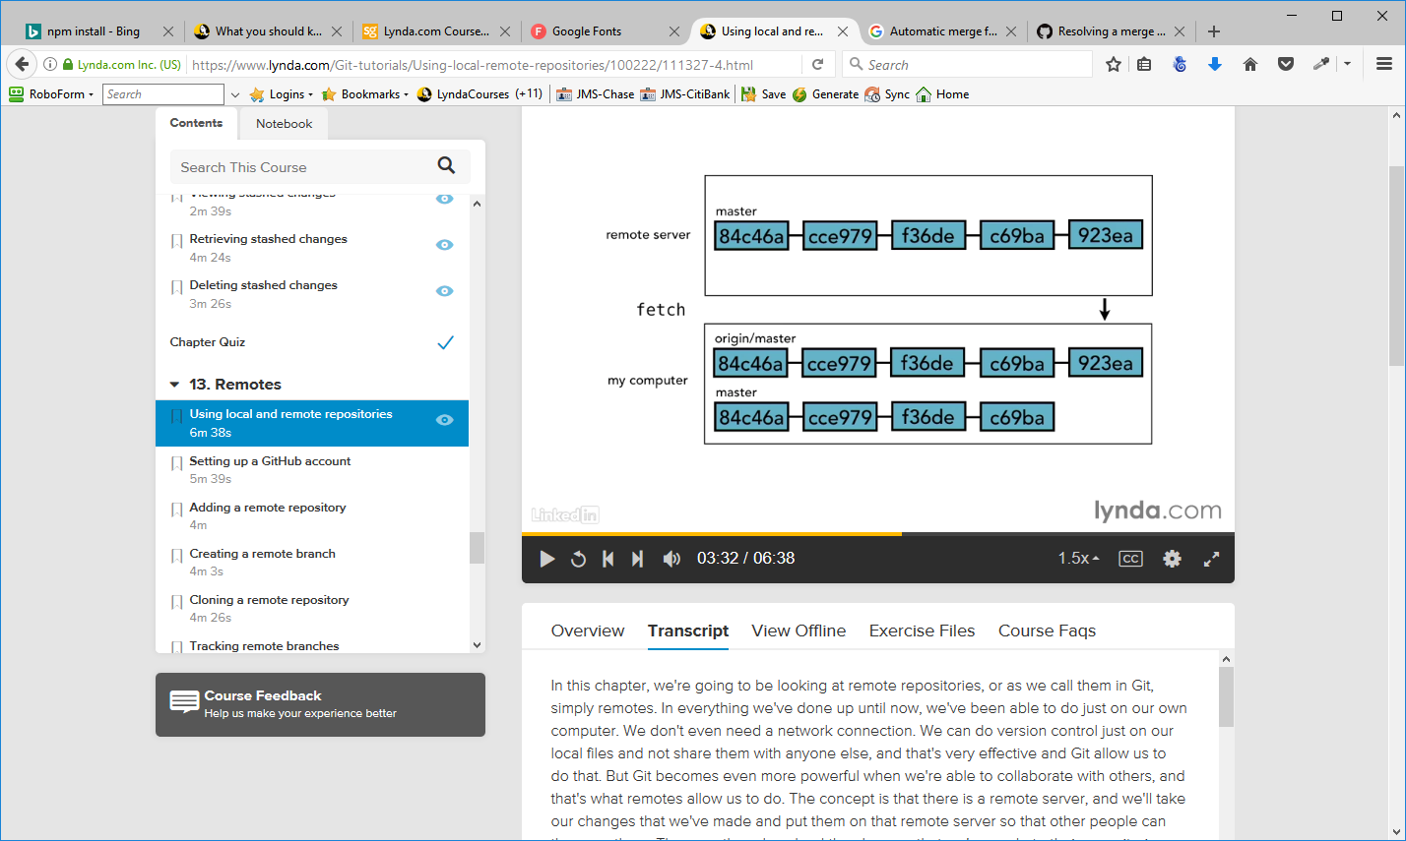
origin/master really is just a branch, it's just like the other branches that we're working with. The only difference is that it tries to stay in sync with what's on the remote server.
So generally speaking, the process that you go through when you're working with a remote, is that you'll do your commits locally, then you'll fetch the latest from the remote server, get your origin branch in sync, then merge any of the new work you did into what just came down from the server and then push the result back up to the remote server.
Setting up a GitHub account
github.com
Create Account or sign in

Create Repository – use the same name as the project you are working on
Supply Name and description

Copy the command line code supplied for the repository

If you are working with a new git setup (in an IDE perhaps) or just using a new ID in git, use the SSH option to pass your SSH key to the local git setup – this way you won't have to enter you r user name and password each time you do a push to the remote
SSH style – first time use of a git in an IDE or a new git install
git remote add origin git@github.com:greenleafservices/<repo>.git
git push -u origin master
HTTP style
git remote add origin https://github.com:greenleafservices/<repo>.git
git push -u origin master

Use the command - Git remote add and then the alias for what we want to name our remote followed by the URL of where it can find it. That is the URL provided in the second chunk of code above.
git remote add origin https://github.com/greenleafservices/explore_california

We don't have to call it origin. By convention, typically, you call your primary one origin, that's what most people do.
Check to see if the remote repository has been created
git remote -v
origin https://github.com/greenleafservices/explore_california (fetch)
origin_lessons https://github.com/greenleafservices/explore_california (push)

Note: If you want to remove a remote is just simply git remote rm followed by the alias

To see all branches – (local and remote)
git branch -a
* master
seo_title
shorten_title
text_edits
remotes/origin/master

Cloning a Remote Repository
How to go to a remote repository and pull it down to have a local copy of it to work with. This is assuming that we don't have a local copy to start with. This kind of circumstance would come up, if someone said, hey come and collaborate on a project with me.

Back out of any present git projects

explore_california(master) > cd ..
documents(master) > cd ..
jms2(master) >

go to git_hub and find the project you want to work on

git clone https://github.com/greenleafservices/explore_california.git new_version
Make a local copy (new_version)on my computer
Cloning into 'new_version'...
To verify existence of new project
documents(master) > cd new_version
new_version(master) > git branch
* master
We just have the master branch because that's all that exists on the remote branch. If there had been more than one branch up there, it still would have brought down the master branch by default. You can specify the -b option and tell it which branch you want, if you want a different one, but by default it's going to take whatever GitHub has as its default branch, and by the way, you can also configure which branch is the default in GitHub, in the GitHub admin controls.

Tracking Remote Branches
When we use the -u option in push, git knows that we want to track that branch.
To test non-tracking branches
go to the project you want to work with
cd explore_california
Make a new branch
git branch non_tracking
Push that to remote but don't use the -u option – a non-tracking brach will not automatically update when you push to the remote
git push origin non_tracking
Total 0 (delta 0), reused 0 (delta 0)
To https://github.com/greenleafservices/explore_california
* [new branch] non_tracking -> non_tracking

Pushing Changes to a Remote Repository
Make changes to a branch and commit them in the usual way
git push
Only command necessary because this is a tracking branch – uploaded to remote using the -u option
Looking at the remote in github will show you that the change has been pushed because it will have the notation you used when you did the commit.

Fetching Changes from a Remote Repository
Now there is both a new branch and a new commit on GitHub that new_version can't see yet. Why is that? Well, it's because new_version needs to do a fetch. A fetch is what synchronizes origin/ master with whatever is on the remote repository.

To fetch into another project
Change to the project using the cd command

explore_california(master) > cd ..
documents(master) > cd new_version
new_version(master) >git fetch origin
remote: Counting objects: 3, done.
remote: Compressing objects: 100% (1/1), done.
remote: Total 3 (delta 2), reused 3 (delta 2), pack-reused 0
Unpacking objects: 100% (3/3), done.
From https://github.com/greenleafservices/explore_california
6f0e941..ad82e08 master -> origin/master
* [new branch] non_tracking -> origin/non_tracking
Now origin/master is in sync with what is on the remote, so it has all the same commits that are there, all those same git objects have been brought down to our machine. if we look at the log for just master, not origin/master, but just our master branch, you can see that that commit is still not there. It didn't bring it all the way into our master branch, that's ours to manage. It just brought it into the origin/master, which is going to try and always be a perfect sync with what's on the remote repository. It's just our local cached version of the remote repo. So that's an important point, when we synchronize with remote repository using fetch, we just update origin/master. Master doesn't change at all. If we're in the middle of working on something, and we've got some edits in our working directory, those aren't affected. If we've made some commits over the last hour, those aren't affected.

“A fetch is not harmful in any way at all, and because of that there is absolutely no reason not to fetch often. In fact, I want to give you three basic guidelines that you should try and follow. The first is always fetch before you work. The very first thing in the morning that you should do when you sit down at your computer is do a fetch. Find out what's on the remote repository, what commits were made over a night by your collaborators. Get those all down onto your computer, and then you can decide what to do with them from there.
The second is fetch before you push. You've got your commits, you've made them, they're not on the remote repository, before you push them up there find out what else is on the remote repository. Maybe someone else already pushed the similar commit or maybe they pushed something that's going to conflict with what you're about to push. Go ahead and get those changes downloaded so that you know about them before you start putting new stuff on there. And then third is just to fetch often. It's not destructive, so there is no reason not to do it often, and you certainly want to do it anytime you're about to leave a network connection. If you're going to go take your laptop to work in the park or you're about to get on an airplane, you want to do a fetch to make sure that your repository is in sync with what's on the remote. “

Merging in Fetched Changes
When we use git fetch in order to sync up origin/master with the master branch on the remote repository, but we noticed that while it brought those commits down into origin/master, it didn't bring them into master on our local repository. All it did was get origin/master in sync. If we want those changes to be incorporated into our master branch, we need to do that additional step ourselves.

Remember that origin/master is just a branch like any other branch.
It's a remote branch, the only thing that really differentiates it from the branches that we normally work with is the fact that we can't check it out, other than that it's really the same.
That's an important point to remember, because we are going to merge with it just like any other branch.

git merge origin/master
Updating 6f0e941..ad82e08
Fast-forward
tours.html | 16 ++++++++--------
1 file changed, 8 insertions(+), 8 deletions(-)
Notice that here we get a Fast-forward merge – no commits have been made to the new_version project since the fetch from the remote

Shortcut : git pull. Git pull is equal to git fetch+git merge.
It does it all in one step. It goes out there, finds the latest, brings it down and merges it into your current branch, all in one big shortcut.

Checking out Remote Branches
Command to see what in the new version
new_version(master) > git branch -r
origin/HEAD -> origin/master
origin/master
origin/non_tracking

These remote branches are exactly like regular branches with one exception, and that's that we can't check them out. Since it is just like every other branch, we can create a branch from it that we can then work with;
new_version(master) > git branch not_tracking origin/non_tracking
Branch non_tracking set up to track remote branch non_tracking from origin.

Or you can check it out of the remote and create it at the same time
new_version(master) > git checkout -b non_tracking origin/non_tracking
Branch non_tracking set up to track remote branch non_tracking from origin.
Switched to a new branch 'non_tracking'

Pushing to an Updated Remote Branch
from Lynda Course:
“Imagine that we have our remote server and our local repository and both of them have three commits in it. We do a fetch, so we know that we are completely in sync, we just have these three git commits. So once I know that I am in sync, I start my work for the day. And over the course of the next hour I put together a commit. I then commit it to my local repository. At the same time though, my coworkers and collaborators have also been making commits and they've been pushing their commits up to the remote server.
So now when I try to push my commits to the remote server, the remote server says, well, I don't know what to do with your commits, there has been some new stuff that's come in in the meantime. Git never tries to do a merge during a push. Instead what Git says is, some new stuff has come in. I'm not sure what to do about all this. You need to fetch the changes that are on the remote server, then sort it out on your end and come back and try again. So we do a fetch. We've got the new information about what's on the remote server, we now see why there's a problem, oh, there were some other commits there.
But that doesn't solve our problem. We've still got to merge our changes in with those. This is not just because there's a conflict, it's not because I changed Line 37 of index.html and someone else changed Line 37 of index.html, it's just simply because there were new commits. So what we need to do in this case is git merge origin/master, that will then merge my changes in with origin/master and create a new merge commit, and then I can push again and the remote server will accept it.
If there were merge conflicts, I would need to fix those just like we do with the normal merge conflicts. But in most cases you don't even get conflicts, you just simply have to do the merge in order to send it to the remote server. So just keep that in mind, if you can't push the remote server, you'll just need to fetch, then merge, then push again. That way we can make sure that everyone's changes are taken into account. “

Deleting a Remote Branch
git push origin --delete non_tracking
To https://github.com/greenleafservices/explore_california.git
- [deleted] non_tracking
Enabling collaboration
What if we want other GitHub users to be able to access our project? The way we do that is you go to the project homepage, and you click on Admin, it'll bring up a page with Collaborators as one of the options, and then we can start typing the GitHub username of the person that we want to collaborate on it.
You have got to know the person's username or at least be able to find it in the listing, and then once you do, you'll click Add to add them to the project. Once you add them to the project, then GitHub will send them an email telling them that they been added to the repository, and also providing them with the URL of the repository so that they can then clone it and start working. And they'll have the ability to both read and write to that project.

If you want to work on an open-source project:

Everyone has read access to an open-source project, so everyone can see it, but not everyone can actually make changes. Instead the way that you make changes is that you need to make a fork.
From lynda.com
Now before you even make a fork, I suggest the first thing you do is decide what changes you want to make, what contribution do you have to make. Look at the network, make sure that someone else isn't already working on that change, make sure there is not a branch that's dedicated to that change, and look through the issues list to see if someone has posted there about the problem or the feature and maybe has even started a discussion about it.
There's no sense in duplicating someone else's effort. And then it's also good form for you to post an issue there so that other people can see that you've already staked out this territory. The next thing I want to do is make a fork of the project. This will make your own version of the project on your own GitHub repository. It's no longer part of the main one, and this one you will have write access to. So you go ahead and clone the repository, work with it locally just like you normally would, commit those changes up to your version of the project, and then once you got it all done, it's ready to go, you go back to the GitHub page for the main project, and you issue a Pull Request.
Essentially a Pull Request is like raising your hand and saying I have something here that I want to show you. You submit a message with your request so you identify what the problem was that you saw, or what feature you decided you wanted to add, talk about how you want to do it, and why you think it's good for the project, and if you make the case effectively and your code looks good then they will accept your changes and incorporate them into the main project. They'll grab your branch and merge it in. And then at that point, everyone will have access to your new feature. So that's how you can enable collaboration using Git. The process is little different if you're going to give someone else read/write access or if you're going to work on a project where you don't have write access.
Collaboration workflow
From lynda.com
For this example, I am going to collaborate with my coworker Lynda on adding a new feature to the Explore California web site and our new feature will be a feedback form, so the customers of Explore California can share their comments and feedback.
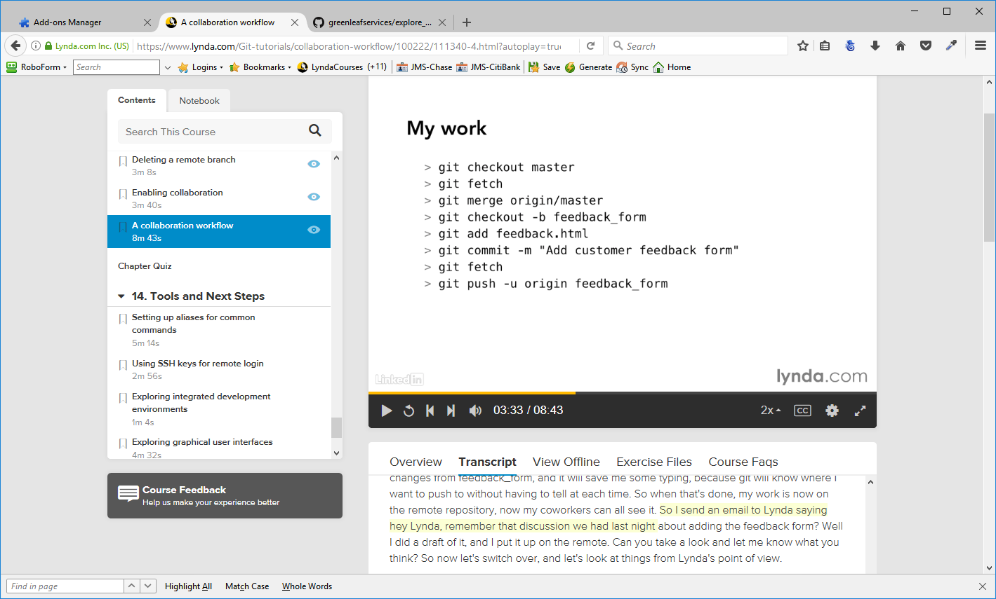
So I send an email to Lynda saying hey Lynda, remember that discussion we had last night about adding the feedback form? Well I did a draft of it, and I put it up on the remote. Can you take a look and let me know what you think? So now let's switch over, and let's look at things from Lynda's point of view.
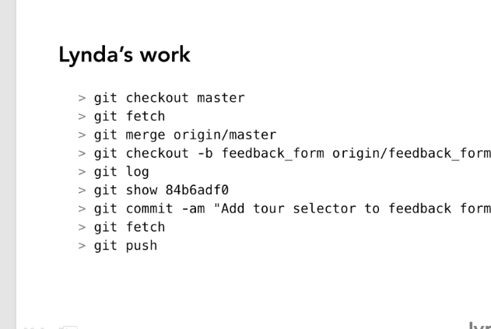
At this point Lynda is done. So she sends me back an email saying, it looks great I just made one quick change. On my side again, I want to see what change she has got, so the very first thing I do is fetch, so I can see the change.
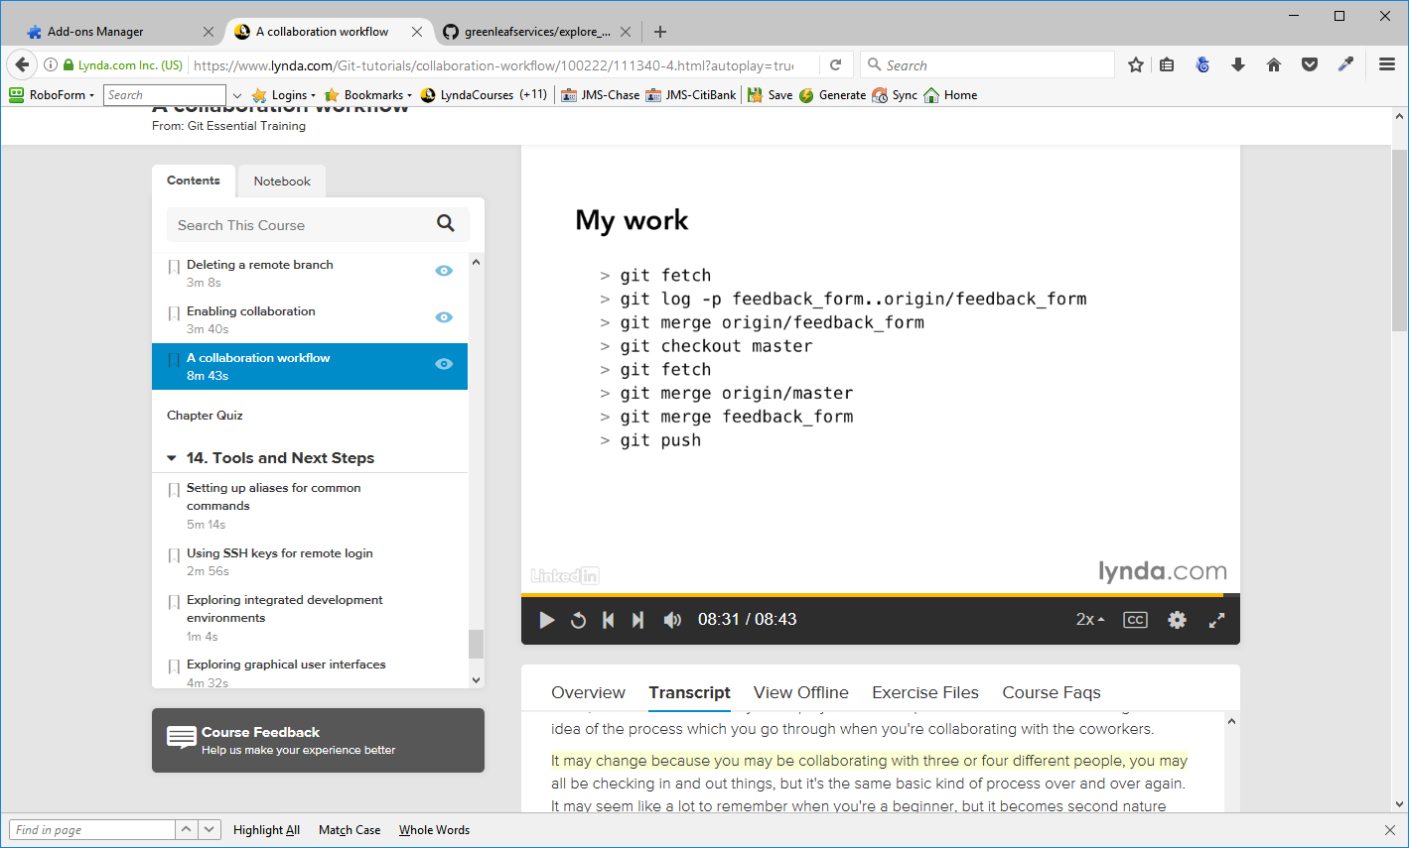
Tools and Next Steps
Setting up Aliases for Command Commands
Aliases can be a little bit dangerous. So it may be to your benefit, to stick with the actual Git commands for a while, until you get really familiar with them, and then when you are really are looking for a speed increase and trying to have less typing, to do something that you already know how to do well, then you can start using aliases.
When we set up aliases, we are going to set them up in any git config file, but it probably makes more sense to have them in our user global config file then it does to have them in the project config file, because we probably want to have them available to us in every project that we work on, and they are often going to be user specific.
Format is git config --global alias.<alias you are making> <command the alias is representing>
Example git config --global alias.st status → now st will represent the status command

Using SSH keys for Remote Login
Secure Shell (SSH) is a cryptographic network protocol for operating network services securely over an unsecured network. The best known example application is for remote login to computer systems by users.
This will eliminate the need to enter user name and password for push, fetch to the remote branches.
The idea behind SSH Keys we have a little bit of code, an actual file that resides on my computer. And I take that same code, or actually a complementary part of it, and put it up on the GitHub server.
Help article on github - http://help.github.com/articles/generating-ssh-keys

Creating a new project from a github clone
These notes are from Lynda – Up and Running with Git and GitHub

Clone the project from the github repository you want to use and place it in a folder on your hard drive
Once you have the project cloned, removing the .git folder will remove all logs, commits, etc
responsivebootstrap(00_start) > git log --oneline
e806da8 01_04 Using Rows & Columns
f3cf9e3 01_03
e7c305f start without any bootstrap
e75d84c start code
925c94e cleanup of css and html files
2824c17 got rid of images for uploads
9235abf new gitignore file
ccaaeec first commit

responsivebootstrap(00_start) > rm -dfr .git
responsivebootstrap > git log
fatal: Not a git repository (or any of the parent directories): .git

Files will still be there and you can make a new repository to start tracking your own project

Whenever I'm ready to make this be a brand new git project, I can execute a git init command and now it's going to initialize this as a new repository with absolutely nothing in the log. So I could git add everything, git commit -m, type in a "first commit" message and now it's added everything into git as if it were a new project.
responsivebootstrap > git init
Initialized empty Git repository in C:/gitprojects/lyndaprojects/02-20-17/Start/responsivebootstrap/.git/

git add .
git commit -m "Initial Commit"

This will cause the branch master to be created – project will be tracked

Git Notes – from Udemy
Cheat sheet for git - C:\Users\JMS2\Documents\Documentation\git_cheat_sheet.md

.gitignore changes – if you make changes to .gitignore, you have to clear the git cache so that git doesn't remember what you stored before and duplicate the storage

git rm . -r –cached
git add .
Git commit -m “Cleared git cache”
git push

Make a change to the file(s) you added into the gitignore file and they will not appear in the files to be committed anymore.

One file you should make sure git is ignoring is /config/secrets.yml. You don't have to be concerned with the development and test environments unless you work with API keys or any other things you want to store.

If you put an application into production, the server will store the secret key
production:
secret_key_base: <%= ENV["SECRET_KEY_BASE"] %>
so you don't need to be concerned about that either.

Developing a feature that is not ready for production
If you have a feature you want to add the to the application and you want to be able to make small changes to the app as necessary while the new feature is being developed, create a branch for that new feature and work on it there.
Git checkout -b <newBranchName> the -b creates the branch
make any changes and commits as appropriate.

If you need to make changes to the main app, you can switch back to it by entering
git checkout master
then make the changes, commit them and push them up to the application

The switch back to the feature branch
git checkout <newBranchName>
and you can work with the new feature

Pushing to github.com
The first time you want to send a new branch to github you may have to “notify” github of its existence
git push --set-upstream origin <newBranchName>

Once the new branch is in github you can make local changes and push it up normally.

Merging a branch with the master branch
When the new feature is ready to be published and the final commit and push have been made, there are two ways to merge the new branch into the master branch

1. Local git console
git checkout master
git merge <newBranchName>
git push – push master to remote

2. github
Go to the branch you want to merge into the master branch and click on Compare & pull request
Github will show you the changes it will merge into the master branch for you
Make any comments about the merge and click on Create pull request
You should get a page with the notation
This branch has no conflicts with the base branch
Merging can be performed automatically.

Click on Merge pull request. This will merge the branch into the master on github when you click on confirm merge. You should get a message
Pull request successfully merged and closed
You’re all set—the generator-controller branch can be safely deleted.
And you can delete the branch if you want to

Go back to console, verify you are on the master branch
git checkout master
git pull
This will bring in the merger master branch from github

To revert back to a previous status, removing all changes to a file, enter
git checkout <filefolder/filename>
This will get the last committed version of the file and the app will remove any changes you made in that file

Markdown language
You can integrate styles in to readme.md (mark down file) – see www.markdowntutorial.com – or daringfireball.net

