Bootstrap Notes
1 rem = 16px

Container – makes a page responsive

There is a set of four opinionated styles. Display-1, display-2, display-3, and display-4.
They're all bigger than h1s. Sometimes you need something really dramatic, for say the top of a website. So these display styles give you the ability to use something that is bigger than the traditional headlines

Another class the lead. It becomes just a paragraph that is a lot bigger.

sm, md, lg – works with media to make site responsive
xs – (default) < 576 sm - 576-767, md - 768-992, lg – 992-1200, xl - >1200 see bootsrtap docs – responsive breakpoints
These can be combined in one style statement

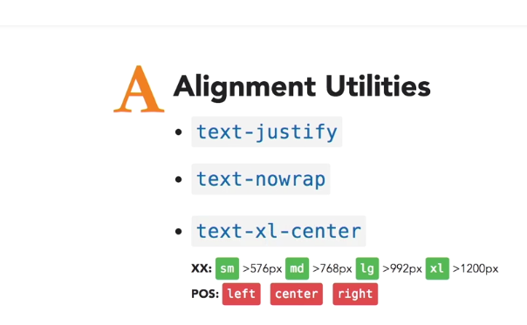

Images
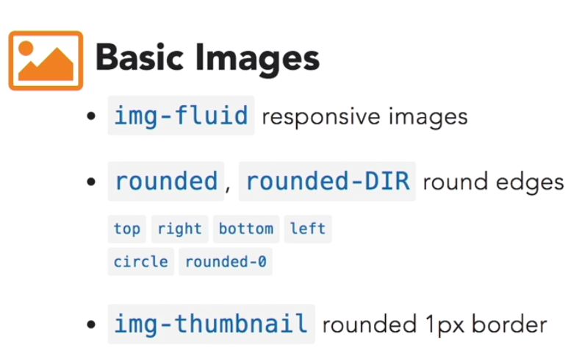

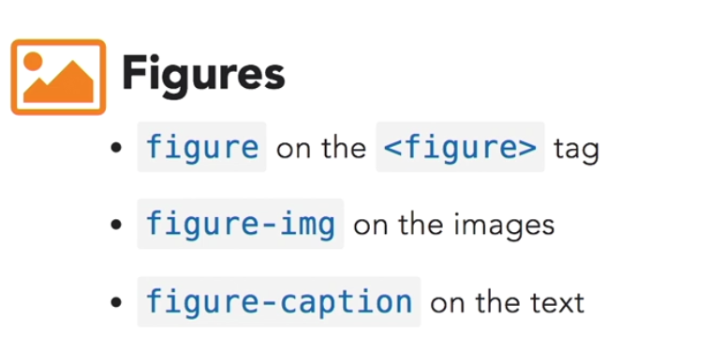
Chapter 3 – Mastering Layout with Bootstrap
Containers - can be either responsive fixed width that snap to certain breakpoints, or completely fluid containers which take up 100% of the width of the view port,
Inside containers, you can also place content in rows and columns.
Bootstrap uses a 12-column grid system that has breakpoints for extra small, small, medium, large, and extra large devices.
The grid is extremely flexible. You can create multiple layouts for different breakpoints, reset, offset, nest, and even customize the order of the columns at different breakpoints.

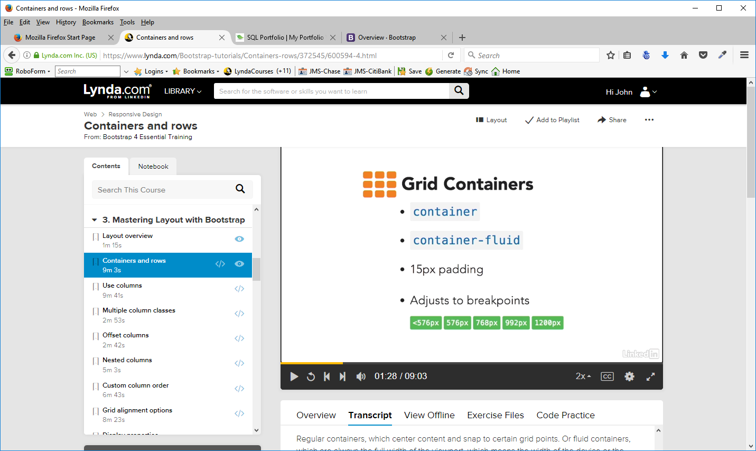
Row – should be inside container
Create columns inside rows
col tag – simplest – will fit up to 6 columns on a row – responsive
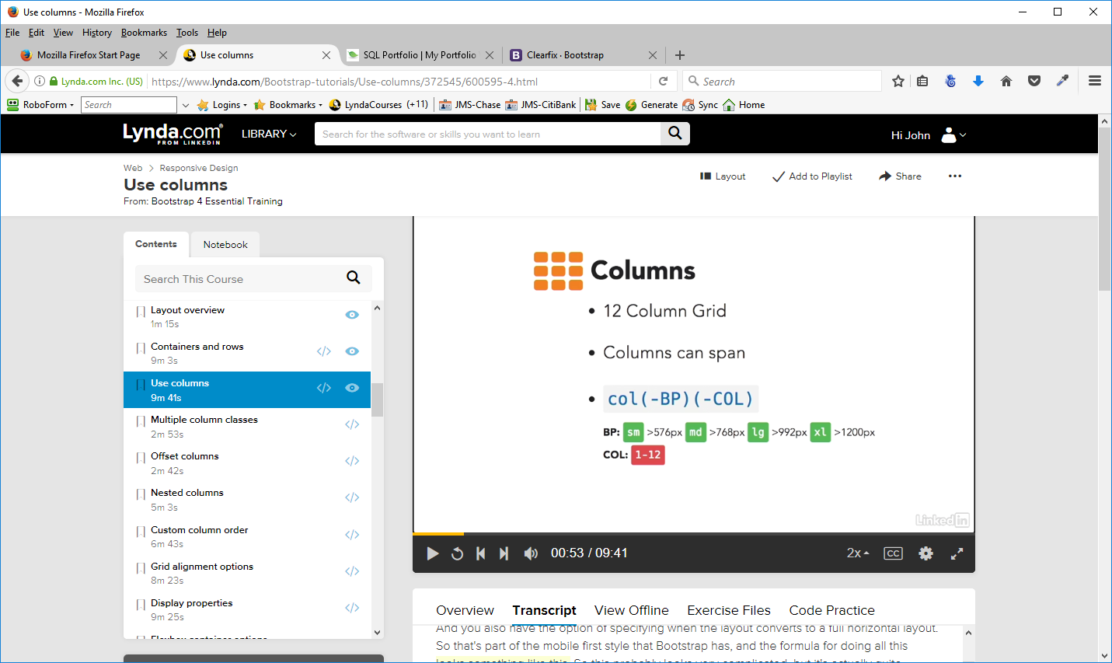
BP – breakpoint (sm, md. lg) - the column would normally take up the whole width of the browser until it reaches the breakpoint,until the next breakpoint up. You don't have to include this breakpoint either. And then what will happen is the column will always try to be the number of units at every one of the different sizes. The advantage of the breakpoints is that they allow you to control when your columns go full width, and then the columns actually let you specify how much of the space they should take.

The number you put in the col class determines how much of the space in the container/row that the col will take. Divide the number into 12 to make the calculations (6- 50%, 4-33%)

The last thing that you can do is specify a breakpoint at which the columns will start taking up a certain amount of room. Col-sm - when we get to 576, or the sm breakpoint, it's going to make the column fit the full width of the container because it's assuming that at that point you're trying to reach a small mobile device, and so you want everything to go the full width.
Col-sm-6 – will always be 50% until it gets to the breakpoint, when it will be full width

Multiple breakpoints
We can multiple-column breakpoints for each of our grid elements.
col-sm-6 col-md-4 col-lg-3 col-xl-2
So, when we get smaller than 576, we're going to see it go to a full-width layout. And then when we get bigger than that, this column is always going to take half of the units. When we get to that medium breakpoint, now each one of these items is going to take up four of the 12 units, which means that they're going to appear three-up. Once we get into the larger breakpoint, now each one of those takes up three of the units, which means that they're going to go four-up. When we get really big, you'll see that each one of these has taken up two of the 12 units. That means that it's going to try to fit six columns on the screen.

Offsetting Columns
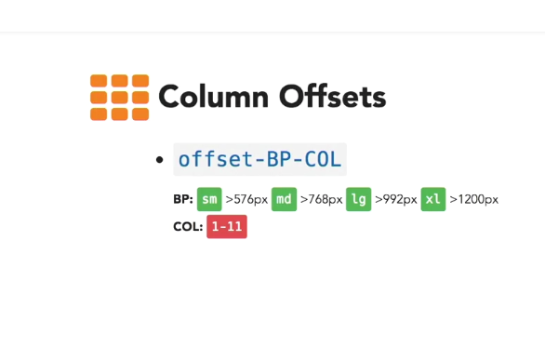
This is a way of having fewer columns across the page but moving them to the right
col-sm-4 offset-1 – the first displayed will be to the right 1 column – with a column of 1 on the left also

col-sm-4 offset-2 – basically will center the two columns it will display – 2 + 4 + 4 + 2 = 12. You only have to put the offset in the first column of the row. The offset will go in front of the column you are adding it to.

03-06 - Nesting Columns
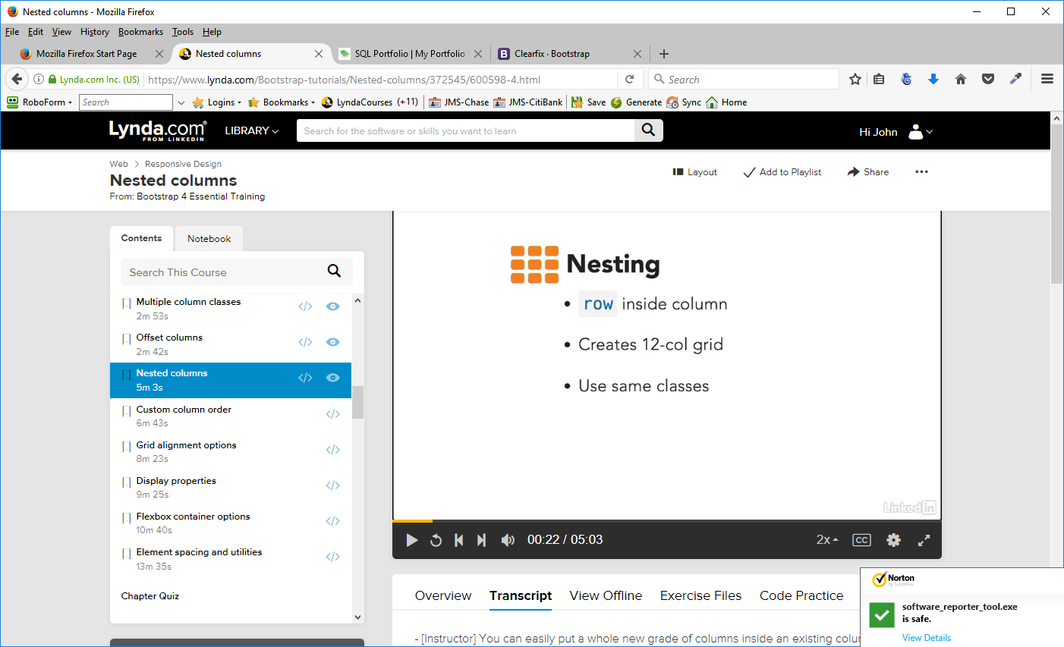
First section, row and column (8)
Make a second section and make a row and column (4) inside that
See code at G:\WebsiteStorage\BootstrapLessons\Ex_Files_Bootstrap_4_EssT\Exercise Files\03_06

03-07 - Custom Column Order
You can reorder higher layouts work at different breakpoints, which means at different screen widths. Now there's two ways to do this. First by using flex order or you can also use push and pull

Flex Order flex-(-bp) – ord
bp – usual
ord – first, last, unordered
first if you want that column to appear first regardless of the order that the columns are actually in.
Last of course if you want it to be last and
unordered if you want it to not have an order. Actually unordered will work only if you're trying to reset a previous thing that you've made first or last
Push & Pull act (-bp) – ord
Act = push (to the right), pull (to the left)
bp – usual
ord – 1 – 12 – how many columns to push or pull
See code at G:\WebsiteStorage\BootstrapLessons\Ex_Files_Bootstrap_4_EssT\Exercise Files\03_07

03-08 Grid Alignment
Vertical Alignment
Use in rows/columns
align-items-ALN (start, center,end)
sometimes to get the desired effect you may need to nest the columns

Individual Alignment
Use in rows/columns
align-self-ALN (start, center,end)
start – beginning of row - default
Center – enter of row
End – end of row

Horizontal Alignment
Use in rows/columns
Need to specify column width – can't use col keyword
justify-content-ALN
start – beginning of row – default - extra space towards the end (right)
Center – center of row – extra space on each side of column
End – end of row - extra space towards the start (left)
around – tries to put extra spaces between the columns
between – puts extra space between the columns

See code at G:\WebsiteStorage\BootstrapLessons\Ex_Files_Bootstrap_4_EssT\Exercise Files\03_08e

03-09 - Display Properties

Position classes
Fixed-top
Fixed-bottom
Sticky-top – stick to top as you scroll – not fully supported

Display properties
block
inline
inline-block
flex (options)

Basic Flex Container
d(-BP) (-inline (optional))-flex

03-10 – Flexbox Container Options
When you're working with the flex container you have two options. You can add additional classes to the container, and that modifies how all of the internal items work, or you can modify individual items within the container with additional classes. We're going to focus on just the classes that you can add to the container.

Basic Flex Container
d(-BP) (-inline (optional))-flex
If you don't put inline it'll default to a block container

Direction

flex (-BP) (-DIR) (-reverse)
Dir – row or column – row is the default – column will make them stack up
reverse – reverse the order of the elements in the row
justify-content (-BP) – ALG
ALG – start, end, center, around, between
Wrap - lets you control whether then elements wrap in relation to the space in their container
flex (-BP) – WRP - (-reverse)
WRP – wrap, nowrap
Vertical Alignment
align-content (-BP) – ALG
ALG – start, end, center, around, between, stretch (makes the element fit in the container vertically)

03-11 – Element Spacing and Utilities
G:\WebsiteStorage\BootstrapLessons\Ex_Files_Bootstrap_4_EssT\Exercise Files\03_11\index.html

Floating Elements
float – (BP) -SID
SID – left, right, none
When you use float, any container will lose track of the height of the element (the element will “disappear”). In order to prevent his, use clearfix in the container or div that contains the elements that are being floated. Adding clearfix to an element adds it to the element above it in the layout

Margin and padding
PRO (SID) (-BP) -SIZ
Pro – m(argin)/p(adding)
SID – top,right,bottom,left,x,y
BP – usual breakpoints
SIZ – 0 – 5, auto
Sizes - one through five correspond to what is happening with a base variable, which for Bootstrap is set at
one REM - 16px.
1 - .25 times that one REM (4 px),
2 - .50 REMs (8 px).
3 - 1.0 REM (16 px)
4 - 1.5 REMs (24 px)
5 - 3.0 REMs. (48 px)
SIZ - (-AMT)
width, height, max width, max height
AMT – 25, 50, 75, 100 - percentages of the container

Visibility
invisible – toggles but leaves room for it
hidden – BP - Dir – doesn't take up space
DIR – up, down – breakpoint specs – from the bp up or down

Align Self - take individual d-flex or display flex elements and align them separate from other elements. What you do here is for each of the elements that you want to align like this, you use a class of align self and then a breakpoint and then one of the alignment properties
align-self (-BP) -ALG
ALG
start
end
center
baseline
stretch – to the height of the container – can be specified by style="height: ##vh (height of view port)

Chapter 4 - Using Navs and Navbar Components

Overview
Navs
Tabs
Pills
NavBars

04-02 Basic Navigation
G:\WebsiteStorage\BootstrapLessons\Ex_Files_Bootstrap_4_EssT\Exercise Files\04_02\index-1.html
With or without UL
nav
nav-item
nav-link
active
disabled
Two styles
nav-pills look likes buttons – somewhat rounded when selected
nav-tabs looks like tabs when selected – adds horizontal row
Nav alignment
justify-content-center
justify-content-end (right align)
nav-fill – take up entire width of the container – each link will be as wide as its content
nav-justified – space in between each element is the same
flex-column – add breakpoints for responsiveness

04-03 – Create a Navbar
G:\WebsiteStorage\BootstrapLessons\Ex_Files_Bootstrap_4_EssT\Exercise Files\04_03\index.html
Navbar classes
navbar
navbar-toggable-bp
navbar-toggleable plus the breakpoint is going to tell the browser when to stack the item. The navbar will be stacked until it reaches (is greater than) the breakpoint.
Internal components inside the navbar
navbar-nav – where you put the links
Navbar Colors
bg-COLOR for backgrounds
primary, success, info, warning, danger, inverse, faded
text colors
navbar-light – for info or faded
navbar-inverse – text lighter
you can also use css properties to color the navbar
navbar-nav Options
nav-item – inside the anchor tag or list item
nav-line – inside the anchor tag
active – what link you are using
disabled – grayed out

04-04 – Branding and Text
G:\WebsiteStorage\BootstrapLessons\Ex_Files_Bootstrap_4_EssT\Exercise Files\04_04\index.html
Brand – enhanced text or logos
in-line text -
Navbar Options
navbar-brand
link or headline (margin adjustment may be required)
images – some style adjustment may be required
navbar-text – add text to navbar – not a link, just text – can be placed anywhere

04-05 – Add a dropdown to Navigation

G:\WebsiteStorage\BootstrapLessons\Ex_Files_Bootstrap_4_EssT\Exercise Files\04_05\index.html

Create a dropdown container in order to keep it aligned – use the class dropdown
dropdown-toggle – indicates where the dropdown is on the navbar - caret
activate using javascript or
activate using data-toggle=”dropdown”
create a element – dropdown-menu
menu items – dropdown-item
add id and aria attributes for compatibility with accessibility devices

04-06 – Add form elements in Navbars
G:\WebsiteStorage\BootstrapLessons\Ex_Files_Bootstrap_4_EssT\Exercise Files\04_06\index.html
Form Classes
form-inline
form-control
Create a from control outside the nav but inside the container in which you want it to be aligned
<form class="form-inline">
<input class="form-control mr-2" placeholder="Search">
<button class="btn btn-info">Submit</button>
</form>

04-07 – Control placement and alignment
G:\WebsiteStorage\BootstrapLessons\Ex_Files_Bootstrap_4_EssT\Exercise Files\04_07\index.html

Placement Options
fixed-top -
fixed-bottom
Both of these take a navigation out of the normal flow of the document, and puts it on top of all the other elements, and top of the screen or the viewport. Content in the above it will be hidden and content below it will have to be styled with CSS to account for the elements being taken out of the flow.
sticky-top - scroll the navigation until it gets to the top of the screen, at which point that navigation would stick there, and continue to scroll the rest of the document. Warning: it is not well supported in most browsers. See the listing here – http://caniuse.com/#feat-css-sticky
mr-auto – margin right auto -commonly used to separate nav sections. Makes the navbar fit in with anything else that may be in the container along with it

04-08 – Collapsible content
G:\WebsiteStorage\BootstrapLessons\Ex_Files_Bootstrap_4_EssT\ExerciseFiles\04_08\index.html

Collapse navbar content into a “hamburger menu” - we want this to appear on the right when the navbar collapses responsively – this will hide the list of links until the “hamburger” is clicked on
Three pieces
collapse - Content to collapse make a separate div for these items
navbar-collapse - so that the browser knows that this is actually a navbar-collapse and not a regular one.
Id - an id on this collapsible content that's going to tie together the collapsible content with the item that's going to do the toggling.

Toggler Classes
navbar-toggler and alignment (right or left)
Other properties -you need to tie the content from the toggler to the collapsible content with a data target.
And it's going to get the id that you use for the content that needs to be there, for example. And there's a series of aria properties that you should also add on this element to make it compatible with screen readers. Now, finally, you're also going to add a navbar-toggler-icon that's going to show the little hamburger menu.
Note: You can just put in the word menu at the end of the button setup and remove the navbar-toggler-icon.

Chapter 5 – Basic Style Elements

05-02 – Create Buttons
G:\WebsiteStorage\BootstrapLessons\Ex_Files_Bootstrap_4_EssT\ExerciseFiles\05_02\index-1.html

05-03 – Button Groups
G:\WebsiteStorage\BootstrapLessons\Ex_Files_Bootstrap_4_EssT\ExerciseFiles\05_03\index-1.html

Two button group classes
btn-group
btn-group-vertical (stack vertically – mostly for mobile devices )
btn-toolbar – create groups of button groups – use aria label property to add context to the groups

05-04 – Badges
G:\WebsiteStorage\BootstrapLessons\Ex_Files_Bootstrap_4_EssT\ExerciseFiles\05_04\index-1.html

Badges are contextual – will resize according to their container
Classes
badge
badge-pill
badge-ColorOption - standard BS4 colors or use CSS

05-05 – Progress Bars
G:\WebsiteStorage\BootstrapLessons\Ex_Files_Bootstrap_4_EssT\ExerciseFiles\05_05\index-1.html

progress container
progress-bar items
styles – width, height (percentages )
Label text
Colors
bg-color
progress-bar-striped
progress-bar-animated
multiple bars
Accessibility options
role = “progressbar”
aria-valuenow
aris-valuemin
aria-valuemax

05-06 - List Groups
G:\WebsiteStorage\BootstrapLessons\Ex_Files_Bootstrap_4_EssT\ExerciseFiles\05_06\index-1.html

Classes
list-group - containers
list-group-item - items
li, button, a
Styles
active or disabled - may need javascript to fully disable them (disabled does not work with buttons)
list-group-item-action – makes clickable - style
list-group-item-color – standard BS4
Adding Badges – common to do this
badge classes
justify-content-between (flex-box)

05-07 – Breadcrumbs
Used to indicate where you are in the navigation structure of your site or for secondary navigation.
G:\WebsiteStorage\BootstrapLessons\Ex_Files_Bootstrap_4_EssT\ExerciseFiles\05_07\index-1.html

breadcrumb – container
breadcrumb-items – items on the breadcrumb bar
style
active
use as li or nav>a items (links)

Chapter 6 – Layout Components

06-02 – Jumbotron
The Jumbotron is a component for a highlighted section of content that is commonly used at the top of many websites.
G:\WebsiteStorage\BootstrapLessons\Ex_Files_Bootstrap_4_EssT\ExerciseFiles\06_02\index-1.html

jumbotron – container
jumbotron-fluid – items – no rounded edges – takes up entire space

When you place a jumbotron outside of a container(as part of the header for example), it will take up the entire width of the page. If you put it inside a container, ti will fill the container only.

06-03 – Tables
G:\WebsiteStorage\BootstrapLessons\Ex_Files_Bootstrap_4_EssT\ExerciseFiles\06_03\index-1.html

Classes
table
sub classes
table-inverse
thead-inverse
table-striped – every other cell is gray
table-bordered
table-hover – mouse highlights row
table-sm
table-responsive
Colors
table-COLOR on row/td
usual BS4 colors

06-04 – Basic Card Layouts
G:\WebsiteStorage\BootstrapLessons\Ex_Files_Bootstrap_4_EssT\ExerciseFiles\06_04\index-1.html

Classes
card – container
card-COLOR
card-inverse – make the text white
card-outline-COLOR
card items
card-block – main container for the elements inside the card
card-text
card-title
card-subtitle
card-link
card images – usually outside the card block but inside the card
card-img-top
card-img-bottom
card-img-overlay – lets you have a card with a background image

06-05 – Card Content Classes
G:\WebsiteStorage\BootstrapLessons\Ex_Files_Bootstrap_4_EssT\ExerciseFiles\06_05\index-1.html

Headers & Footers
card-header
card-footer
Lists & Tabs
list-group-flush
card-header-tab

06-06 – Card Layouts
G:\WebsiteStorage\BootstrapLessons\Ex_Files_Bootstrap_4_EssT\ExerciseFiles\06_06\index-1.html

Traditional layouts
col - grid
flexbox – grid
Layout Classes
card-group – containers
card-deck -
card-columns

Card style samples
d-flex - see index-1 – not responsive
card-group – index2 – aligns top and bottom if cards – somewhat responsive - use divs to break the set into columns if necessary
card-columns – index3 - bottom of cards don't align
card-deck – index4 - aligns top and bottom if cards – most responsive - use divs to break the set into columns if necessary

06-07 – Media Elements
G:\WebsiteStorage\BootstrapLessons\Ex_Files_Bootstrap_4_EssT\ExerciseFiles\06_07\index-1.html

Images and texts side-by-side – based on flex-box

Classes
media – containers
media-body – text
flexbox classes

Use a div for the media body and an image tag – to the right or left of the media body class
Use styles along with the image tag to control the size of the image
Use d-flex align-self (center or end(bottom) classes to place the image
To move the element to the right, place I below the media

Chapter 7 – Forms

07-02 – Basic Forms
G:\WebsiteStorage\BootstrapLessons\Ex_Files_Bootstrap_4_EssT\ExerciseFiles\07_02\index-1.html

Classes
form-group - can be used with any block element like fieldset – a div for forms - and divs and
adds a bit of spacing to the bottom of the element.
sets the group to display block.
required for proper layout of some elements
form-text - basic form text elements like paragraphs and text that belongs underneath input fields.

Input classes – helps with spacing and padding

form-control - meant for inputs, select and text areas
form-control-label - use on labels belonging to form controls – also helps set the form up for validation styles
form-control-file – for file inputs

Options – labels – sr-only – hides the label but allows screen readers to “see” it

07-03 – Checkboxes and radio classes
G:\WebsiteStorage\BootstrapLessons\Ex_Files_Bootstrap_4_EssT\ExerciseFiles\07_03\index-1.html

Classes
form-check – container
form-check-label - specifically for the labels that belong to these type of fields
form-check-input - for the checkbox or radio button input field itself
form-check-inline - Checkboxes and radio buttons display as block elements by default. This will cause them to display side-by-side – work as float – counteract with – d-block – keeps label on a separate line – use in conjunction with form-check-inline

07-04 – Size and validation styles
G:\WebsiteStorage\BootstrapLessons\Ex_Files_Bootstrap_4_EssT\ExerciseFiles\07_04\index-1.html

Classes that let you control the size as well as the validation styles for forms.
form-control-sm - make the input field smaller
form-control-lg - make it bigger.
form-inline – make form groups display as an inline element - the label and the input field and any text after that input field will all show up in the same line
Validation styles – have to be used with javascript
has-success, warning, danger – outline around the fields
form-control-success, warning, danger - this will give you a little bit of an icon inside the input field

07-05 – Multi-column Forms
G:\WebsiteStorage\BootstrapLessons\Ex_Files_Bootstrap_4_EssT\ExerciseFiles\07_05\index-1.html

Uses BS grid
Needs container class to use the grid
does not need the form element or to be in a form group
uses rows and cols
Special Classes
col-form-label - gives labels a better spacing inside form elements that are inside columns

Notes:
To change fort sizes, margins, padding
Find the control you want to change in bootstrap.css
Copy the class to your custom style sheet
make the changes in the customs style sheet
To make multi-column layouts use a row call and multiple labels and divs inside the row
The first column in a row has to use a col class in order for it to align to the row above it
In the grid, any label takes up 1 grid unit, even if you don't use a col class for that label – not using a col will limit responsiveness

07-06 – Input Groups
G:\WebsiteStorage\BootstrapLessons\Ex_Files_Bootstrap_4_EssT\ExerciseFiles\07_06\index-1.html

Allows you to turn form elements with input fields and labels in a horizontal layout with an integrated look
Classes
input-group-addon
Uses inside an input-group class
Add this to an additional piece of text, and this will make that element appear like it belongs side by side with the input field
Can be added on each side
Other elements can be added – check boxes, buttons
Use a span tag to add the class to the element – see the code

Chapter 8 – Working with Interactive Components

08-01 – Overview

Work with javascript and jquery to deliver content that depends on interaction
Tooltips - provide a simple action that displays when you hover over links
Popovers - let you toggle more complex content when someone clicks on an element
Alerts - insert content into existing content depending on user interaction, for example, when a user makes a mistake and you want to display an inline error message, perhaps during form input.
Dropdowns - used most commonly in menus, display additional content beneath an element
Collapses and accordions - used to contract or expand content.
Modals - a way of creating alerts and dialog boxes to display things like images or additional pieces of data. It has a pretty rich set of styles to control how things are displayed.
Carousels - the most popular interactive component in Bootstrap, which loop through a few pieces of content.
ScrollSpy - lets you inject classes into HTML elements to highlight content as you scroll through a page.

08-02 – Tooltips
G:\WebsiteStorage\BootstrapLessons\Ex_Files_Bootstrap_4_EssT\ExerciseFiles\08_02\index-1.html

Tooltips are a great way to show some additional information for links and other controls. Now you should only use tooltips on HTML elements that are focusable, like links and form controls, because of problems with usability. Tooltips require an extra library called Tether, which is a separate installation. You can read more about Tether on this website – tether.io.
To create a tooltip, you add a data toggle attribute
data-toggle=”tooltip”
with the value of tooltip on the element that you want to create it on. In addition to that, you use a title attribute
title=”text”
with a value of the text that you want to display.
To set these up, you do have to activate them, and you do that with JavaScript. If you want to control the tooltips, you do that through either JavaScript or additional data attributes.
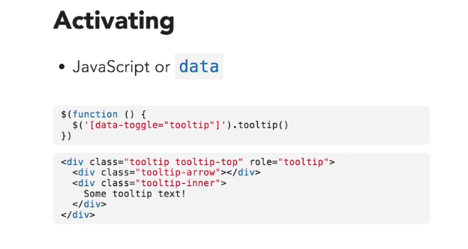
<div class="tooltip tooltip-top" role="tooltip">
<div class="tooltip-arrow">Test</div>
<div class="tooltip-inner">
Some tooltip text!
</div>
</div>

Common options
placement – top (default), right, bottom, left
trigger – click, hover (default), focus
You can set a default for all the tooltips on the page by altering the script
Tooltips script pages and code
index1 – default
G:\WebsiteStorage\BootstrapLessons\Ex_Files_Bootstrap_4_EssT\ExerciseFiles\08_02\index-1.html
<script>
$(function() {
$('[data-toggle="tooltip"]').tooltip();
});
</script>

index2 – clickable
G:\WebsiteStorage\BootstrapLessons\Ex_Files_Bootstrap_4_EssT\ExerciseFiles\08_02\index-2.html
<script>
$(function() {
$('[data-toggle="tooltip"]').tooltip({
placement: 'bottom',
trigger: 'click'
})
});
</script>

However, you can set each of these individually by entering the parameters in the link containing the tooltip - index 3
G:\WebsiteStorage\BootstrapLessons\Ex_Files_Bootstrap_4_EssT\ExerciseFiles\08_02\index-3.html

You can also do some simple HTML inside the tooltip by adding data-html="true" in the parameters – see the top tooltip on each index page

08-03 – Popovers
G:\WebsiteStorage\BootstrapLessons\Ex_Files_Bootstrap_4_EssT\ExerciseFiles\08_03\index-1.html

PopOvers are another component that lets you display additional content triggered by elements like clicks or hovers. They're almost exactly like tooltips, but they have a title as well as a content section, and they're displayed a little bit different.

Setup
Uses Tether library
data-toggle=”popover”
on link or button
title - “text”
data-content = “content”
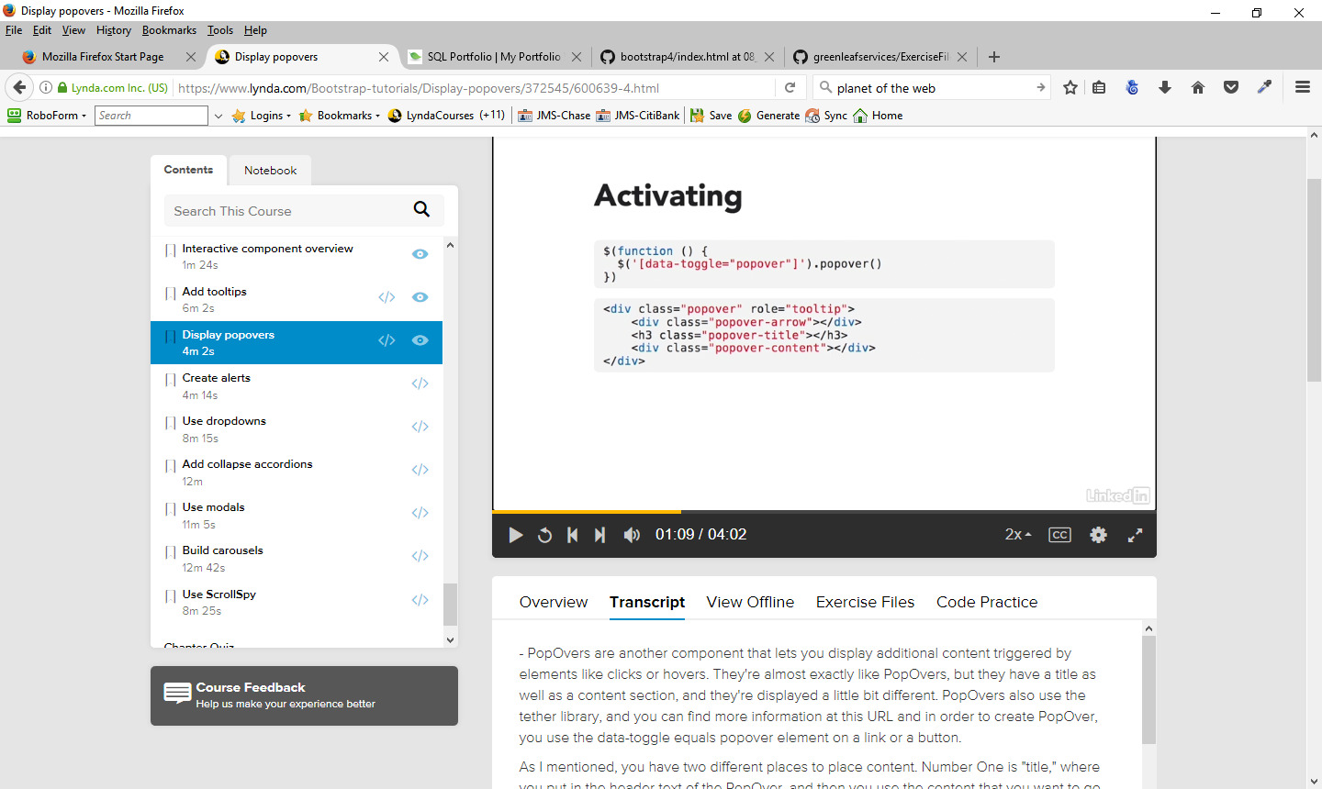
Common options
placement – top (default), right, bottom, left
trigger – click (default), hover , focus
container - You can specify that the container of the current PopOver is a specific element in your html page, and if you are getting some problems with multiple PopOvers not aligning properly, you may want to use this option.

08-04 – Create Alerts
G:\WebsiteStorage\BootstrapLessons\Ex_Files_Bootstrap_4_EssT\ExerciseFiles\08_04\index-1.html

Alerts are messages with special contextual styles that are designed to display in great looking boxes. They are a way of accenting a certain message. They are not related to javascript alerts. They're optionally dismissed and can have any have any sort of mark up. Setting up alerts is pretty simple. You start out with the basic alert class on a container. There's a few contextual classes that you can use for color - success, info, warning, and danger. A few classes are available for internal content, like headings as well as links, although you can fit just about any HTML content inside an alert. Just be aware that it is really meant for very simple content.
Classes
alert-heading
alert-link
Dismissable
alert-dismissable fade show
Add a close button to make this work

08-05 – Dropdowns
G:\WebsiteStorage\BootstrapLessons\Ex_Files_Bootstrap_4_EssT\ExerciseFiles\08_05\index-1.html

Can be used in Navs, Tabs and buttons
Created in two parts
Create a trigger
Create the menu
Classes
dropdown – in the container for the dropdown
dropdown-toggle – triggers the menu
dropdown-menu
dropdown-item – link of button
Dropdown elements
dropdown-header
dropdown-divider – horizontal line to divide elements
disabled
Dropdown Options
btn-sm, btn-lg
dropup
dropdown-menu-right
btn-group dropdown-toggle-split – Breaks button into two parts – label and active part – sample index-2

08-06 – Collapse and Accordions
G:\WebsiteStorage\BootstrapLessons\Ex_Files_Bootstrap_4_EssT\ExerciseFiles\08_06\index-1.html

Collapse and accordions are a set of related components that allow you to show or hide HTML content. Collapse is the simplest, and lets you show or hide content on a click. Accordions are similar but part of a bigger group. When one item shows, another hides, so accordions are essentially group of collapses.

Set up Collapse
link or button
data-toggle=”collapse”
#id or data-target
collapse class
Accordion – set of collapses
Container
collapse show – if you want any original element to show – in the div that contains the text to show
dropdown-menu
Use Card style

08-07 - Modals
G:\WebsiteStorage\BootstrapLessons\Ex_Files_Bootstrap_4_EssT\ExerciseFiles\08_07\index-1.html

Modals allow you to show and hide content that is in an element showing up as an overlay on top of your page.
Like with other components, modals have two parts:
trigger - a button or a link, as well as a piece of content that you want to show in the modal.
#id, data-target attribute.
data-toggle="modal"

modal – class for content you want to show
Structural classes
modal-dialog
modal-content
modal-header
modal-body
modal-footer
Modal Options
modal-title
data-dismiss=”modal”
data-backdrop=”static” - makes modal dismissable only through clicking on the button in the modal
sample with form embedded in modal
- G:\WebsiteStorage\BootstrapLessons\Ex_Files_Bootstrap_4_EssT\ExerciseFiles\08_07\index-2.html

Bootstrap docs - https://v4-alpha.getbootstrap.com/components/modal/

08-08 – Carousels
G:\WebsiteStorage\BootstrapLessons\Ex_Files_Bootstrap_4_EssT\ExerciseFiles\08_08\index-1.html

Carousel is one of the most popular Bootstrap components. It allows you to cycle images and has a lot of options
set up
container with the carousel class.
ID so that you can target the different components like the buttons for going to the previous and next slide, as well as the indicators.
If you want the carousel to automatically animate when the page loads, you can use the data-ride="carousel" property.
other options
data attributes
Carousel-inner is an internal component, and it actually is what holds all the images.
Active - element you want to show up when the page loads should have a class of active, and that will be the first slide that shows up in the slide show
make sure you crop and resize your images so that they have the same proportions.
additional CSS to make things work properly.
div with a class of carousel caption, and then you can put any HTML that you want in there as a caption.
Every navigation element should include a data target that matches the ID that you used when you created the carousel.
buttons, the carousel control previous and the icon for the previous button and then you have the next classes for the next container and the next icon.
indicators. You can add indicators that look like little dashes at the bottom of your carousels.
carousel indicators
data target
data slide
setup, you can use JavaScript or data attributes. Data attributes are a lot simpler; and anything that you can JavaScript

data attributes

Options
interval : ####
pause: hover|null
ride – how the photos rotate:
true – click on control
false – prevent the carousel from rotating
carousel - automatically play the slide when the page loads
wrap - what happens when the slide show reaches the last slide.
true – default - the slide advances to the first photo after the last photo.
false - it'll turn that off - you won't be able to advance after the last photo.

08-09 – ScrollSpy
G:\WebsiteStorage\BootstrapLessons\Ex_Files_Bootstrap_4_EssT\ExerciseFiles\08_09\index-1.html

ScrollSpy lets Bootstrap keep track of the scrolling of the page and modifies classes in an app according to the position of the scroll.
data-spy=”scroll
position: relative
data-target=”ID”
fixed-top – need to make this work -takes the element out of the flow of the document
data-offset – helps overcome the fixed-top attribute

Basically allows direct access to page section by the navbar and also changes the nav bar active designation as you scroll to the section

