Website Development Projects
Lynda Courses
Lynda - jQuery Essential Training – makes Hplus Sport Website
C:\xampp\htdocs\Lynda-jQueryEssentials
Teacher – Marini

Lynda - Accessing Databases with Object-Oriented PHP
Makes pages using mysqli database oophp – XAMPP
E:\htdocs\DBOOPHP – moved to backup – uses object oriented mySQL format
Teacher – David Powers

Lynda - JavaScript and AJAX
C:\xampp\htdocs\Lynda-Ray-JavaScriptandAjax
makes site to demonstrate us of javascript and Ajax to search for data in json files
Teacher – Villalobos

Lynda - PHP with MySQL Essential Training – makes WidgetCorp Website
Uses mysqli database widget_corp – XAMPP
C:\xampp\htdocs\JMS-WidgetCorpProject
Teacher – Skoagland

Lynda - CSS: Styling Forms
C:\xampp\htdocs\Lynda-Ray-Ex_Files_CSS_Styling_Forms
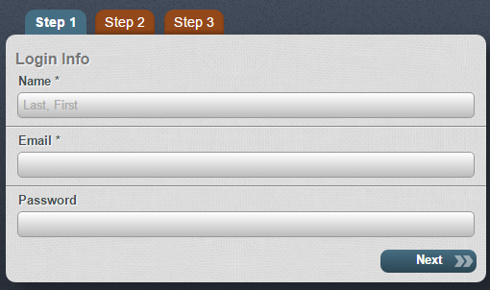
Creates form for submitting data – HTML only
Teacher - Villalobos

Lynda -Sass Essential Training
C:\xampp\htdocs\Lynda-Ray-SassEssentials
SASS practice – Website – Gulp to compile SASS index.html only
Teacher - Villalobos

Lynda - Up and Running with Git and GitHub
C:\xampp\htdocs\Lynda-Ray-UpAndRunningWithGitHub
GitHub practice – no output but for simple HTML files
Teacher - Villalobos

Lynda - Git Essential Training -
C:\Users\JMS2\Documents\explore_california
makes Explore California Website - HTML only
GitHub Repository – explore_california

Lynda - Web Project Workflows with Gulp.js, Git, and Browserify
C:\xampp\htdocs\JMS-Workflow-GitHub-Browserify
makes Roux Academy Website - HTML only
GitHub Repository – workflows
Teacher - Villalobos

Lynda - Coding Faster with Emmet - Shortcuts and tip for using Emmet – Bracket PlugIn
C:\xampp\htdocs\Lynda-Ray-CodingFasterWithEmmet
Teacher - Villalobos

Lynda - Installing and Running Ruby on Rails 5: Windows
C:\Users\JMS2\Documents\RubyProjects\sites\demo_project

Teacher - Skoagland

Lynda – Atom Basics
C:\xampp\htdocs\Lynda-Ray-AtomBasics
Teacher - Villalobos

Lynda - Ruby on Rails 5 Essential Training – makes simple_cms – document management system
C:\Users\JMS2\Documents\RubyProjects\sites\RubyonRails5Lessons\simple_cms
Makes ROR website with mysql database
Teacher - Skoagland

Udemy Courses
Udemy - PHP for Beginners – makes CMS Website
C:\xampp\htdocs\CMS

Udemy – Build Responsive Real World Websites with HTML5 and CSS3 -
makes Omnifoods website
C:\xampp\htdocs\Udemy-Jonas-BuildResponsiveWebSites

Udemy – The Complete Web Developer Course

Variety of websites using PHP, javascript, jQuery. MySQL etc.
Good Resources
myWorld Website, BBC duplicate website, etc
Movie Rental Project, Student Grading System in python

Udemy - The Complete Python/PostgreSQL Developer Course
Intro to Python/PostgreSQL and gitHub
Uses IDLE to run code
Code zip files are stored at
C:\Users\JMS2\AppData\Local\Programs\Python\Python35-32\UdemyLessons

Udemy – The Complete Javascript Course
Coding for Pig Game, Budget Website
C:\xampp\htdocs\Udemy-Jonas-CompleteJavaScript-PigGame and Budgety

