Claim Graph for Turenne GA and Price BD. Glycogen synthase kinase 3 beta phosphorylates serine 33 of p53 and activates p53’s transcriptional activity. BMC Cell Biology 2001; 2:12. http://www.biomedcentral.com/1471-2121/2/12

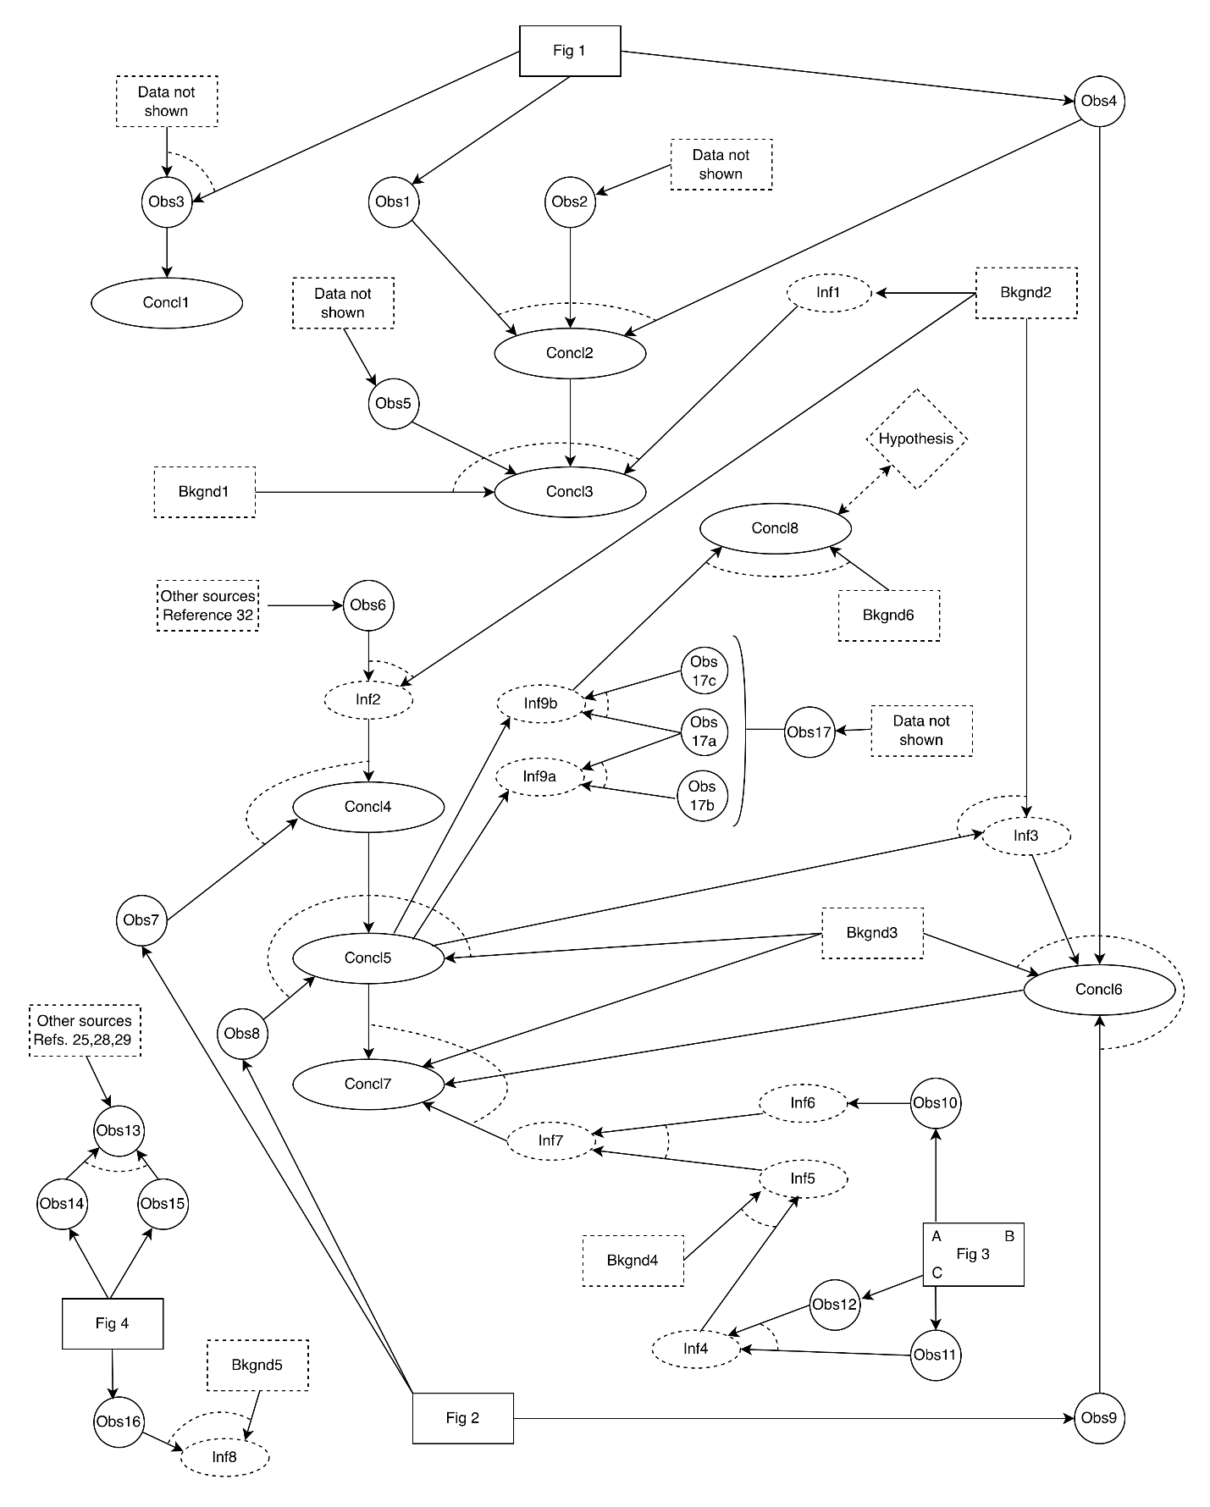

Note: Edges denote relationships among premises and conclusions; rectangles (e.g. Fig 1) signify data sources, circles (e.g. Obs1) observations, ovals (e.g. Concl1) conclusions, and diamonds hypotheses. Implicit information is indicated by a dashed outline (e.g. Bkgnd 1). Linked premises of an argumentation scheme are linked by a dashed arc. For example, Concl2 follows by Method of Difference from linked premises labelled Obs1, Obs2, and Obs4.

Paraphrases of premises and conclusions in graph:

Obs 1 (Fig 1) – GSK3-beta did not phosphorylate p53-GST in vitro.

Obs 2 (data not shown) – DNA-PK was able to phosphorylate p53-GST in vitro.

Obs 3 (Fig 1 and data not shown) – GSK3-beta did not in vitro phosphorylate p53-GST that had been previously phosphorylated with MAP kinase, PKA, PKC, CK2, JNK1, or JNK2.

Conclusion 1 (Default Inference: Obs3) – Phosphorylation of p53-GST by any of the kinases MAP kinase, PKA, PKC, CK2, JNK1, or JNK2 does not create conditions such that GKS3-beta can phosphorylate p53-GST.

Obs 4 (Fig 1) – GSK3-beta in vitro phosphorylated p53-GST that had been previously phosphorylated with DNA-PK.

Conclusion 2 (Method of Difference: Obs 1, Obs 2, Obs 4) – Phosphorylation of p53-GST by DNA-PK creates conditions such that GSK3-beta can phosphorylate p53-GST.
Obs 5 (data not shown) – GSK3-beta did not in vitro phosphorylate GST that had been pre-treated with DNA-PK in vitro.
Background 1 – If p53-GST is phosphorylated, it must be on either the p53 part or the GST part.

Background 2 – GSK3-beta phosphorylates serine residues at position 1 in the consensus sequence Ser-X-X-X-Ser(P), where the serine at position 5 has already been phosphorylated.

Inf 1 (Default Inference: Bk 2) – If GSK3-beta phosphorylates a protein, it does so at a site that is close to, or is in the same part as, a site that has been previously phosphorylated.

Conclusion 3 (Elimination: Concl 2, Obs 5, Bk 1, Inf 1) – Phosphorylation of p53 by DNA-PK creates a site at which GSK3-beta can phosphorylate p53.

Obs 6 (reference 32) – DNA-PK phosphorylates p53 at serines 15 and 37.

Inf 2 (Subtraction: Ob 6, Bk 2): residues in p53 that GSK3-beta could phosphorylate in Ser-X-X-X-Ser(P) (if they were serines) would be located at 33 (37-4) or 11 (15-4).

Obs 7 (Fig 2). Residue 33 (but not residue 11) of p53 is a serine.

Conclusion 4 (Elimination: Inf 2, Obs 7) – Residue 33 of p53 is the most likely site at which GSK3-beta phosphorylates p53-GST after phosphorylation of p53-GST by DNA-PK.

[Entity ID S33A: p53-GST in which residue 33 has been mutated from serine to alanine]
[Entity ID S37A: p53-GST in which residue 37 has been mutated from serine to alanine]

Obs 8 (Fig. 2) – GSK3-beta did not phosphorylate S33A that had been phosphorylated by DNA-PK.

Background 3 – Protein kinases cannot phosphorylate alanine residues.

Conclusion 5 (Method of Difference: Concl 4, Obs 8, Bk 3) – GSK3-beta phosphorylates p53 on residue serine-33.

Inf 3 (Addition: Bk2, Concl 5) – Serine 37 (33+4) of p53 is the most likely site where DNA-PK phosphorylates p53-GST.

Obs 9 (Fig. 2) – GSK3-beta did not phosphorylate p53-GST S37A that had been treated with DNA-PK.

Conclusion 6 (Method of Difference: Inf 3, Bk 3, Obs 4, Obs 9) – It is necessary for DNA-PK to phosphorylate Ser-37 of p53 before GSK3-beta can phosphorylate p53 on Ser-33.

Obs 10 (Fig. 3A) – When genes encoding p53, p53-S33A, and p53-S37A were inserted separately into human cells with no endogenous p53 expression, p53, p53-S33A and p53-S37A were detected at similar levels to each other.

Obs 11 (Fig 3C) – When the gene for GSK3-beta is added to cells along with the gene for p53, luciferase activity increased by 160% relative to adding the gene for p53 alone.

Obs 12 (Fig 3C) – When the gene for GSK3-beta is added to cells along with the individual genes for p53-S33A or p53-S37A, relative luciferase activity did not increase by nearly as much as was observed with p53.

Inf 4 (Difference No Effect: Obs 11, 12) – Adding GSK3-beta to mutated p53 has a lesser effect on luciferase activity than adding GSK-beta to unmutated p53 (i.e. p53 with Ser33 and Ser37).

Background 4 – Luciferase activity is directly proportional to the activity of p53 in promoting transcription in vivo.

Inf 5 (Default Inf: Inf 4, Bk 4) – Adding GSK3-beta to mutated p53 has a smaller effect on the ability of p53 to activate transcription of luciferase than adding GSK-beta to unmutated p53 (i.e. p53 with Ser33 and Ser37).

Inf 6 (Default Inf: Obs 10) – Any difference in effect of GSK3-beta on p53 transcriptional activity between mutated and unmutated p53 is not because of differences in levels of the p53 proteins.

Inf 7 (Method of Difference: Inf 5, Inf 6) – Mutated p53 is less able to activate transcription of luciferase in response to GSK3-beta treatment than unmutated p53.

Conclusion 7 (Default Inf: Inf 7, Concl 5, Concl 6, Back 3) – GSK3-beta activates p53 transcriptional activity in vivo by phosphorylating Ser-33.

Background 5 (ref 1 in Introduction) – p53 is activated by DNA damage caused by ionizing radiation.
[This provides the rationale for why they are doing the experiment in the first place. They expect irradiation of cells, which causes DNA damage, to increase p53 activity, and they want to find out how this happens]

Hypothesis - GSK3-beta phosphorylation of p53 is responsible for the increase in p53 activity when cells are exposed to ionizing radiation.
[Note: Given what they’ve found up to this point in the paper, a plausible scenario is that phosphorylation of p53 by GSK3-beta is what causes the increase in p53 activity upon exposure to ionizing radiation. This experiment is designed to test this hypothesis.]

Obs 13 (refs 25,28,29) – The activity of GSK3-beta is less in growing cells than it is in cells arrested in stage G0 of the cell cycle.

Entity ID – peptide substrate. A short peptide known to be phosphorylated by GSK3-beta.

Obs 14 (Fig 4) – When GSK3-beta was immunoprecipitated from growing human cells, the pellet phosphorylated peptide substrate with a certain activity.

Obs 15 (Fig 4) - When GSK3-beta was immunoprecipitated from human cells arrested in G0 phase, the pellet phosphorylated peptide substrate with higher activity than seen in Obs 14.
[Note: This is a demonstration that the authors are able to detect changes, and specifically increases, in activity of GSK3-beta in cells with this assay. Thus Obs 16 is not because the authors are incapable of seeing an increase in GSK3-beta activity with this assay.]

Obs 13-reconfirmed (Method of Difference: Obs 14, 15) – The activity of GSK3-beta is less in growing cells than it is in cells arrested in stage G0 of the cell cycle. [Note: Obs 13 was cited earlier in the paper based on references 25, 28, and 29. After deriving Obs 14 and Obs 15 by the experiment, they provide a Method of Difference argument to reconfirm (conclude) Obs 13.]

Obs 16 (Fig 4) - When GSK3-beta was immunoprecipitated from growing human cells exposed to ionizing radiation, the pellet phosphorylated peptide substrate with lower activity than seen in Obs 14.

Inf 8 (Default Inference: Obs 16, Back 5) – GSK3-beta activity in growing cells is lower when irradiation causes DNA damage than in normal growing conditions.

Obs 17 (data not shown) – When p53-GST is used as a substrate in place of peptide substrate in the experiments of Obs 14-16, similar results are seen.
Obs 17a (similar to Obs 14) When GSK3-beta immunoprecipitated from growing cells, the GSK3-beta pellet phosphorylated p53-GST with a certain activity.
Obs 17b (similar to Obs 15) - When GSK3-beta was immunoprecipitated from human cells arrested in G0 phase, the pellet phosphorylated p53-GST with higher activity than seen in Obs 17a.
Obs 17c (similar to Obs 16) When GSK3-beta immunoprecipitated from irradiated cells, the GSK3-beta pellet phosphorylated p53-GST lower activity than seen in Obs 17a.

Conclusion 5 (from previous analyses): GSK3-beta phosphorylates p53 on residue serine-33.

Inf 9 (Default Inference: Obs 17, Concl 5) – Phosphorylation of serine 33 of p53 by GSK3-beta is likely elevated in cells arrested in G0 phase, but decreased in cells exposed to ionizing radiation.
Inf 9a – Phosphorylation of serine 33 of p53 by GSK-beta is elevated in cells arrested in G0.
Inf 9b -- Phosphorylation of serine 33 of p53 by GSK-beta is decreased in irradiated cells.
[Note: Inf 9b is inconsistent with the idea that GSK3-beta is responsible for activating p53 upon exposure to ionizing radiation (i.e., in response to DNA damage) – GSK3-beta activity goes down under these conditions, not up. This gives rise to the implication (Conclusion 8) that GKS3-beta is not involved in the DNA damage response of p53 (which occurs when cells are exposed to ionizing radiation).]

Background 6: If GSK3-beta were part of the p53-DNA damage response pathway, then GSK3-beta activity would increase in cells exposed to ionizing radiation.

Conclusion 8 (Inconsistent with Expectation: Inf 9b, Background 6) – GSK3-beta is not part of the p53-DNA damage response pathway. [Note: stated in “Conclusions” section of paper]

Conclusion 8 contradicts Hypothesis.

Additional notes:

Why do the scientists use a peptide substrate instead of p53-GST to compare GSK3-beta activity in growing cells to activity in G0-arrested or irradiated cells (Obs 14-16, Inf 8)?
GSK3-beta phosphorylation of p53 is being presented for the first time in this paper, and is not established in the field. As an initial test of GSK3-beta activity, they use a peptide substrate that has been well established to be phosphorylated by GSK3-beta. Enzyme activity on this substrate is likely to be accepted as valid by other researchers. After using the peptide substrate, they demonstrate the same pattern of activity using p53 as a substrate (Obs 17, Inf 9). Consistency of activity with both substrates makes the result with p53 more reliable.

Why do some of the Observations use comparison to cells arrested in G0?
Previous results indicate that GSK3-beta has its highest activity in resting cells (i.e., cells arrested in G0). GSK3-beta activity is expected to be lower in growing cells. These researchers demonstrate that their assay is working as expected by finding a higher GSK3-beta activity in arrested cells compared to growing cells. Then, they measure activity in irradiated cells and find that activity is lower than in growing cells (counter to the hypothesis that GSK3-beta phosphorylates p53 in response to irradiation). Their observation of high activity in arrested cells provides more confidence that their observation of low activity in irradiated cells is valid.

